Contents

Analysis: 2

A description of the problem 2

Identify all the stakeholders 2

Justify why the problem can be solved by computational methods 3

Research 4

Features of the proposed solution 7

Software and hardware requirements 8

Success criteria 8

Design 10

Decompose the problem 10

Structure of the solution 10

Algorithms 12

Key variable and structures 12

Usability features 12

Test data for development 12

Test data for beta testing 12

Iterative Development of the Coded Solution 12

Iterative development 12

Prototyping 12

Annotated modular code 12

Validation 12

Reviews 12

Testing to Inform development 12

Testing to inform development 12

Testing to Inform Evaluation 12

Testing to inform evaluation 12

Evaluation of Solution 12

Testing 12

Usability features 12

Evaluation 12

Maintenance 12

# Analysis:

## A description of the problem

Crossley Heath School is a mixed selective grammar school with academy status located on Skircoat Moor Road, Halifax, West Yorkshire. The school continuously achieves top grades in both GCSE and A-Level examinations. A common problem in secondary schools is having an inadequate record of monitoring behaviour and giving sanctions to those who misbehave. Many schools still use mainly paper based systems to monitor behaviour instead of a faster more efficient electronic use which could potentially cut down the tasks of other worker within the school.

My project will be a school detention system specifically designed to meet the needs of the Crossley Heath School. However it can still be adapted to suit any high school who would like to have the same type of standards. The program will be a web based program to help teachers and staff be able to report detentions and for more senior members of staff to get an overview of behaviour of each year and see which students aren’t behaving.

The program can be broken down into various areas to create the project systematically first the web based program will have logins and the type of log in will affect what the user is seeing. For example the senior teachers will get to see an overview of all the detentions given out in a given amount of time. Also some senior members of staff are teachers so they will be able to log detentions as well. Other teachers will just be able to log in and track all the detentions they have given out and log any detentions they are yet to give. This is one aspect of the program that can be broken down alongside other features that could be added such as: a certain amount of detentions will lead to an after school one, an email is automatically sent to the students parents. This will have to be discussed with my client on what their personal preferences are.

This web based program is with the intention to help teachers keep track of detentions and sanctions. But it also is used as a faster means to give out detentions instead of writing notes in students planners which can be time consuming and hinders the learning of others.

## Identify all the stakeholders

A stakeholder is a person with an interest or concern in something, especially a business. Many people will be in contact with this program as either user or as part of the maintenance team. Also, other schools around the area may have interest in the program because they may be interested in using it themselves for their own individual schools.

The stakeholders include:

1. Teachers: The teachers are required to use the program as the main needs for logging the detentions that they are giving out in class. Therefore the teachers are the main end user the program is tailored for their needs specifically. They will benefit from the program by having an easy online place in which all the records of detentions are stored. Also it saves them time to go write in the students planner so they will increase their efficiency within the class room
2. Senior teachers: These teacher tend to have bigger roles outside the of class room. Many of they involve tracking down student who have misbehaved and giving them more serious sanctions. However they get this information slowly as the paper system for detentions goes down the staff. However by them being able to log in and just get a straight summary of all the detentions given on in for example a head of year will see for just there year. They can easily track the behaviour which will save them time and effort.
3. The IT staffs at school are in charge of maintaining the computer systems within the school. They’re called to help teachers who have any problems with electrical equipment also they help set up any new programs or software that need to be use. For example the pars registering system will have been downloaded by the IT technician with the head teachers’ approval. They’re contact with the program will be fairly brief as they may come in contact with it if any teachers have problems using it. Or showing new or existing teachers how to navigate around it once it’s been made. Even though the program should be user friendly enough.

## Justify why the problem can be solved by computational methods

The problem can be used for solving using computational methods because the whole program will use bits of code and algorithms to solve various sub procedures and when all those sub procedures are put together the program will be fully functioning. The program is completely web based, this would suggest the problem is can only be solved by programming techniques and no other methodology.

The program can be broken down into several small pieces and each piece will act as a separate sub program that I will solve then eventually have the whole web application running. The program can be split into various categories from the login which will require some sort of validation check. Also a password change every six weeks or start of a new term as part of security therefore the program will know when to alert a program user to change password. This means the program will need to be able to count the days. A way to count the days would be either to have a count that will add one each day until it reaches a certain amount and then the password for every account will become invalid. And thus forth need changing.

The program will also need to be able to read the database and be able to be updated when new students start the year. This means the web application needs to be linked to a database and making this project computerised means that names that are updated on the database can be automatically attached to the web application. This process would be incredibly slow without the program which can do it all quickly and efficiently saving time and effort.

The computational methods will be used in the case of keeping count of the detentions received within a term. For example: five detentions in a half term could be equal to an after school detention for this to be true I could use methods to accomplish this. I could use a counter that will have each name and the amount of detentions they have been given. Once this reaches five the program will use selection to input the after school detention onto the system. To not use a computational method would mean an individual would have to physically check every day and somehow try to keep track of the detentions that way. This would just be too hard for an individual to accomplish even if you split the task up a computer can do it effortlessly.

By having the program completed computationally this means the features of this detention system will be stretch beyond the main feature which is to log detentions. The teacher will enter the student’s name; subject and a drop down box with the most common reasons will be able to appear straight away. But teachers can also add a comment if they feel there is anything else that is relevant to the reason for the detention. At the end of the day all detention will be e-mailed to the parents of the students notifying them of the reason for the detention and when it shall be served.

Also a summary e-mail could also be sent to all heads of the years where they can clearly see all the detentions given out in a day so they are able to see frequent detention receivers which will help monitor behaviour. The system will also keep count of how many detentions a student is getting and a specific amount of detentions in a half term will lead to an after school. Once an after school detention has been issued the head of year will receive a personal e-mail specifically notifying them of the after school detention alongside the summary of all detentions for the day. With all the detentions being stored in one place head teachers, head of years and heads of departments have access to all detentions received from any student. Teacher will be able log in to see the history of their detentions they’ve handed out. And student will also be able to log in and see the history of their detentions. These are all factors that can use computational methods because to do it on paper wouldn’t be as efficient. So my program will be the most effective way of doing this will benefit the teachers who are able to now spend time doing other things. They are the main benefiters from this, however all these ideas will need to be approved by my client who many have some different ideas.

## Research

During my research into what sort of detention systems are already out there I came across a program that was being used in Headlines School which was said to ‘not only to encourage good behaviour in school, which in turn creates the ideal learning environment for your child, but also to deliver a clear message to our students that inappropriate behaviour will not be tolerated and will be sanctioned accordingly.’ This was interesting to see because this was part of the problems I wanted my detention system to fix. The detention system worked by a note in the student’s planner, the school will e-mail the parents to inform them of the detention only if the detention is after school. If the student is not logged as being present to the detention they will serve isolation for the full day the next day. The system wasn’t using computational methods to the degree in which I want mine to do so it wouldn’t be able to be used in place of mine but it was good to get more ideas from this program as well.

This is a suitable solution for what the school was trying to accomplish. This is because they have an accurate way of tracking detentions with the e-mailing of parents who have daughters or sons in after school detentions. However it wasn’t so much of a written program it was more of a system the school used in order to inform parents on after schools detentions. But this is still a system I can incorporate into my program. Even though I intend for my program to be more electronically and avoid paper work but the Headline School method was a good way to see what other methods are out right now.

Another program I found which was much more relevant to sort on online detention system I am trying to create was called IRIS which was said to be ‘highly effective and versatile online behavior and rewards solution for secondary schools.’ This was an online detention system that required a log in; its main benefit was to increase staff engagement with behavior management systems. The IRIS was an excellent to track detentions as involved full staff involvement and it was all online which was what I wanted mine to be like so there were some similarities into between the two ideas. The IRIS allowed the detentions to all are stored online and e-mails were only sent to parents able students who received after school detentions. Also this showed me that the program I’m trying to create it actually solvable because of the all the similarities.

I could take some ideas for this because IRIS was said to be very reliable to prove to Ofsted that the schools behavior is improving. And the IRIS was able display a summary at the end of each term which was a good idea I could use in mine. The summary includes an average amount of detentions and after school detentions give in each year per week. Therefore by comparing two terms you could show how behavior is improving or going down. This is something I’d like to include into my program because it’s a great addition to all the other features included. However it is something I’ll have to ask my client when I have my first interview so decided how much use that will be.

During my research I was unable to find a school detention system that had the extra features that mine is going to have if my client agrees to it. Also none of the programs researched had the ultra-friendly usability which mine should have, because some teachers may not be the best at using computer systems therefore my program needs to be simplistic in parts. However the research was useful because I was able to collect some more ideas to similar problems that I didn’t think of myself. Therefore the research will help me create a better program.

First interview with client- Transcript (paraphrased):

This interview was conducted with a senior member of staff, who could have a big role in the outcome of the project as he makes decision for various departments. Therefore asking this teacher to help with the design and over product would be a good addition to ensure the final outcome is adequate.

(Introduction)

Me: So sir could you please explain to me the current system that is kept for detentions and how to track them?

Teacher: Okay, so currently each year has a head of year which will be informed if a student receives an afterschool detention. Lunchtime detentions are written in planners by the subject teacher and the student goes to the detention. If they don’t attend they will receive an afterschool detention, it is always up to the teacher to chase after students who don’t go to the lunch time detentions.

Me: Okay is there a place where all the detentions of students are kept?

Teacher: Not really after school detentions are logged into the system but lunch times aren’t really looked into too much.

Me: Would you find it useful for a system that would keep track of all detentions given out, is that something you would like?

Teacher: Oh it would definitely be useful in that case we could easily see the students who are getting detentions often instead of teachers chasing me up.

Me: Alright I’ll tell you my idea for the school detention system. My idea is to have all the detentions given out to be stored on one program, well a web application. So the teachers can select the reason for the detention and which student it’s for. An e-mail is automatically sent to the students parents notifying them the detention and reason for it. Also at the end of each day a summary e-mail is sent to all the heads of year to show the detentions that have been given out over the day. Also, the head teacher and deputy heads can log in to see all the detentions at anytime. The class teachers won’t be able to see what detentions others have been given just a history of their own. Maybe five detentions in a half term would be equal to receiving an after school detention the system will alert for this. Then the final thing is at the end of each term the system will produce the average amount of detentions given out in a week over the term. What do you think?

Teacher: Wow okay is this for all years or just the sixth form?

Me: This is just for years 7 – 11, as detentions aren’t common for the sixth form.

Teacher: Okay yes well all the point you mentioned is something the school could definitely benefit from. The summary e-mail that would be sent to the head of each department may not be necessary if they can log in and see the detentions on the system.

Me: Yes and I was hoping that this would then cut down the time teachers spend writing in planner.

Teacher: Yeah well I like everything that you’ve said it should be good.

Me: Is there any changes you’d make?

Teacher: Maybe don’t send an e-mail at the end of everyday with the summary of detentions. That could be at the end of each week instead because not that many detentions get given out per day to be useful.

Me: Okay no problem anything else?

Teacher: Can other teacher access all the detentions given out?

Me: No that’s not the initial plan

Teacher: Okay how come?

Me: Because to make other teachers be able to see other teacher’s detentions isn’t beneficial and it can be a privilege for senior staff.

Teacher: Ok that makes sense, how are we going to start using it.

Me: Well it’s a web application so it’s separate to all the other programs like pars. Each teacher will have a log in so they can access there detentions and other student can’t mess with it. And once create the IT technicians will be the ones to get the staff up and running with it.

Teacher: Okay that’s fine have you spoke to them about it?

Me: Not yet but that’s something I can once I’ve designed the program.

Teacher: Right I like this, when will it be done by?

Me: Possibly by Christmas time but I’ll keep you informed as I’m going along with it. If there’s anything that I can’t do or anything I think we should add

Teacher: Okay great that be fine

(End interview)

## Features of the proposed solution

1. One criterion that needs to be solved in the programming part of this project alongside the basic backbone such as the user interface and liking the program with a database of the students. Is the logins for the teachers such as that head staff can see the whole of the detentions and non senior members can only see the ones they give out. This isn’t as an important area as the others to be mentions as my client didn’t seem to keen to have that emplace nor seemed to care too much about if that was part of the program or not, however it’s a nice add on I’d like to have.
2. One important criterion is having the program send an e-mail of all the detentions given out in a week to the head of the years so they can receive a summary or to have all the detentions stored on the application where senior member can access it. This would be quite tricky to do as the program would now have to be able to know the email addresses of the teachers which I’ll have to collect and be able to log all the detentions and send the right years of to the right teachers. Similarly to this the program will have to do the same thing with the parents of the students.
3. Another important part would be having the program that can count the amount of the detentions a student has had in a half term. And if they surpass five they will be given an after school detention, the program will then make the amount of detentions in the database go back to zero. This will be the same for when a half term is reached therefore the program will need a calendar installed to when all the detentions should go back to zero but a record of all the detentions should be kept somewhere.
4. Finally the user interface is a big part of the program so less skilled teachers in IT can use the software effectively. Therefore ill need to make the program as user friends as possible and easy for eve the work teachers to navigate. To trial this I could have some teachers test the user interface during my development of it.

These are the essential features to my program as they are the key add adaption’s to the

Average detention system. This is what makes it applicable for The Crossley Heath School.

Limitations:

1. The main limitation to producing the perfect detention system which solves all the proposed features is time. Based on the fact I have a limited amount of time in which to complete this program it may not be completed to the full functionality I intend for it. With the time limitation this means if I run into any major problem I could really struggle to correct these mistakes if the problems come in the latter stages in the program, as I may not have time to properly correct these problems.
2. Another limitation is knowledge; my own skills in coding may not be adequate to complete the full program. As I can’t actually solve what I am trying to code for this would mean I may find myself simplify something’s as go along, but the program should be useable by the time I am finished with it.
3. The one flaw with the internet is it is not everywhere yet. If your internet goes down or you happen to be in an area that has not been connected yet you will not be able to access the application therefore detentions won’t be logged for the duration it’s down.
4. Based on the fact that the programs information is stored on a cloud based service, the data tends to be less secure to hackers, even though detentions systems may not be a target for hackers but we still shouldn’t ignore the fact it could be a possible target for some reason.

## Software and hardware requirements

A computer system consists of two major elements: hardware and software. Computer hardware is the collection of all the parts you can physically touch. Computer software, on the other hand, is not something you can touch. Software is a set of instructions for a computer to perform specific operations. The program is a visual basic web application that will be loaded on Google chrome or some sort of web browser. Therefore the hardware and software requirement are the ones that are required to load up web pages.

Reference: <https://support.google.com/chromecast/answer/3209990?hl=en-GB>

1. Windows minimum system requirements:

2nd-generations core i5

Windows 7 or later

1. Apple OS X minimum system requirements:

Macbook Pro 2011 or newer, Macbook Air 2012 or newer

OS X 10.9 or above

## Success criteria

1. Create a web application to log detentions this is to ensure I have a working basic detention system, this is so my client can have some sort of working product at the end, in the off chance I cannot completed any of the extra features we have discussed.
2. The program must also be user friendly to teachers who aren’t as equip in using computers so therefore the program needs to be easily usable by all member of staff, and everyone feels comfortable using it.
3. Options to change the password after 6 weeks due to security reasons this is done to ensure account are kept secure from others. Also so the teachers feel secure using the program as they know there passwords are frequently changing therefore the chances of unwanted access from people will be reduced.
4. Have logins that vary what the non senior and senior members of staff can see, this is so the senior members of staff are allowed to have access to more documents from within program.
5. 5 detentions in a half term signify an afterschool, this so the senior members of staff know who to give the after school detentions too and this so automated so they can save their time and not have to be counting or trying to keep track of the detentions themselves.

Design:

## Decompose the problem

To decompose the problem further into computational area I will take the success criteria for the development of the program. And take this further to think about the user interface that will have to be easily usable for the entire teachers who are the main users of the program.

Firstly before I start any coding I will produce some layout screens for how I intend the program to look. By doing this it enables me to have a predetermined view of how I want the program to look, and I won’t need to be thinking about the look whilst doing the more challenging part of coding it. Alongside doing designs making it easier for me to see how the program is going to turn out I am able to take the screenshots to my client and he can offer advice on what he likes and doesn’t like. And I can continuously produce copies for him until he’s happy with it. This is good because instead of getting to the end result and then have the client not keen on the colour scheme and other factors would mean I have to go back and alter things which would be poor planning on my behalf. Within doing this I can create a solid plan for what the bottoms should do and how they will all work together and see what pages should connect to what pages. So by the end of designing the user interface I will have the bases of how the program will function and I will be in a position to start actually creating the program.

After this stage I will move on to actually coding the project, this will be the backbone of the project so just the simplistic detention system. By doing this I will be able to logically work through the project and not try to do too many things at once. Also by coding the basic detention system this will include just the bare minimum so it will be the program linked to the database of names. And the teacher can input what the student has done wrong and this will then get stored in area to be checked. By starting from this bare place and making sure it works perfectly it ensures I have some sort of working detention system that I can hand to my client if for some reason I am unable to completed the unique bits that make it tailored to my clients specific needs.

By this stage I have completed the user interface and I have a working minimum school detention system so by this time I will be doing the difficult added bit that make the program more complex bits to how it works. Based on my success criteria I think I will tackle this in the systematic factor of difficulty, but when I start to program I may find some bits harder than other parts. For example I may find coding the 5 detentions will notify an after school detention very difficult and I don’t want to be stuck doing this and not accomplish anything else so I may move on to other things. So I intend to do the complex parts in this order but when I start it may change based on difficulty. I intend to solve the project in the order the success criteria is listed in.

## Structure of the solution

Based on all the feedback I have from my client and all the factors I have taken into account of my range of skills and what I will be able to produce I now have firm idea of what the structure of my program and all the features that comes with it.

The program structure will be very user friendly has that is a major part of the program and insuring it does what the program is designed to do. I am currently in the process of creating the designs for each page of the program and this has enabled me to break the program down into more manageable sections. Also this is has been beneficial to see the link between button and which button will link to certain pages. I will now produce a sort of data flow diagram to show the structure of the program.

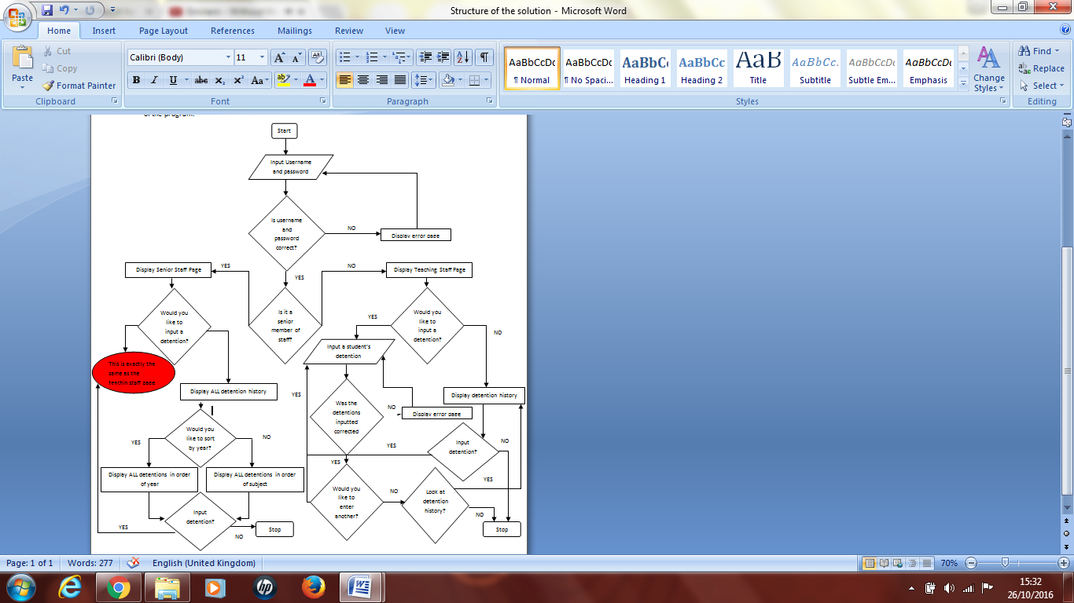

This flow diagram illustrated the flow of data that end user will experience during the usage of the program. This will be the structure of how the program will be navigated, I clearly shown the difference between signing in on a teaching account and a senior account as the senior account have more options to what they can see which won’t be available to the normal teaching staff so that’s the reason for the two different side within the flow diagram. I think this is the best way the program should be structured because I am continuously keeping in mind the fact that the program need to be incredibly user friendly. Therefore the program could be set up in a more efficient way but this more efficient way may not be the best for being user friendly for teachers who aren’t as skilled in computer. Hence this is the structure of the program I will produce.

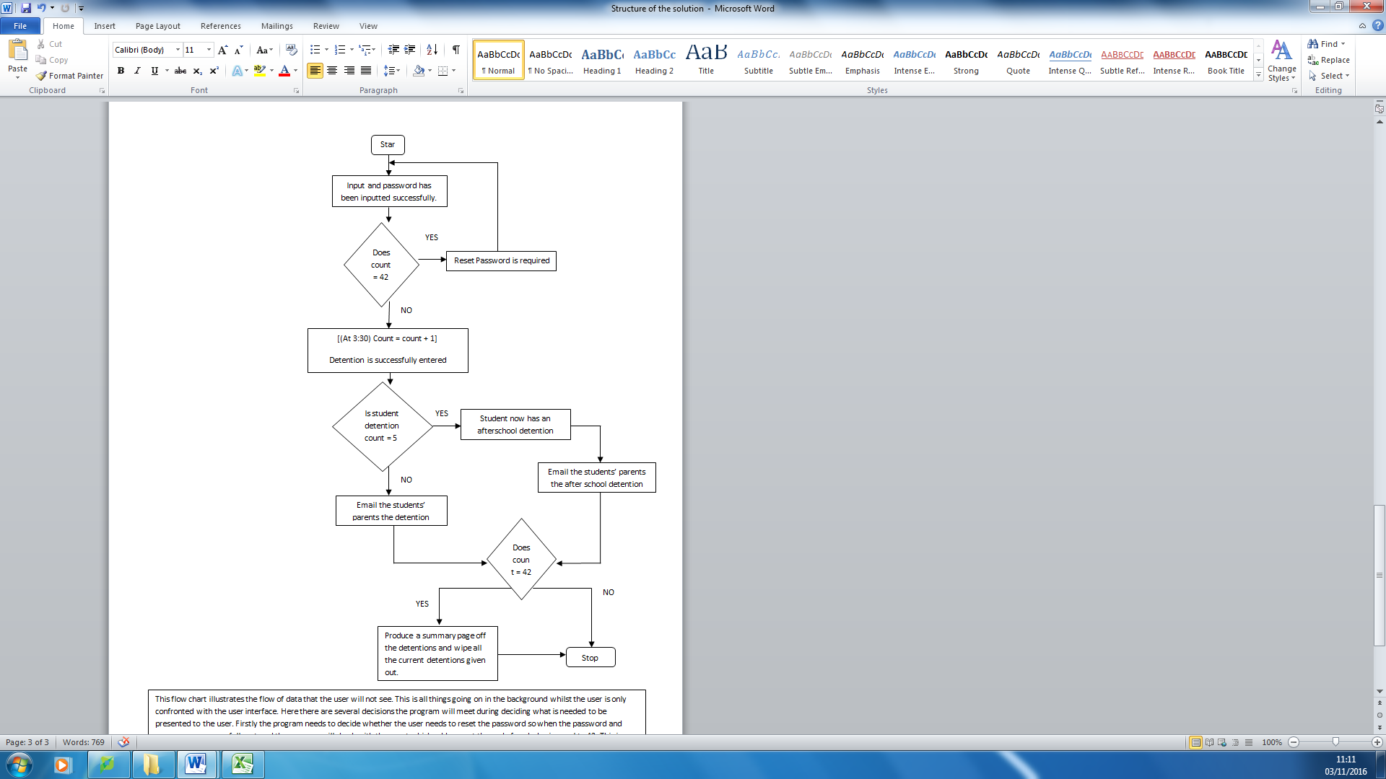

This flow chart illustrates the flow of data that the user will not see. This is all things going on in the background whilst the user is only confronted with the user interface. Here there are several decisions the program will meet during deciding what is needed to be presented to the user. Firstly the program needs to decide whether the user needs to reset the password so when the password and username as successfully entered the program will check with the count which adds one at the end of each day is equal to 42. This is because are normally 6 weeks in a term and then that is 42 days in which the passwords are valid for. Next the next decision the program has to make is if the number of detentions assigned to a certain name is equal to 5 because in this case an after school detention will then be issued. But if not a lunch time detention will be issued and both of these two circumstances will involve emails being sent to the parental guardant of the student. And the final decision is the same as the first decision if the count is equal to 42 then the program will then produce a summary page of all the detentions received by year and stored this in a folder with the date. This is so the senior staff don’t have to scroll back constantly they can select a region in which they want to see which will be neatly stored in the folder.

## Algorithms

An algorithm is an abstraction of a computer program, and consists of a set of instructions to achieve some well-defined task in a finite number of steps, though the bound on the step count might be very large and the individual steps might be complex tasks in their own right.

In my program I will require quite a lot of algorithms comprised of smaller sub tasks within them for example the log in query which reads the table and will have to pass the information of the field that it is recognising will require an algorithm in order to do so.

Login Query:

1. Define Provider = “Access Database Version”
2. Define DataFile = "Connection to the database”
3. Define ConnString = Provider & DataFile
4. Define CMD as new Command = "Select from the teacher table WHERE the [user name] = Username.textbox AND [Password] = Password.textbox”
5. Define dr As = CMD.ExecuteReader
6. Define userfound As Boolean = False
7. Define Senior As String = ""
8. Define TeacherID As String = ""
9. While dr.Read

Userfound = True

Senior = dr ("Senior")

TeacherID = dr ("Teacher ID")

End While

1. If userfound = True Then

If Senior = "Yes" Then

Redirect ("Senior_Staff_Page")

Else

Redirect ("Teaching_Staff_Page ")

End If

Else

Message.Box("Sorry your username of password was incorrect please try again")

End If

This is the pseudo code for the log in query algorithm which takes the inputs from what the user types in and checks if the username and password typed in are equal to a field in the teacher table. If they match this code then retrieves the teacher ID and whether the teacher is a senior member of staff or non senior then it take the user to the senior staff page of the normal teaching staff page based of the information entered. This query is linked with the insert query which would work almost the opposite way round by taking the user inputs and putting them into the table in order to read by the log in query, the insert query would looking something like this in my program.

Sign Up/Insert Query:

1. Print("Your account is now set up please go log in")
2. Define Provider = “Access Database Version”
3. Define DataFile = "Connection to the database”
4. Define ConnString = Provider & DataFile
5. Define STR As String
6. STR = "Insert into The Teacher Table ([User Name],[First Name],[Second Name],[Email],[Password],[Senior],[Subject])
7. Define CMD As New Command(str, myConnection)
8. CMD.Parameters("User Name",(Username.textbox, String))
9. CMD.Parameters("First Name",(FirstName.Textbox, String))
10. CMD.Parameters("Second Name",(SecondName.Textbox, String))
11. CMD.Parameters("EMail",(Email.Textbox, String))
12. CMD.Parameters("Password",(Password.textbox, String))
13. CMD.Parameters("Senior",(Senior.Textbox, String))
14. CMD.Parameters("Subject_Teacher",(Subject_Teacher.Textbox, String))
15. Try

Close Connections

1. Catch ex As Exception

Message.Box ("Sign up was not processed please try again") 'error message.

1. End Try

This would be the insert query; this works by taking the information the user types into the textboxes, then uses the text box IDs in order to put this information into the table, which is connected to the login query that will read the table. Therefore the two queries do interact with each other through the table.

## Key variable and structures

Variables are naming words in which values are stored under they allow for the manipulation of values without predetermining what the value can be but, based whatever the chosen value assigned to the variable is.

Some key variable that will be need within my program would be to name the text boxes appropriate names to allow for easy manipulation. This is because if I allowed for example on the sign up page where the user has to enter a range of different information surrounding themselves into the textboxes and this will be queried and put into a database. Therefore when I am trying to provide this query and the textboxes are default names such as ‘textbox1’ this will prolong the task where it could be called ‘Username. Text’ if the box the user is writing it relates to their username. This would changed for the other fields but naming the textboxes appropriate variable would be a good way of keeping track of input and make the production of my code run more smoothly.

In my program it will require a record data structure, a record is a group together collection of related fields under a single name. This will be used because when the user signs up all there information is assigned to one unique name being ‘Teacher ID’, which will then allow me to pull all the information stored under this record name. A record will be the only data structure I will need in the production of my program.

Some validation that will be required will be based on user preference. This could be entering the date that a detention is being given out, for example one user may enter the date ‘12/12/2017’ and one may say ‘12th Of December’ this makes for a lack of consistency in the table. This would be bad because if the user then wanted to sort there history of detentions in date or the different type of dates that have been given would confuse the table. Therefore I need some sort of validation that only allows the dates to be entered in a specific sort of format. This will be the same for subject as there different ways of typing in the subject such as ‘Physical Education’ or ‘P.E’ again this will lead to confusion within the table. Therefore I will provide a drop down list with a predetermined set of subjects to choose from therefore this will marginalise what the user is allowed to input. These will be the two main validations required within the program.

## 

## Usability features

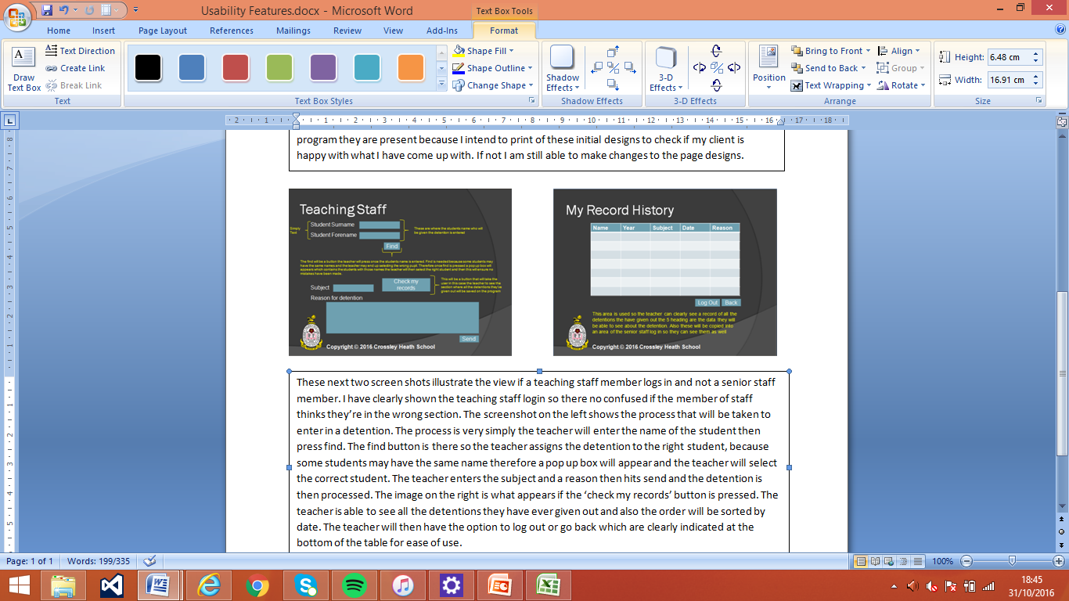Here are the first two designs I have done for the beginning of the program. These pages illustrate what the login page will look like and the then that page will link to the error page if the password entered does not match the password that is linked with that user name. I think this is a good start to the design as the program is very easy to navigate because of the contrasting text therefore users shouldn’t struggle with these initial pages. The yellow writing font seen will not appear on the final program they are present because I intend to print of these initial designs to check if my client is happy with what I have come up with. If not I am still able to make changes to the page designs.

These next two screen shots illustrate the view if a teaching staff member logs in and not a senior staff member. I have clearly shown the teaching staff login so there no confused if the member of staff thinks they’re in the wrong section. The screenshot on the left shows the process that will be taken to enter in a detention. The process is very simply the teacher will enter the name of the student then press find. The find button is there so the teacher assigns the detention to the right student, because some students may have the same name therefore a pop up box will appear and the teacher will select the correct student. The teacher enters the subject and a reason then hits send and the detention is then processed. The image on the right is what appears if the ‘check my records’ button is pressed. The teacher is able to see all the detentions they have ever given out and also the order will be sorted by date. The teacher will then have the option to log out or go back which are clearly indicated at the bottom of the table for ease of use.

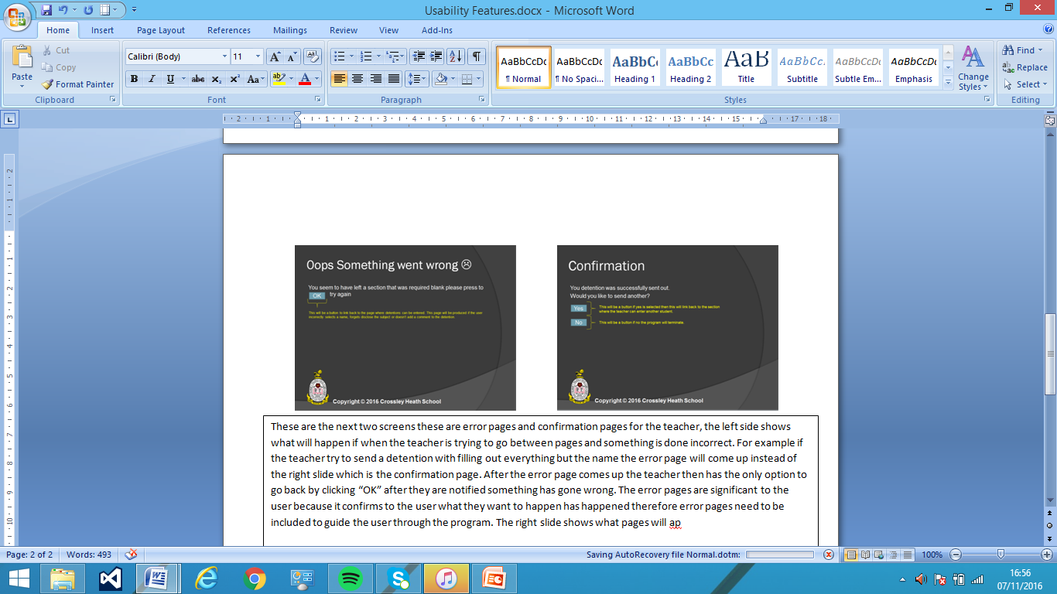These are the next two screens these are error pages and confirmation pages for the teacher, the left side shows what will happen if when the teacher is trying to go between pages and something is done incorrect. For example if the teacher try to send a detention with filling out everything but the name the error page will come up instead of the right slide which is the confirmation page. After the error page comes up the teacher then has the only option to go back by clicking “OK” after they are notified something has gone wrong. They can then go back and try again. The error pages are significant to the user because it confirms to the user what they want to happen has happened therefore error pages need to be included to guide the user through the program. The right slide shows what pages will appear once the detention has been logged correctly and been sent through on system. The page showed confirmation and the user will then has to option to add another which means they then don’t have to reload to program. Therefore this needs to be there or after the confirmation page is sent the program could just terminate but that wouldn’t be ideal for the user who find themselves often needed to put through various detentions in one period so this will be useful for the end user. The user can also click no the so in this case the program will terminate and not loop back to the page where detentions can be entered in the system

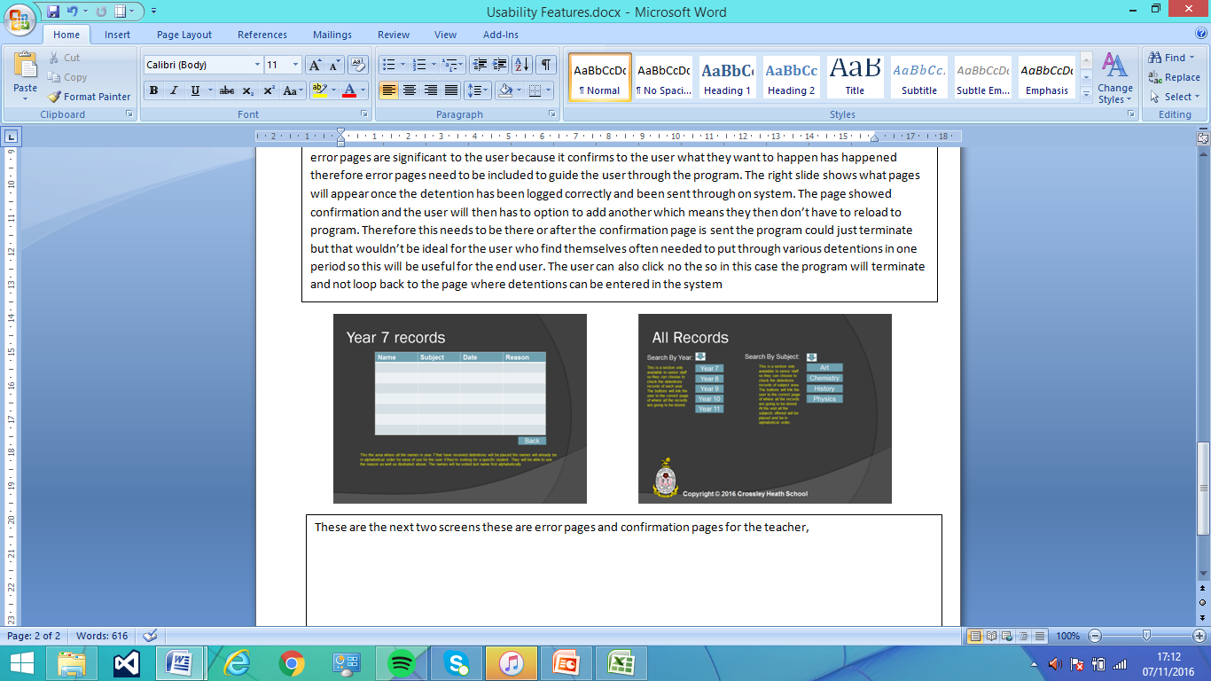These are the next two screens what we be seen by the senior team the slide on the left is the same as the teaching staff the real difference comes from the slide on the right. Because the detentions are submitted with a year and subject criteria I thought it could be beneficial for user to be able to sort the detentions into different subject and years. Therefore if a senior member of staff wishes to view all the detentions given out they can select either by subject then all the detentions given out in that subject will be displayed. Or they can do by year, after this they can either log out or go back to sort in a different order.

After I completed the designs for user interface I did conduct another interview to ask what his thoughts were on the designs. And he was completely in favour of all the design aspects and had nothing he would at towards it, as it fitted all the things we discussed earlier during my analysis.

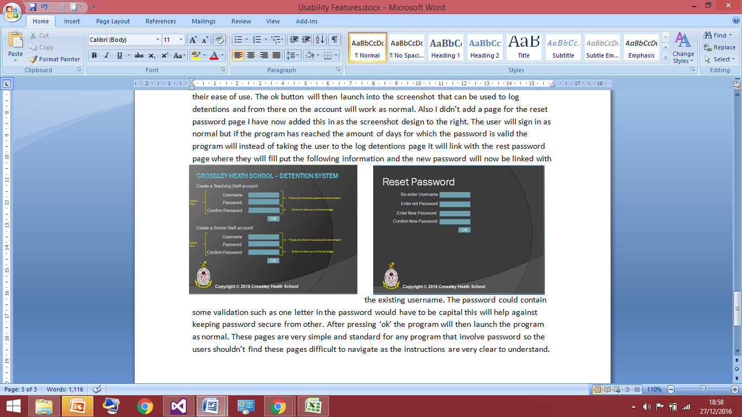However my client did pick up on the fact I was missing three pages I initially had overlooked. These pages are the ones that can be seen below I had missed the page where the teacher initially sign up this needed so they can now access an account. The screenshot on the left signifies this page, based on whether the teacher signing is a senior member of staff or a normal teacher they will sign up using the appropriate heading which is clearly shown at the top for their ease of use. The ok button will then launch into the screenshot that can be used to log detentions and from there on the account will work as normal. Also I didn’t add a page for the reset password page I have now added this in as the screenshot design to the right. The user will sign in as normal but if the program has reached the amount of days for which the password is valid the program will instead of taking the user to the log detentions page it will link with the rest password page where they will fill the following information and the new password will now be linked with their user account.

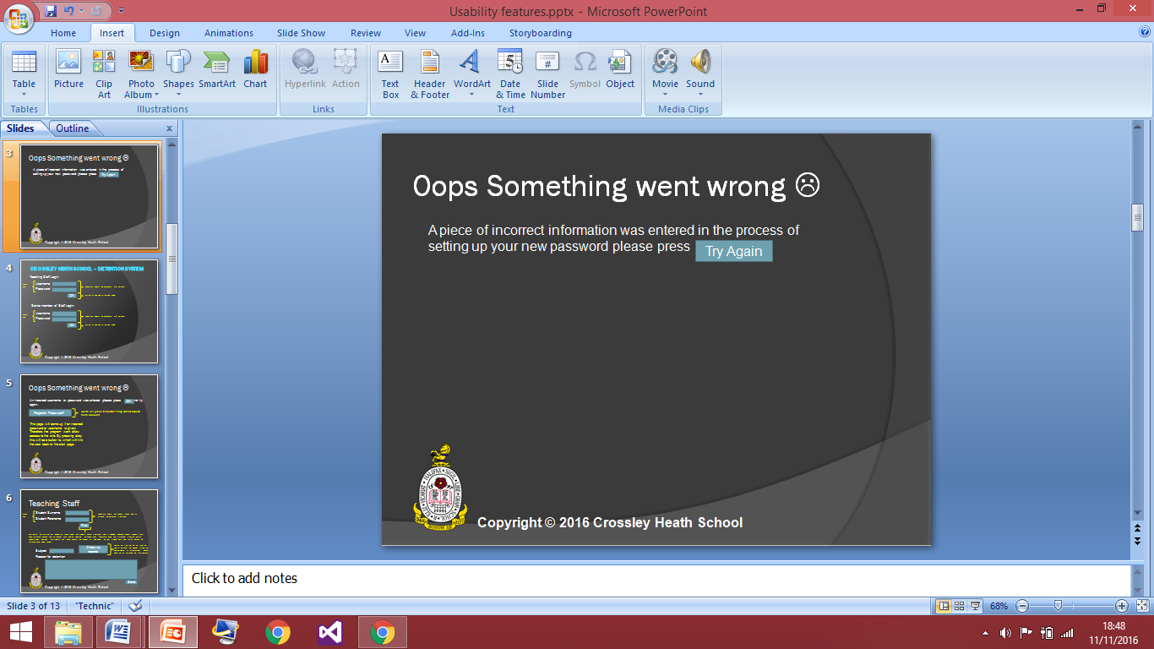If the new password entered do no match, the old one was entered incorrectly or the username was incorrect the program will link to this page below which will notify the user that there was a problem with setting up the new password. Then pressing try again will then link them back to the reset password page where they will then start the process again.

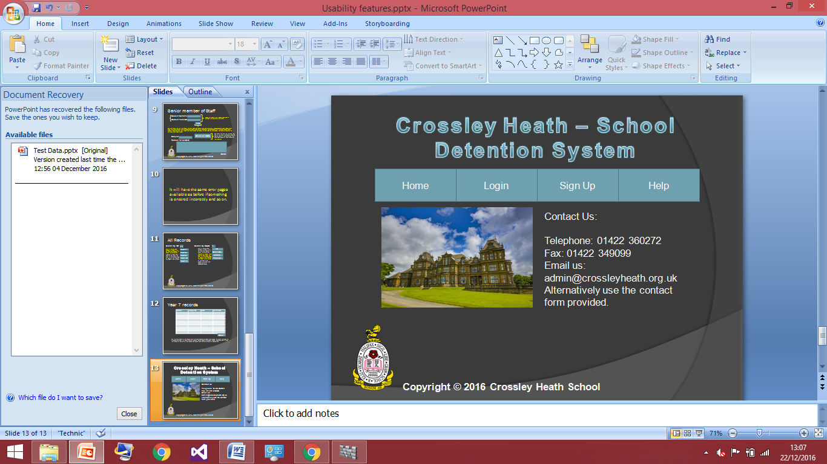

Another page I had forgotten is the generic home page. This is what the user will see when they first open the web application and they will be able to navigate through the program and go to either login or sign up alongside some other features that will help them along their way. So the screenshot above on the right is a design of what I hope the home screen to look like. This is just a first idea of what the home page could look like this could change over development as I decided more link bars are needed or some designs may not look right on the screen. But to begin with I’ve gone for a very easy simple design to ensure user friendliness and not to confuse users with a lot of information. The colour scheme is very plan basic and works well to not look odd on the page. Therefore I think this is a suitable homepage that can be used with some changes during development.

## Test data for development

During my development of the detention system I will have to iteratively test at stages of making the web application in order to my program works correctly as I and my client have envisioned hence making sure the functionality is correct. Also the testing will ensure that the program work as a whole because if I was to just code and develop the whole program without testing there could be a huge flow of errors which would become incredibly hard to decode given that I’ve finished the program so this is why test development is a very important process to undergo.

A test I will have to carry out during my development would be on the first page of the user creating the account. On this page the user will have to enter a username, e-mail address in the case of forgetting the password, a password and renter the password to confirm it. These sections must be filled in so there will be some sort of validation check to firstly ensure all the sections have been filled out. The registration should not be allowed to be completed if there is a wrongly filled box. I will test that the program will produce an error message is an invalid e-mail address is entered in to do this, this will require some another sort of validation check on what is entered into the textbox corresponding to the e-mail address. Finally for the registration page the password entered must match the confirm password so there will be testing to ensure that this happens and works correctly. During the testing I will enter a lot of incorrect information on purpose to ensure that the code works properly. Also the passwords would have to be case sensitive to I will test and produce screenshots to ensure that, that happens and the registration section works perfectly before I move on to other things such as linking it with a database. I will provide evidence of this through screenshots.

Another test I will carry out will be to test the functionality of my homepage. This means do the buttons link to the correct pages which is easy to implement but I should show proof that these work right, because this could cause a lot of confusion for the user if the links titled to certain pages once clicked go to another page instead. So to test this will just click the hyperlinks and ensure they connect to the correct pages. I will provide evidence of this through screenshots.

As I carry on coding I will need to test that the password will expire after 6 weeks (the average school term) this is important to ensure the security of the user’s password and prevent unauthorised access to their accounts. These may be tried to be accessed by students who want to mess about with the system or try get rid of detentions they’ve been given. I can test this by advancing the internal calendar on the program to check ensures that a reset password function is given. Alongside this test I will test the ‘forgotten password function’ this will be used in the case that the use has forget his or hers password by chance and needs to reset it. Therefore an email will be sent to the user account that will in turn allow them to reset their password instead of just starting a new account. These needs to be tested because it’s vital that accounts aren’t just lost because of a forgotten password because this will not help the user when they have to restart and re enter all their detentions. The new password will then have to be updated in the database for that username.

Another test that will need to be done is that 5 detentions in a term will mean and after school detention. This is important to test because my client was keen to have this implementated so I’d like to ensure this works adequately to please my client. This would work in the fashion that the heads of each year check the database on for example Friday afternoon and they are displayed with all the names that have been given a detention within the week and the names of who have had 5 and they can dish those out accordingly. It is also important to test this because it is a part of my success criteria I would like to achieve. Including the 5 detentions in a term, I also have rule stating detention are wiped after a term so all the detentions given out in a term will go back to 0. This can be down with the 6 week average time lapse alongside the password change. Therefore after 6 weeks detentions go back to 0. This will involve doing the same sort of tests as the password but just for a different part of the program. I will have to test this because if I didn’t then student may be given after school detentions unfairly because the program has not wiped the old ones. This is unfair on the students.

## Test data for beta testing

Post development testing is very important to the success of the program as it is strong informant that that I have successfully created a program that will meet all the success criteria. Therefore my post development will rely heavily on the basis of if it I have completed the tasks I have set for myself in the success criteria. Therefore first I’ll judge weather I have created a basic detention system this includes the update query for when a new user is setting up an account, so I will test if that works correctly and makes sure program moves smoothly and is user friendly. Alongside this I will run the program entering student’s names and searching the correct names and inputting their detentions into the database, where in which it can be checked by the senior members of staff. If the program works this far without any problems then I have successfully met my first success criteria of making a basic school detention system that works, but has none of the features that I have aimed to implement in the program alongside the features my client asked for as well.

After I have tested this basic detention system works as a whole, I may do some beta testing and give it out to a couple of teachers to use in their class rooms for a couple of day and get feedback from them if they feel it’s finished or not. They may offer advice on the user friendliness which is a key part of my program because my client made it clear its vital all teachers feel comfortable using the program so I want the usability to be to a very high standard. I think the giving the program a trial run with teacher will be an excellent form of testing because I’ll be able to see how the program works in real life environment whereas before it was just me typing in values what it was expecting anyways. Alongside testing I can get advice from other teachers on what they feel about the other success criteria e.g. the password change every six weeks and if they feel that is necessary.

Alongside giving the program out for some beta testing once I feel it is finished I need to ensure the password reset rule works, the 5 detentions in a term is an after school detentions and the detentions are wiped after a half term. This is important because they are a part of my success criteria and contribute to the functionality of the program itself and how complex it is.

During my post development testing I should be as in-depth as possible and try to enter values that the program wouldn’t be expecting to be dealing with in the hope of breaking the program. Is because the best testing is designed to break whatever it’s attempting to test therefore if I can go through my whole post development testing without breaking the program this will suggestion I have made a very solid and working school detention system that can be used in my clients school.

Iterative Development of the Coded Solution:

## Iterative development

Creating the Home Page (Design/functionality):

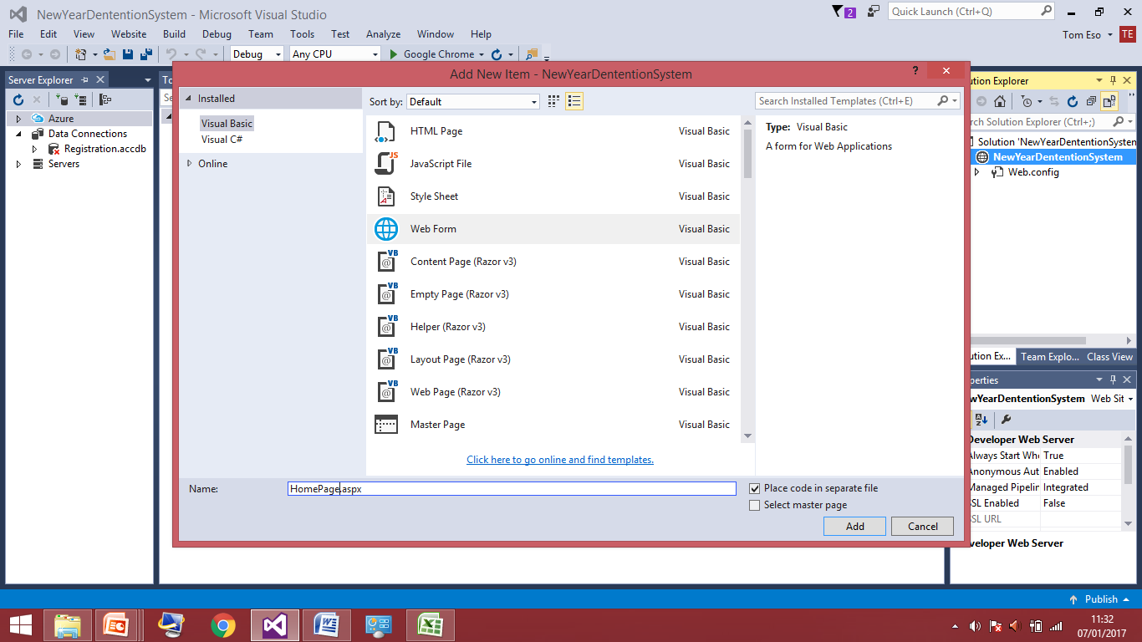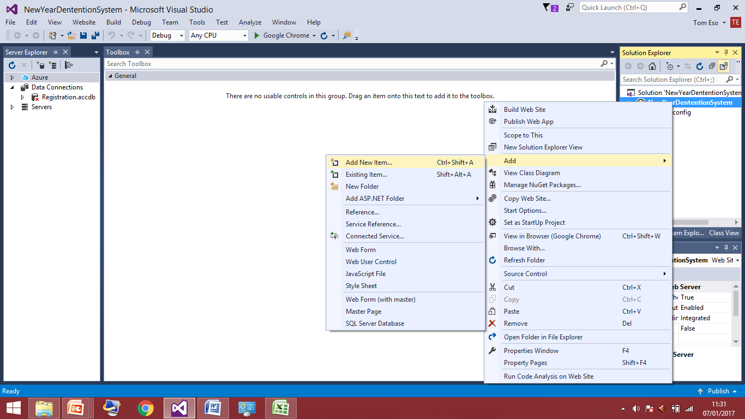For my development of the program I have decided to break it down into stages in which that will make the coding easiest for me. Therefore I have started with designing the homepage which involves CSS to alter how the words look on the page and HTML which allows me to set up the look over page.

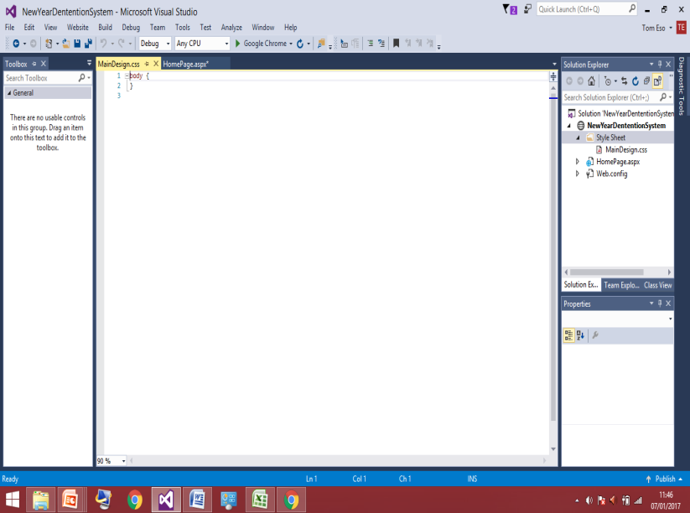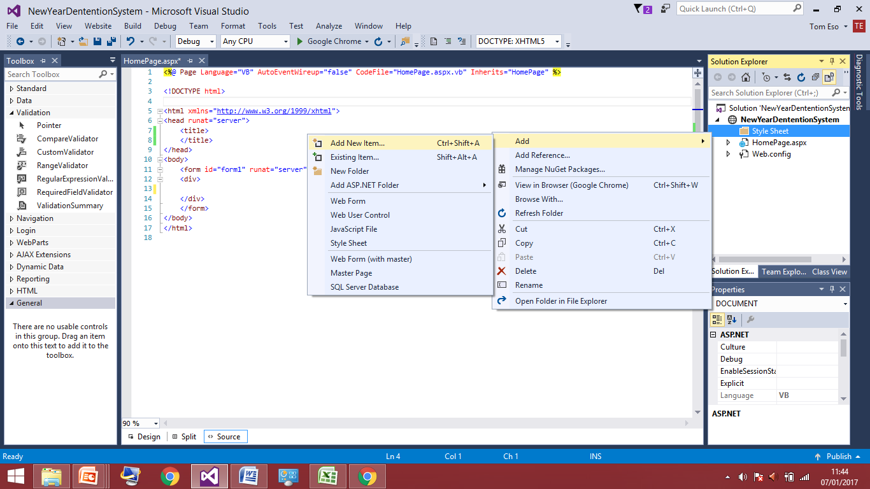

I started with loading the visual basic program and starting a new project called ‘NewYearDetentionSystem’ which I later changed because previous I didn’t realise I had a spelling mistake so the program was changed to just ‘DetentionSystem’ these screenshot show how I set up the program I add a web form to where I’ll design the homepage and which I names ‘HomePage’, very simplistic name so I can clearly differentiate between the page instead of allowing it to be called default1 or 2 etc. The 3rd screenshot shows me adding the CCS style sheet into the web form this will allow me to alter text size, position and font therefore it was something I needed to set up at the beginning of my program. So now I have set up everything I need in order to start designing the home page to an appropriate standard for my client so I shall move onto that now.

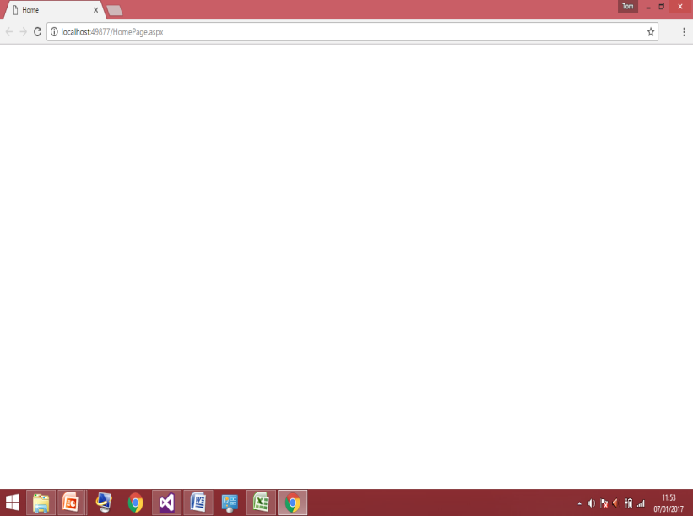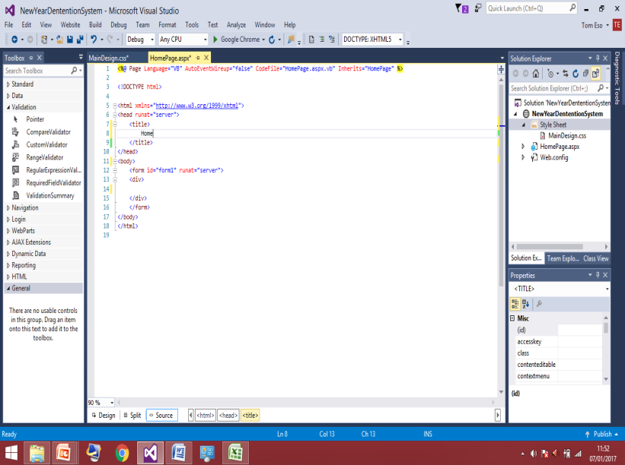This screenshot to the left shows how I’ve started to alter the code in the HTML section. In the title tags I have added the word ‘home’ to be displayed this is just so the user can see what page they are currently seeing this word ‘home’ will be displayed in the top grey bar that appears on every website, so I think it’s an important asset to have in my program to keep the website as professional as possible. I will now test this by loading the program in the Google chrome.

## 

## This screenshot shows that the home is displayed in the grey tabbed area of the web page, which is where I wanted it to be so I can now move on to other things now knowing that works correctly.

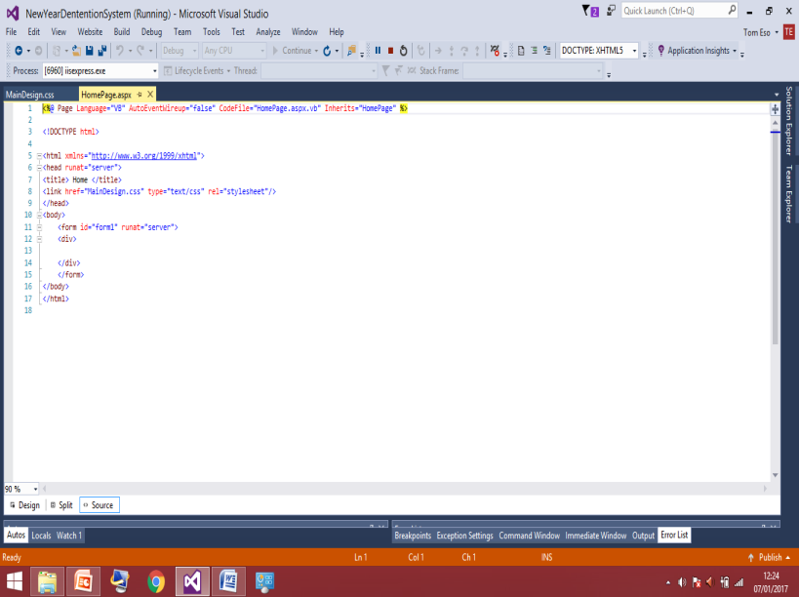

In this screen shot I have altered the HTML code. I Have added the code <link href = “MainDesign.css” type = “text/css” rel = “stylesheet”/>. I have added this because this is what allows code written in the HTML to be manipulated in the CSS file. Without it the two web forms wouldn’t be linked so they couldn’t interact with each other, therefore whatever I put into the CSS file wouldn’t be translated onto the web page 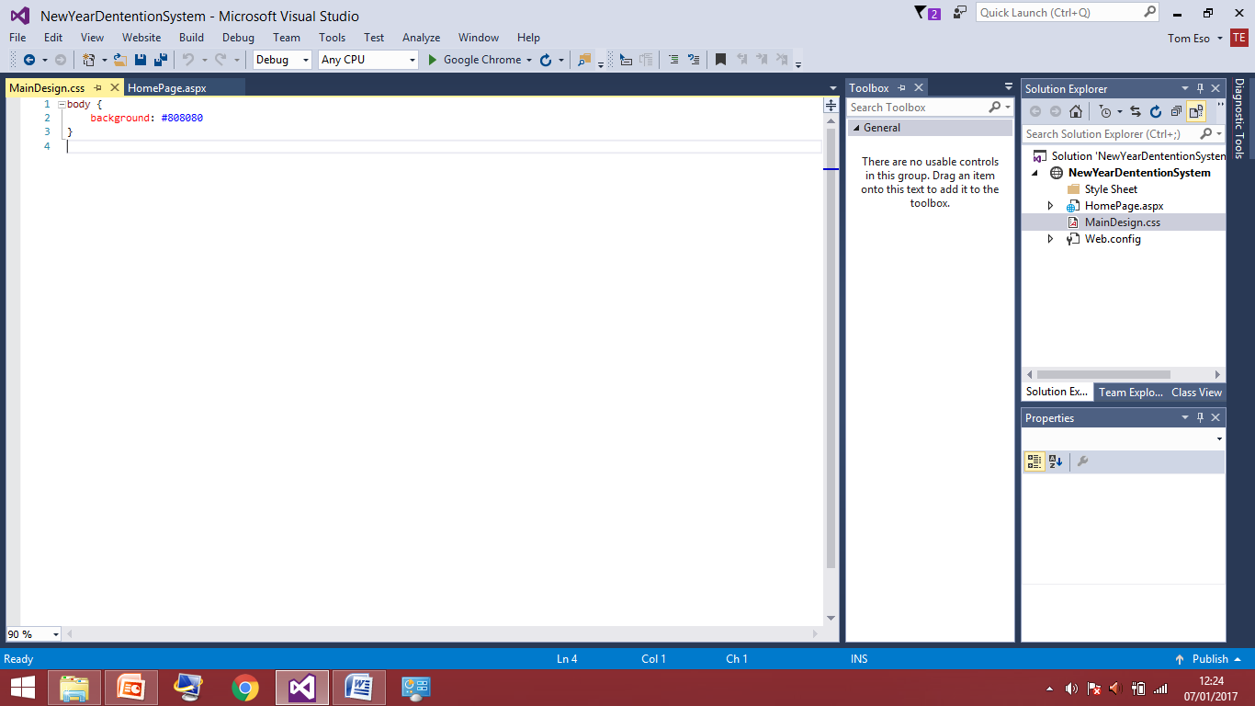because it couldn’t communicate with the HTML code.

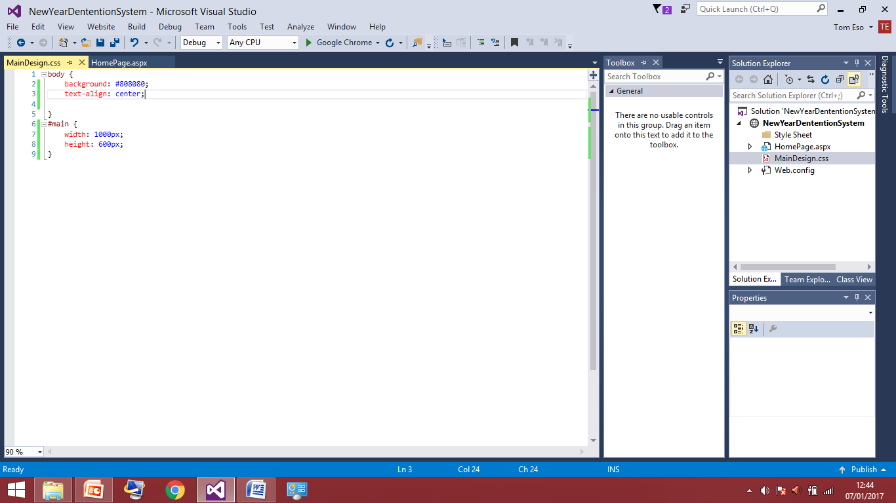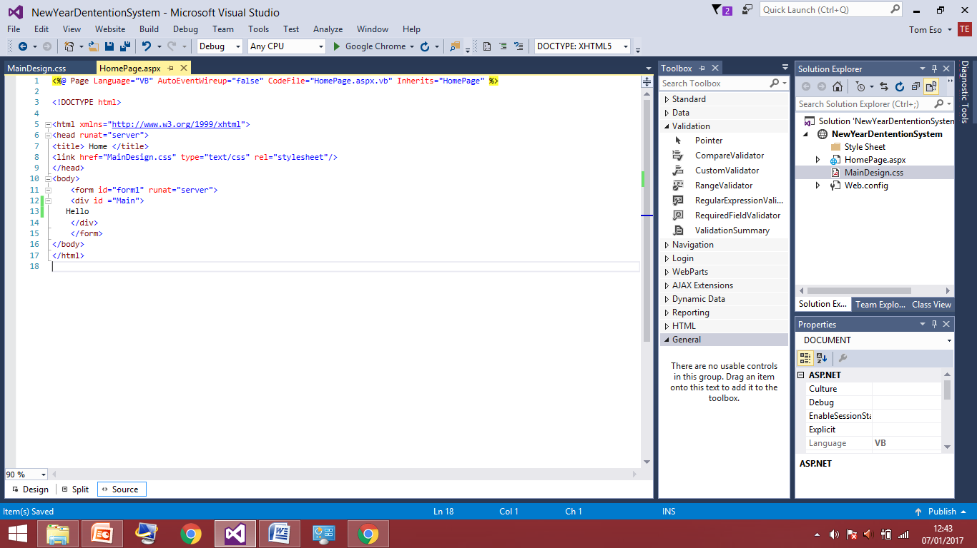The screenshot to the left shows that I am now adding colour to the page so within the body tags of the HTML so the whole page on a web browser. The CSS file will have the page with a colour of grey. That is what the hash tagged number, this colour may still change during the development if my client doesn’t like the look on the page or I am not satisfied. I’ve mainly added the colour as a basic thing I can test and ensure that the CSS file is connect to the HTML before I carry on doing other things and find out when I run the program they are not connect. Therefore I will now run the program I am expecting to see a blank grey page with home in the top tab bar as before as shown in the screen shot to the right. This screenshot shows this was a successful test as what I predicted and codes was displayed correctly on the page without any mistake so I can move on now.

The screenshot above to the left is how I have altered the HTML code. What I have done is defined an ID which I’ve name ‘main’ because it’s suitable and easy to remember as I mean main title. This needs an ID because it acts a variable in which I am able to manipulate the contents of it within the CSS file to change font size and colour later on. This has been positioned in-between the body tags because what I have written will be in the main section of browser and not to be in the tabs of anywhere else. So far I have just added the text hello as I am not really concerned about what the title is I’m just making sure it’s displayed and looks correct and after I shall alter the text within the ‘main’ id. The screenshot to the right shows the CSS file I haven’t done a lot to have the text is being displayed I’ve started slow and just code it to so the text is aligned to the centre because it’s going to be the title so it needs to be in the centre of page. I will now test this have been code correctly by running the code an again the browser should now have added the word hello to the page and in the centre at the top of the page.

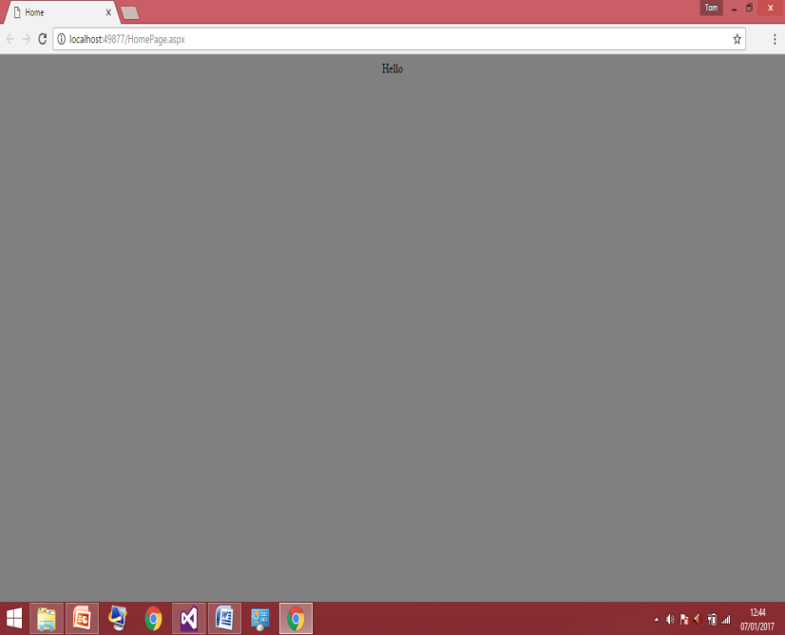

## This screenshot shows that the hello is displayed in the centre of page correctly so I know the web browser design is how I am expecting right now. So I can move on further now.

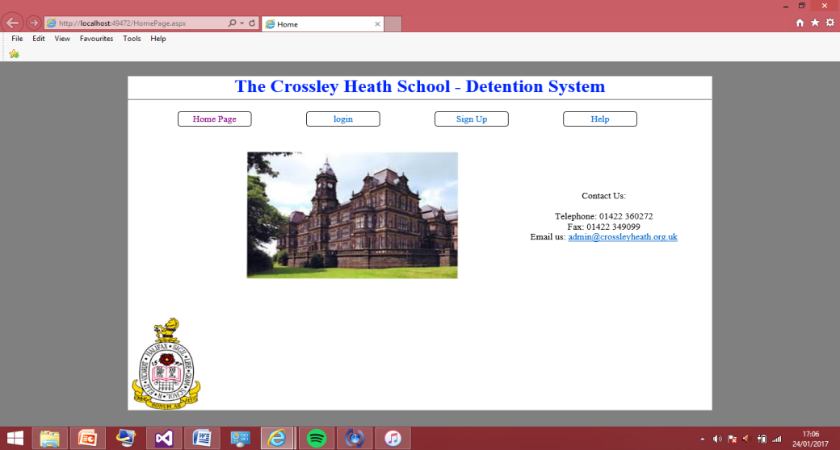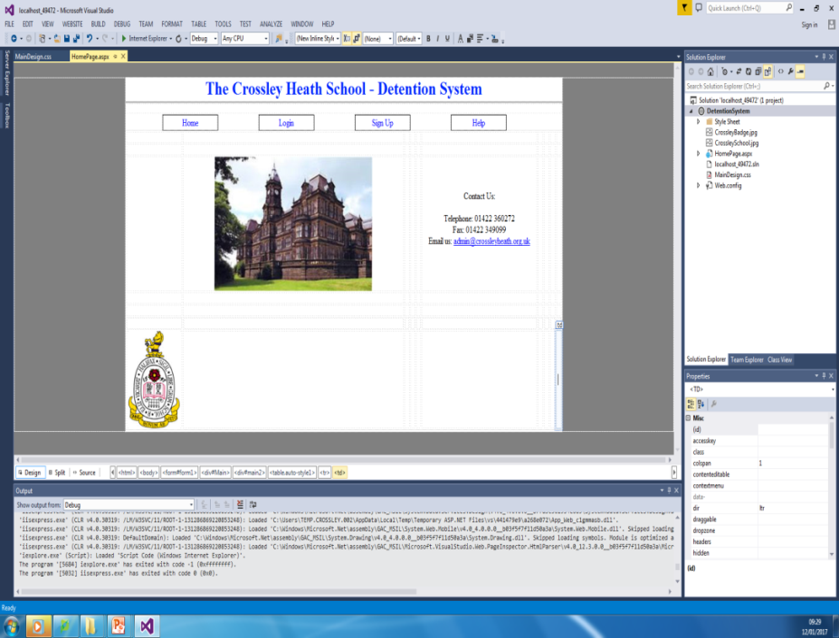

This screenshot above to the left shows the end of the home page design in the visual basic design view where I’ve added all the features I’d like displayed on my home page the 4 tabs shown above will have the same layout as this home page apart from the pictures. Therefore I when I make the 4 pages and 3 other pages they will already have the designs of what can be seen to the left. To the right shows what the program home page looks in the web browser. But just edit out the big school picture as this is not relevant to every page only the home page.

The last thing I need to do now to these pages is add the links the links allow the user to navigate from one page to another. This will be added in to the html code.

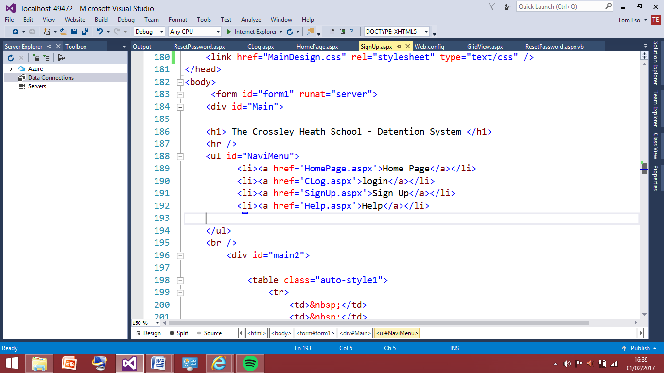

This is the code now added to the all the html codes in the homepage, clog, sign up and help pages. During adding these links I came across the problem, the problem was when I ran the program to test the links were working I was receiving this error from whenever I wanted to go from the login page to another page. This error was called a ‘WithEvents’ error as seen below.

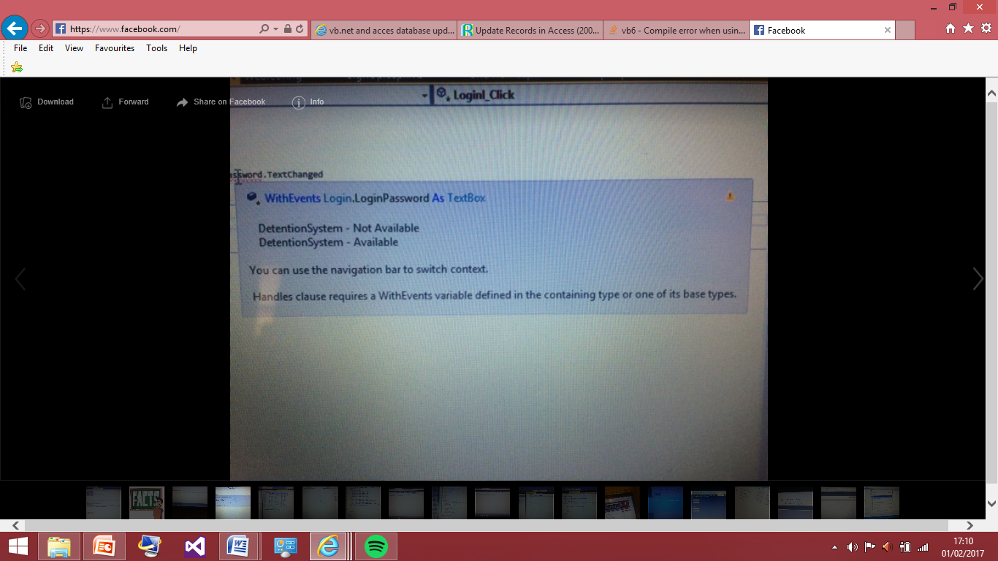

After some research into the problem, I was able to get passed it by copying and pasting my at the time ‘login.aspx’ page and changing the name to ‘clog.aspx’ as login is a pre defined function used within the visual basic program itself to the program didn’t want the page to be called ‘login.aspx’. I then tested the links again to ensure that they now work correctly and there are no other errors that I have overlooked the results are shown in the screenshots below.

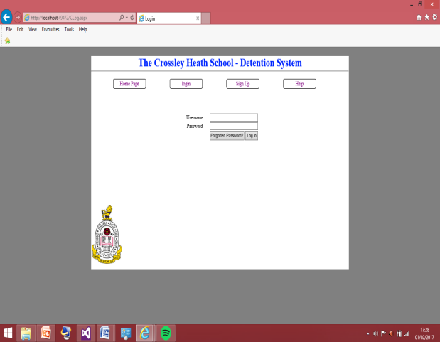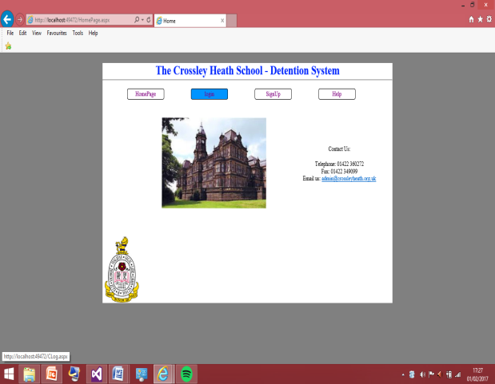Going from the homepage to login page

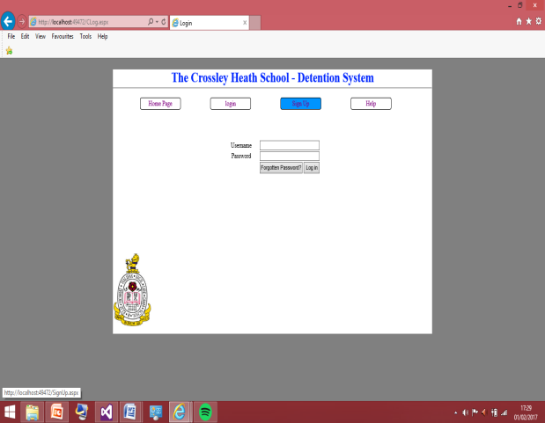

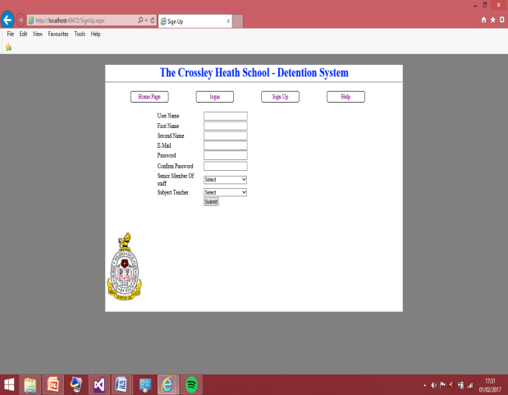Going from the Login page now called ‘Clog.aspx’ in the visual basic program to the sign up page.

The tests were successful as I thought I could successfully go between pages by clicking on the buttons provided to the user. Therefore so far I have designed the home page, sign up page, help page and log in page and I can successfully navigate through them. Now I will move on to the sign up page which should allow a user registration to be entered into a database.

User Registration (Sign up Page):

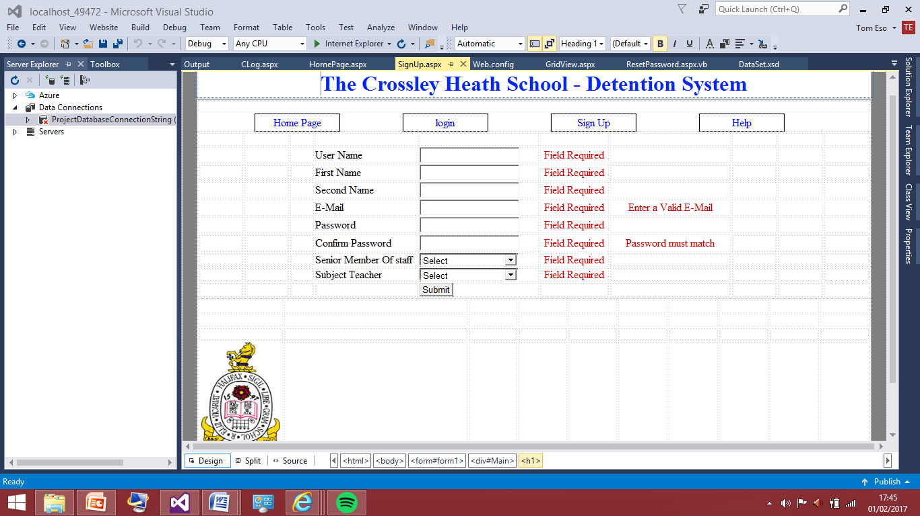To start with, the registration page I had to think about what necessary information I needed to take from the user in this case the teacher or senior member of staff, in order for the database to make use of everything and not require additional information later. The information need with then translate to be the required fields. I decided this was all the information I needed on the sign up page.

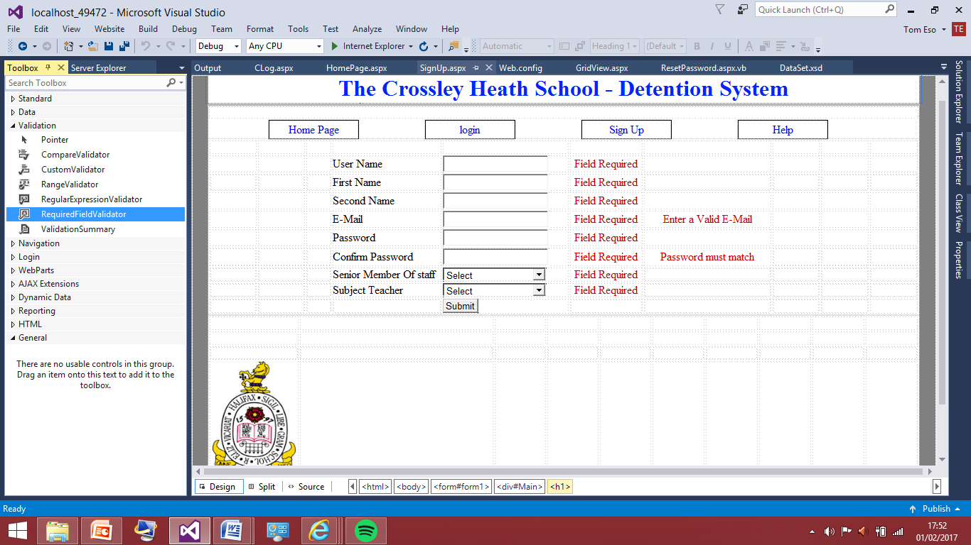This is the registration page, with the required field the writing in red are field validations I added in order to make sure the registration page is full filled in as once the submit button is pressed, the program once linked to the database will not allow this to work without having all the fields entered correctly. I did the field validations like this as shown in the screen shot below

Toolbox – Validation – RequiredFieldValidator and I assign put one next to every textbox. Also all the text boxes are given appropriate ID in order for me to be able to keep track with what I am doing. Also this would comes important with connecting to the database later therefore it is better for me to call them something meaningful instead of having textbox1 then 2 and so on.

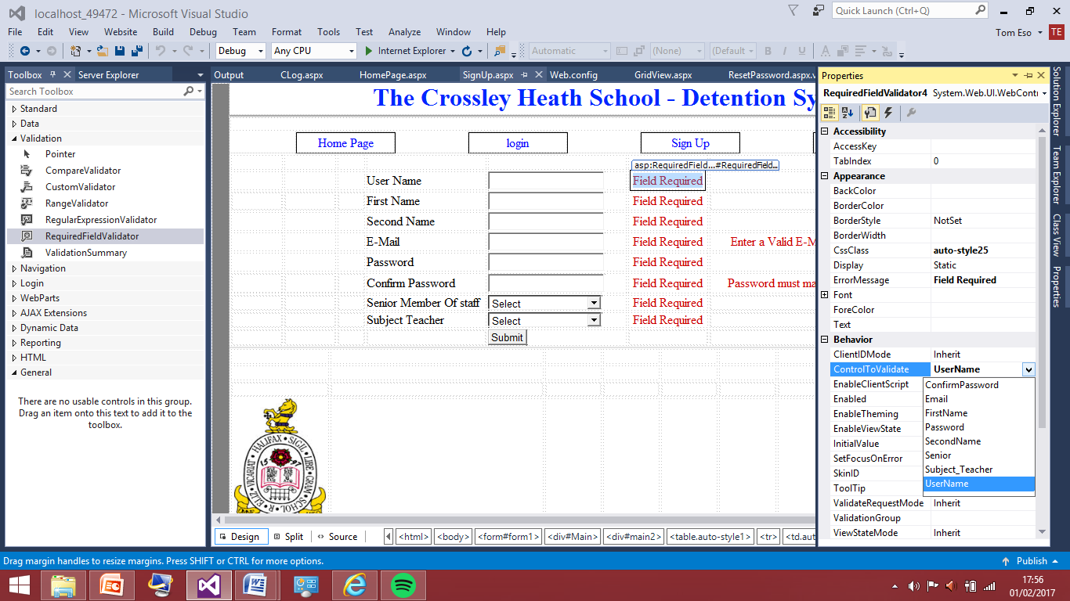

This screenshot shows how applied the validation. By going into the properties of the validation and scrolling to control to validate. Once the drop down box is clicked I am given an option of all my textbox names and I select the appropriate one corresponding to that field.

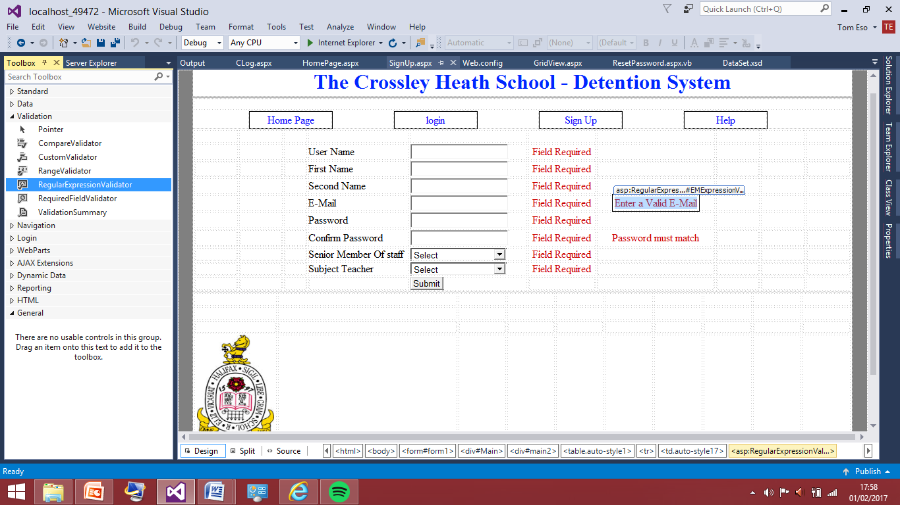

However some fields did require extra validation fields such as the e-mail address textbox this required a regularexpressionvalidation. This is needed alongside the RequiredFieldValidator because all e-mail address follow are format, therefore if the user types in an e-mail that doesn’t follow the format or is miss something the regular field validation will let the user know.

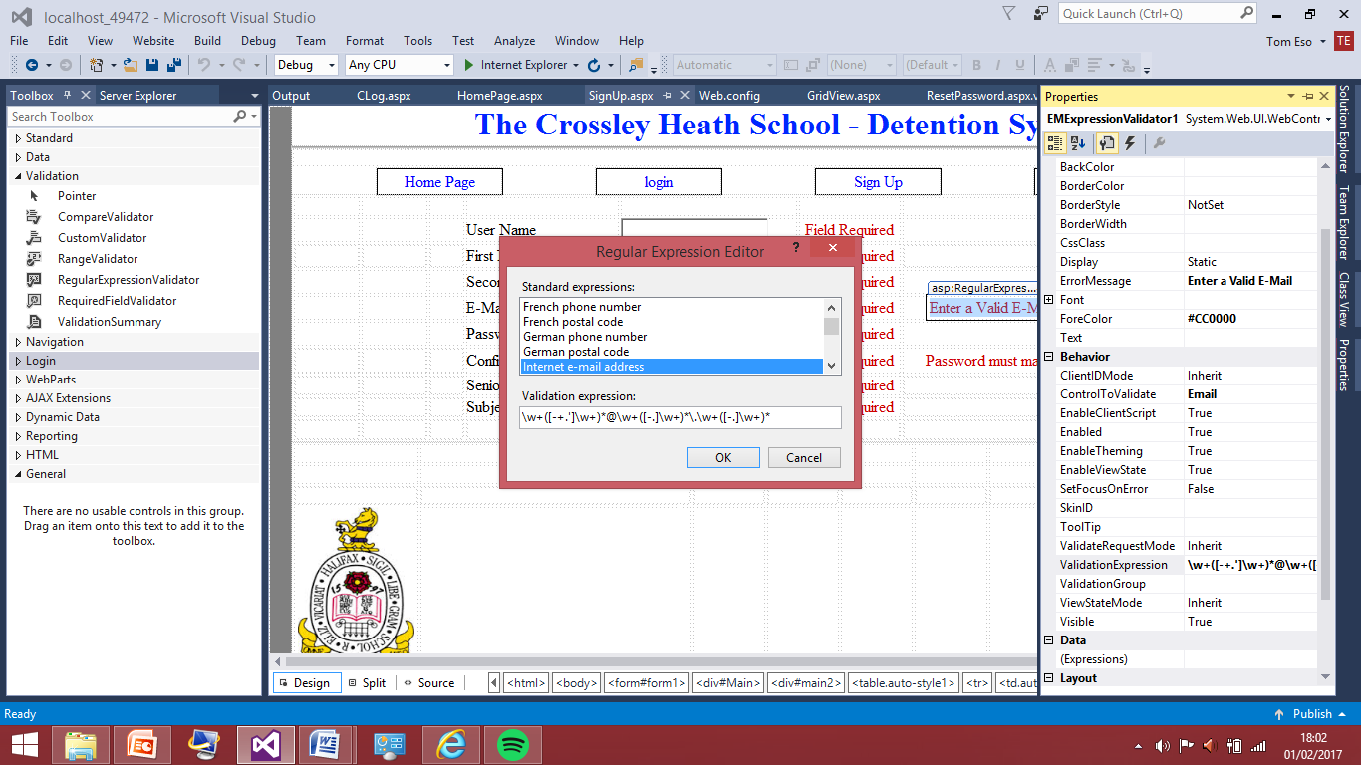

The screenshot above show how I set this up by going into the validations properties and selecting the validation expression to follow and internet address.

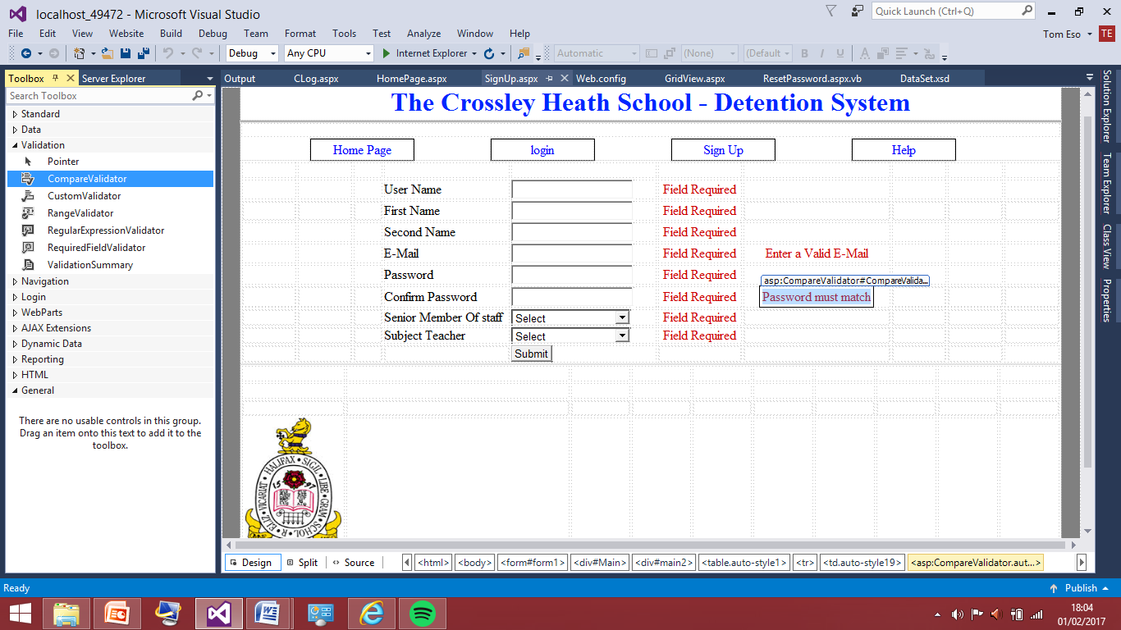

The final validation was for the confirm password field. This validation process was the compare to validate, therefore this validation will compare what is written in the password and confirm password field and if they match the error message won’t come up but if they don’t the error message will display as the user needs to know what their password is.

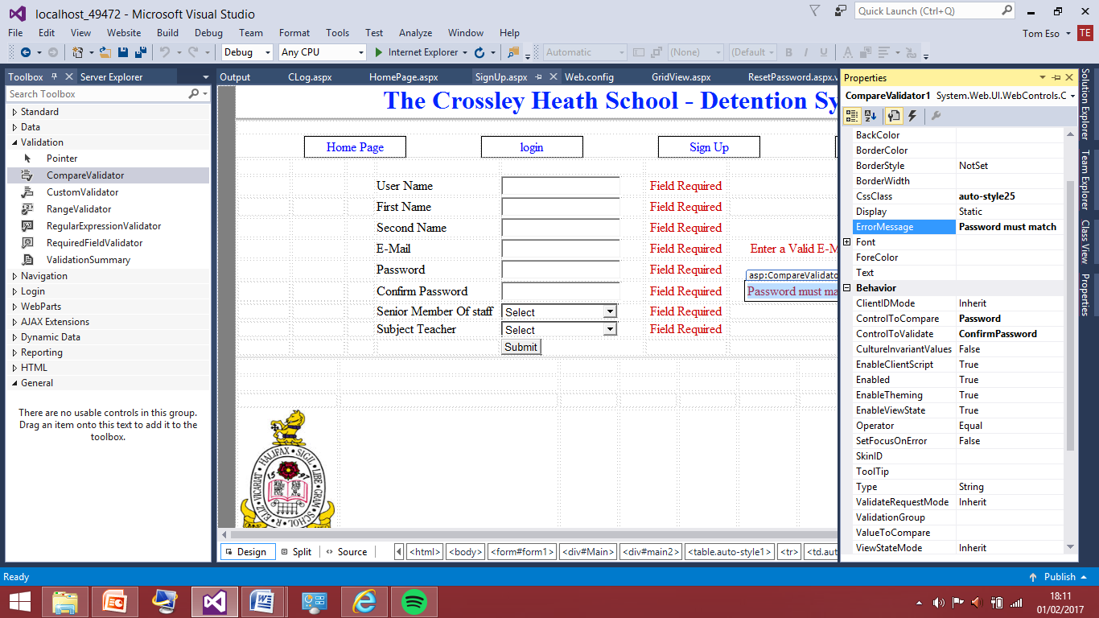

This screenshot shows how the compare validation works by going into the properties of the validation and using the control to compare and setting it to the ID name of the text box that the password is going to be typed into which is password and this validation will do the comparison.

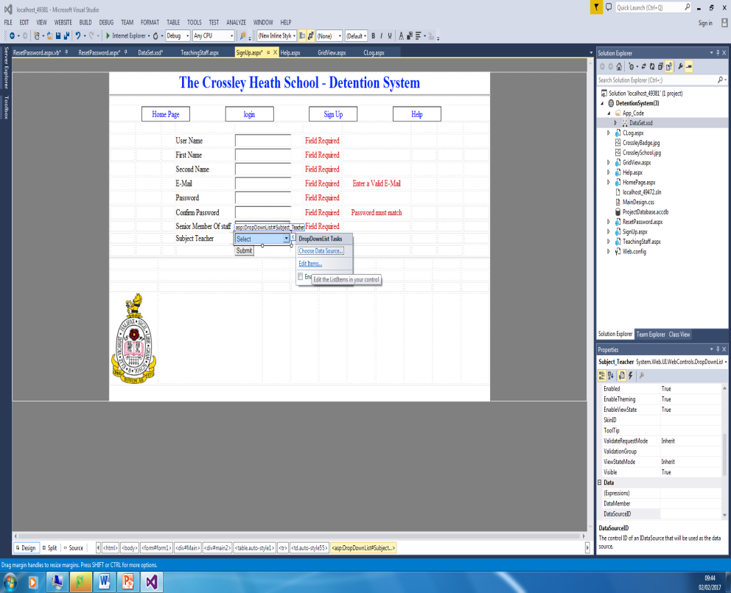For Senior member of staff and subject teacher I decided to do a drop down box the user will select from this is because there are various ways that the user could input the field. For example one teacher might say they are a ‘Religious Studies’ and one could say ‘R.S’ this would be making querying the database to be produce the subject fields awkward as everyone typed in details differently. Therefore I standardised the inputs that would be allowed.

This screenshot shows how I have added the drop down box. It was from the tool box and from clicking on the drop down box we can edit the items and add items and decide what order they are in.

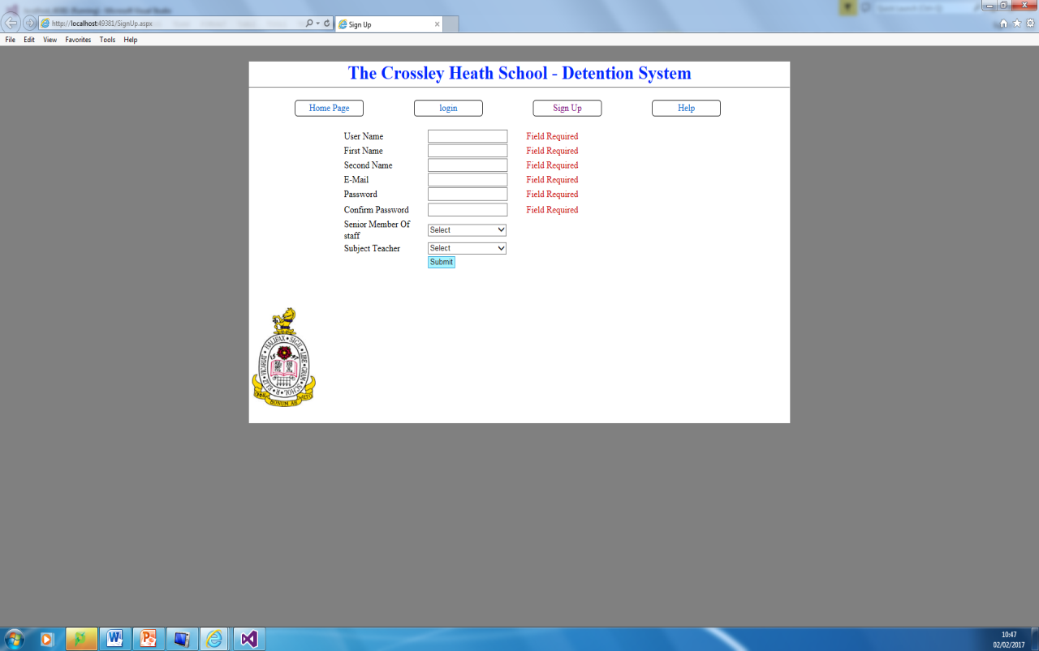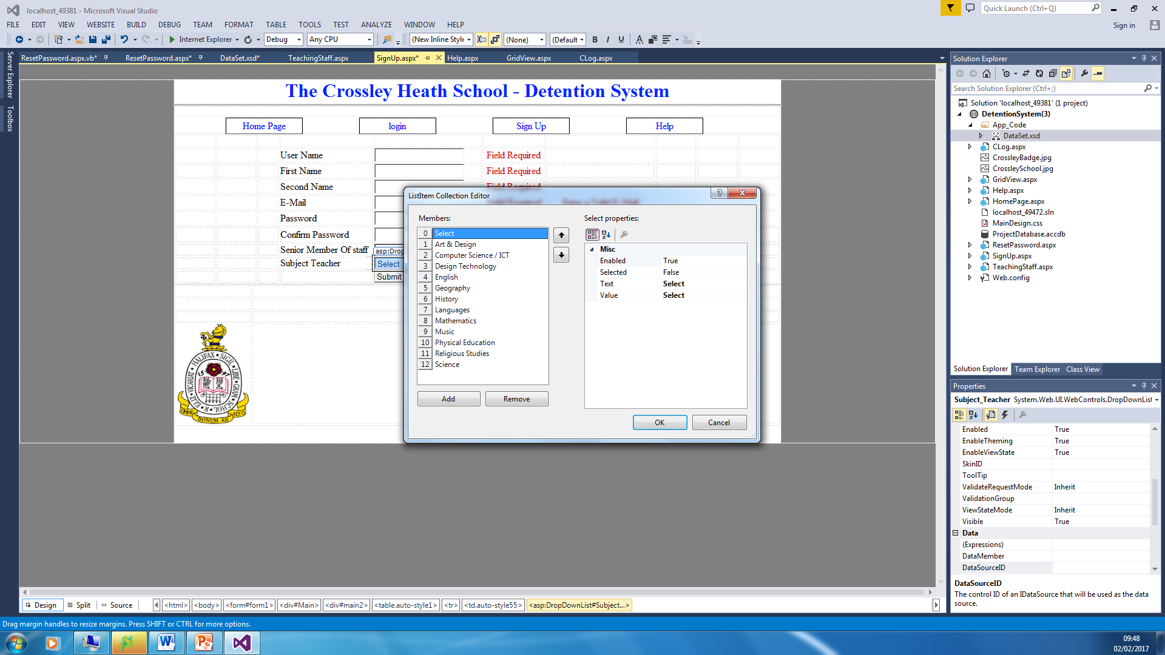This is the subject that is available teacher. Because this system is for the high school and not the 6th form I’ve missed of subjects that only apply to sixth form. Also I have given more generic names for ease. Such as languages instead of having the individual subjects this is because the teachers in the language teach a variety so they need a broader detention slot this is the same for science. The senior member of staff has an option of yes or no. Now I have completed this I can test this works correctly. I should remember the submit button doesn’t do anything yet so that will be what I will tackle next to get the information stored in the textboxes into a dataset. But now I will test this page works correctly with the all the validation fields and the drop down boxes before I move on.

This screenshot shows the field validations are working correctly. Once I clicked to submit button all the required field validations appeared, clearly indicating to the user they haven’t completed the form

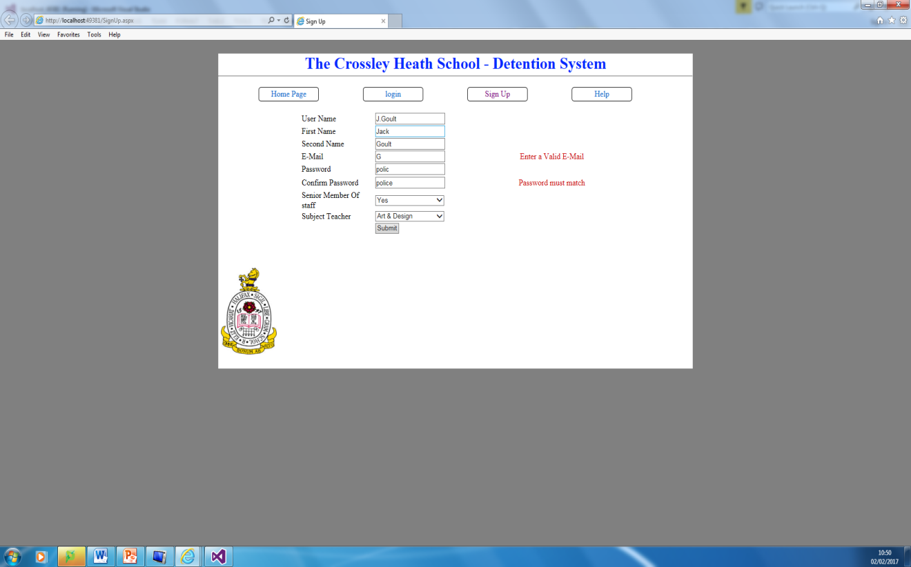This screenshot is showing that the two other types of validations are working in the email address I have entered a something hence the required field validation didn’t appear but the string entered doesn’t match the format of an internet address so the enter valid e-mail appeared. This is the same for the password and confirm password field where I tested that the compare validation works correctly. Now I will change the password setting so the text shows are the black dots on normally seen when entering passwords and then I will check this all works now. I will put a message in the submit button to show that it there have been no errors

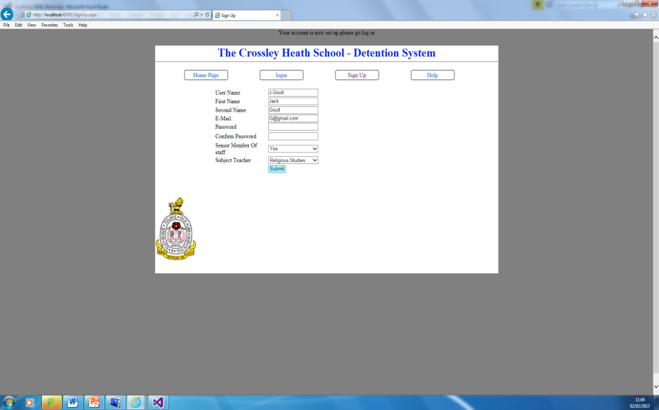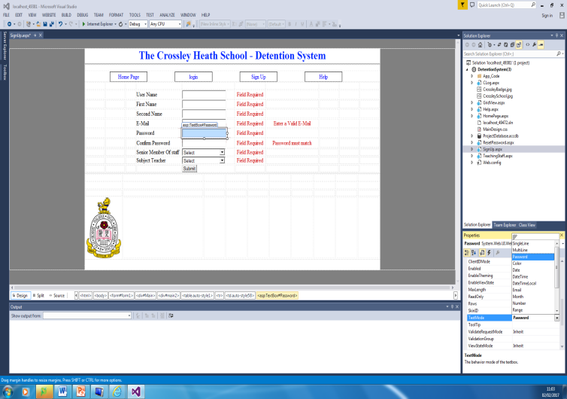

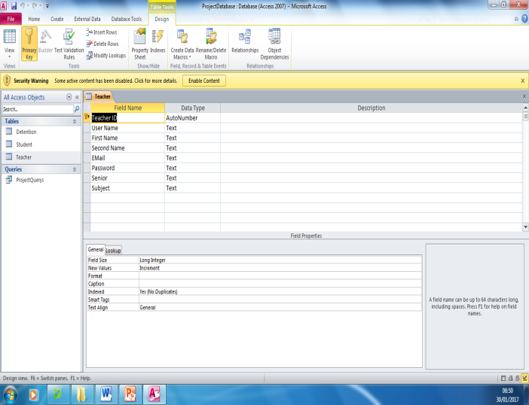This screenshot to the left shows how I change the text mode to being black dots on the program by altering the properties in both the password and confirm password textboxes. The screenshot to the right shows the sign up page works so far as I am expecting. After pressing submit no error messages appeared and a messaged popped up at the top saying the account is set up. So no I am able to move onto making the database in access that will be used as the storing location of the information of the sign up form.

## This is the database I created in access for the registration of the text with same field on the web page this where the information will be linked with the program. The program needs to be linked to a database because to log in and out of the system the information surrounding each user needs to be stored in a database. For the program to know if the inputs given are correct. Therefore now this is done I need to add the connection to my program.

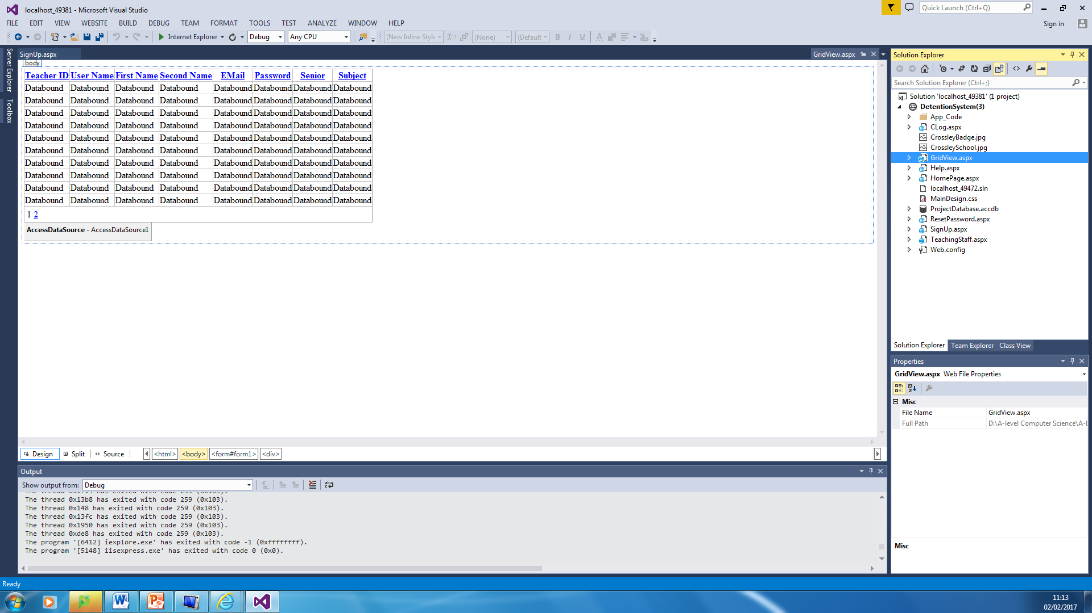

I started by adding a plan web form called grid view. I need this so when the database is linked and I want to check the contents of the database I don’t need to go into the access file directly I can run this page and it will show what is in the database.

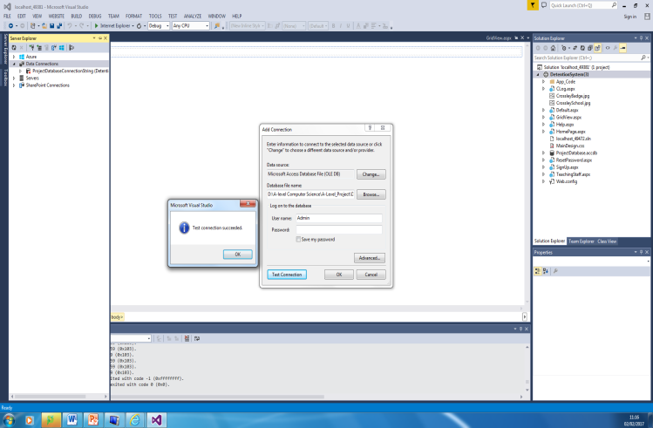

Within the grid view form I’ve added the data connection, to where the database in now connected.

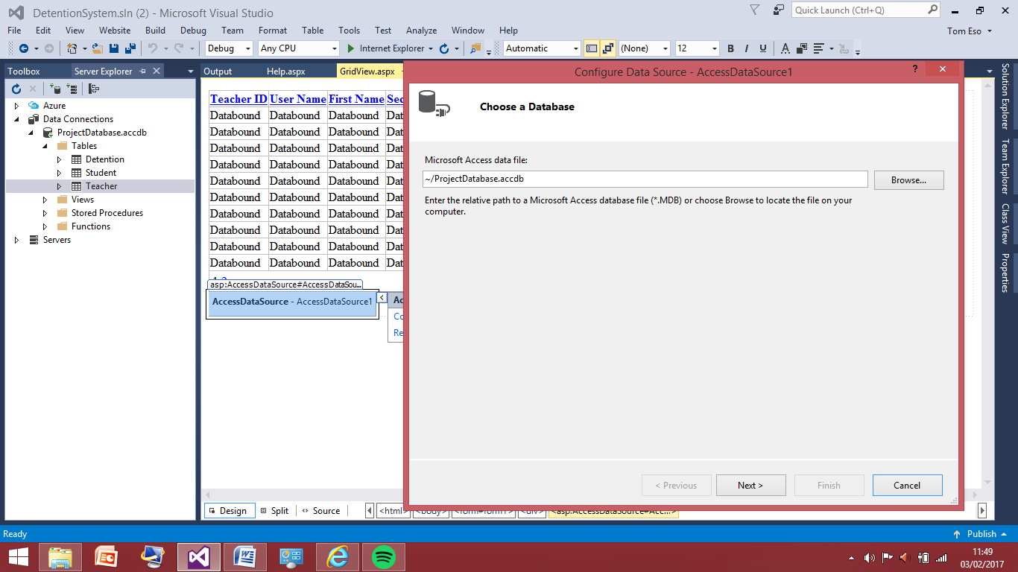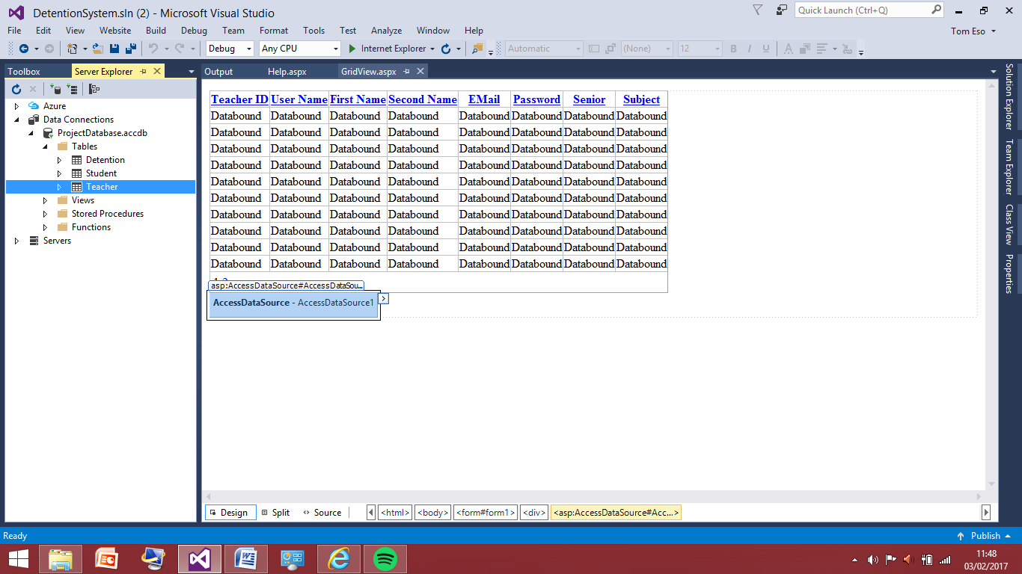The screenshots to the left shows how I added the teach database to the data view form, and configured the data source with the table so the table knows to display what the data source is telling it. And that is the access database, now I can provide the appropriate code needed to have the information in the text boxes inserted into the database.

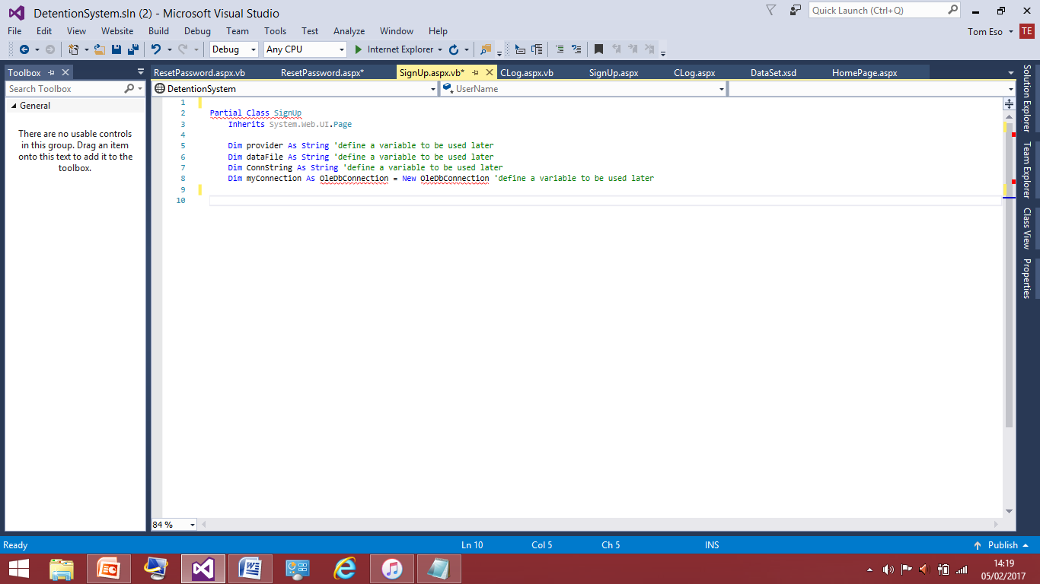

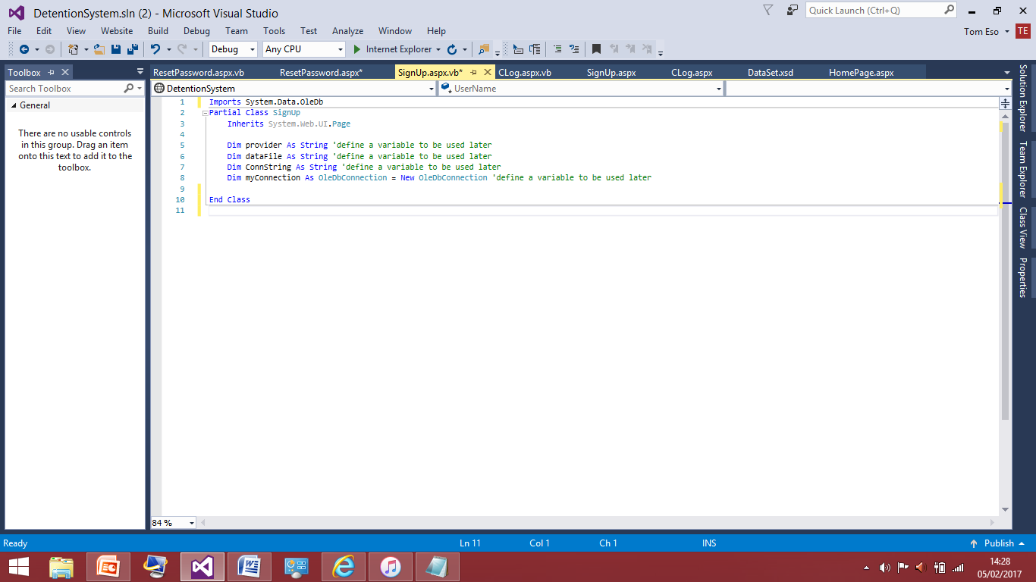To start with this code is going to written in the button sub, meaning that once the button is clicked the code will be executed. I have started by defining some variables outside the sub to be used as global variables; however line 8 seems to have some problems with OleDbConnection, OleDbConnection initializes a new instance of the OleDbConnection class with the specified connection string which will come in later. Before I do this need to work out why OleDbConnection is underlined meaning it is not defined.

To define the OleDbConnection it had to be imported, as seen on line 1. And now all the variables are now defined so I can move on now

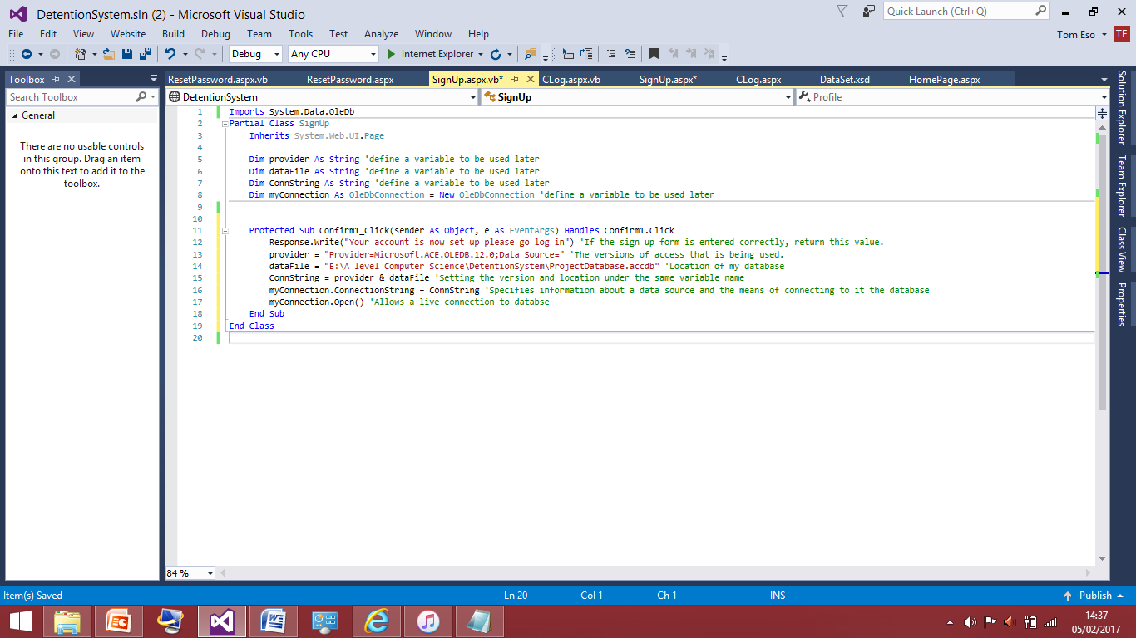I have set my variables to equal the appropriate things in order to manipulate the code. I have annotated the code by adding comments to explain what each line is doing and what it means.

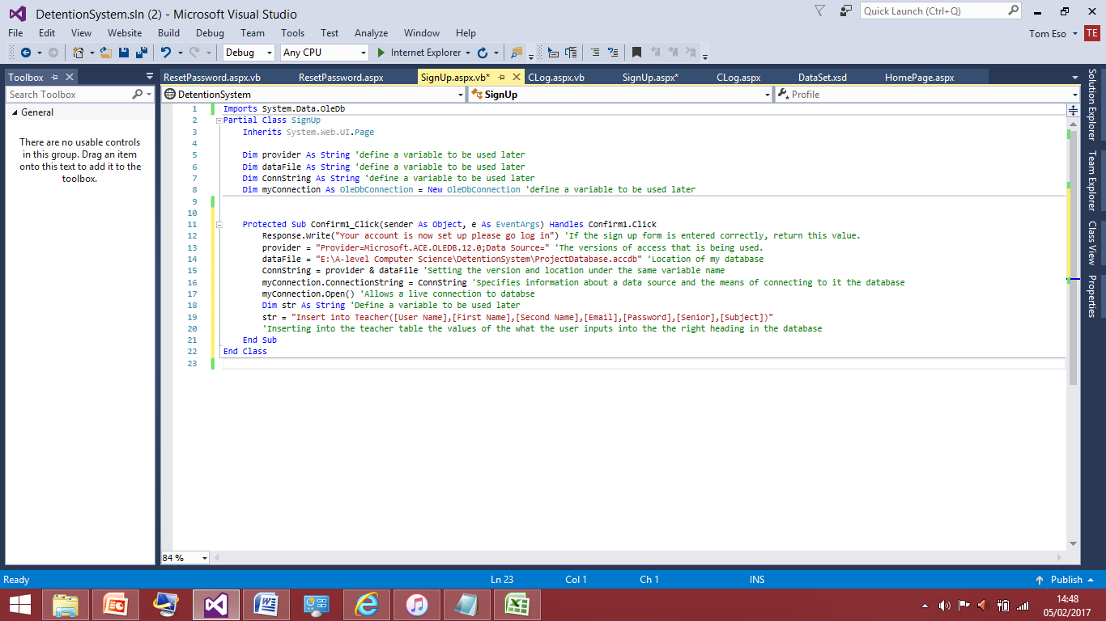

Here I have added two extra lines of code; the ‘Insert into Teacher’ on line 19 is very important as ‘insert’ is the command word so based on the inputs it will put them under the columns in the database. It’s important that the things inside the square brackets are in the same order as the database or inputs could end up under different columns.

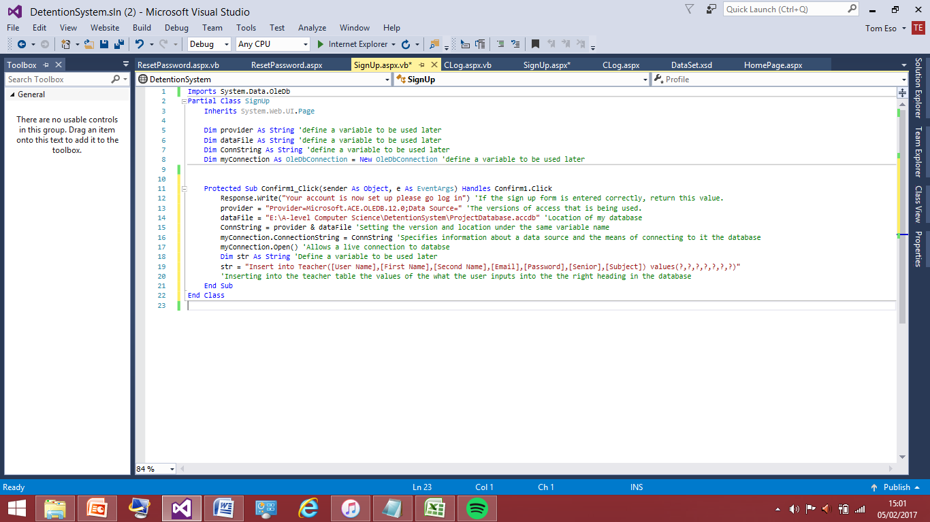After looking over the code I noticed there was mistake. I had remembered from previous projects that I needed this bit of code on the end. As it tells the program to be expecting values not pre determined ones.

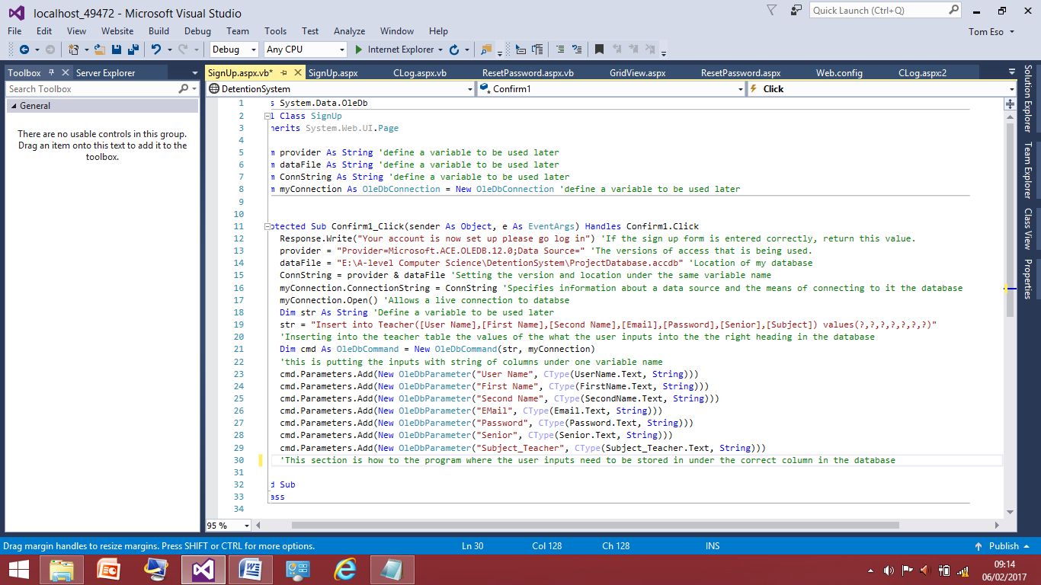

The screenshot above is where I have added the parameters of the text boxes. This was researched so the idea for this section of code is something I pieced to together from research and previous programs. What this code will do is physically take the inputs in the text boxes this why the textboxes needed meaningful variable names so I could manipulate them easily to make the code easier to follow for me and debug later.

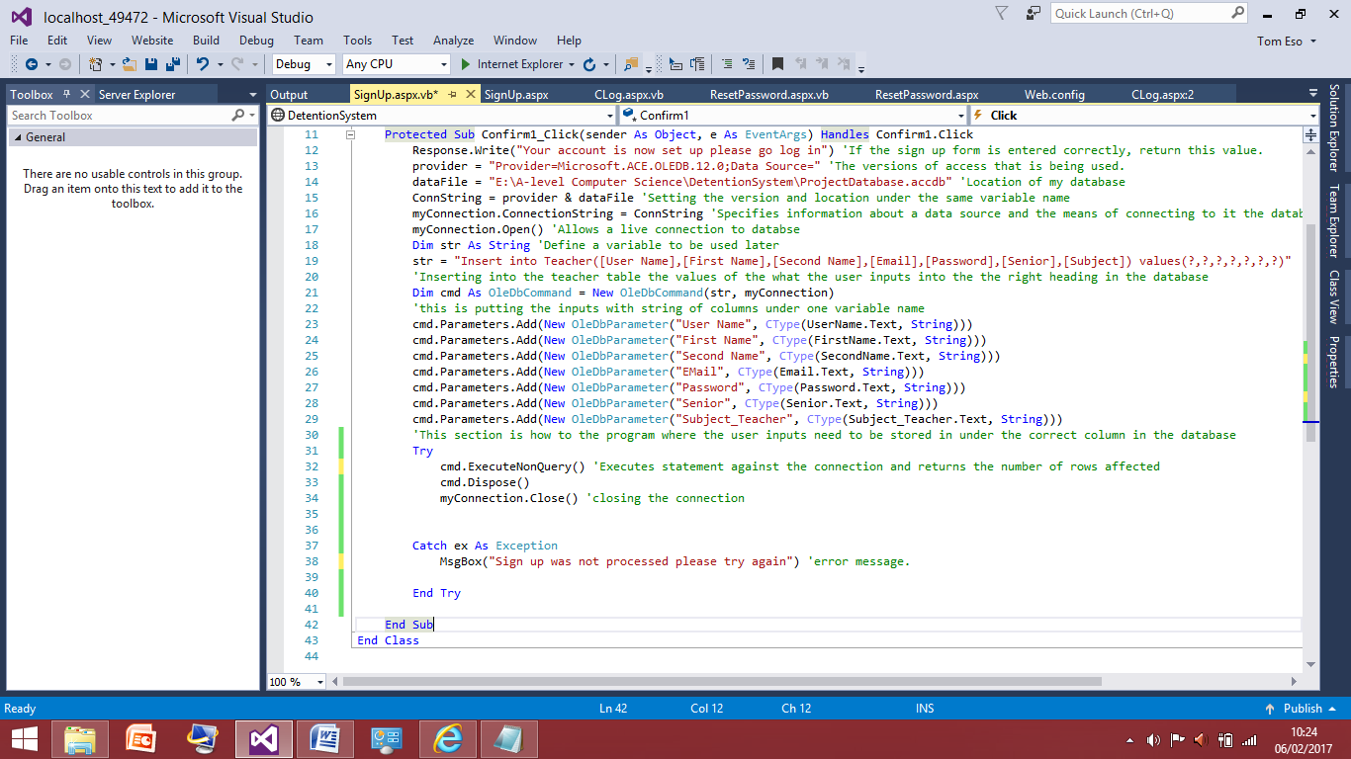

To finish of this section of code I have added a try catch attribute after some research and previous knowledge I think I’d need this statement as. A Catch statement can be used within a Try block in order to catch and respond to a specific exception or multiple exceptions. If an exception occurs during the execution of my code within the Try section, the Visual Basic compiler examines each Catch statement within the block until it finds one whose condition matches that exception. If none is found, an error is produced.

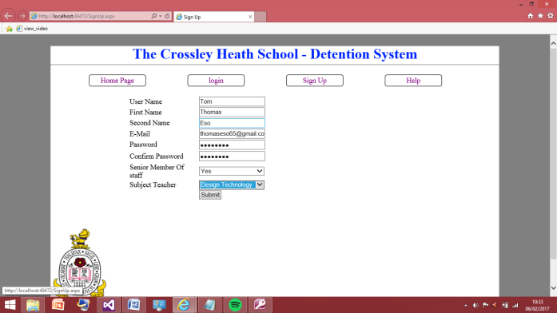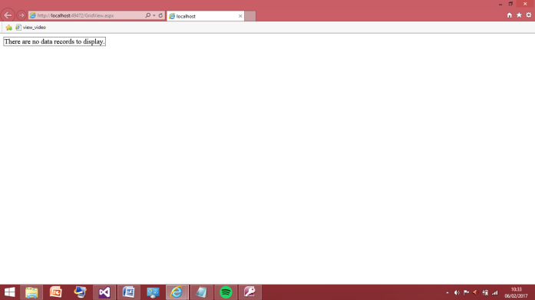I’ve now finished the insert code so now I will test this, because I need to make sure it works first before I use.

The screenshot to the right is the grid view page where no data can be displayed as there is no information in the database yet. The screenshot to the right is the test; I have inputted details into the sign up and I will now submit and this should input data into the database and when I load the grid view page it should have the right information under the correct columns.

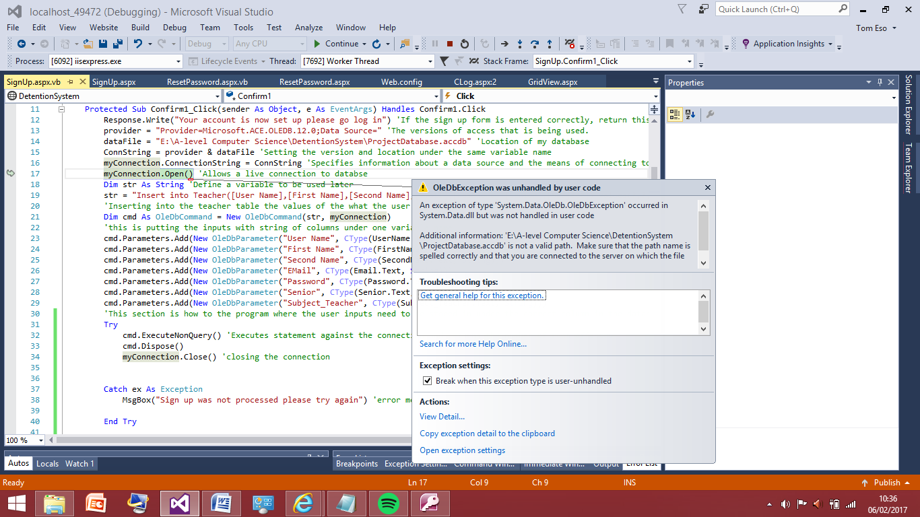During execution there was an error a problem with opening the connection, which is comprised of the data file and provider so I will check these two things are correct and try again.

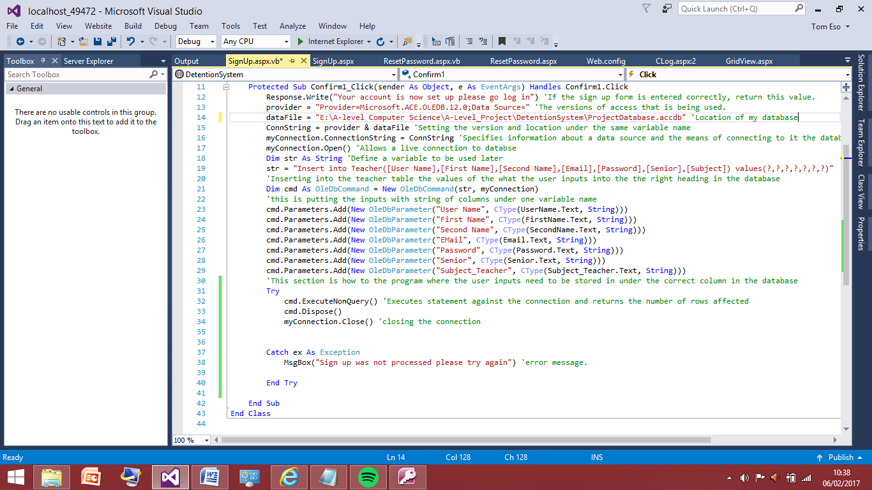

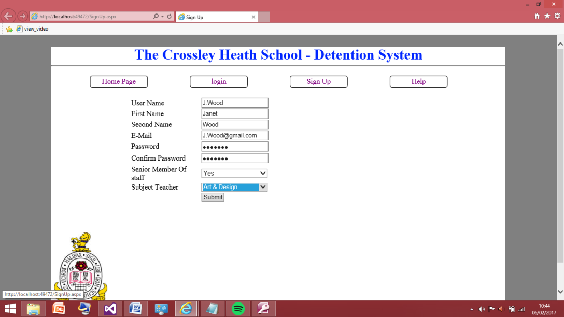After glancing over the code again I noticed the address I entered for the location of the database was wrong under the data file variable. Due to this address being wrong the program wasn’t able to find the database I have now corrected this and will now test the program again.

The new information I am testing.

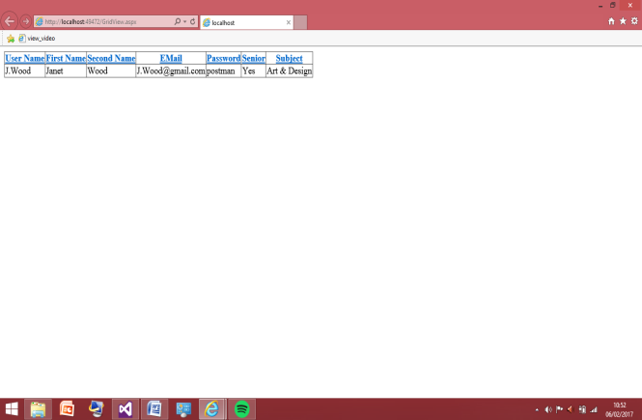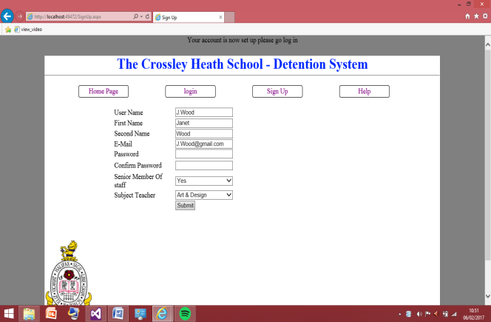This show the sign up is now success full. The confirm message appeared however I may change that to a redirect so once submit is pressed they are automatically taken to the log in page in order to sign in, which will be coded later on. On the right is the grid view so I can now see the teacher named ‘Janet Wood’ is now in the database and all the information was stored correctly I will now 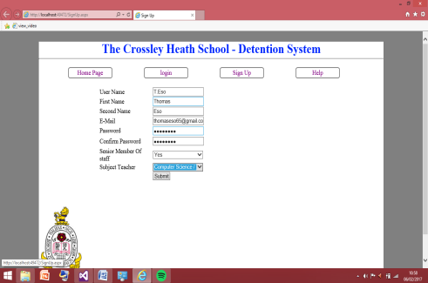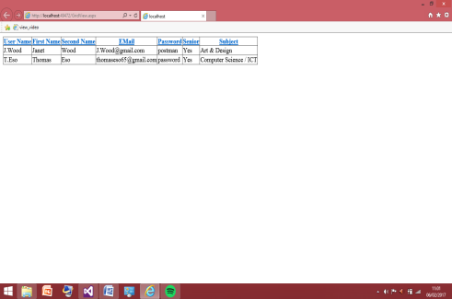test this another 3 times varying inputs just to make sure there’s no bugs I haven’t spotted.

## 

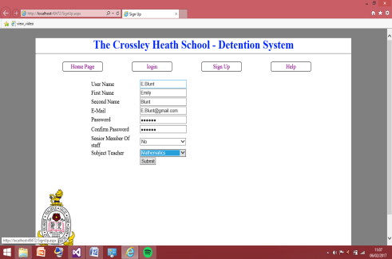

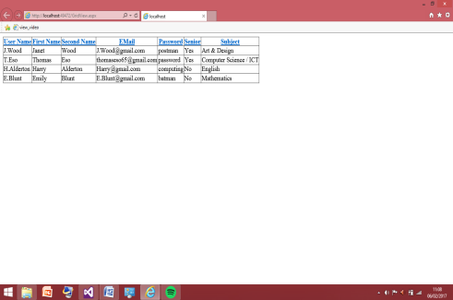

I have now testing this four times in total and there have been no errors after correcting the database address problem, all the information inputted has been put into the database correctly. Therefore this is good time to move onto the login page. This is where the code will have to be written in order to read the database. Therefore this is where I will go to next and do a similar development and testing at the end when the code is written.

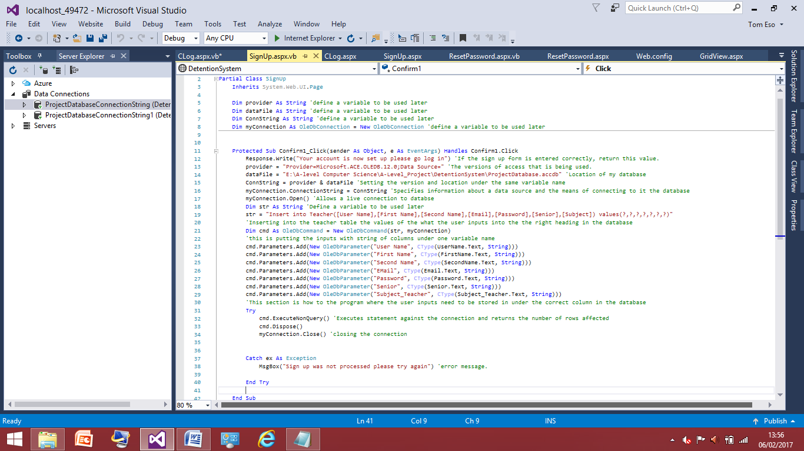

This is the completed code for the user to register with the program.

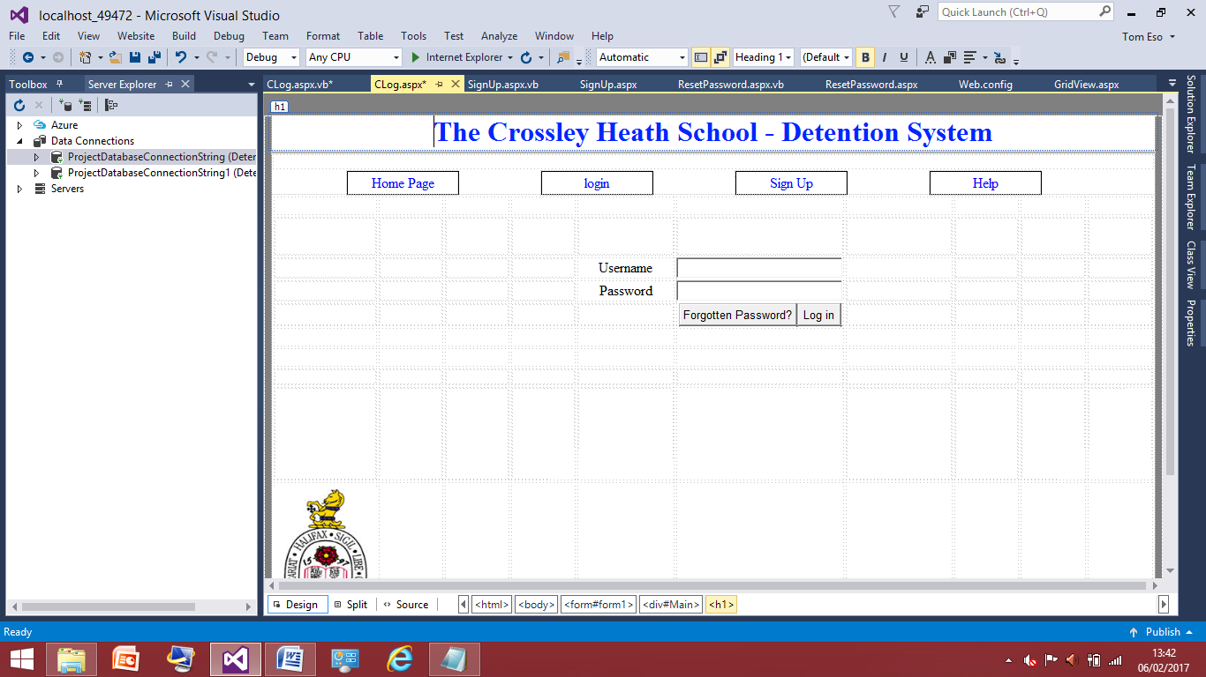Login Page (CLog):

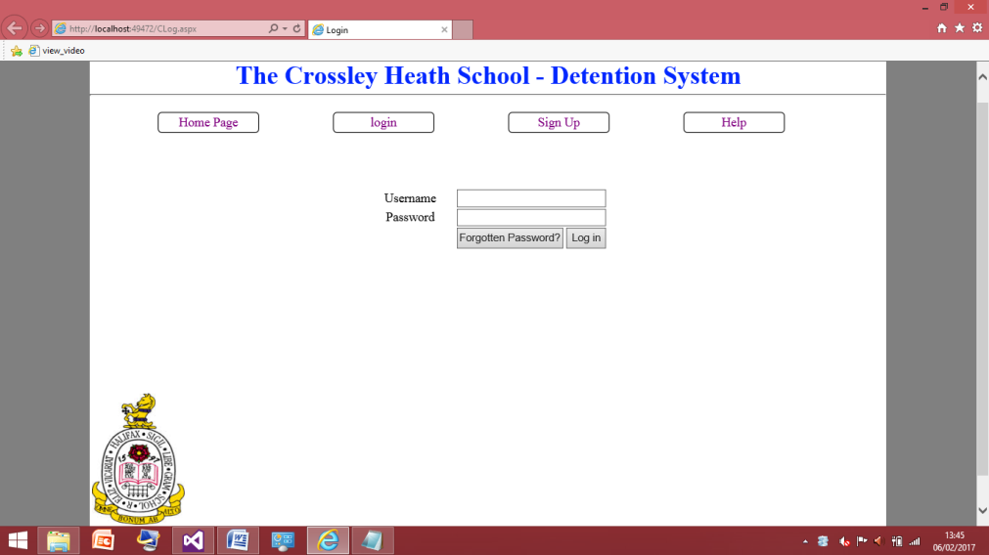This is the now the design on the on log in page, very standard the user must enter the username and pass word into the fields then once pressing the log in button is where the query to read the database will happen. If they find they have forgotten there password they will be able to reset the password, but will sort that out after I’ve coded for the log in button.

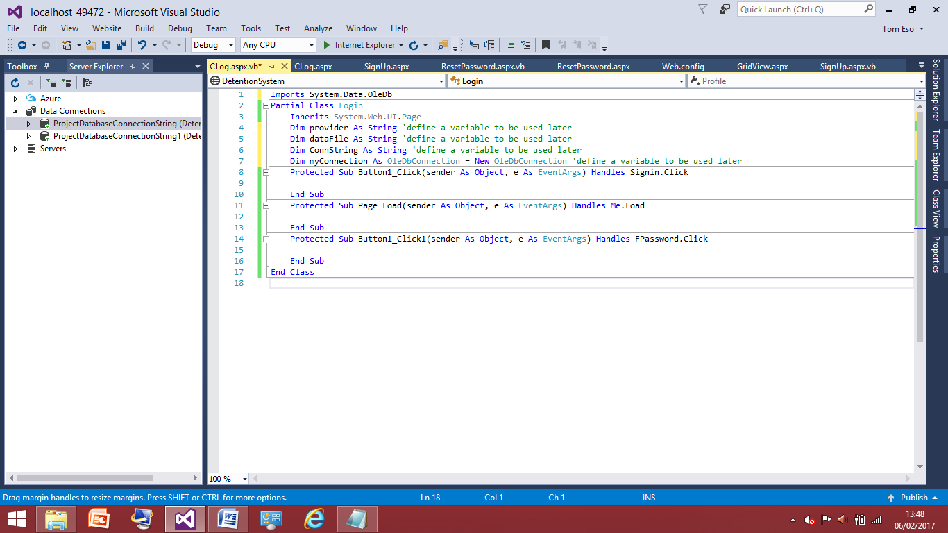

The code starts of the same way as the ‘sign up’ as they both involve the database therefore I know I’m going to need these variable names again, I can reuse the variable names as the pages do not directing interact with each other. Also this time I have remembered to import the systems OleDb therefore I avoided the error I got in the ‘sign up’ page.

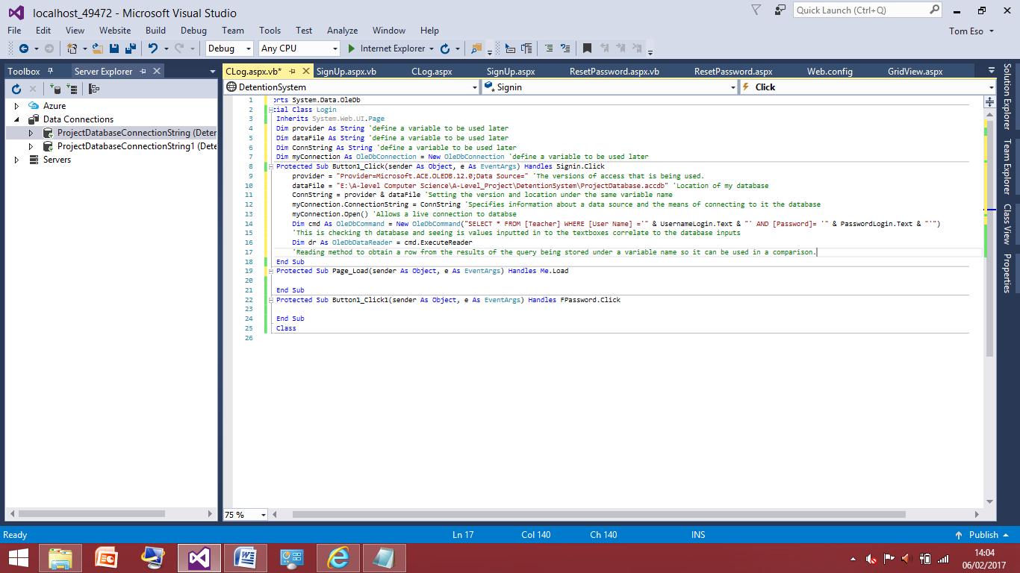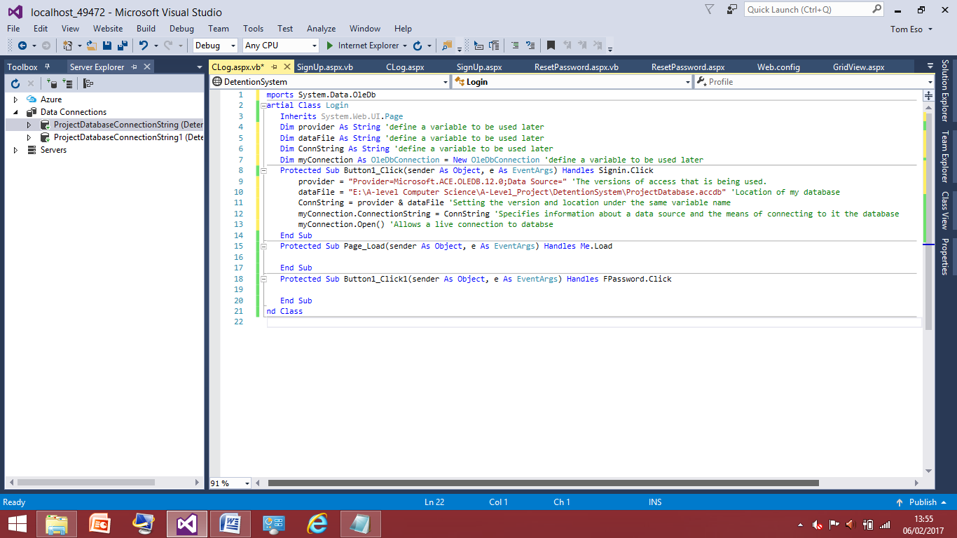The code carries on to the same as before but now I have the location of the database right the first time where unlike before, where there was a problem with the location I gave for the database.

I’ve two important lines of code here line 14 and 16. Line 14 is the select query statement, which I knew to use from a previous program. So I am selecting from the teacher table where ‘user name’ therefore they program is looking in the database now for the ‘user name’ that is equal to the username.login variable which based on the input of the user this is the same as for password and this is being stored under a variable.

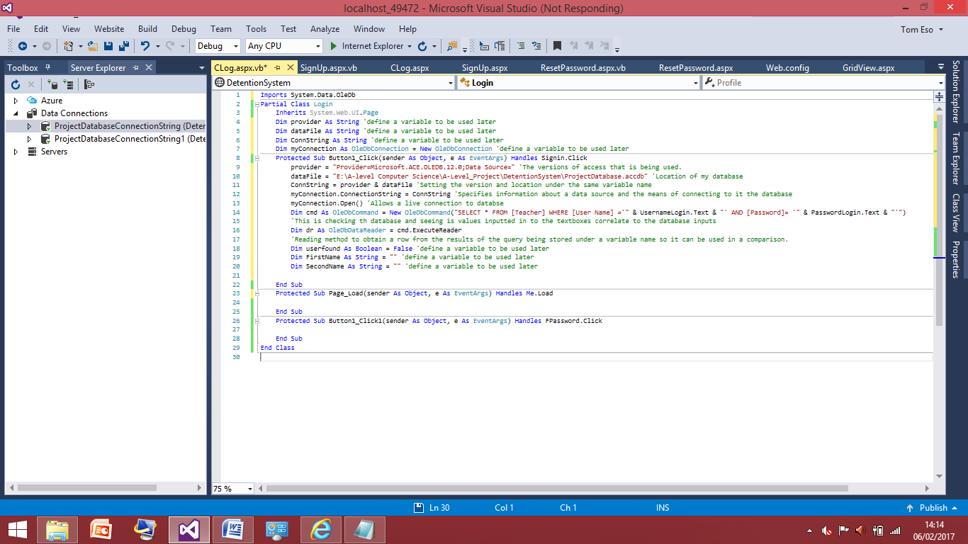Line 16 is explained in the comment.

I have added lines 18, 19 and 20 just defining variables. Line 18 is a Boolean expression because I intend to add in a while loop, so the ‘userfound’ will be a part of the condition needed to stop the loop. The other two is so the program can feed back to me who the user is so when I test it I’ll know they are returning the right values.

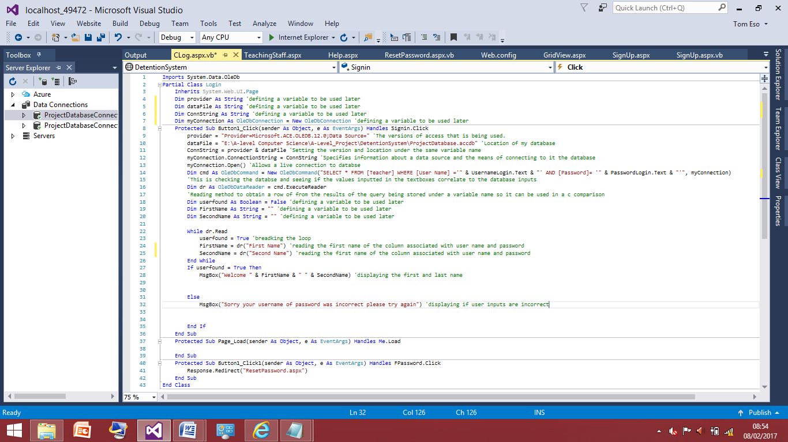

These lines have been added to get the first name and last name of the person associated with the user’s username and password only if they are found in the database. For testing I will display the first name and last name is in a message box just so I know the right users has been found, later on this would just be changed into a redirect to the teaching staff or senior staff but I will add this code later as I need to make sure the basics work firstly. If the username or password is incorrect a message box will appear to say they have entered the details incorrectly. But before I test I need to add these lines of code first.

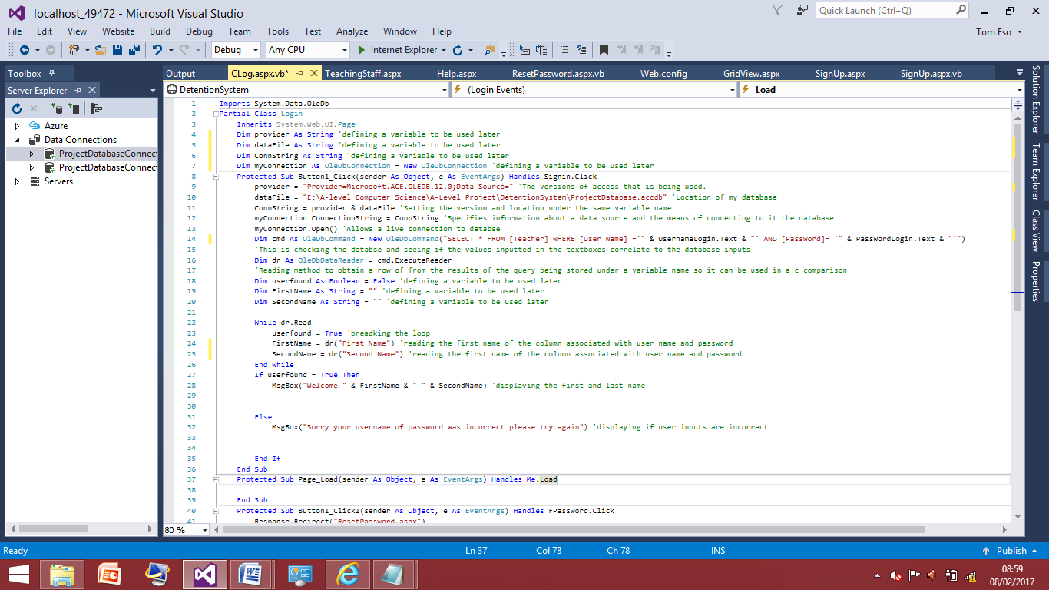This is the simple if statement to print out the first and last name of the user with the user name and password of the inputs. This is good because it allow me to see that database is being read correctly and there are no coincidences of being able to log in without the password. If the user types the password or username in incorrectly there is an error message box to let them know. Now I have finished the code I will test it to make sure there are no bugs and it works correctly.

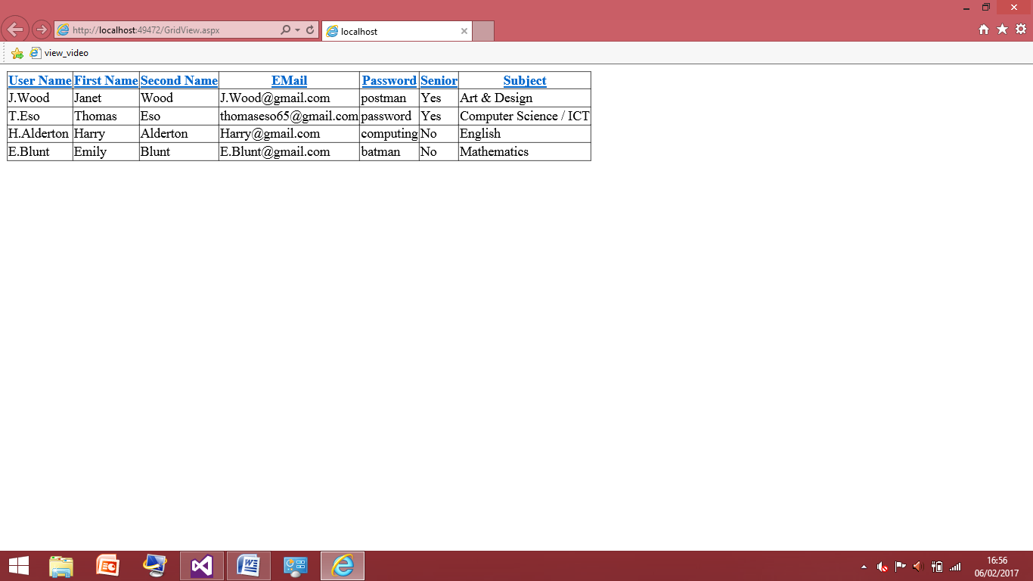This is the full code being tested now.

This is what is currently in the database; I shall test the field with Janet Wood in it and type all username and password in correctly.

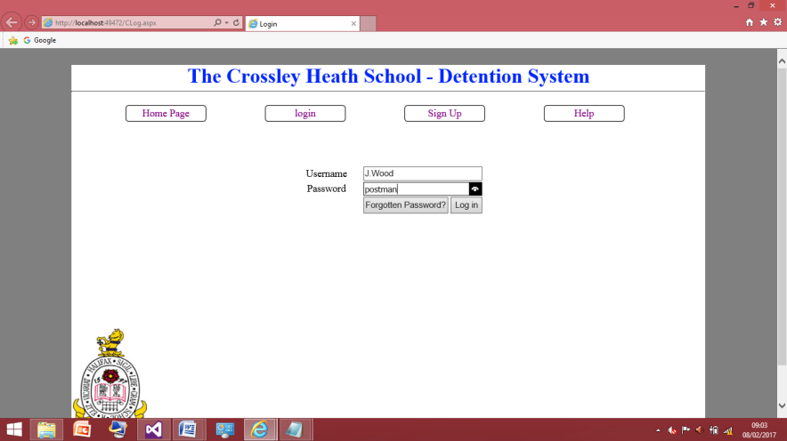

This is the screenshot of the inputs I put into the site they are correct to the user in the database and I pressed log in.

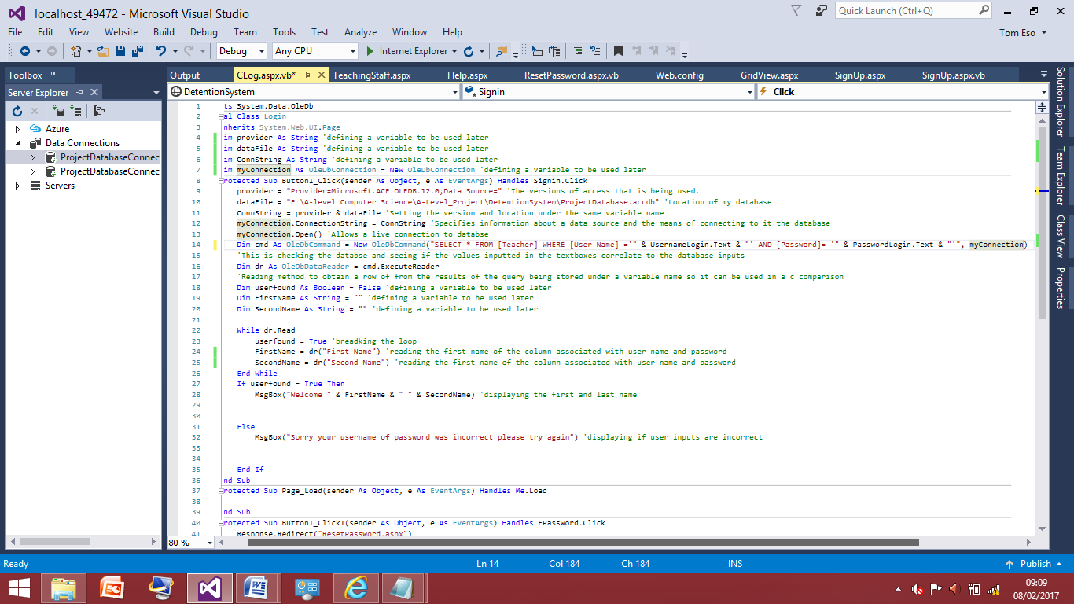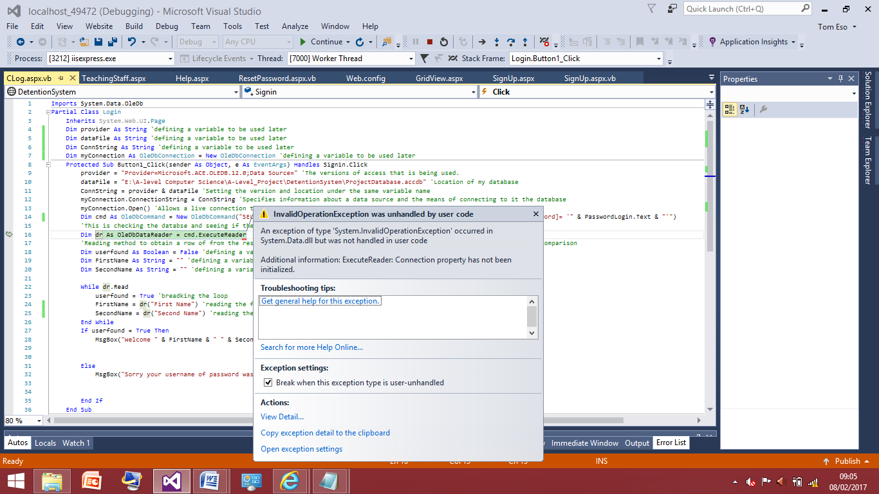When I pressed the log in button there was an error message surrounding the cmd variable, the property had not been initialized. Because the cmd is a variable I can know the problem must lay in the place where the variable has been given attributes which is on line 14.

After some time of looking over the code I realised the line needed the ‘,myConnection’ on the line. This is now the new section of code I shall test I will be inputting the same inputs as in the previous test and see if this code now works. If it does the message box should pop up saying ‘Welcome Janet 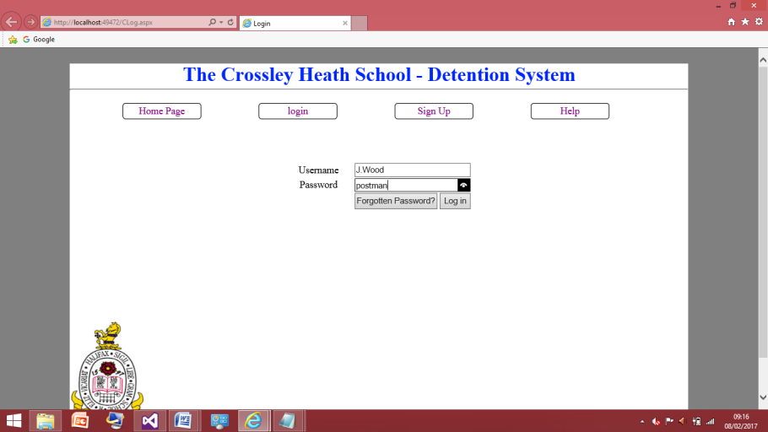Wood’.

This is the screenshot of the inputs I put into the site they are correct to the user in the database and I pressed log in.

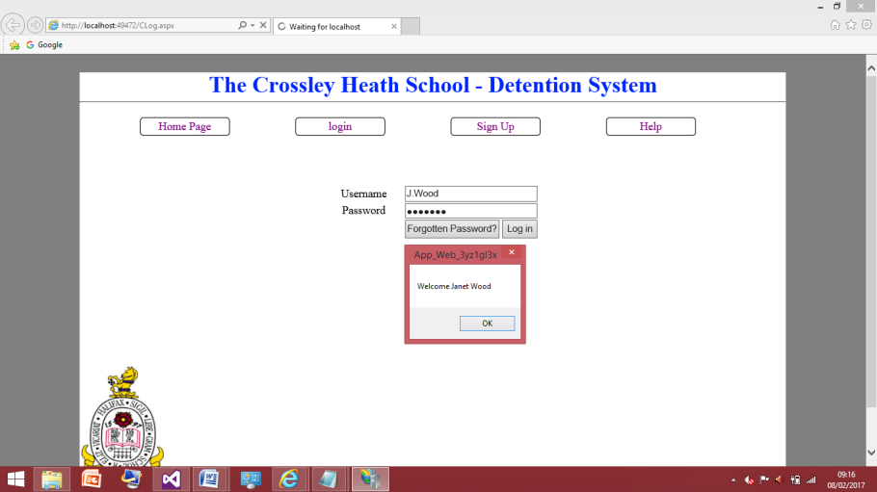Screenshot shows the test was successful as it was able to find Janet Wood based on the inputs knowing the username and password was correct. I will now try Janet Wood again and it put the password in incorrectly and the error message should now appear

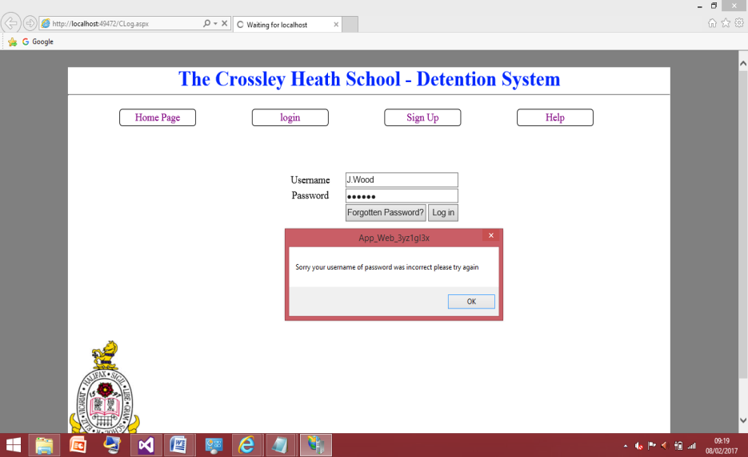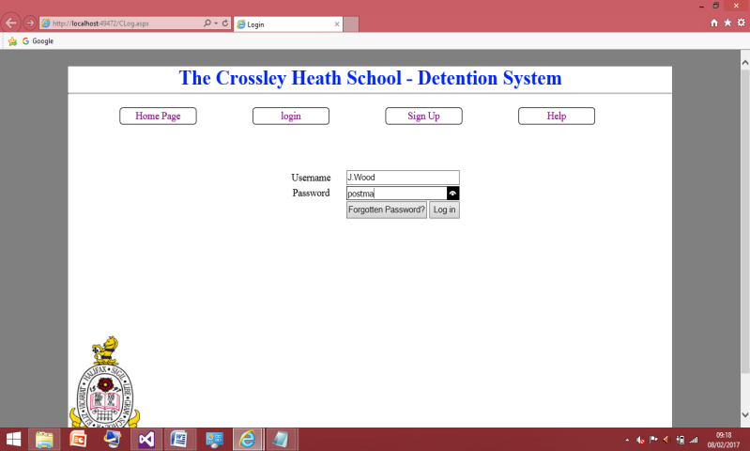

This was a successful test, as I inputted the details for Janet Wood incorrectly and the error message popped up as expected. Now I feel this is in a place where I can test all the inputs in the database to make sure they all work.

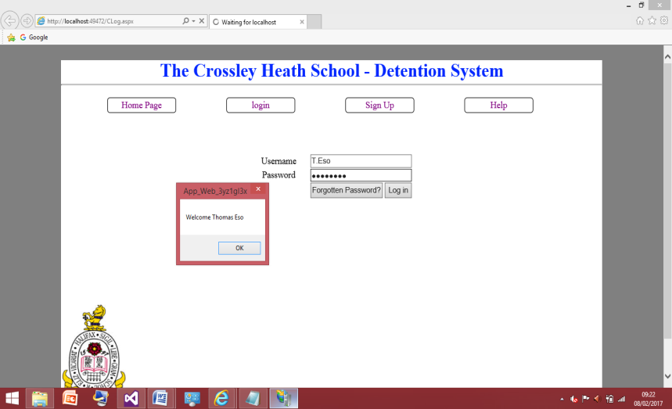

This was successfully able to find Thomas Eso. This time instead of inputting the password wrong I will input the username wrong and the error message should still pop up

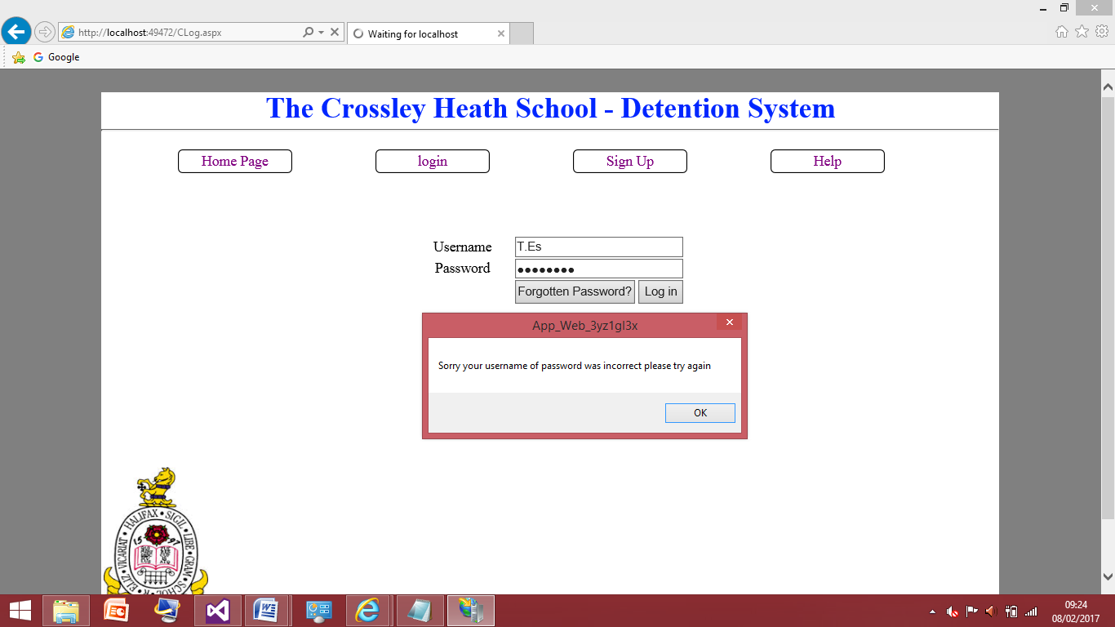

This was also successful, it was import to test the username is checked as well because a user may be able to get into a users account by just guessing there password and not there username. If the code wasn’t checking the both the username and password are correct and just checking for the password in the database.

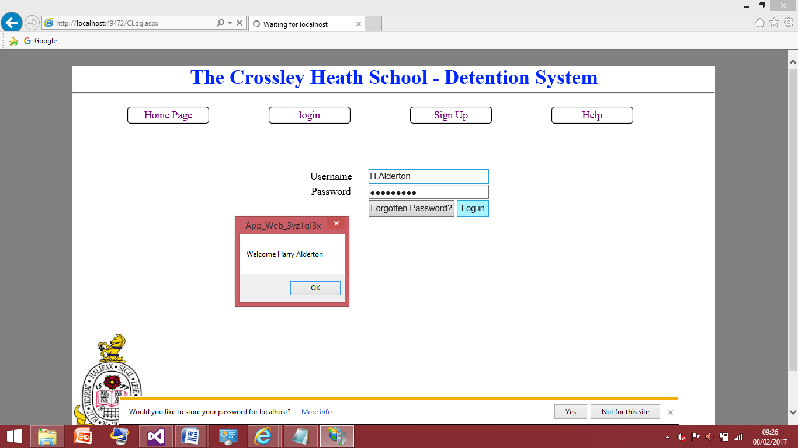

Successfully found ‘Harry Alderton’ from the database.

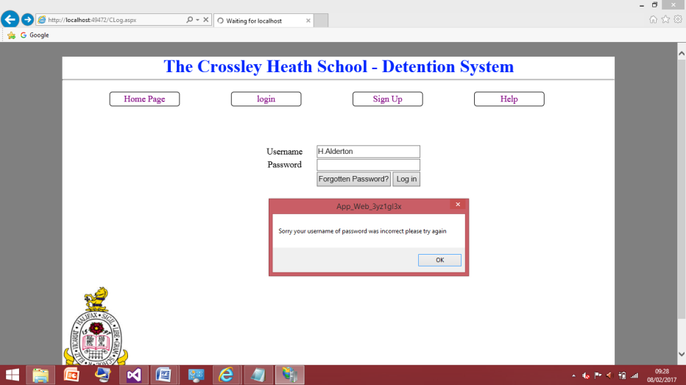

The error message also correctly popped up when the username and password didn’t match.

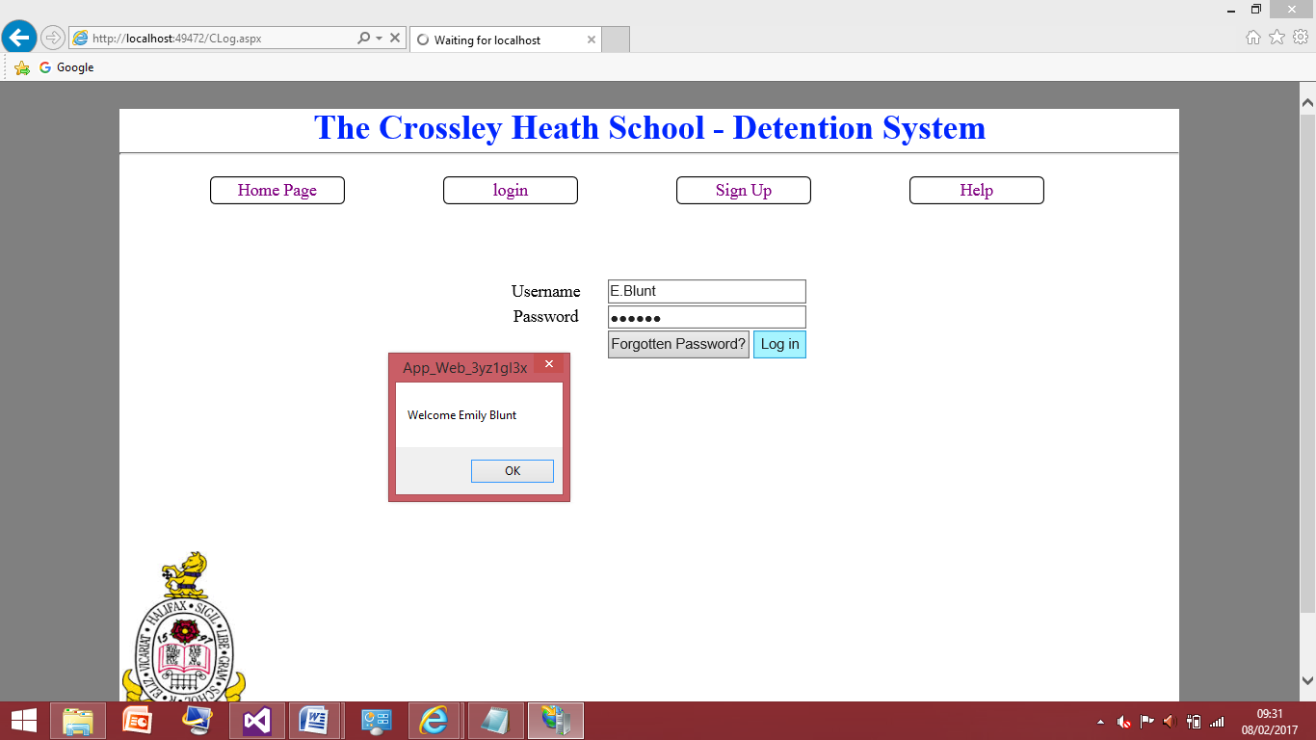

Successfully found ‘Emily Blunt’ from the database.

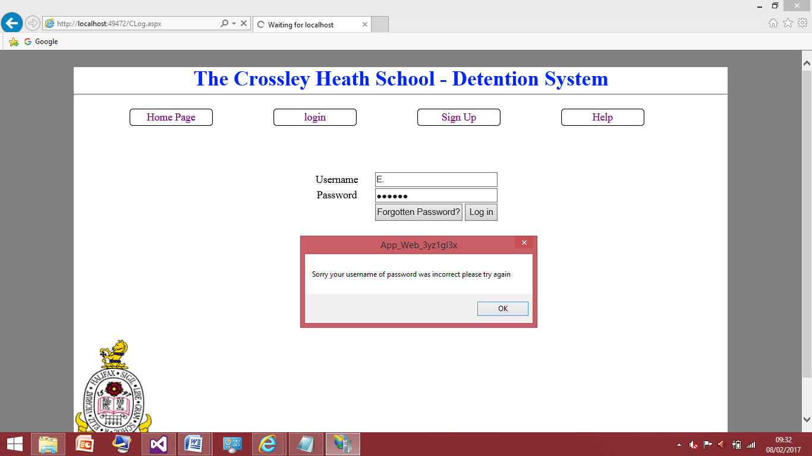

The error message also correctly popped up when the username and password didn’t match.

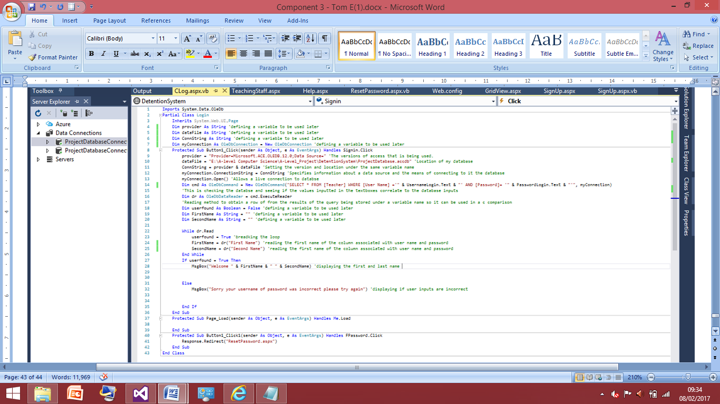

Now I have fully testing this code this is the final screenshot for the code for the log in query. Now this is complete I will move on to developing this code in order to have the senior members of staff and teaching staff go to different place. As this is something I discussed with my client and formed part of the success criteria for this project so this will be attempting to tackle next. After this I will move on to the forgotten password query which will involve the user being able to update their password if they find they have forgotten it.

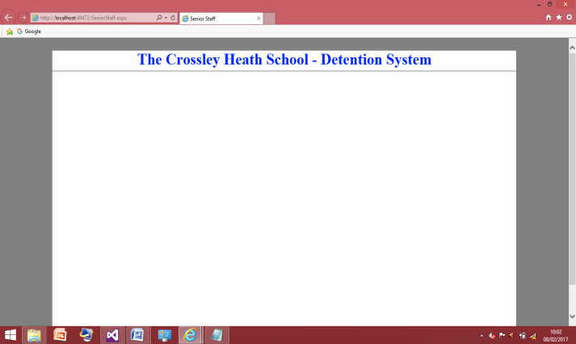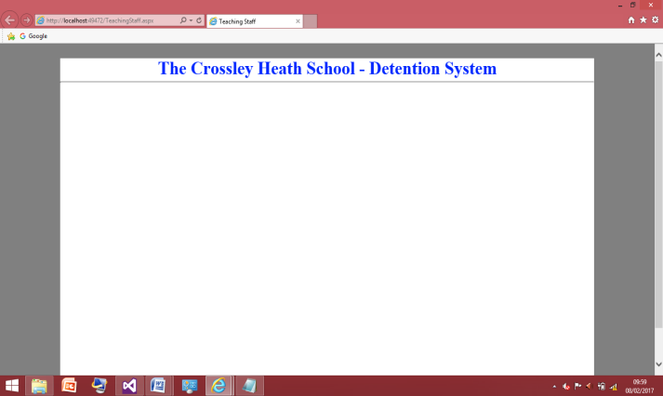Login Page (Senior and non senior staff split):

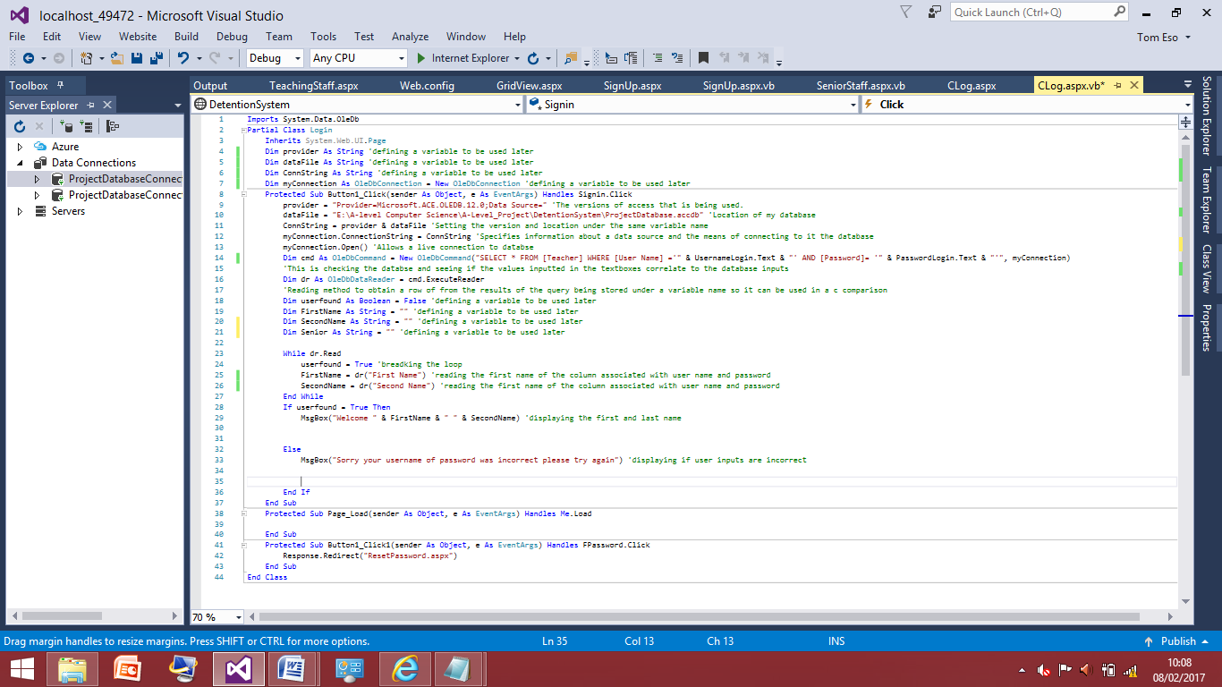The is the starting point of this was creating to home screens that will be where the program will take the user depending on whether they are a senior member of staff or not. Therefore what I will need to do is have the program read the database and have a variable to whether they are a senior member or not and then within the ‘if statement’ the program will link them to the correct page.

I’ve started by building on the code that was with the login page. I’ve added a variable names senior this variable will be used for the value of yes or no for the senior member of staff.

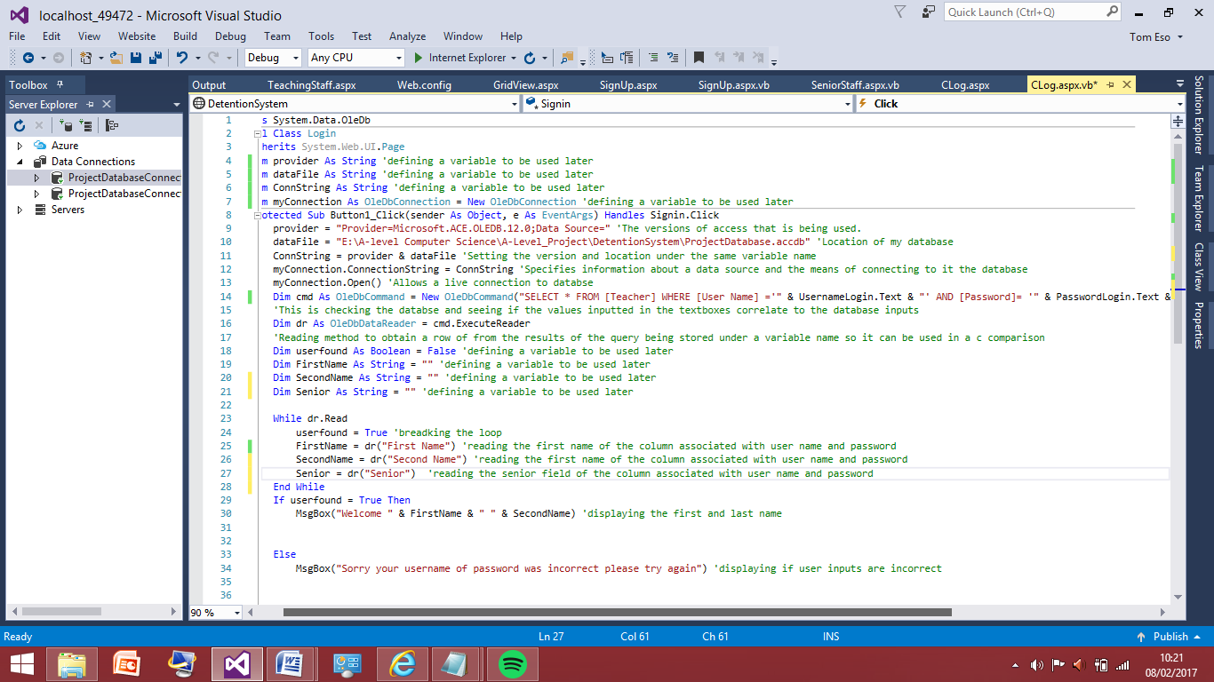

Now I have added the code needed for the program, to get the information in the field of the senior that has the username and password that was inputted in correctly. This value is now assigned to the senior variable within the program.

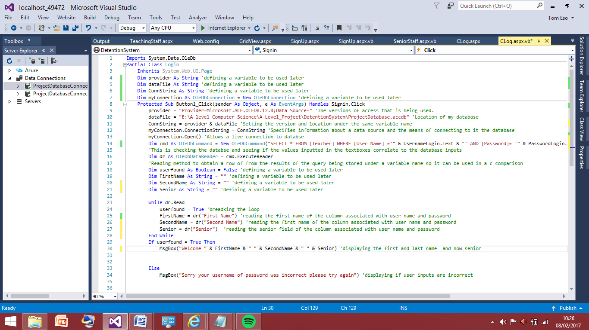I have now added the senior variable to be outputted with the first name and last name as before, I have done this for ease of testing just so I know the senior value is being read. Therefore after I can add ‘if statements’ and redirects to go to the right pages. So now I will test this.

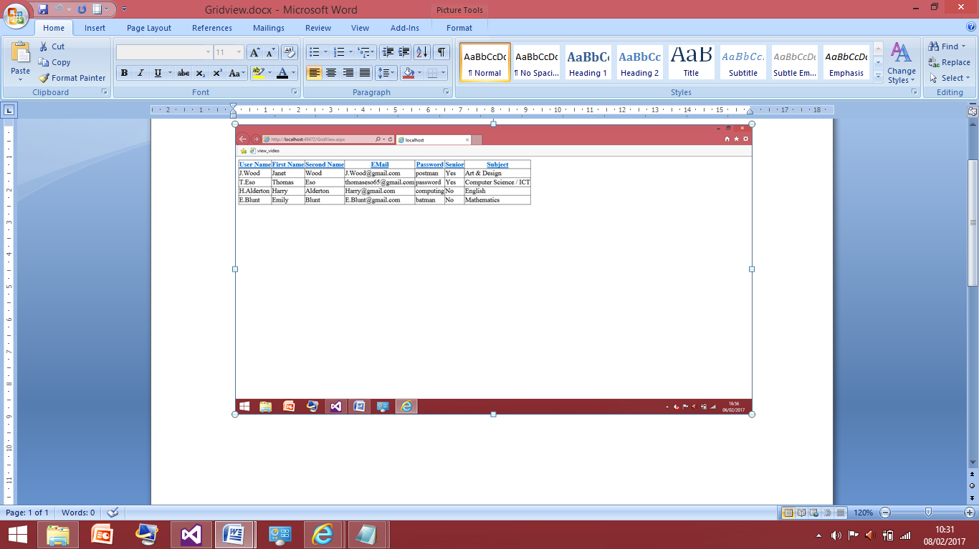

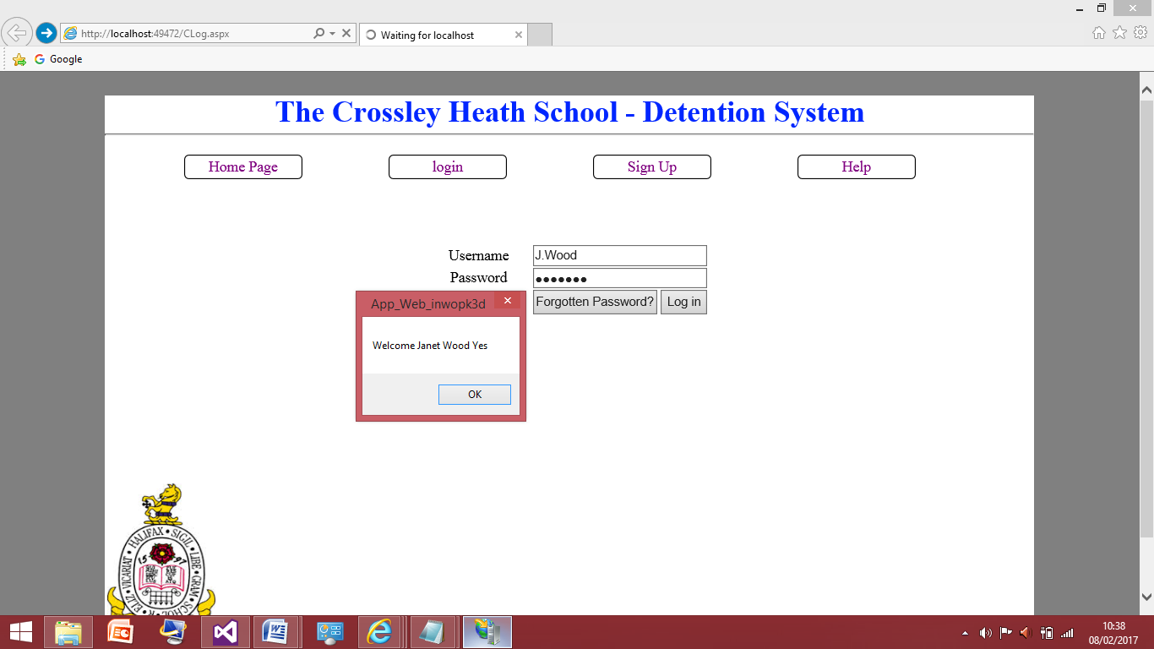This is the values currently in the database I will type in the details correctly for ‘Janet Wood’ as I have already tested the login page there’s no need for me to type anything in incorrectly. Therefore once I entered the username and password. I am expecting message box to display ‘welcome Janet Wood Yes’.

This shows the test was successful as the senior value was outputted as well as the other attributes within the database. I will now test this for the other 4 users to makes sure this is fully working as I am expecting.

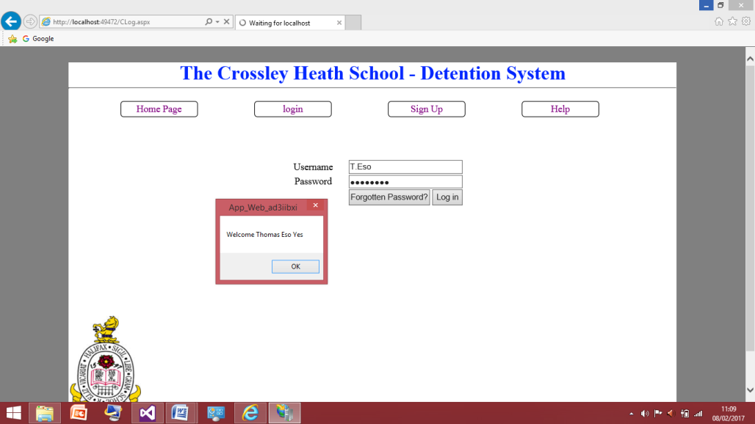For Thomas Eso the output should be ‘Welcome Thomas Eso Yes’

This screenshot shows the test was successful.

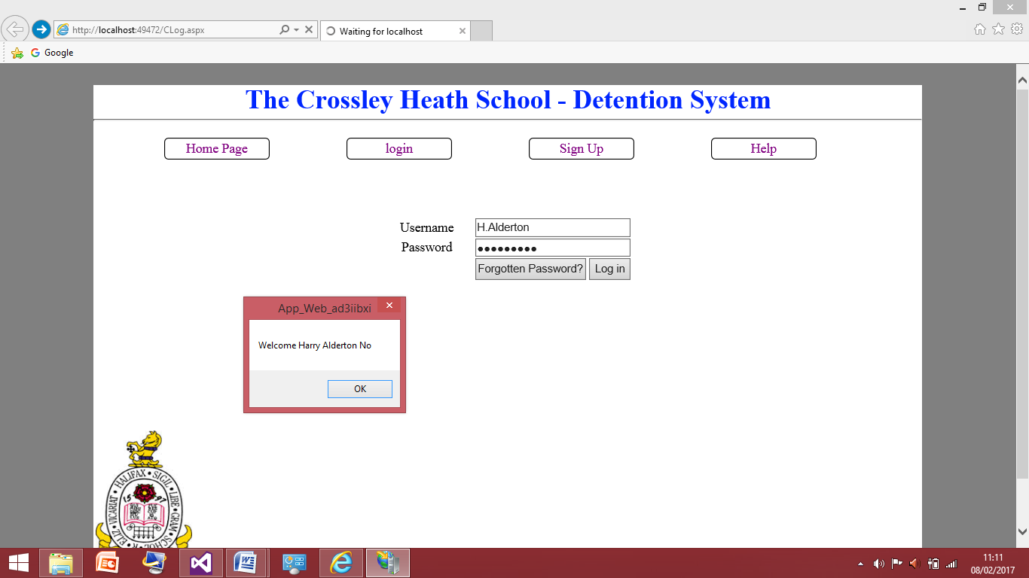For Harry Alderton the output should be ‘Welcome Harry Alderton No’

This screenshot shows the test was successful.

For Emily Blunt the output should be ‘Welcome Emily Blunt No’

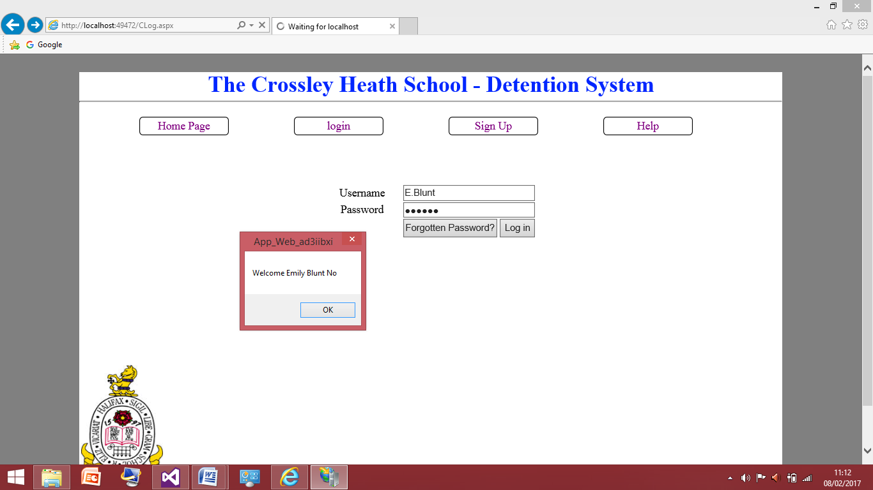

This screenshot shows the test was successful.

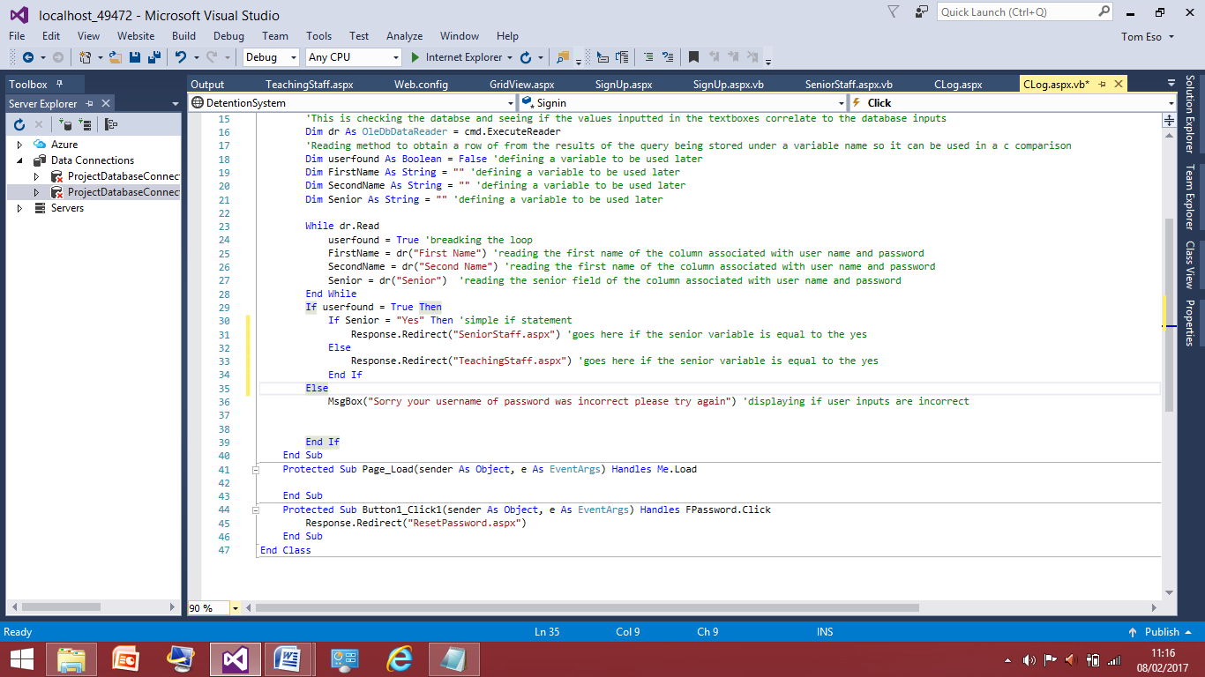Now I know I can successfully pull the data of whether the user is a senior member of staff, I can move on to having the appropriate redirects to the right pages based of this using an ‘if statement’.

So now have added another if statement nested inside the other if statement of producing the message box, the nested if statement is in the first if statement because it should only be executed if the users username and password was inputted in correctly. This if statement checks the value of the senior variable if it is yes then it will redirect to the senior staff page which I made earlier, anything else so ‘no’ it will redirect to the teaching staff page. I can now test this for the 4 users in my database to ensure I have coded this correctly.

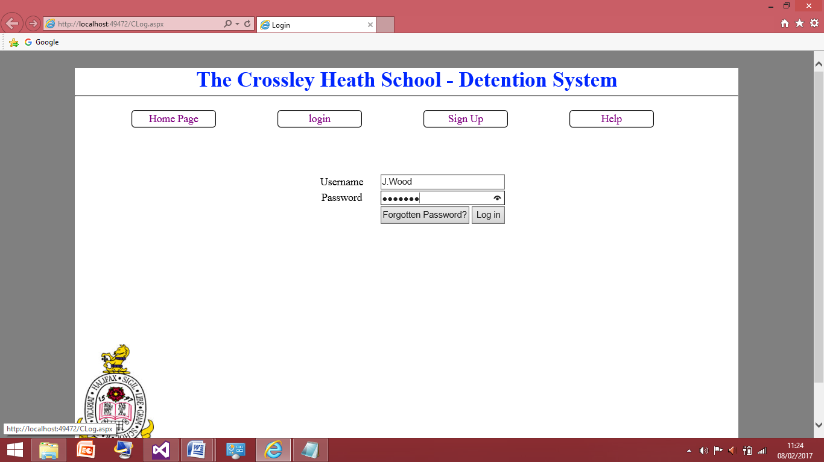

Here I have typed in the correct details for Janet Wood. Within the database Janet Wood is listed as a senior member of staff so when I press log in this should redirect to the senior staff page.

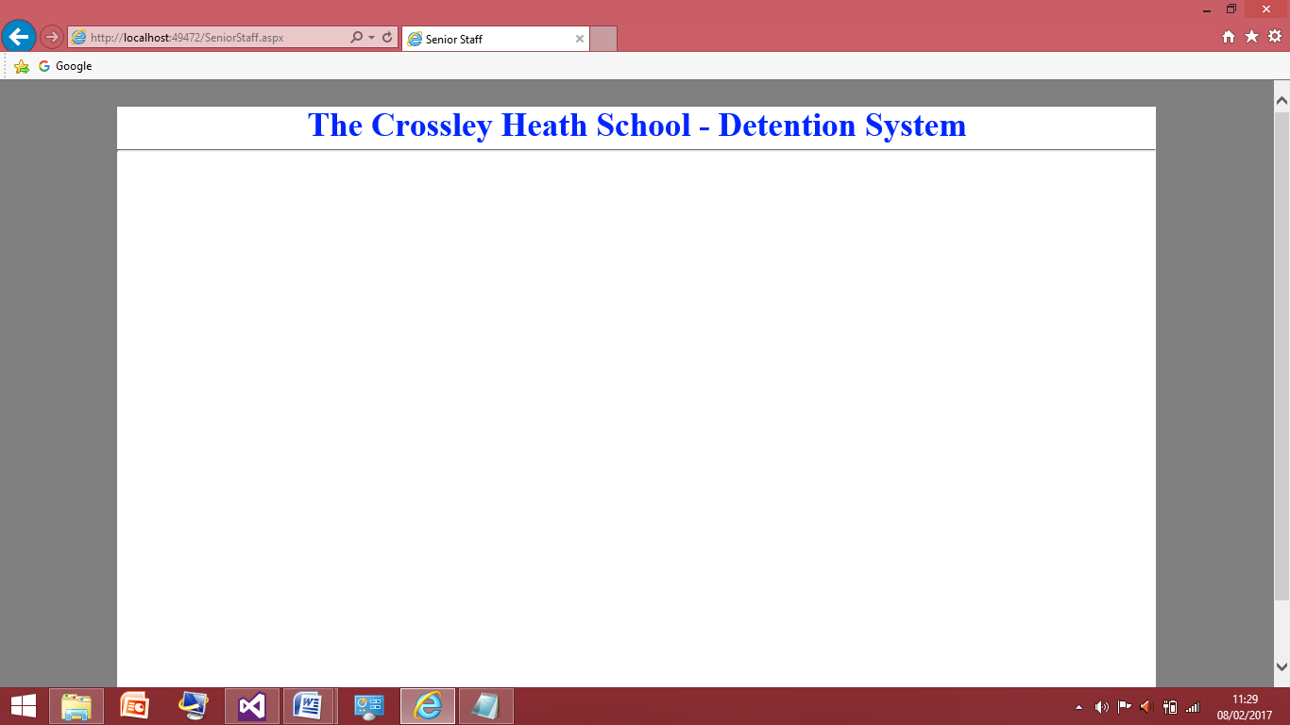

This screenshot shows the test was successful as I was taken to the senior staff page. Therefore I will carry on and test this for the other fields within the database.

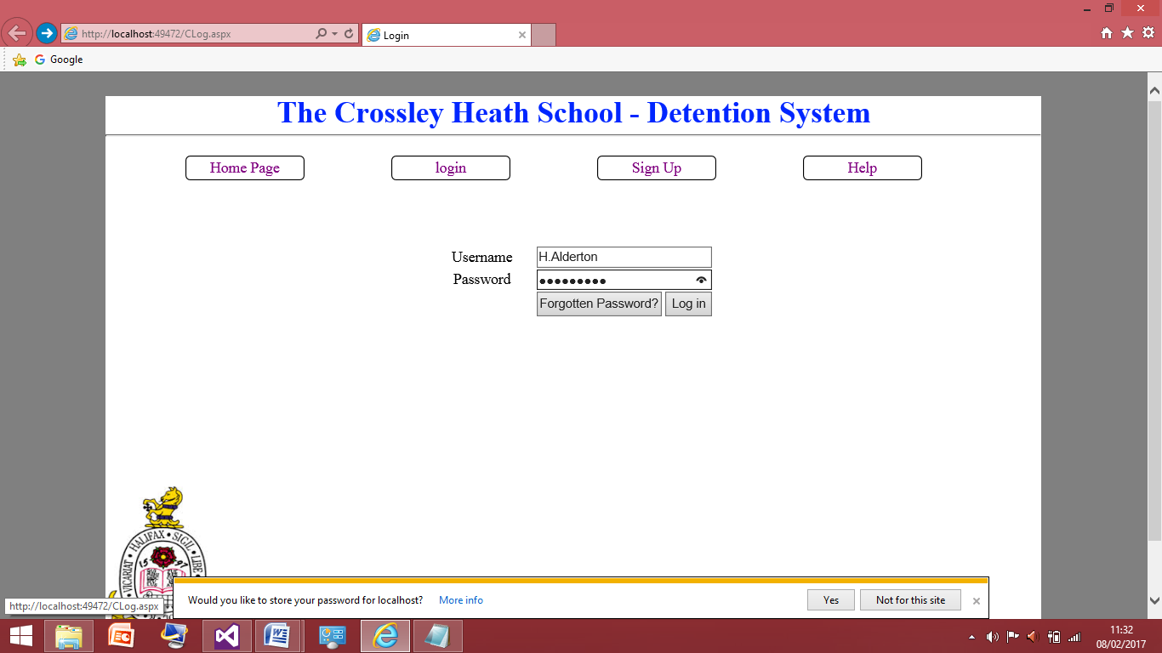

I tested ‘Harry Alderton’ next as this was a normal teaching staff field therefore and I wanted to see if this one worked as well. After I will test the other two users in the database.

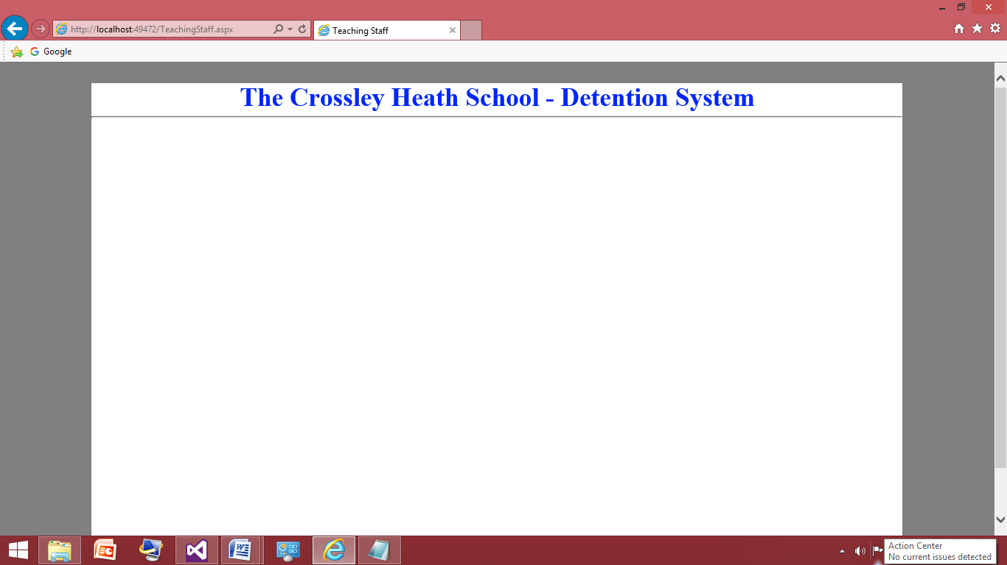

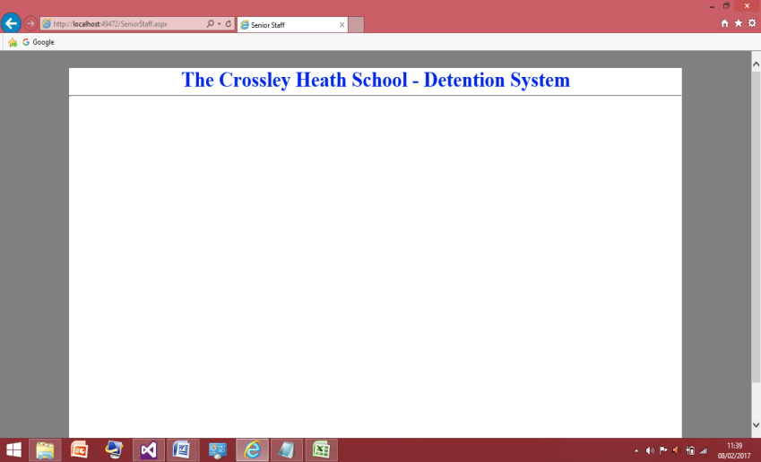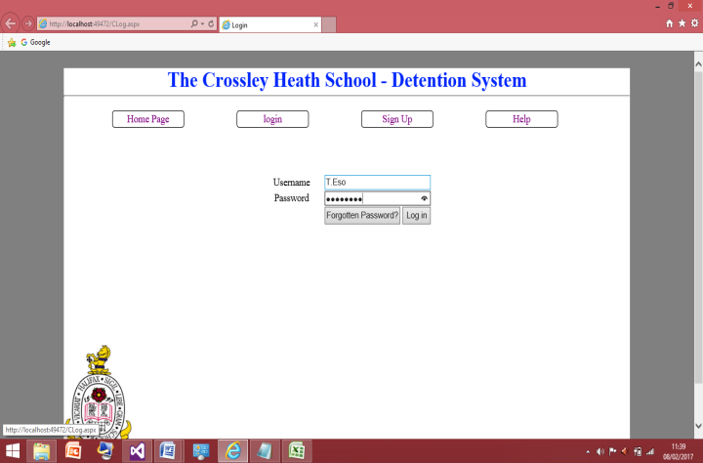This screenshot shows the test was successful as I was taken to the teaching staff page. Therefore I am confident the other two users will work correctly as well but I shall test them now.

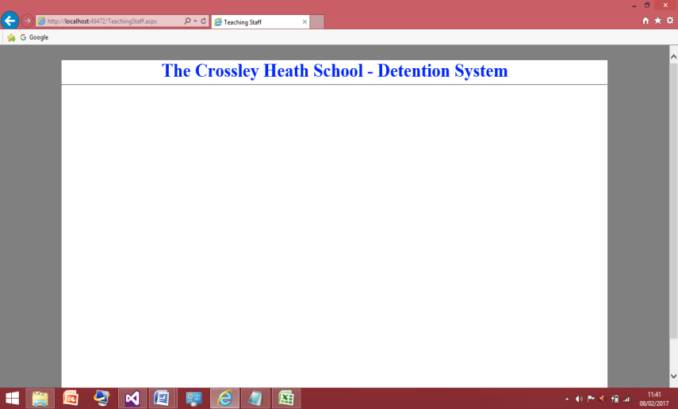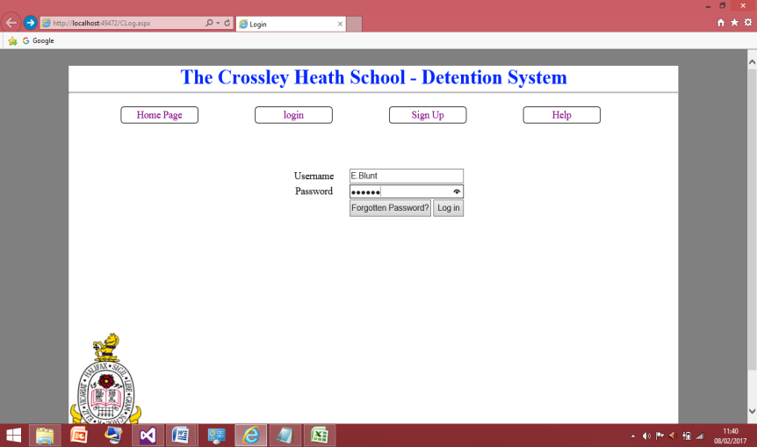These 4 screenshots show that the other fields are working correctly and that I have now completed this section of having different places for the senior member of staff and the teaching staff. Now this is completed I can move on to the update query needed for the program if the user forget their password therefore it needs to be changed so I will now do that.

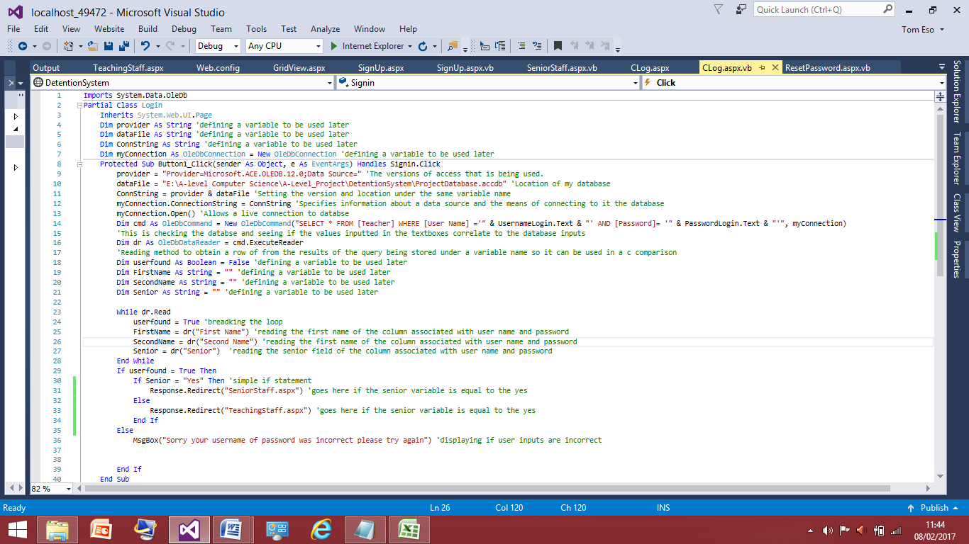

This is the completed section of code for the user to log in.

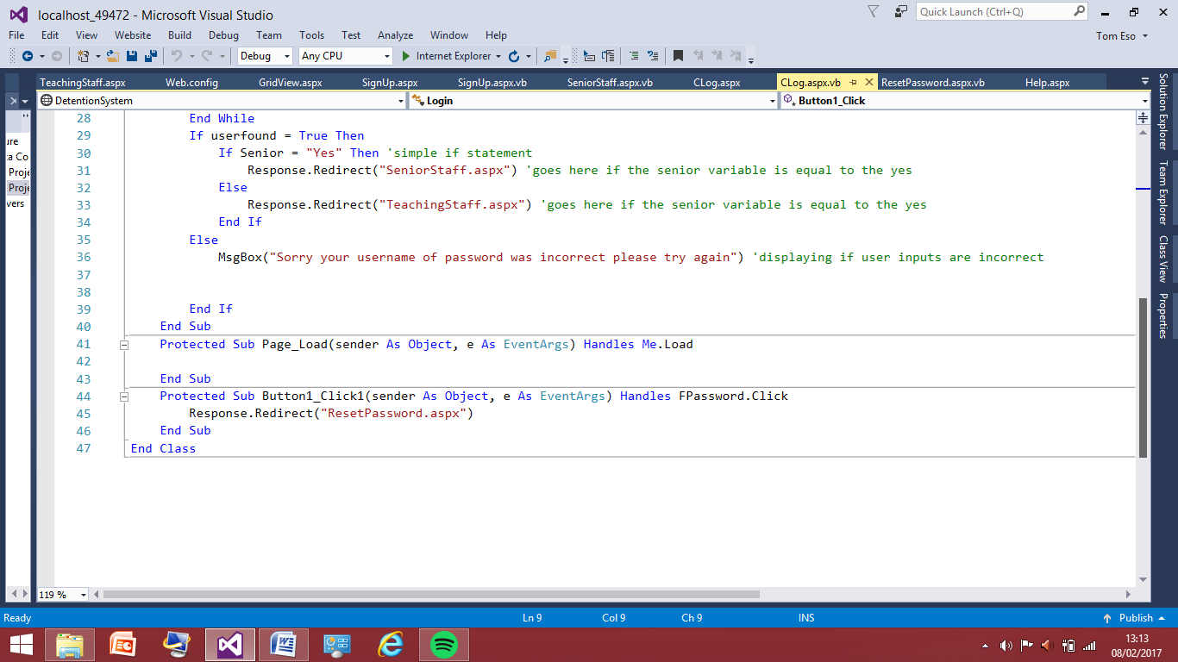Reset Password:

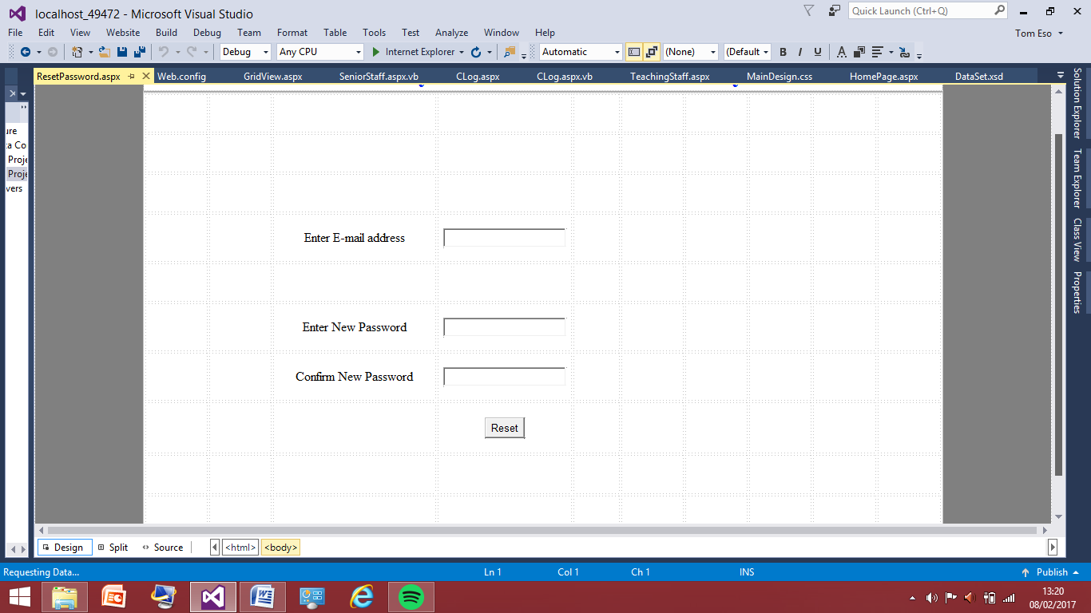To start with I have added as redirect on the log in page, this is within the forgotten password button so if the user finds they seem to have forgotten there password they can click the button and then this will link them to the reset password form I have created.

This is the design is for the reset page. The user need to input there e-mail address. The program will then query the database and update the field with the new password then they will be directed to sign back in.

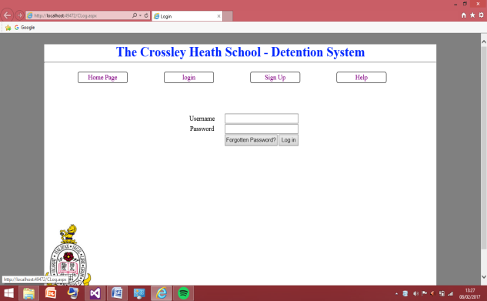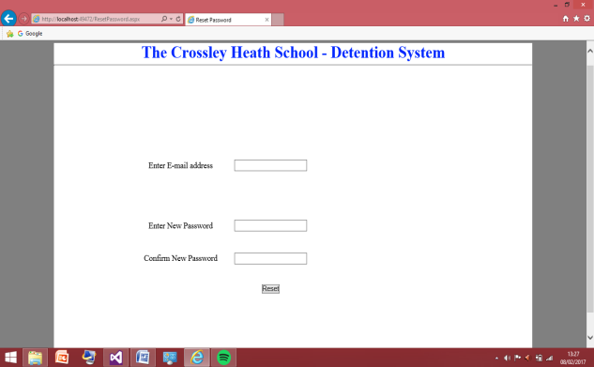Before I right this query I will check the redirect to reset password page is working correctly.

The redirect worked as expected so now I can more on to adding the update query for the fields.

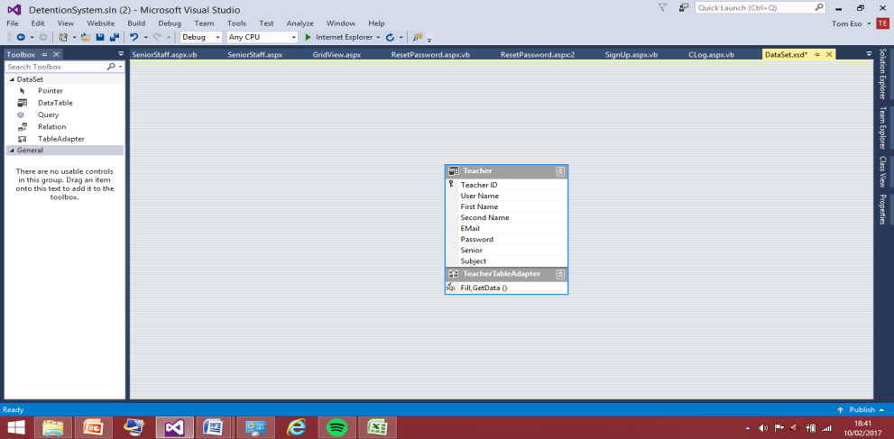

For the update query I’ve decided now to do the data set query method, this will avoid the coding into the button. So here is a screenshot of how I’ve added the database then physically drag and drop the teach table because that is where the up query needs to be written into. So now I can add 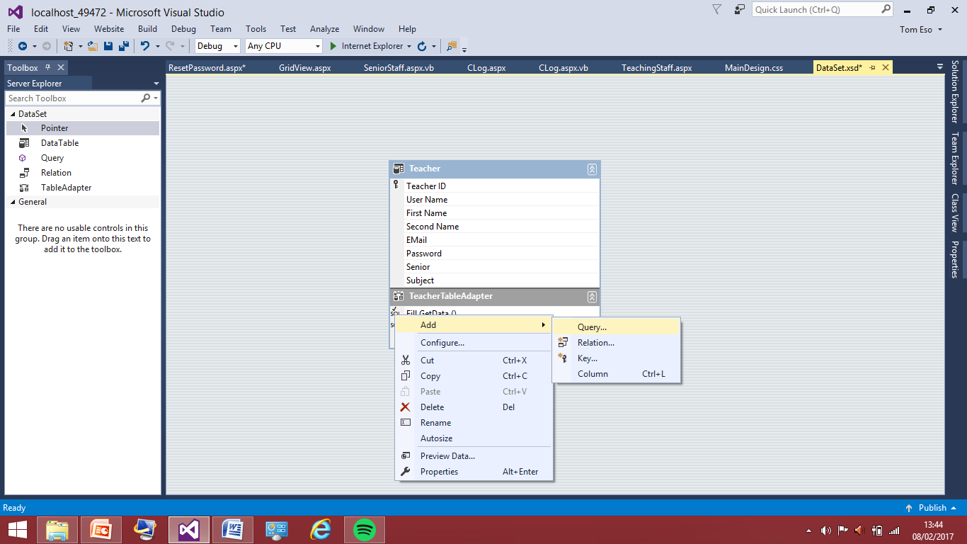the query to the table.

Now adding the query into the teachtableadpater.

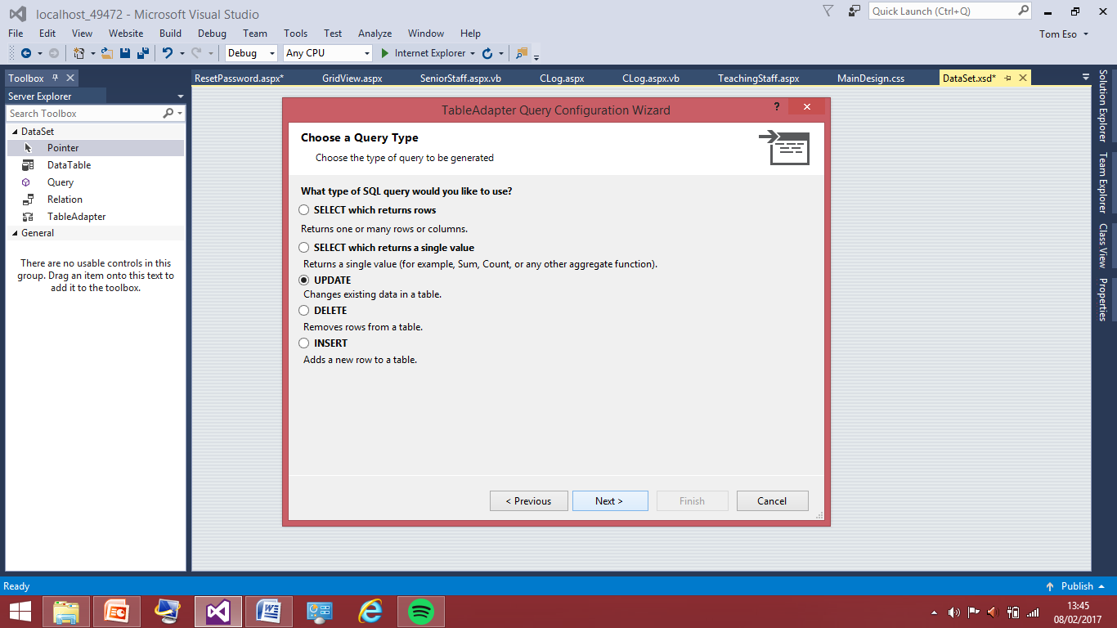

I’ve selected the update query type because I am performing an update query.

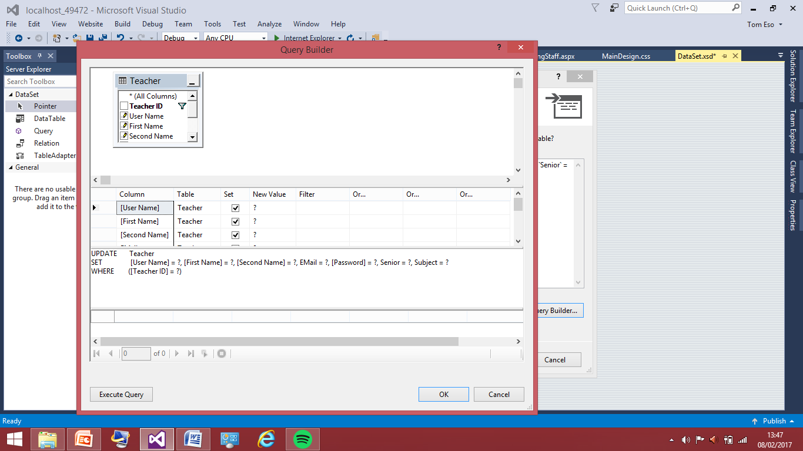

I am now in the query builder so here I can select what fields in the table I need for the reset I need the email and new password field so those are the only fields with ticks I need.

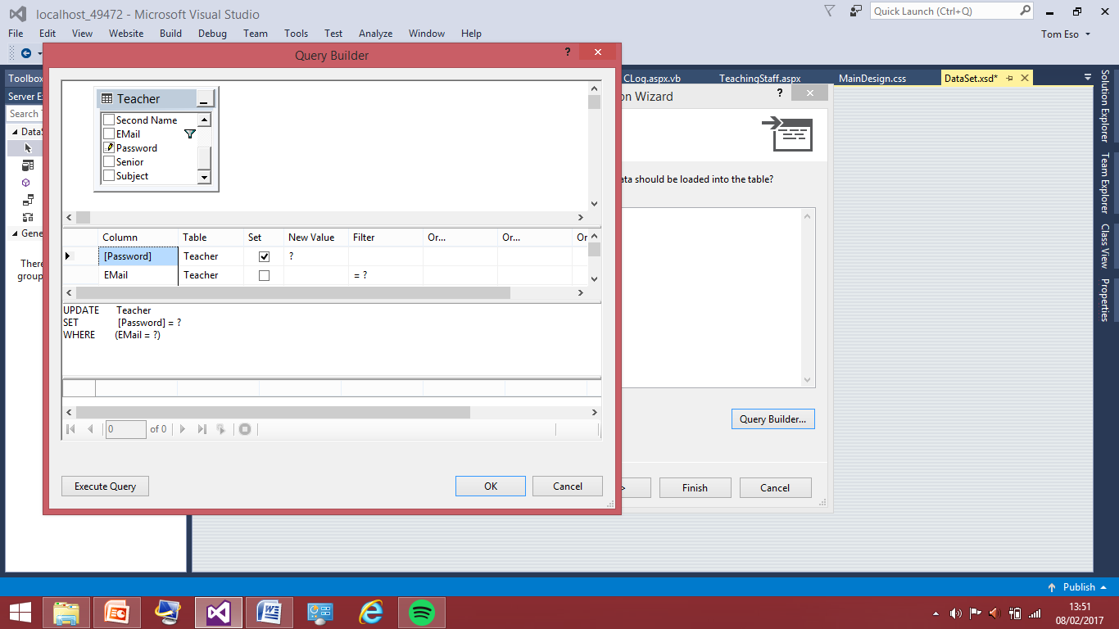I have now written the query so the statement is where the email equals what the user types in so they need to type in their email as it is inputted into the database the password field will be updates with what they typed into the new password text. Now this is written I can execute the query to check it works appropriately.



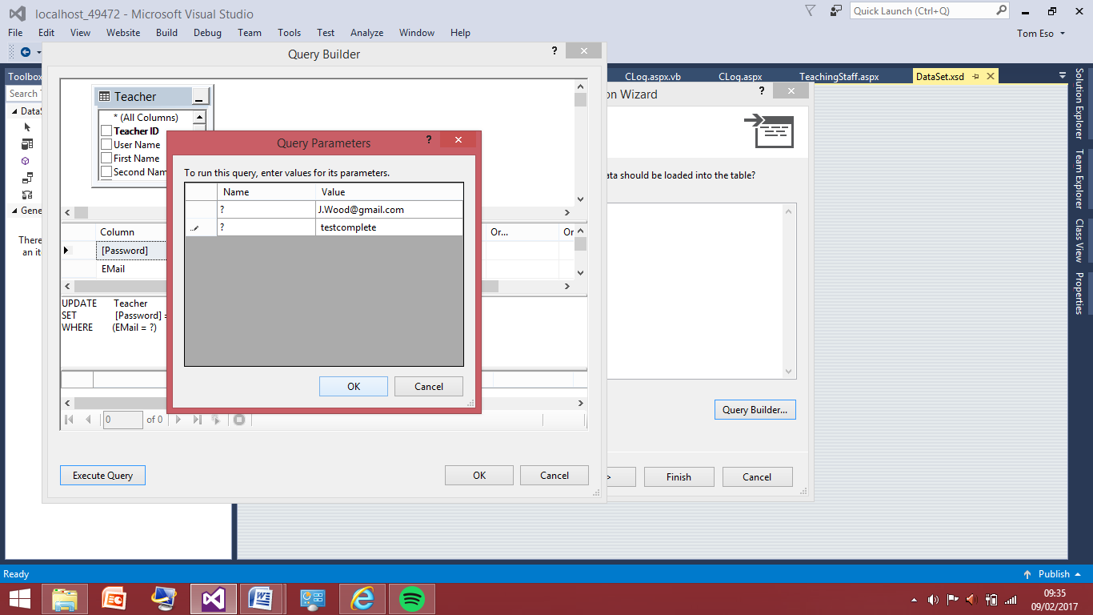This is what the fields are currently showing in the database for testing the query I will attempt change in password in the user name of ‘J.Wood’.

So here is the test query set up I have entered the correct email address for ‘Janet Wood’ and I am attempting to change the password to the ‘testcomplete’ so when I pressed ‘ok’ I should receive a message saying a field as been changed or some sort of message like this.

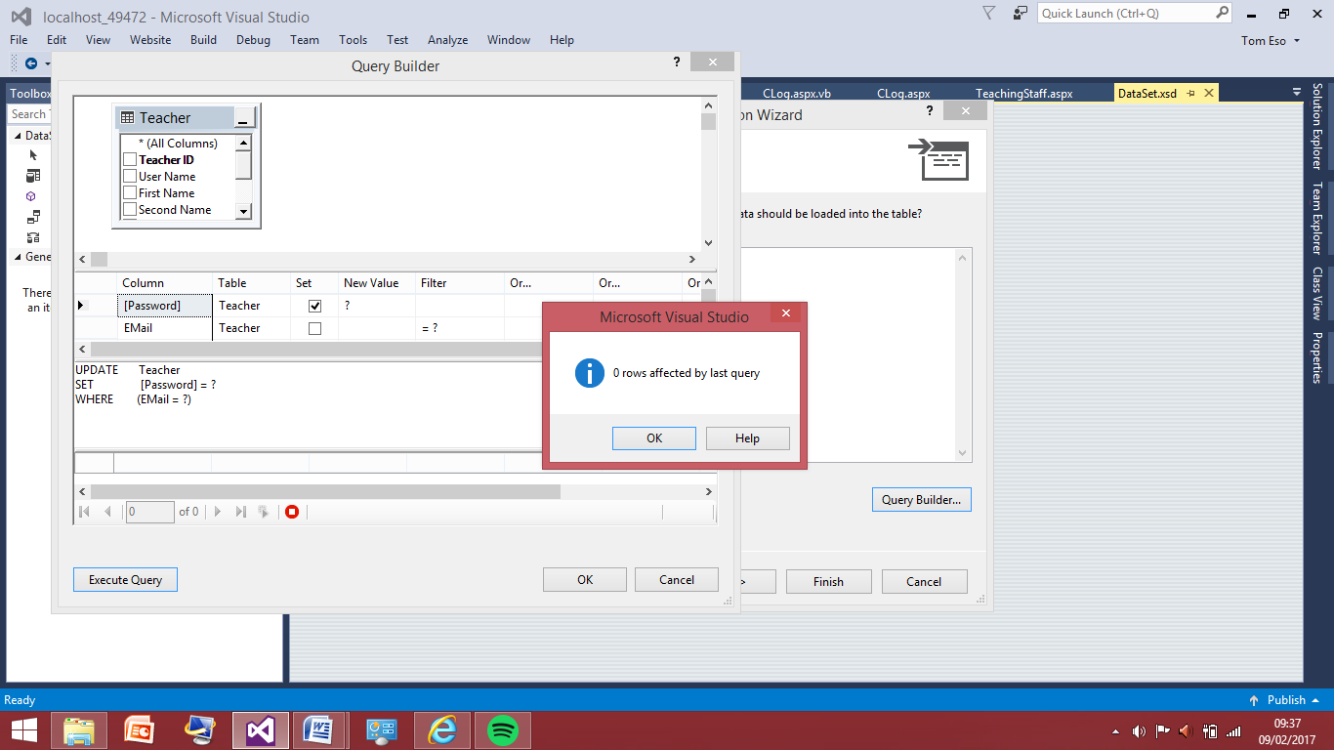

This shows the test wasn’t successful there has been a problem with the query as no row were affected. Therefore now I will look back over the query and see what problems I can spot with it.

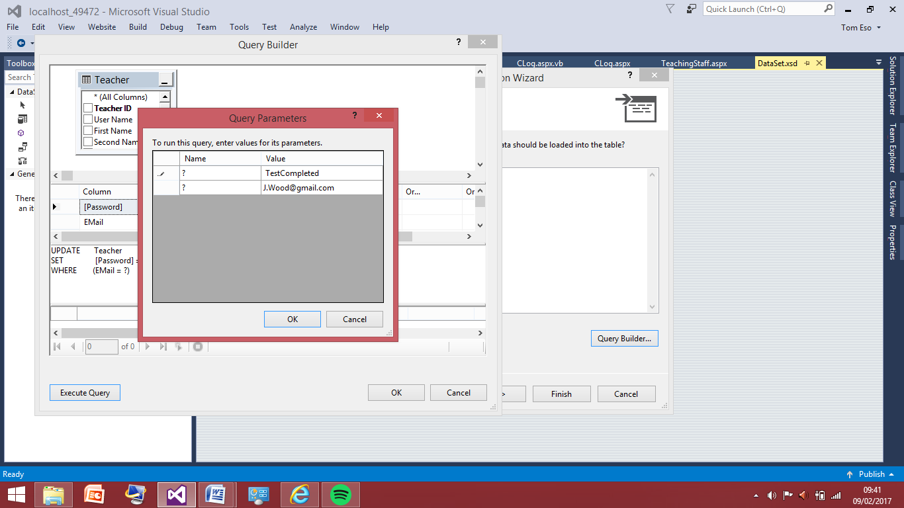After sometime of looking over the query I couldn’t find the mistake, eventually I realised the problem was coming from how I was executing the query. Email address needed to go in the bottom box and the password going in the top box. No rows were affected in the last test because the program was trying to change the field with the email address of ‘testcomplete’ to ‘J.Wood@gmail.com’ which is the opposite way round. Therefore I will test this again with the same name and this should now affect the row.

The test I am about to carry out with the correctly inputted fields now.

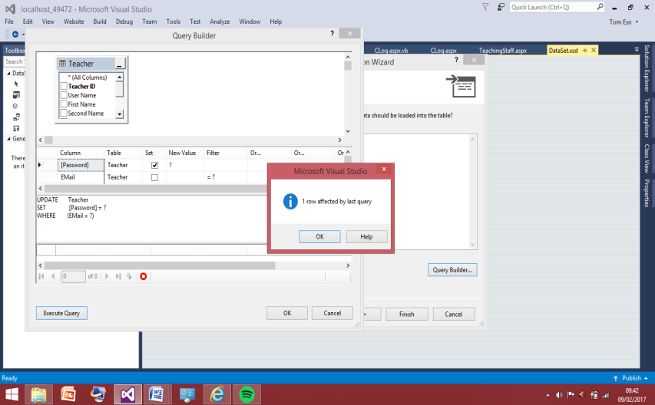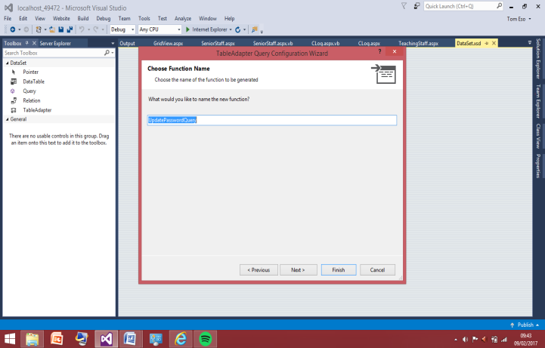

The screenshot to the left shows the field was affect however I don’t know that this was done correctly until II check the grid view in the web browser. Therefore I decided to finish of the query which is shown in the screenshot to the right I called it ‘UpdatePassswordQuery’. This will come in use later because the when I need to call the query in the section of the forgotten password submit button this will be called and used, as the user cannot update their password through these queries as this is not user friendly nor efficient way of doing so. I will now check the grid view and the password in the user name J.Wood should now read ‘TestCompleted’ not ‘Postman’.

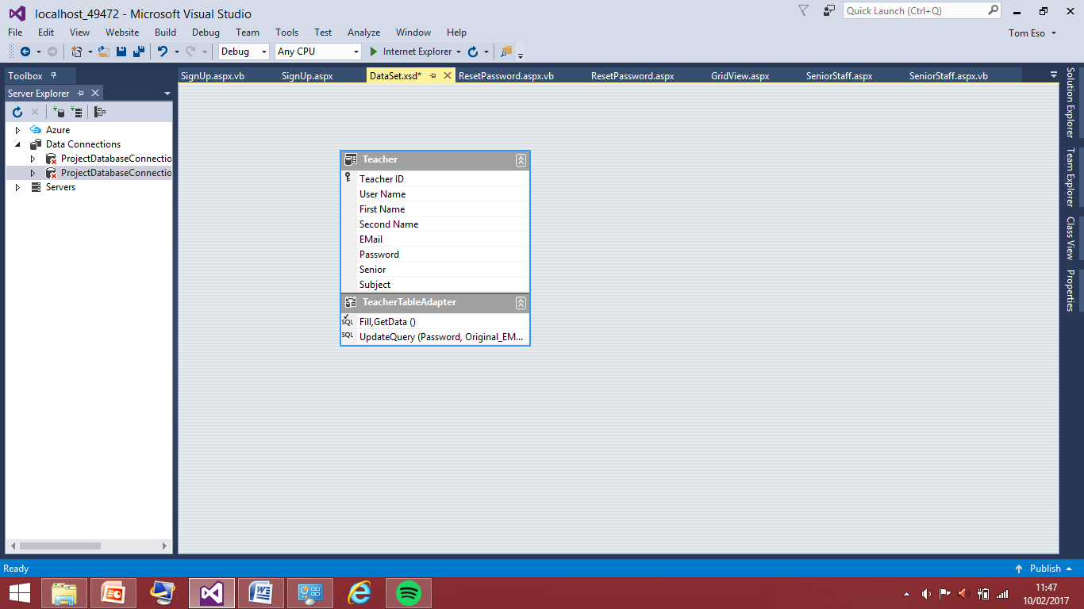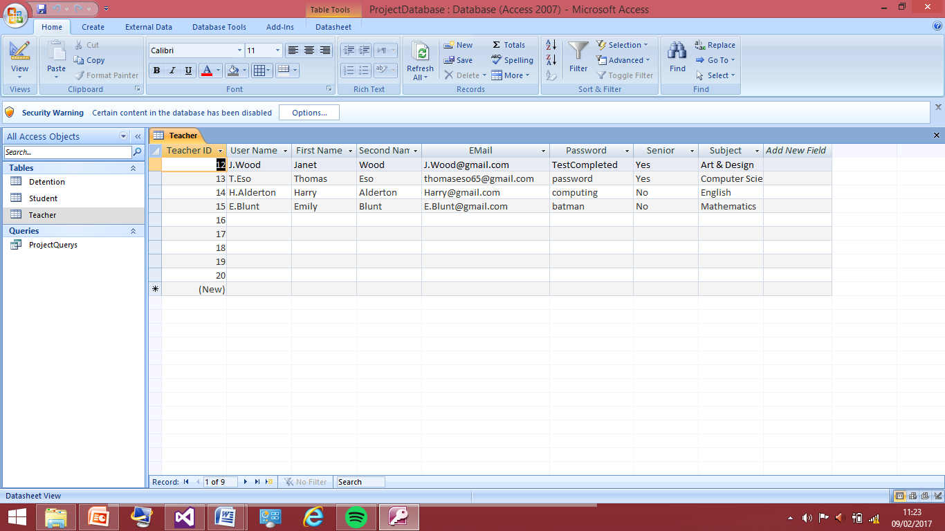This shows the test was now successful as I can see there has been a new password implemented into J.Wood field. Now this query if working correctly I can code the query to be called in the log in button coding section.

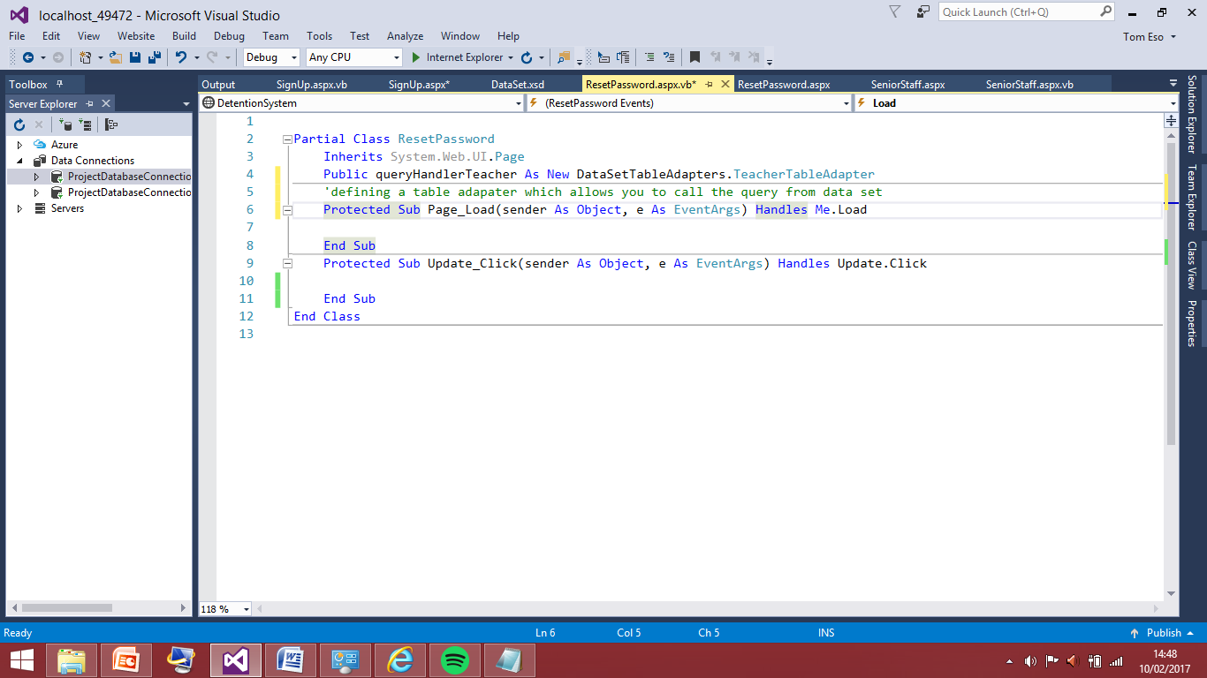This shows the query has now been added to the table adapter.

I’ve added the public variable, for the code to able to call the query from the dataset. The variable name is queryHandlerTeacher, now I need to add the code that will allow execution of the query I have written and briefly tested. I will perform a lot more tests when I have finished the code that allows the calling of the query.

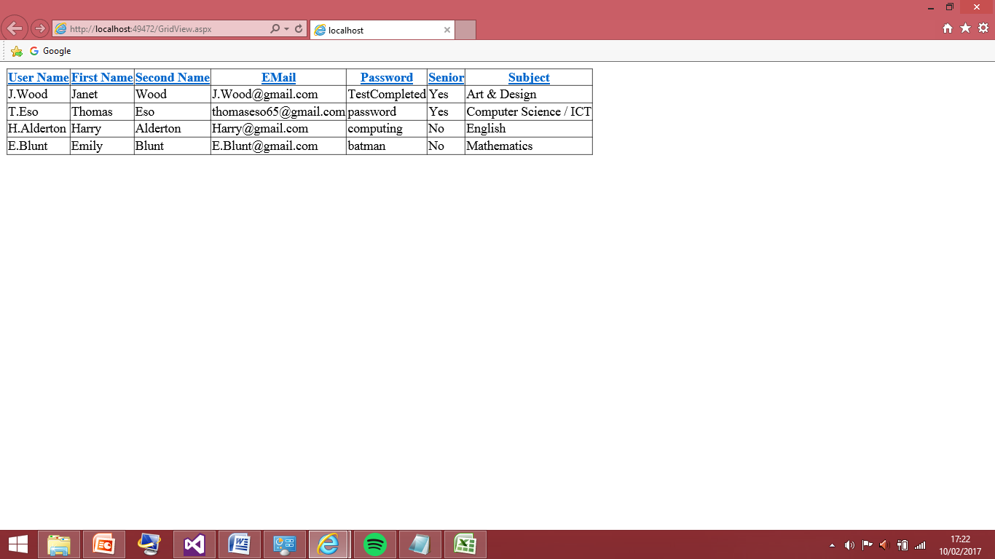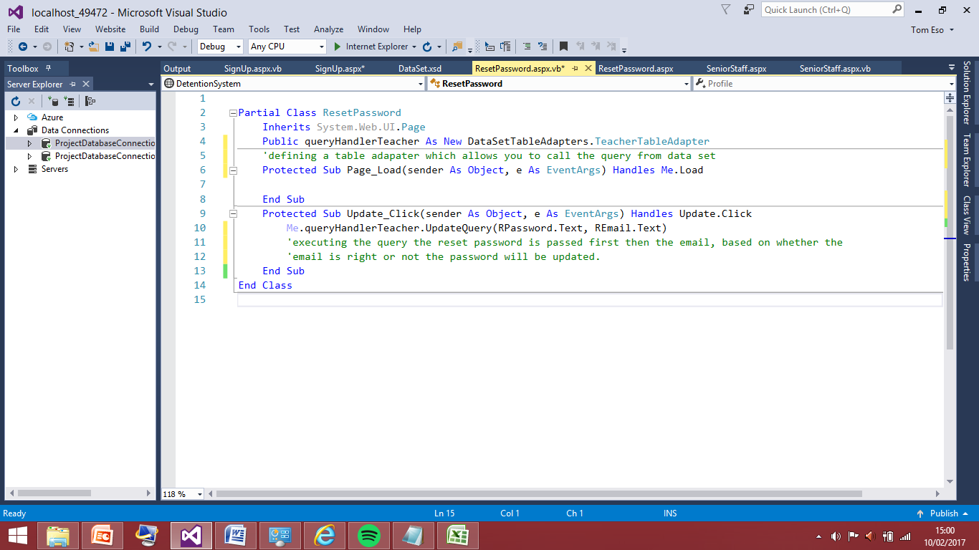This was a very straight forward thing to code for me as I have done this before in previous programs. I have added the executing statement into the sub for the reset button, as this should only be executed once the reset button is pressed. I will now test this for all the e-mail addressing changing all the passwords. Also changing the passwords I will have to unsure the log in works by trying the old password and making sure they are now invalid inputs as the password field has been updated with the new password.

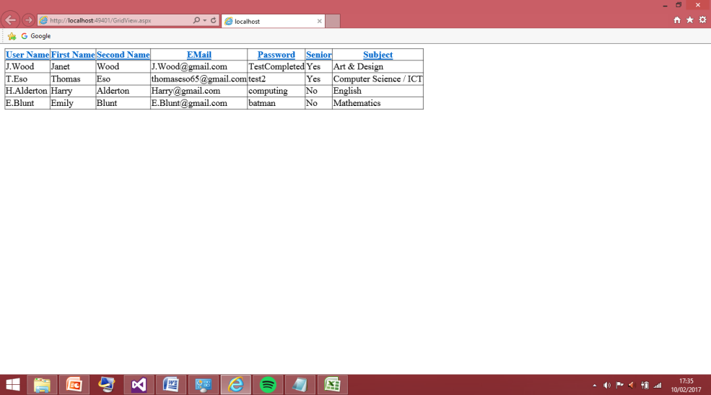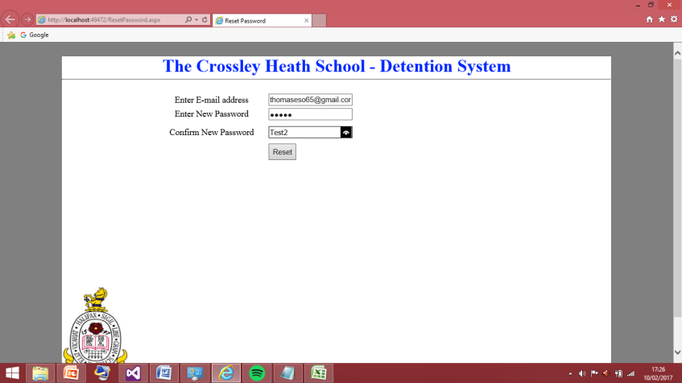This is what is currently in the grid view display. The password field has already been updated with the new password I put in for J.Wood when I tested the query earlier. I will now change the password in the T.Eso user name field to ‘Test2’. I am expecting this to work and I shall show the results in the by loading the grid view again in the website.

The screenshot to the left shows that I entered the new password as ‘test2’ after pressing the reset button and closing the browser. I then went to the grid view where I could see if this was updated in the database and the right shows that it is now been updated, this means my query now works as expected and I will now change the password would of the other fields to ensure they are working as expected as well.

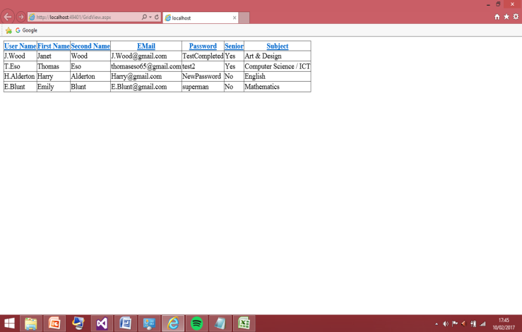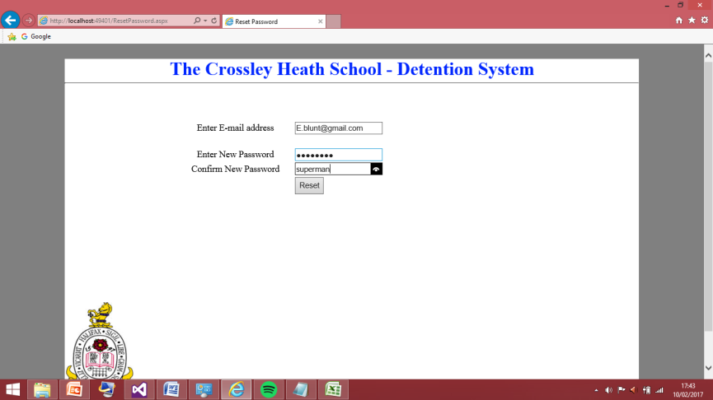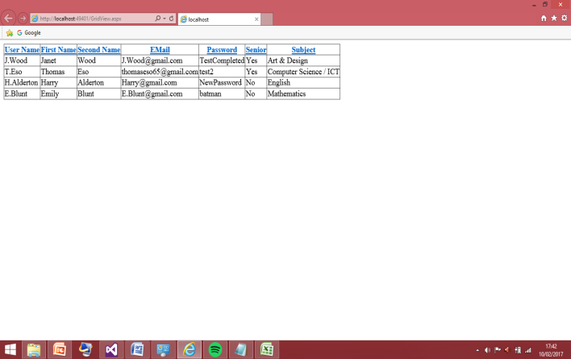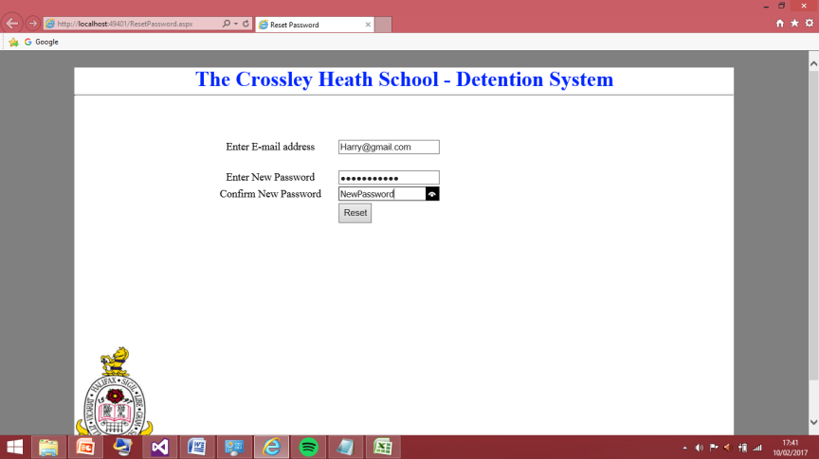This shows this test was successful for the H.Alderton username.

This shows this test was successful for the E.Blunt user name.

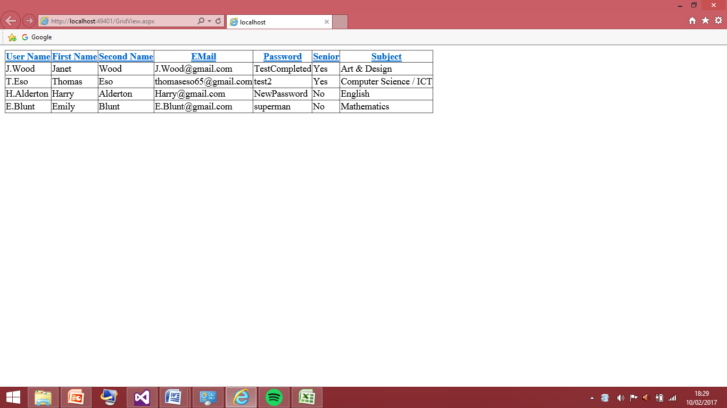I will now test the new password are now recognised in the login page by logging into each user like normal and I should be able to log straight into their respective senior member or no just normal teaching staff pages.

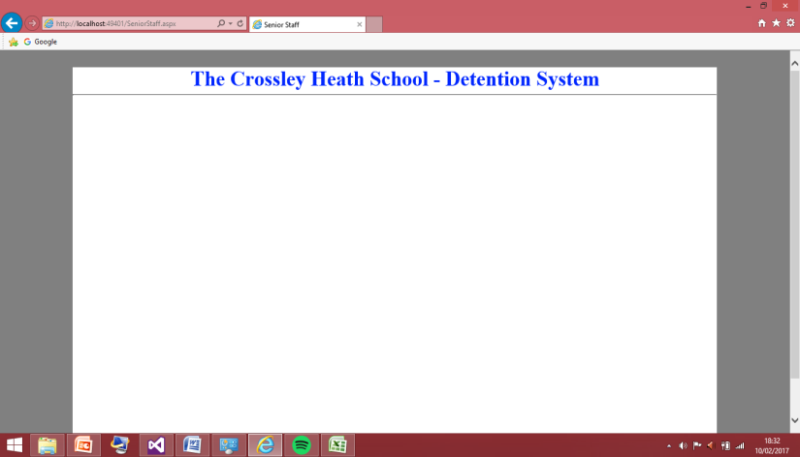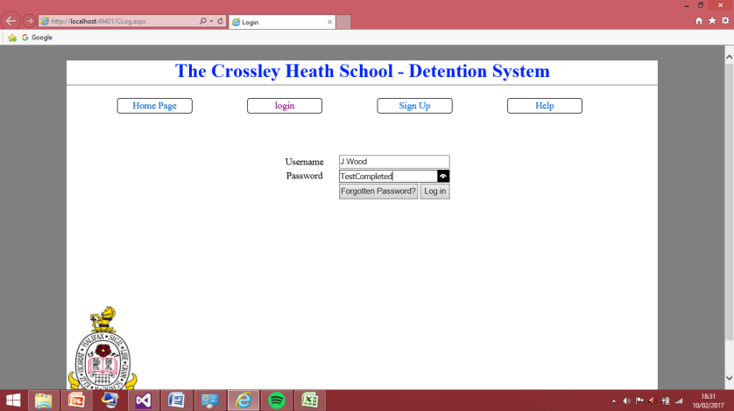These are all the username and password currently in the database I will work methodically down the rows and log in to them.

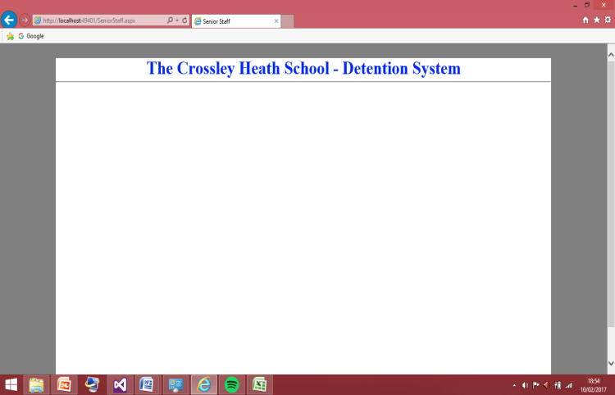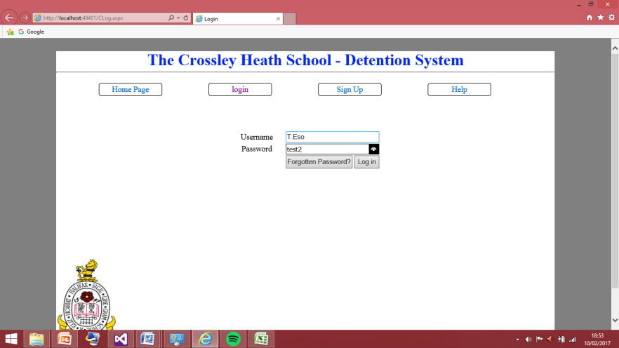This screenshot shows the login was successful with the new password. Just be sure I will be testing this login with the old password for all of their other users just to ensure there is no other password linked with an account as this could be a security risk.

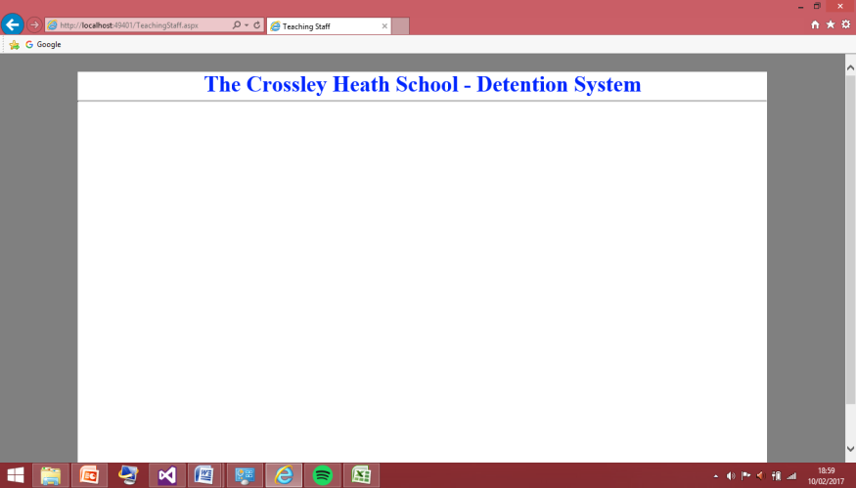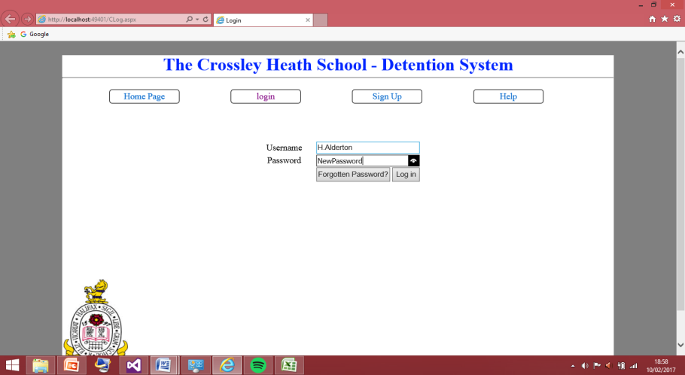These two screenshots show the test was successful for the username of T.Eso.

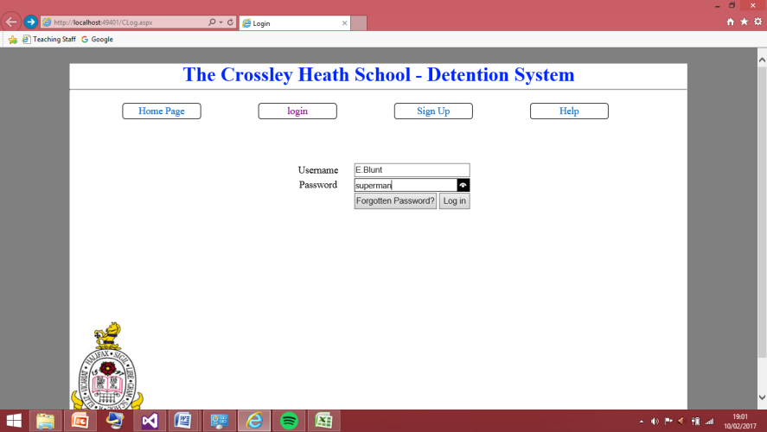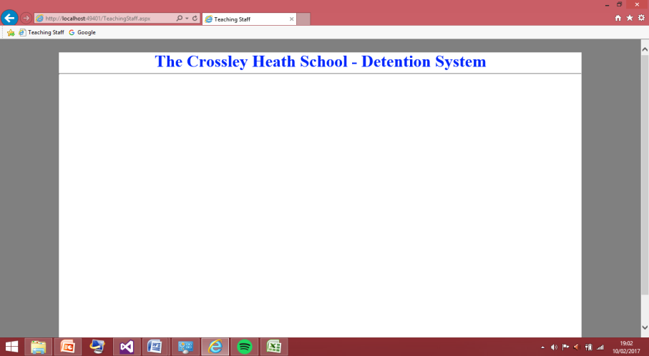These two screenshots show the test was successful for the username of H.Alderton

These two screenshots show the test was successful the last username on the list E.Blunt.

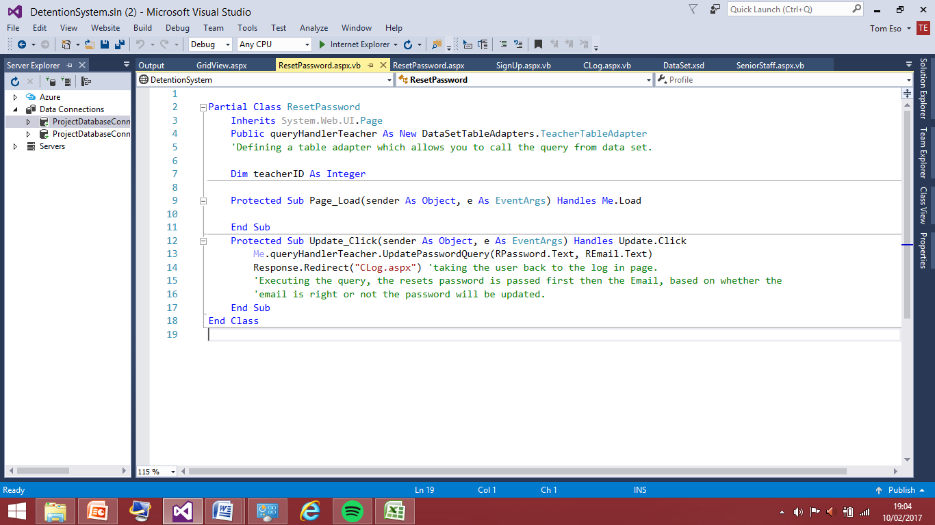

This is the fully finished code for the reset password page. Now I have fully tested this and updated the entire password I am now about to move on to another section of the program. This now marks the end of the home page, sign up, log and reset password of the program. Now I can move on to passing the sessions, and having the controls that I said I would try to achieve in the success criteria of the program within the detention system.

Passing Session:

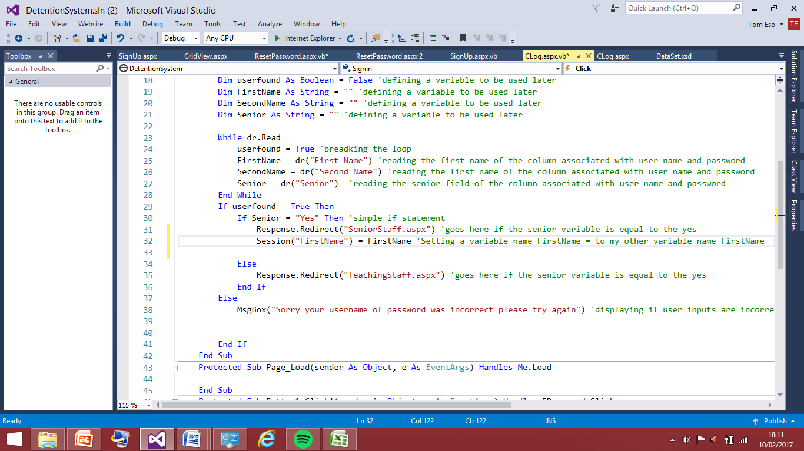Session passing has become important in my program because once the member of staff has logged in they are redirected to either the senior member of staff page or the teaching member of staff page. And within these pages this is where they will give out the detentions, but the program wouldn’t be very useful if it didn’t know what teacher was giving out what detention, therefore the session needs to be passed so the page can know what teacher the actions that are taking place fall under. So I will have this happen now, to do this it requires going back into the teaching log in section and adding bits of code to that.

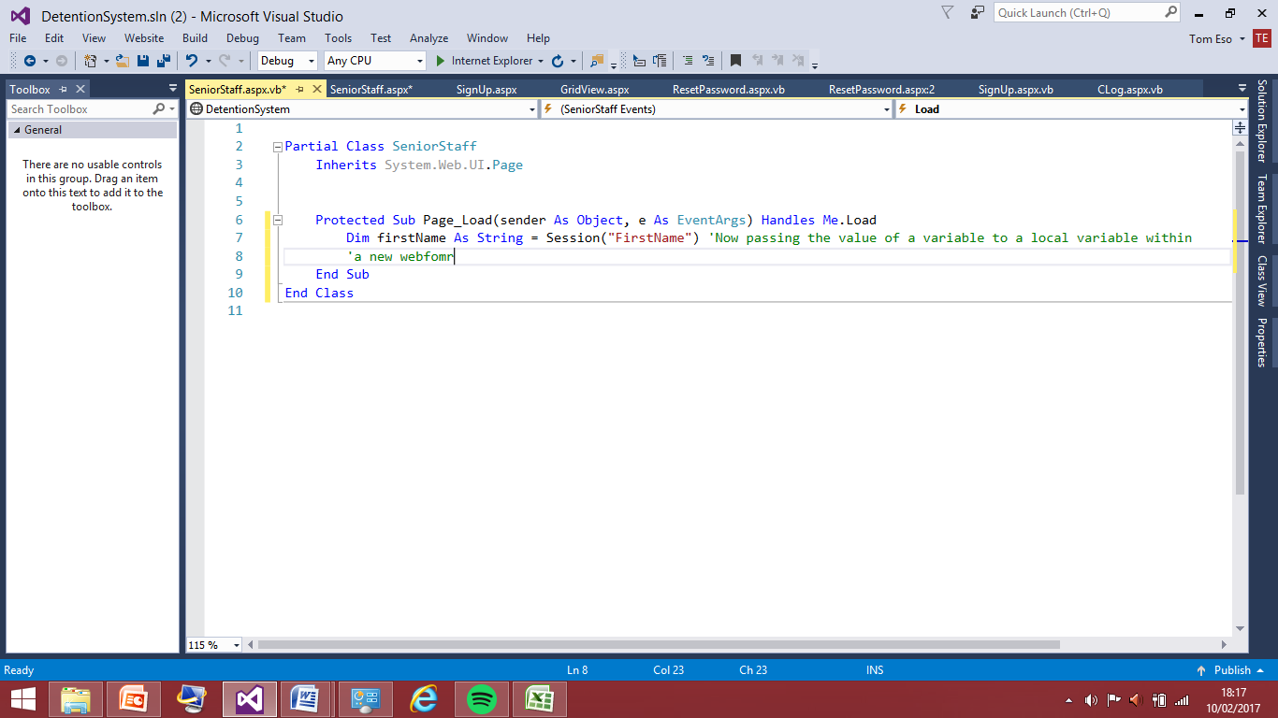I have added this line of code to the CLog page which is the log in page in the program. Here I am setting up my session variable to be passed into the program as FirstName that is the part in red this variable name is equal to the name of who ever logged in which I have already coded for it to be pulled from the database and it is stored under the variable name FirstName in black so this is now been passed to new variable that is awaiting to get passed to the senior member of staff page. I won’t waste time by adding the second names until I know it works so I will add the code for the session into the place where it is supposed to go and test that. If this works correctly I will then add the second name variable.

The line I have added to the senior staff page is very important this is because this is what provides the actual passing of the value of the variable. The session has allow me to take the first name variable from the Clog page and pass it to where it can be manipulated within the senior staff page. I will now this by adding a message box which will allow me to see that the session passing has 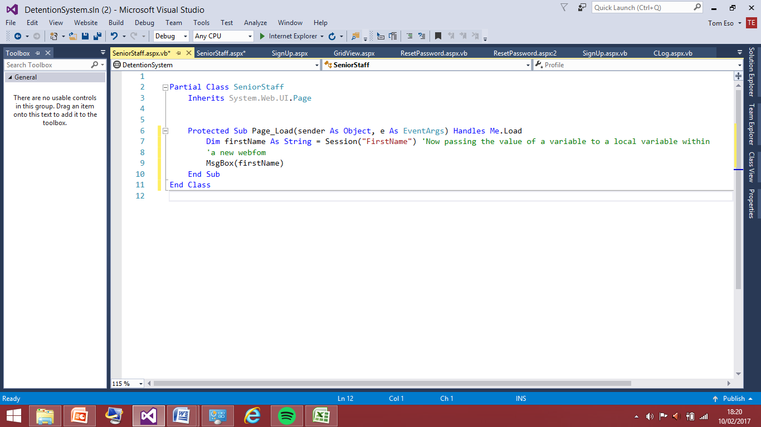worked as expecting.

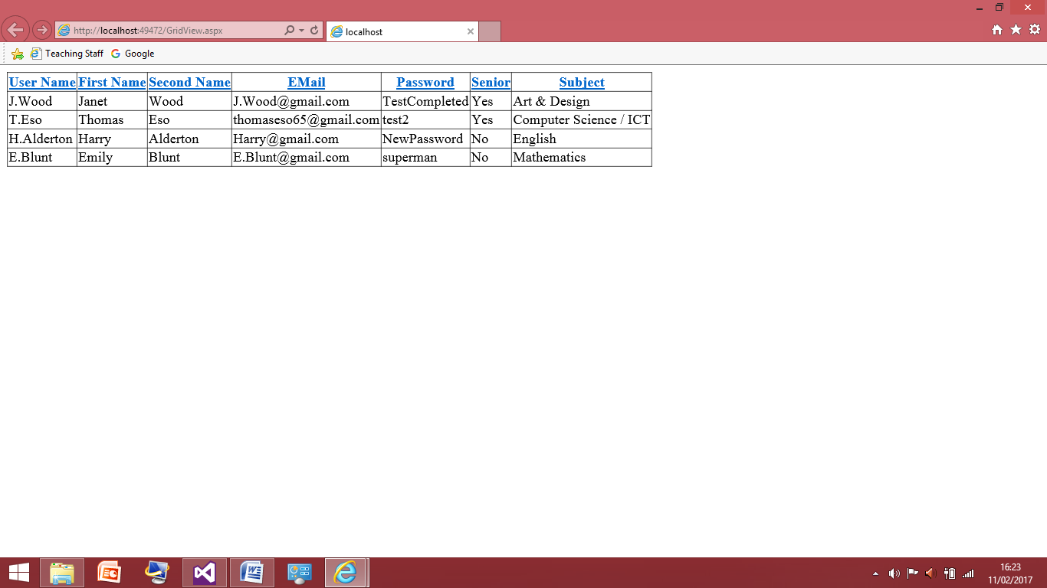This is the code I am now testing in order for this to work I will have to use a user that has the senior member of staff priority as I have no coded this for the teaching staff if this all works correctly I will go to the senior member of staff page then it will produce a box sating who’s name it is, hence forth verifying the page knows who has signed in. I will first test this for J.Wood as this user is a senior member of staff therefore it should work for this user.

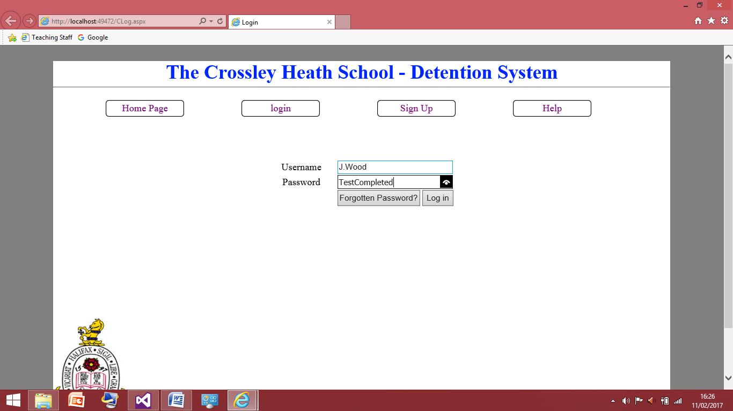This is what is currently in the grid view database all the new passwords are updated as well.

This screenshot shows I am currently trying this for the username, I will press login now and see what happens.

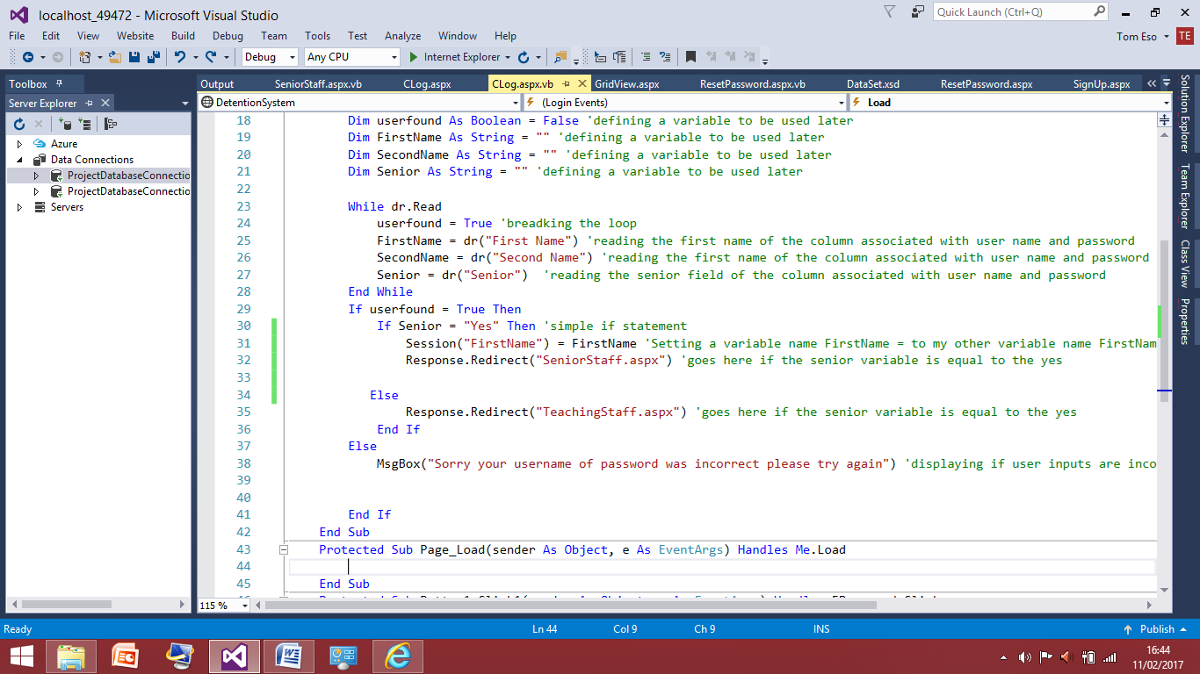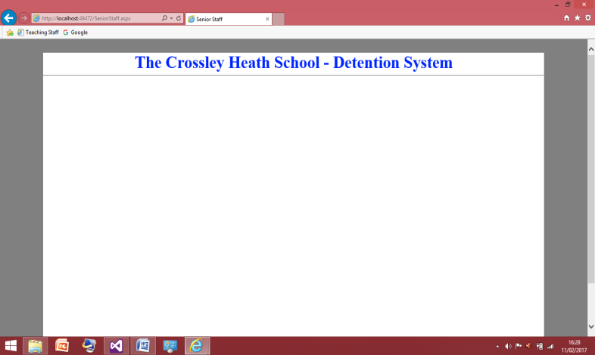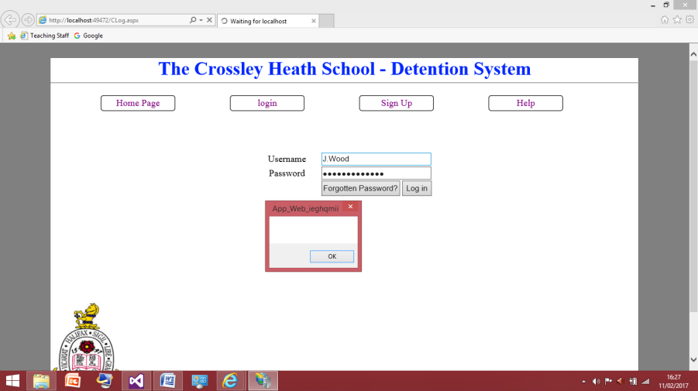The screenshot to the right shows the test was not successful, there seems to be two problems. The message box does display the name the first name is Janet so Janet should be displayed the box. Also the message box was displayed on the login page. This is not what I want to happen, the program needs to move to the senior log in page then display the text box, therefore there must be something wrong with the order of the code, I shall sort this out first and test this again.

At this moment I am not too sure where the error is coming from but I have decided to switch these two lines around and see what happens when I now run the code after.

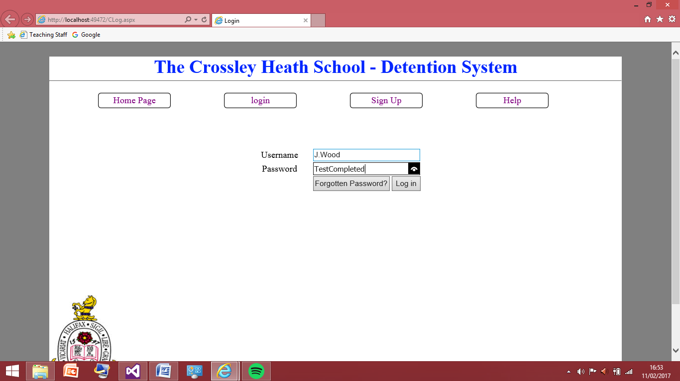

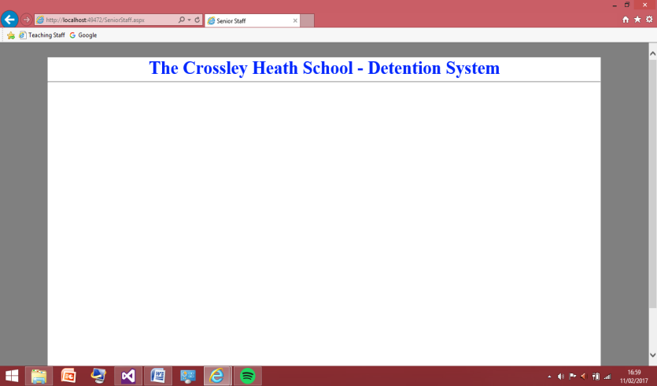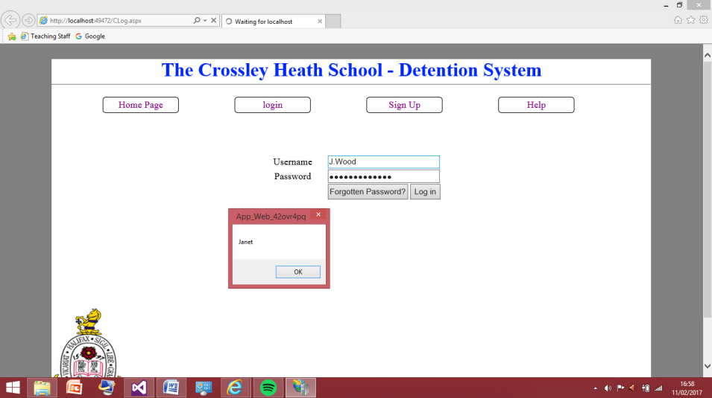I am retesting the J.Wood username again.

This test wasn’t successful but it did fix a problem but not the problem I was hoping it would fix. The screenshot to the right shows the textbox is now displaying the right name; however the same problem happened again I was only redirected to the page after pressing ok. However I have thought about it and this may not be an actual problem as I can get rid of the message box and have a button on the senior staff that once pressed it produces the message this is how I will prove the variables have been passed.

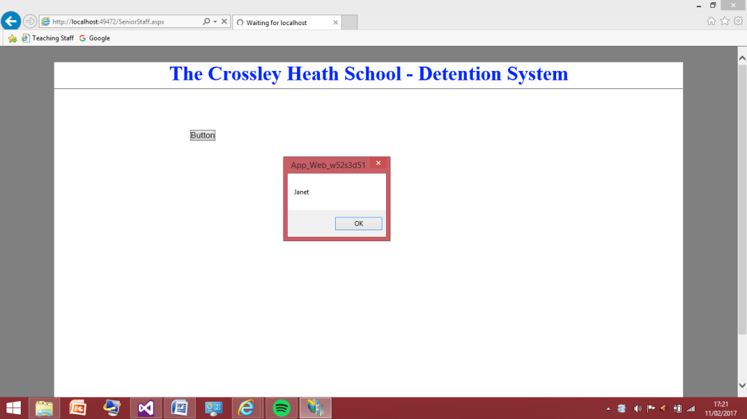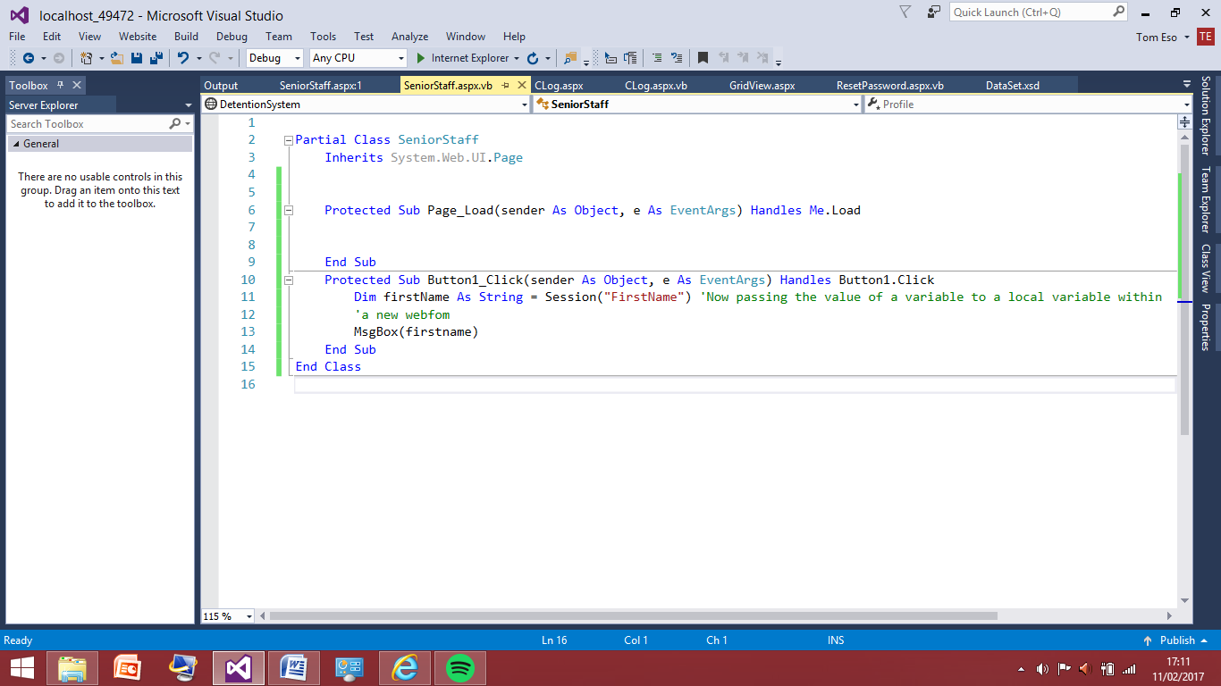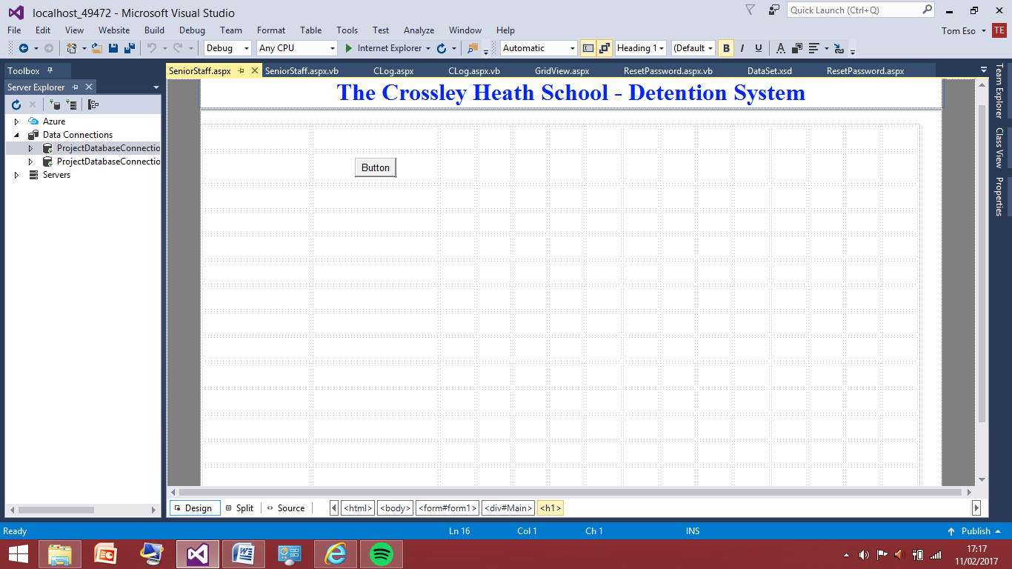This is now the new code I have edited I have added the button to the senior web form once I pressed it the message box with Janet should be displayed on the screen.

This screenshot shows the test was successful therefore I now know the value to the variable is passed successfully I will now add the surname to the code in the log in page. Alongside this I will have to add this to the teaching staff form so passing variable works for the teaching staff as well.

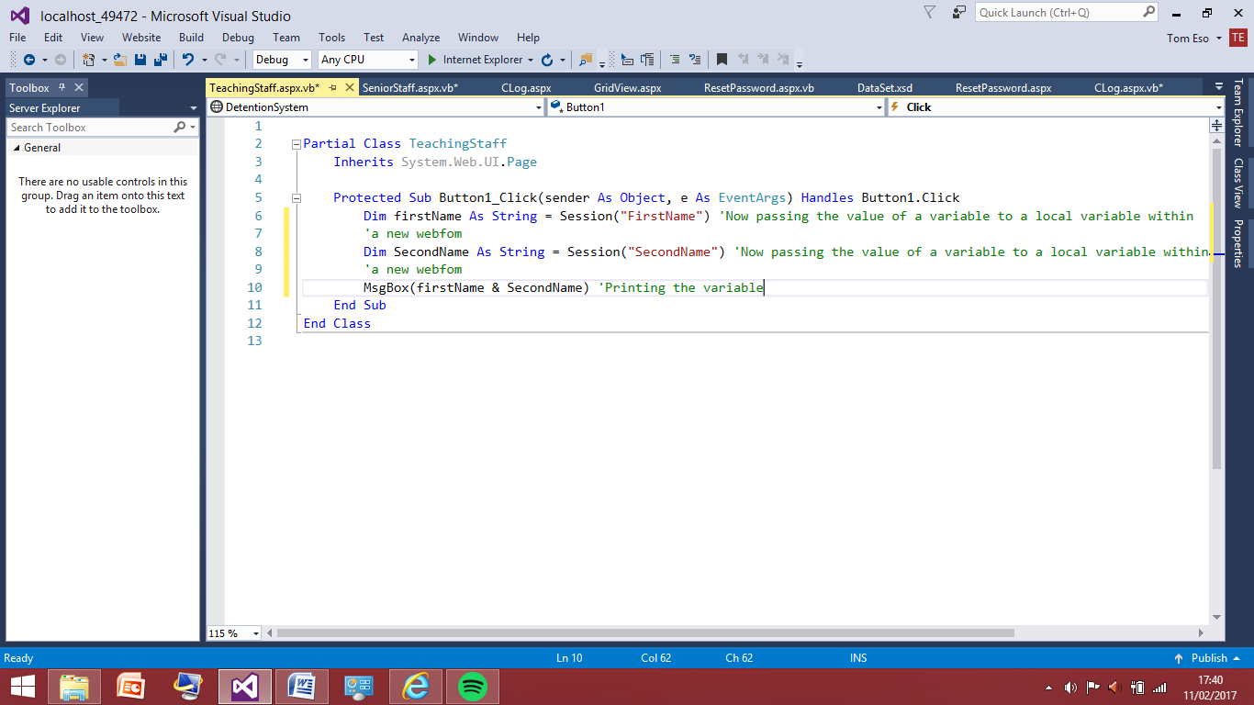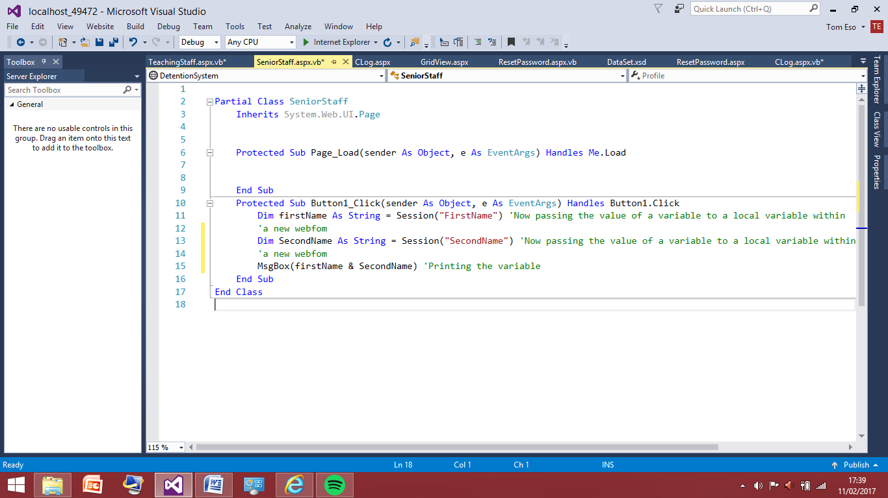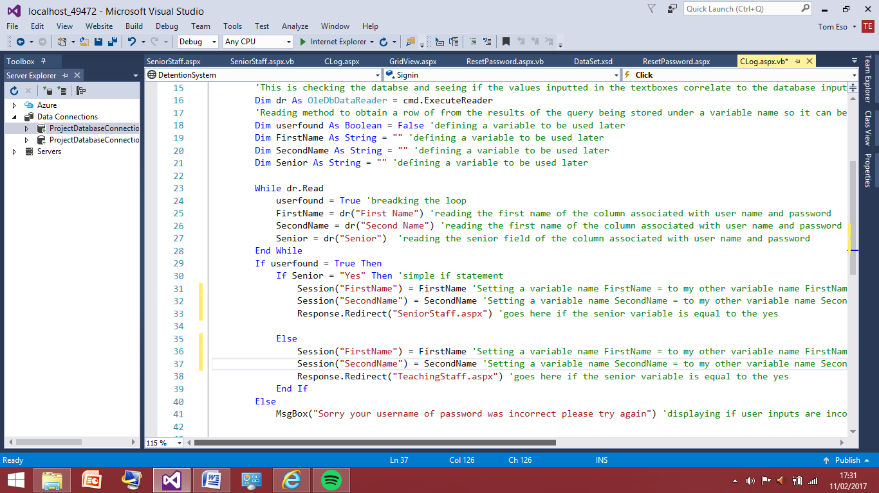This shows how I have now added the extra code which will allow the second name to passed and allow it to be passed to the teaching staff page. This may be adapted later on if I find I need other information to pass such as the ID of the teacher.

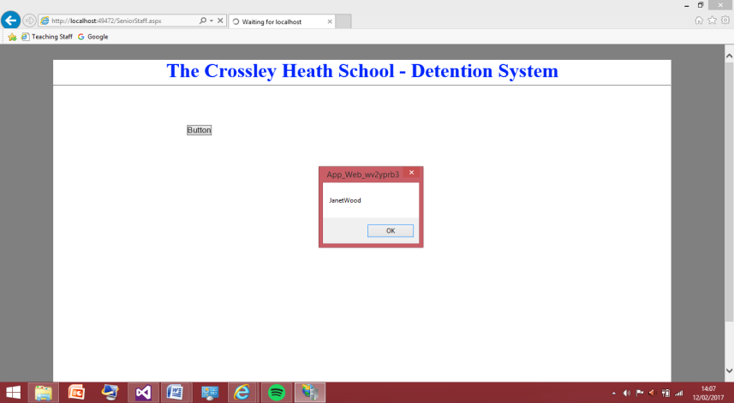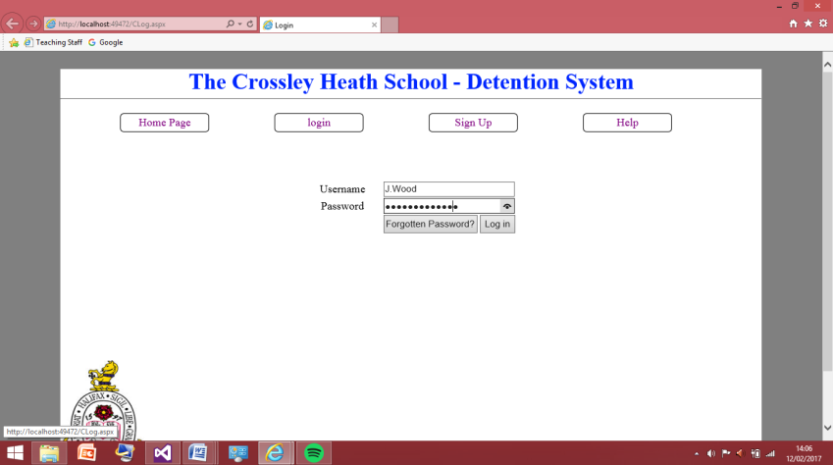These two screenshots are the codes on the pages of teaching staff and senior staffs are identical as they both involve passing the same variable but to different pages. In order to pass the second name it was very straight forward as it was same code but I will now test this for all 4 users currently in my database.

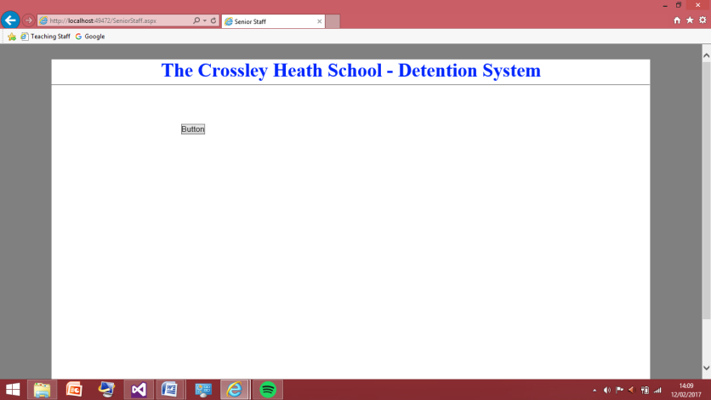These 3 screenshots show the test was successful as the first name and second name for Janet Wood were displayed once the button was pressed and this was on a senior staff page which this user is.

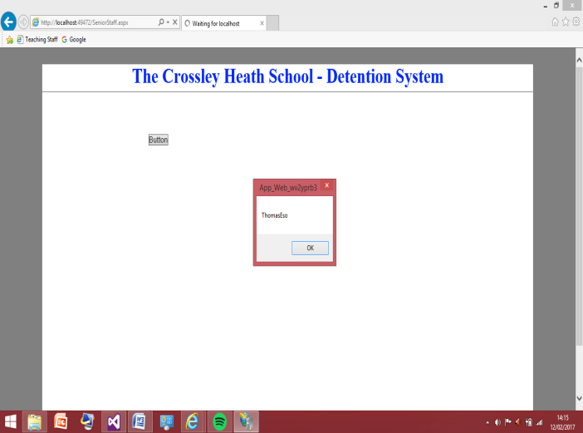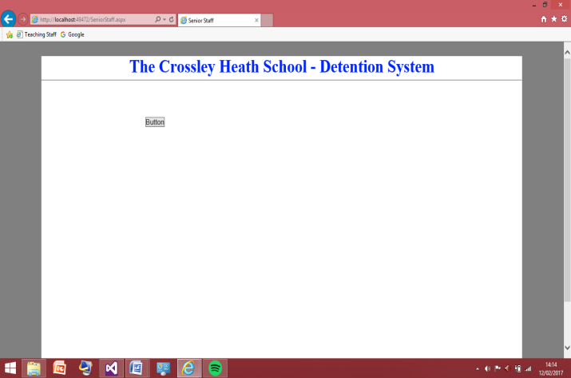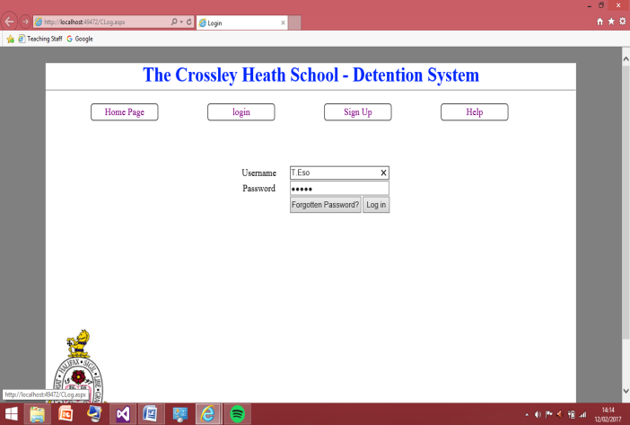

These 3 screenshots show the test was successful as the first name and second name for Thomas Eso were displayed once the button was pressed and this was on the senior staff page which this user is.

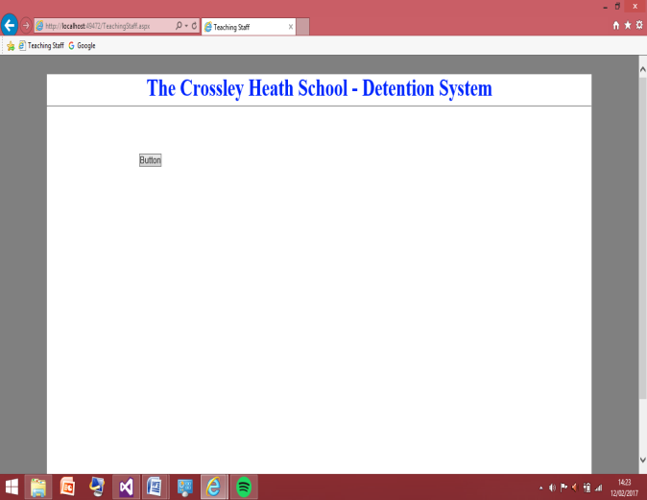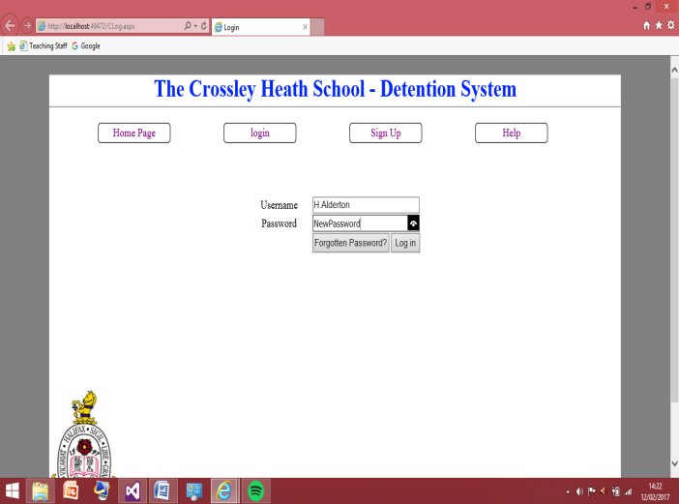

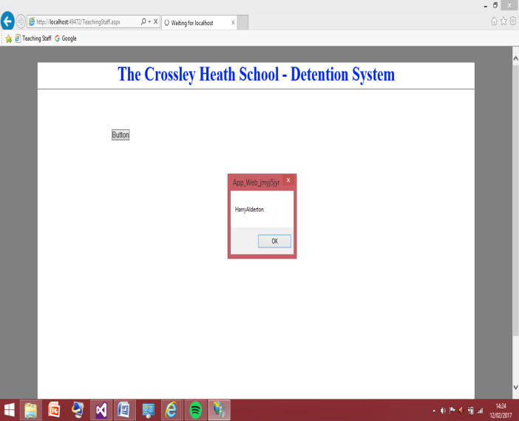

These 3 screenshots show the test was successful as the first name and second name for Harry Alderton were displayed once the button was pressed and this was on the Teaching staff page which this user is.

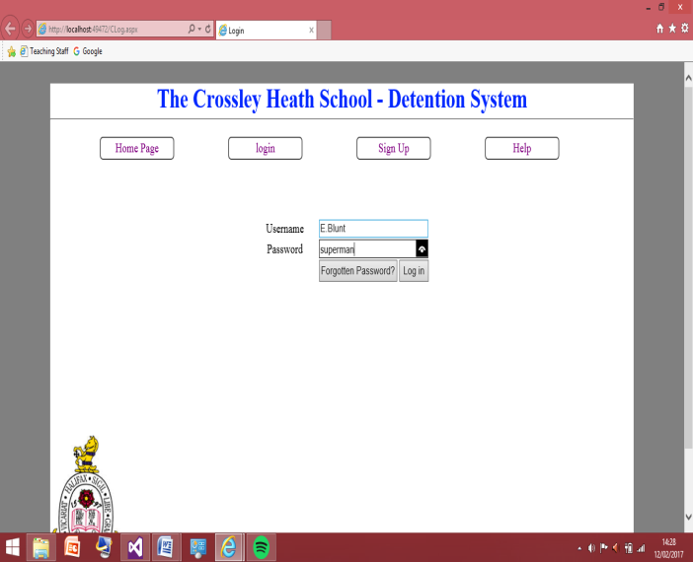

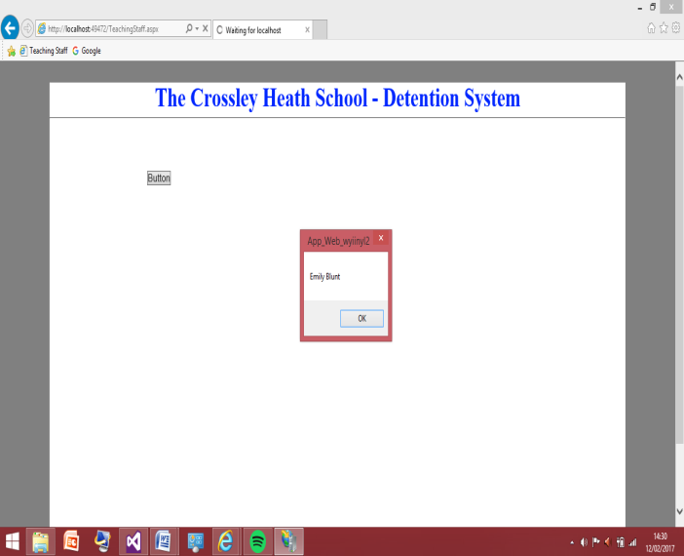

These 3 screenshots show the test was successful as the first name and second name for Emily Blunt were displayed once the button was pressed and this was on the Teaching staff page which this user is.

This now shows I can pass the session for all the users in my database. This means I can now move on to actually having the user log the detentions, I will start with the teaching staff page as there controls are less so I can complete this quicker before moving onto the senior member of staff. Passing session was important because the program needs to know what teacher is giving out what detention. I will now move onto the teaching staff page designing and functionality. Also the code for passing the sessions will not be there now as I only had that code in to check that passing sessions did work effectively.

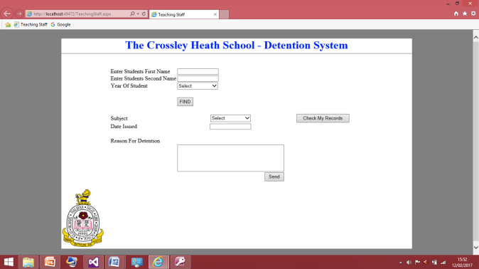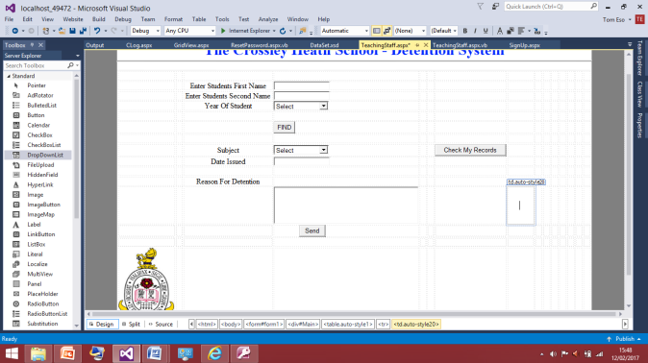 Teaching Staff:

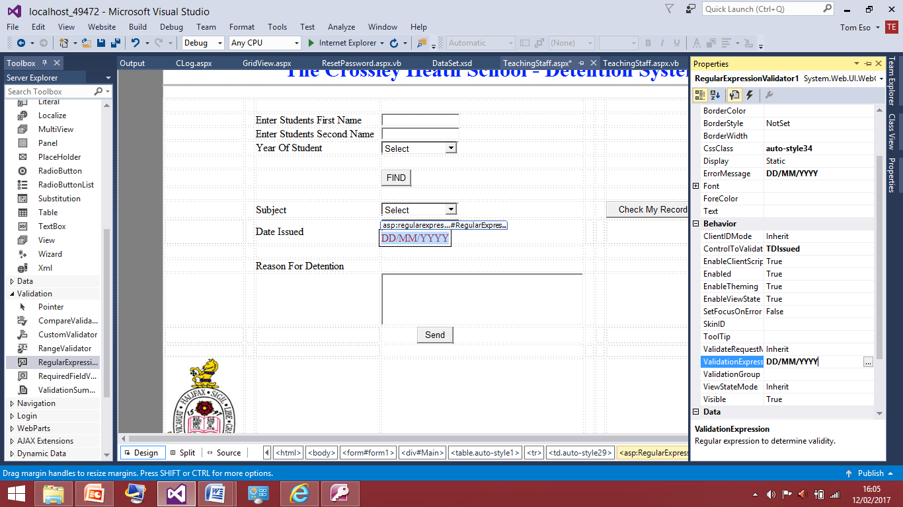These two screenshots show the design for the teaching page for the staff member once they have logged in. They have a clear illustration of fields they can fill in and they have an option to see their own detentions. The way in which this will work is that, the teacher inputs the student’s first name, second name and year they are in. I have added a validation to the year they’re in to restrict their inputs to what I want them to be. Because some teacher may just write ‘8’ of ‘eight’ or ‘year 8’ so I have restricted this to just the number therefore it makes it easier to query the database also this keeps the database looking consistent. The teacher once they have inputted this information will press ‘find’ this ‘find’ button will produce a message saying student found or student not found. The find button will query a table with all the names of the students in year 7 -11 looking for the student that matches the criteria as a detention cannot be given to a student who isn’t in the database. The teacher then will add the subject the student is receiving the detention for; I have added this in the case of supply teachers who teach various subjects therefore I couldn’t just query the subject the teaching member signed up for as they maybe covering a different subject. After this the teacher will have to enter the date which will have a regular expression validate and alongside this they may have a comment box to give a brief reason why the detention was given out.

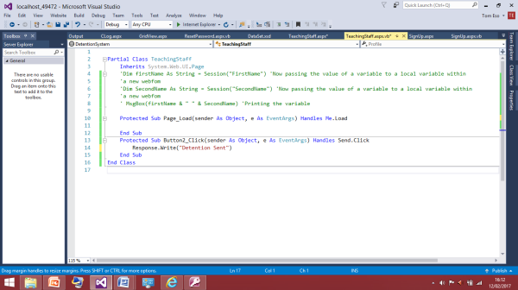I have now added the regular expression this expression only allows the data to be inputted DD/MM/YYYY. I will add a response to the send button to check that this data regulator works correctly. This is another form that I am restricting what the user can input, just so the consistency of the database. I’ll sign in on the Harry Alderton account as this is the teaching account and not a senior one so I will be taken to this page where I can check the date issued validation is working correctly.

I have now added this to the send button sub. This message will be displayed is the date is entered correctly. If not the validation error message will pop up. The detention won’t be logged anywhere as I have not connected it to the database.

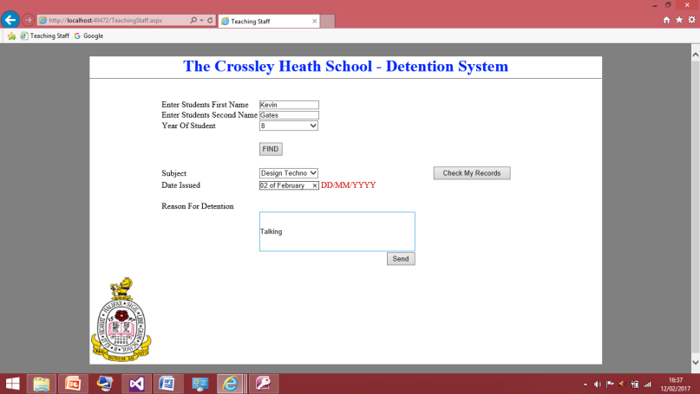This screenshot shows the validation works as expected it reads the message in this test box is not in the format it is validated too. I will now write it in the right format and the validation message should disappear and a message at the top of page should say ‘detention logged’

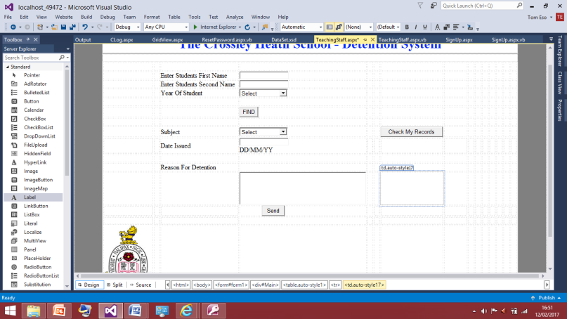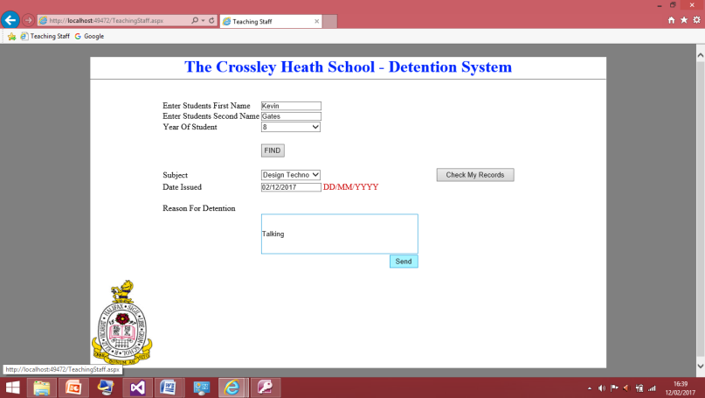This screenshot shows the test wasn’t successful, the validation message still appeared and the message saying the detention was logged didn’t appear even though have inputted the data correctly. Therefore I will need to go back to my code and look for try another way of doing this or correcting how it’s done.

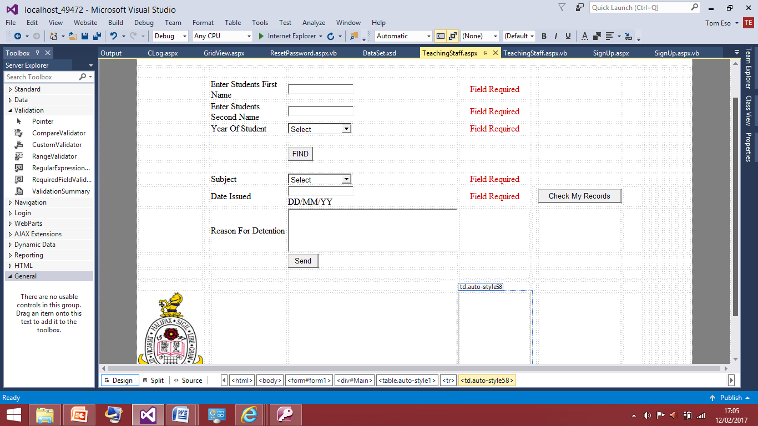After some time I was unable to find the source of the problem so instead of validation I have added a label to let the user know what format the date should be entered in. Later if I have time I could always come back to this and put in a proper validation that restricts them from putting anything else in. I will now add a required field validation for all the textboxes as to log the detention properly all the boxes need to be filled so I will add those and test those before I make the table required in Microsoft access that allows for this data to be stored.

This screenshot shows the field validation I have put into the program. There is one for ever box apart from the reason for the detention, as the reason isn’t important to my program as my program is focusing on the amount of detentions and not the reason. However during my review of this section I can ask my client if He finds it necessary to have this field required and based on what he says I shall change it accordingly. Now I will test the field validations purposefully leaving out fields and once all the fields are filled I should get a message saying the ‘detentions logged’

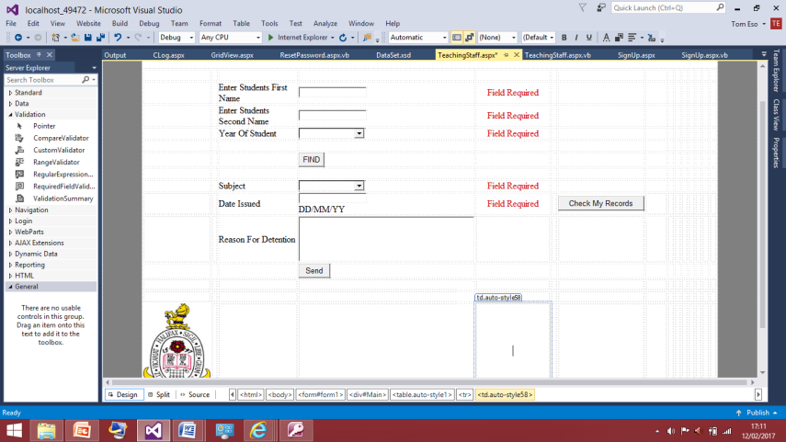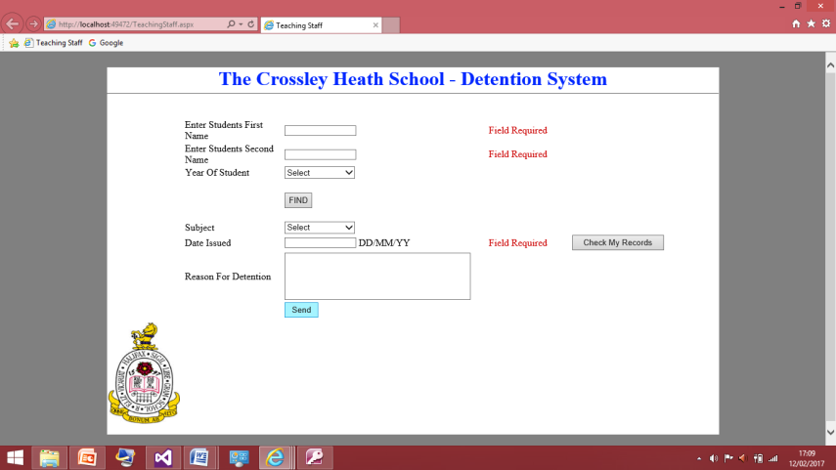Without filling anything in I pressed send to check that the all validations appeared and this screenshot shows it hasn’t. This is because the program registers select as an input therefore I will get rid of this option and just have a black box for the drop down lists.

This screenshot shows how I have updated the drop down boxes to have blanks in their initial state. Therefore I will test this again and all the field validations should appear.

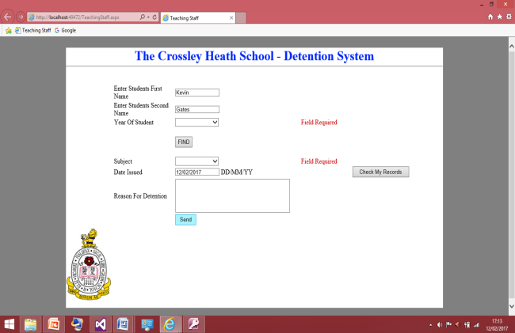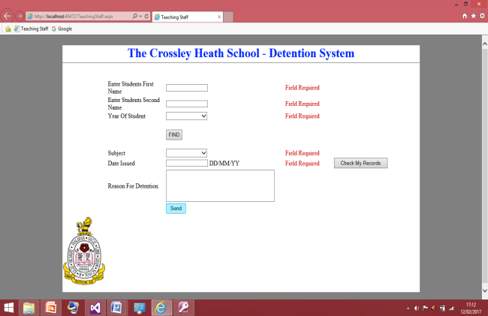

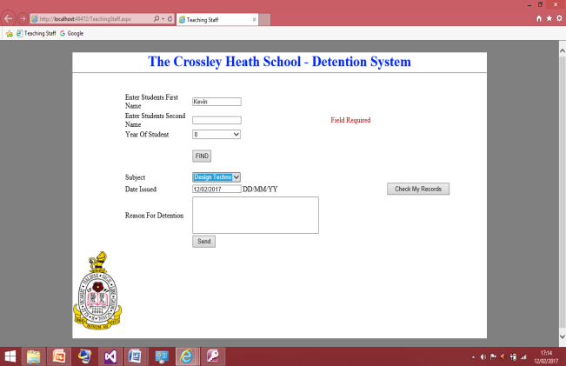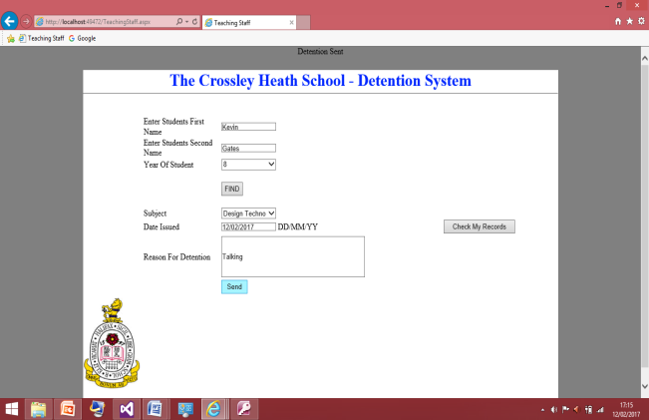

These screenshots show the validations are now working correctly and the detention logged works properly as the message was produced properly at the top of the page. I will now design the table to find for teacher I will enter 3 students for the year as I do not have the schools database of all the students. Therefore this some things that would be part of the school maintenance to sort out the links with the database once I pass the program on to them as I am just replicating what situation the program will work in. Once the program is made this will change the program link to one with 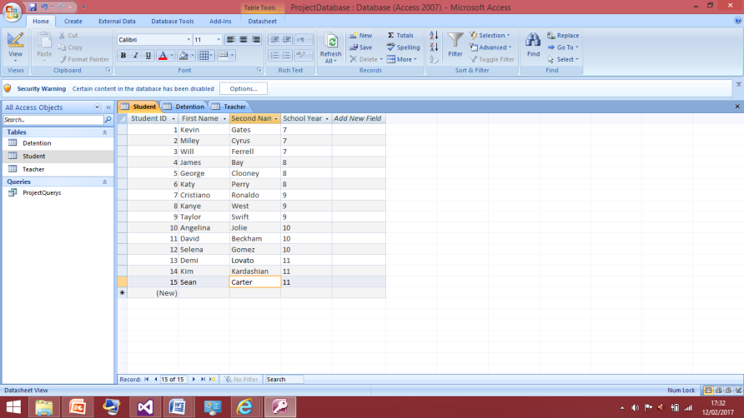the actual database with the students names.

This is the table I have created for the students in each year. They all have first names and last names this how the teacher will know they have inputted the name correctly once the find button is pressed it will query this table and produce a message box saying student found or not just to make sure the teacher has no spelling mistakes in the name or have got the year of the student wrong. This just help get rid of any data redundancy within the table. As this is simpler code to the log in code this should be straight forward to code in to the find button.

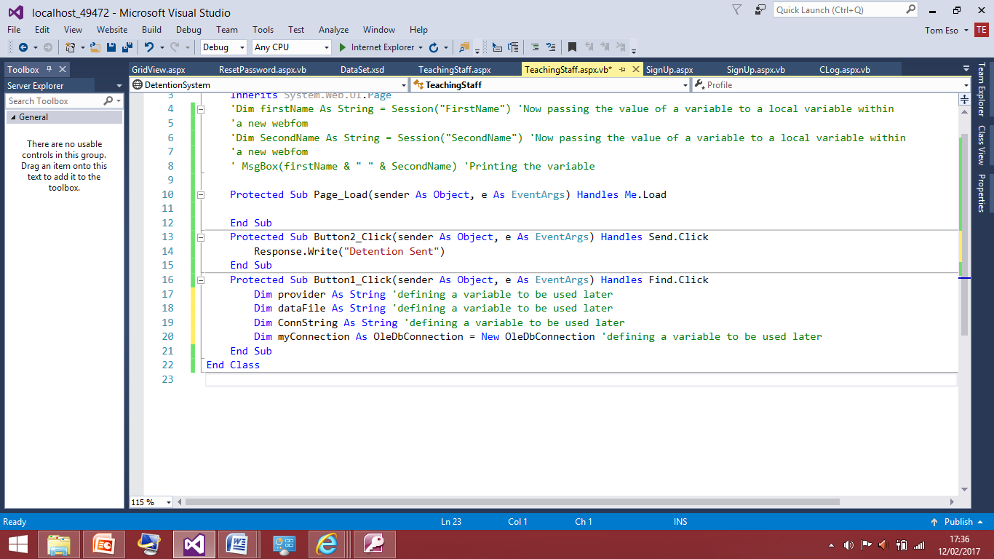I am now working in the sub of the find button. I have defined these variables within the function instead of making it a global variable because as I will be doing an update query later on for the send button I don’t want to confuse myself in the coding so I will declares these again in that sub.

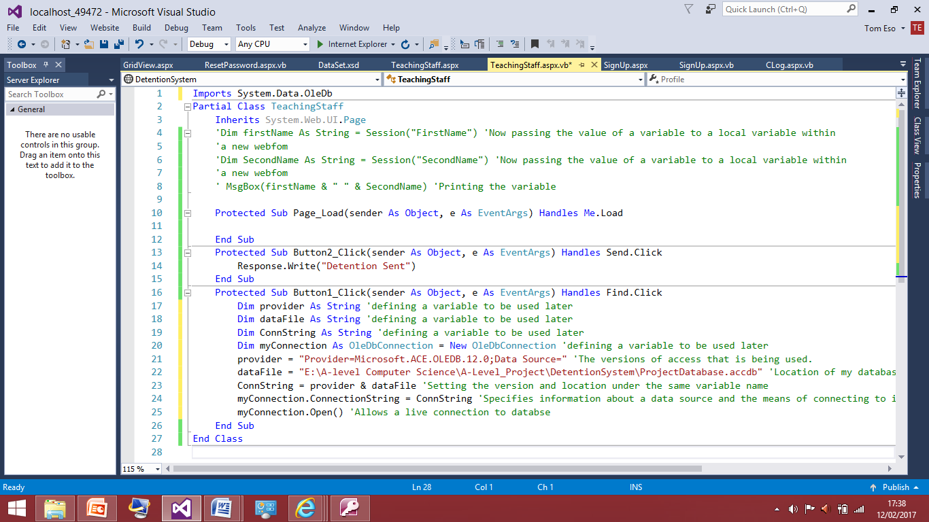

The lines of code added now are the same as the one from the log in page as nothing is different yet so I know this works correctly.

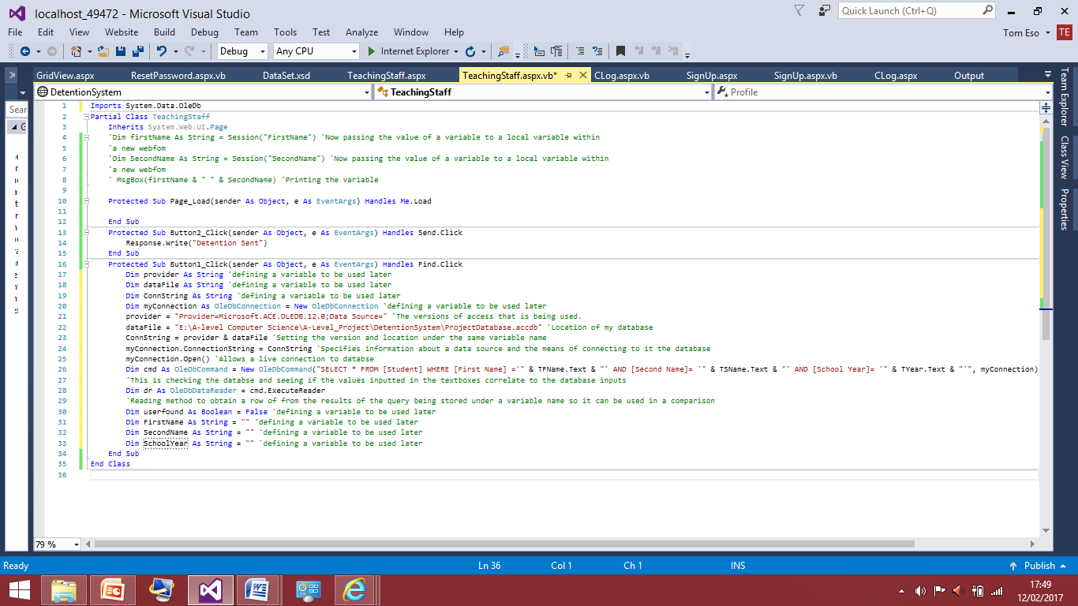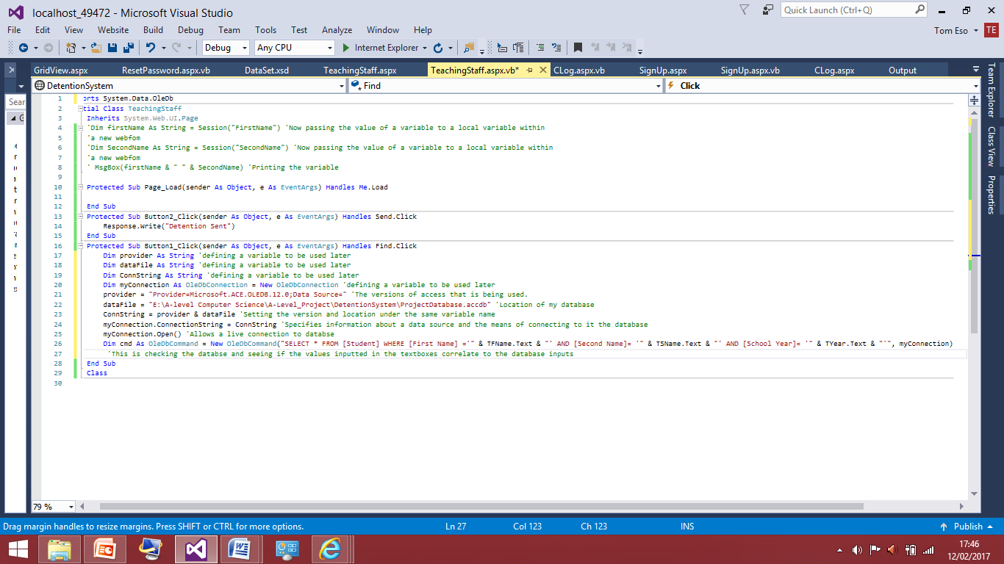The line I had added here is now adapted to this page as I am checking the inputting in the textboxes is all equal to one field in the student table now. This was taken from the log in page and adapted to suit this new need.

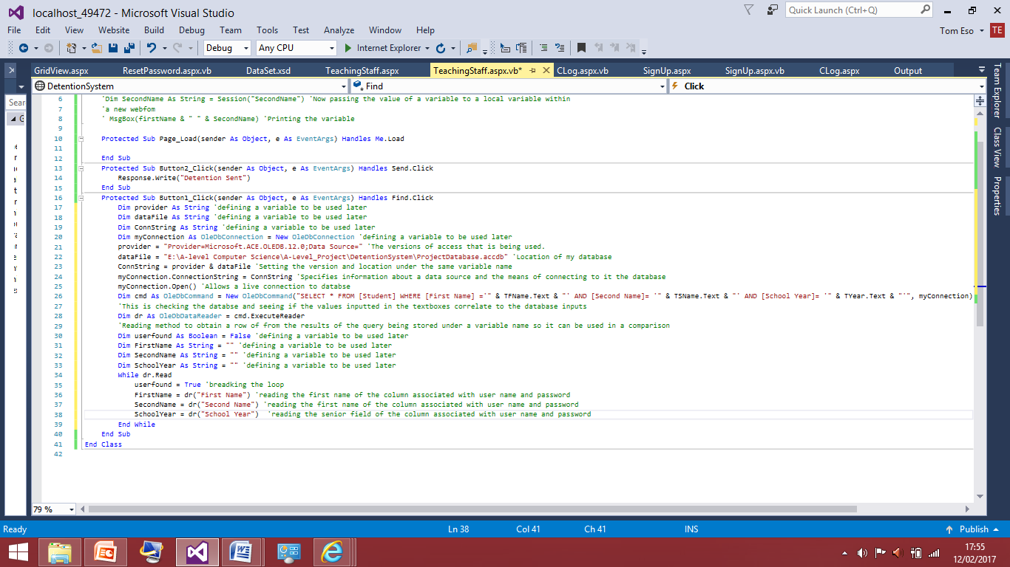I have now added the variables it is getting from the database and this allows me to make the comparison between the inputs and the database. This is also copied from the log in page but the 3rd variable is now school year instead senior.

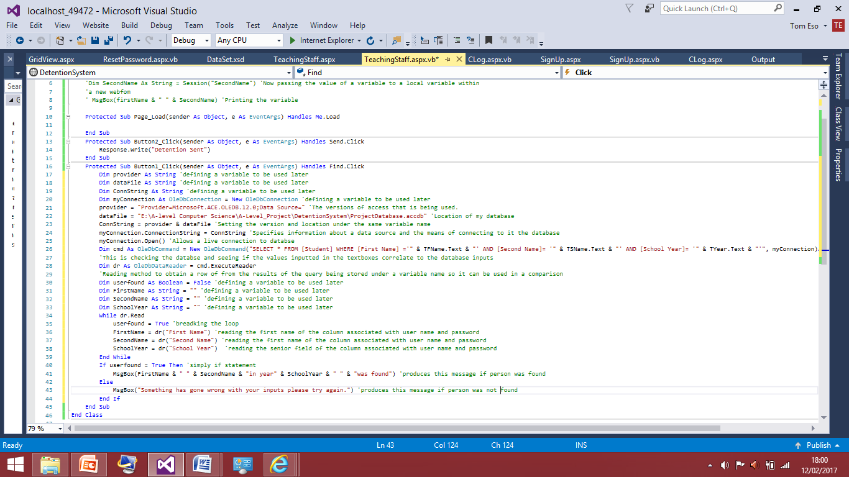The new section added is also from the log in page just with the variable change for the school year next I will add the ‘if statement’ to produce the message about whether the student was found or not.

I have now added the ‘if statement’ based on whether the user is found they will be asked to try again or be told the person was found therefore they can carry on filling out the form. I will now test this for some students currently in the database, to ensure this works correctly before I move on.

These are the inputs currently in the database I will first try search for George Clooney.

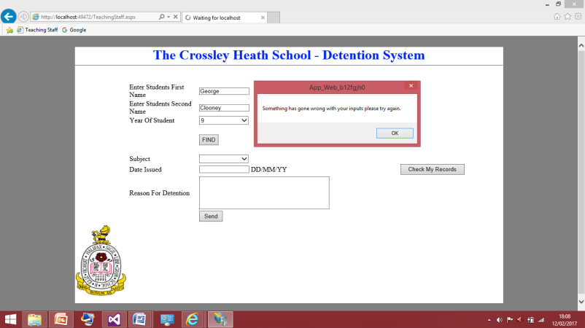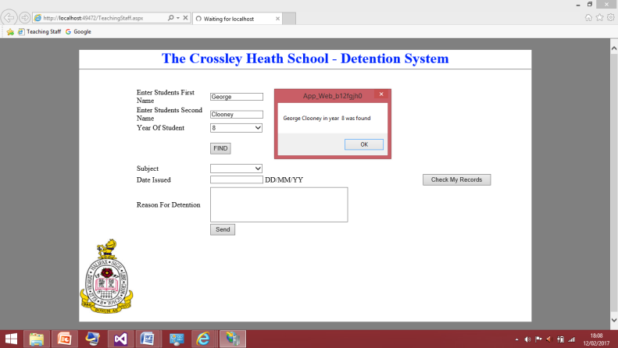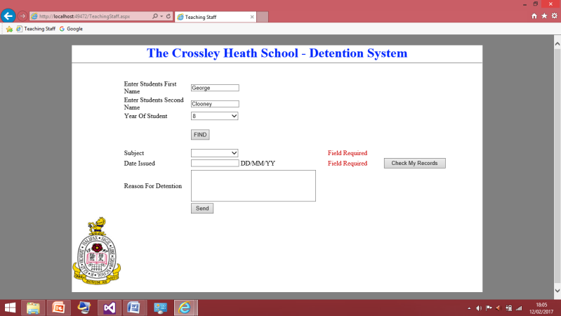During this test I saw I was not able to program find the person without having all the fields filled but realistically the teacher wouldn’t fill all the fields in the find the student as that is a waste of time if they have inputted the student in the wrong or. To get passed this I have removed the field required validations for these two text boxes.

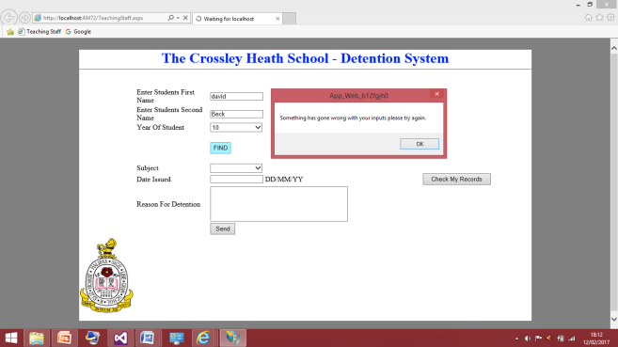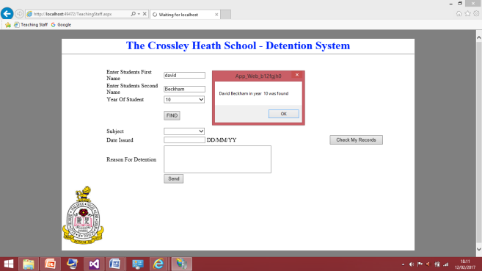These two screenshots show the code works correctly as I typed the details in for the student appropriately on the screenshot to the left and this proves it was able to find the person. Then when I changed the year so I’d have an incorrect field the program produced the error message saying it was unable to find the student which was correct. I will now test this for 3 other random fields to prove that this works correctly for various inputs.

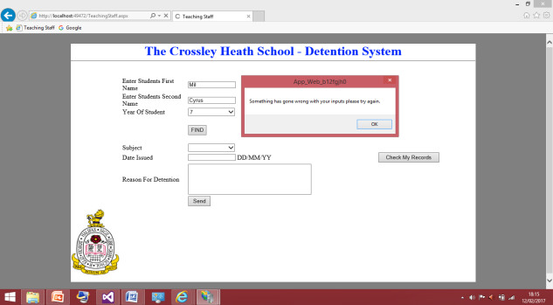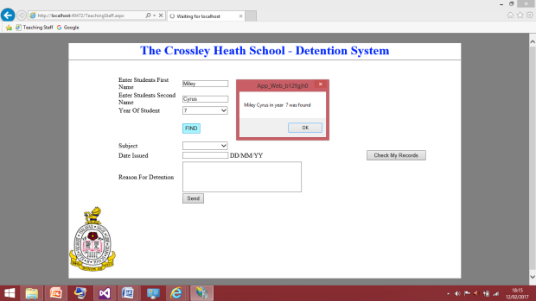These screenshots show the code work correctly for the field of ‘David Beckham’ to make the information purposefully incorrect in this I changed his last name and the program was right in not being able to find this user.

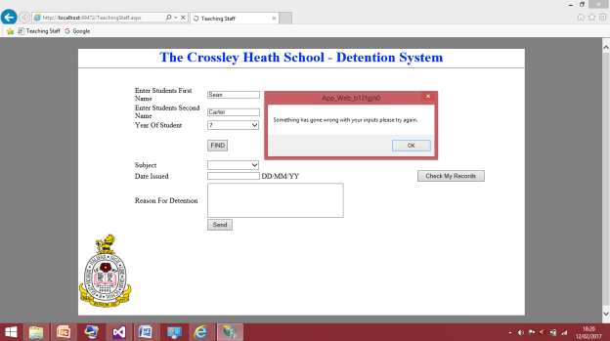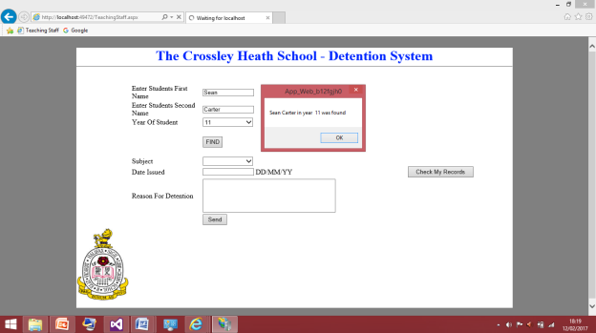These screenshots show the code work correctly for the field of ‘Miley Cyrus

These screenshots show the code work correctly for the field of ‘Sean Carter’

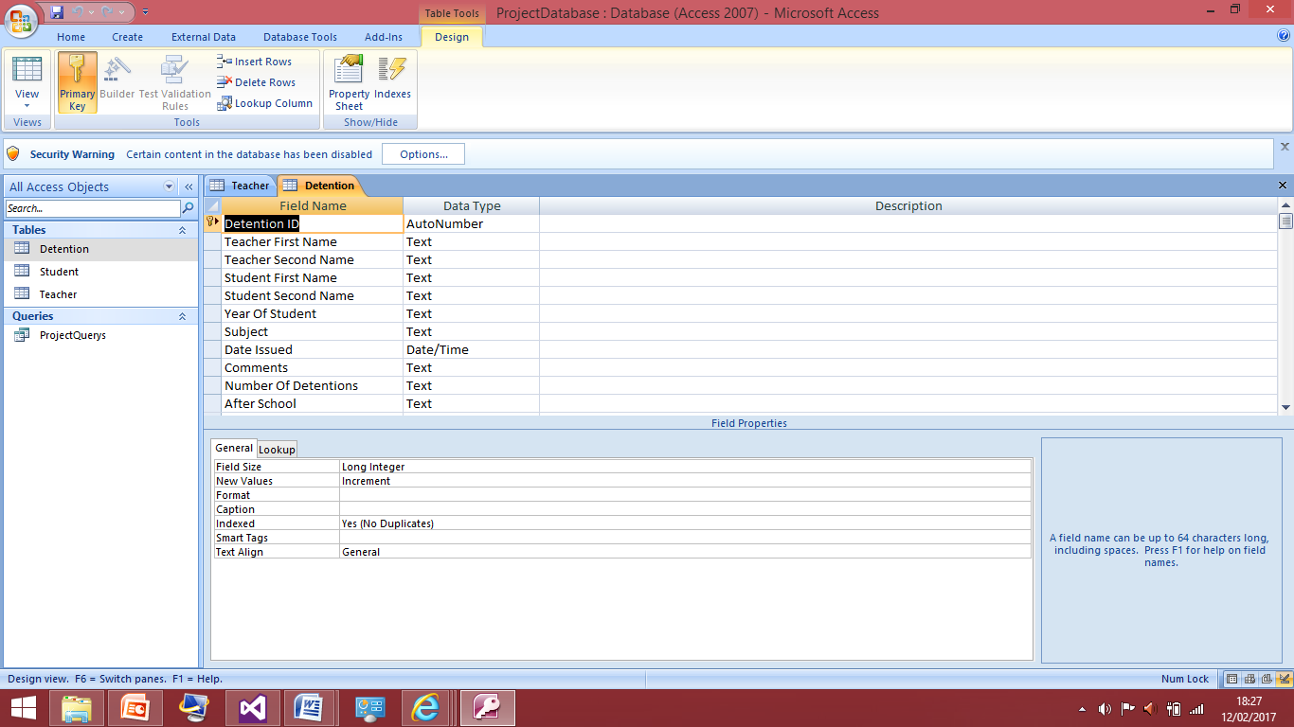Now I know the ‘find’ button works correctly I will now put an insert query into the send button which will allow me to take the information from all these text boxes and save them into a table where normal teachers can see and the senior staff can see. However I first need to design and explain the table I am about to create.

This table is the table there are more fields here that in the page but this is how it needs to be. I have first got the teaching first name and last name because senior member of staff need be able to see which teacher gave out which detention from each student, this information comes from the passing the session I did earlier so that’s how the table will know what teacher it is. Also this is for senior members to know what teacher gave out the detention and when I want to query this table to produce the history for the student it will be queried based of their name therefore they won’t receive any other teacher detention history

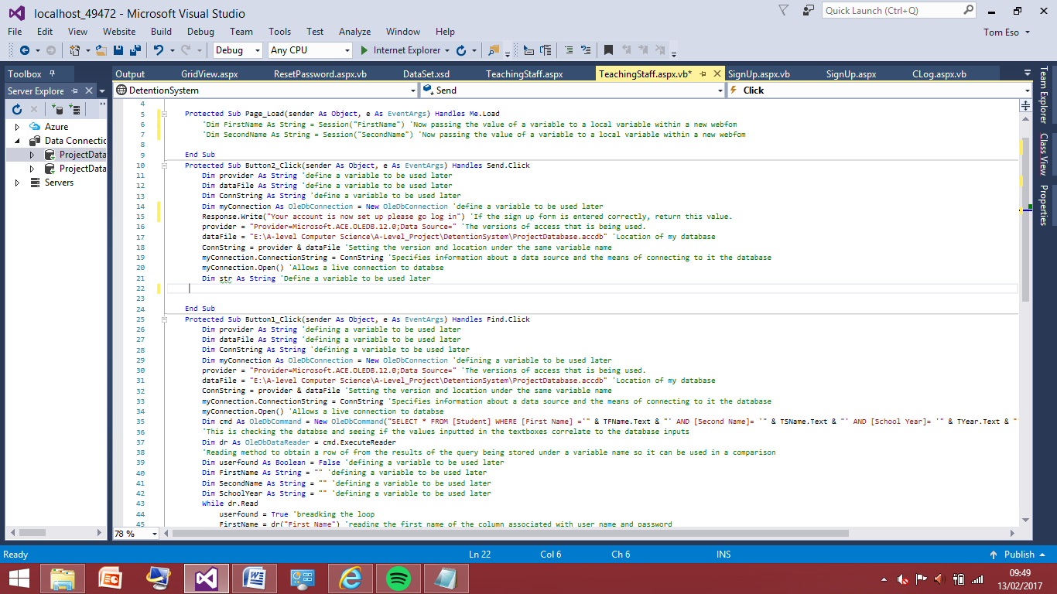Next are the fields that just match the textboxes on the form as they need to be stored as well. Then on the end is number of detentions will be a simply counter and when this counter reaches in a week the after school field will then read yes. When the teaching staff wants to read see their history the only fields queried to them will be the date, reason and student they won’t be able to look at the number of detentions given to the student of whether they have an after school detention or not. This was a part of my success criteria in order to give senior members of staff more power. I will now have an insert query that will take all this information and put it into this table this will be very simple as it is similar to the sign up code.

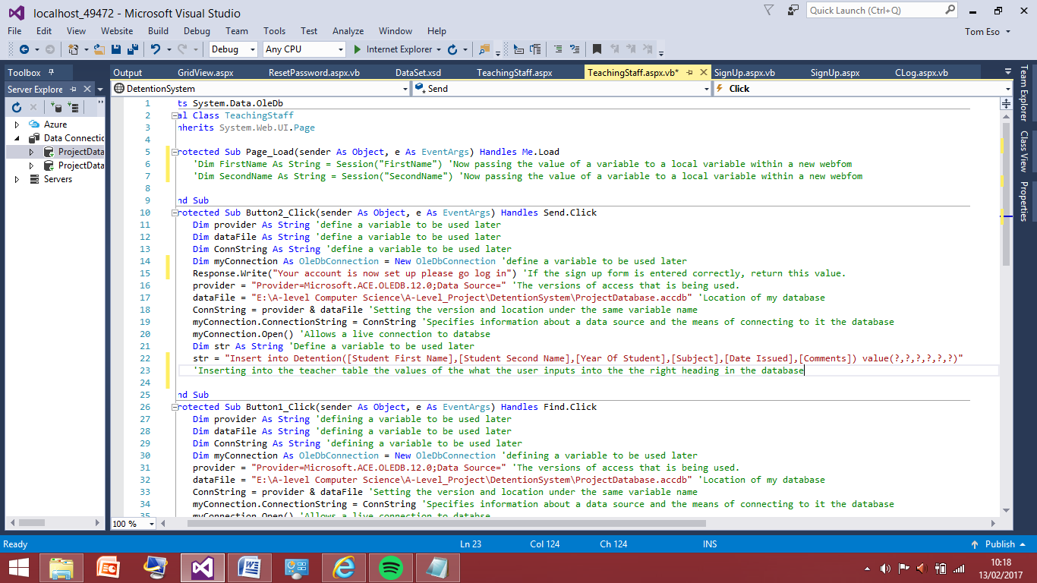This code is copied from the ‘sign up’ as what I am doing here is the same as before I was able to the use the same code the next line is the line that will have to adapted to suit this specific variables.

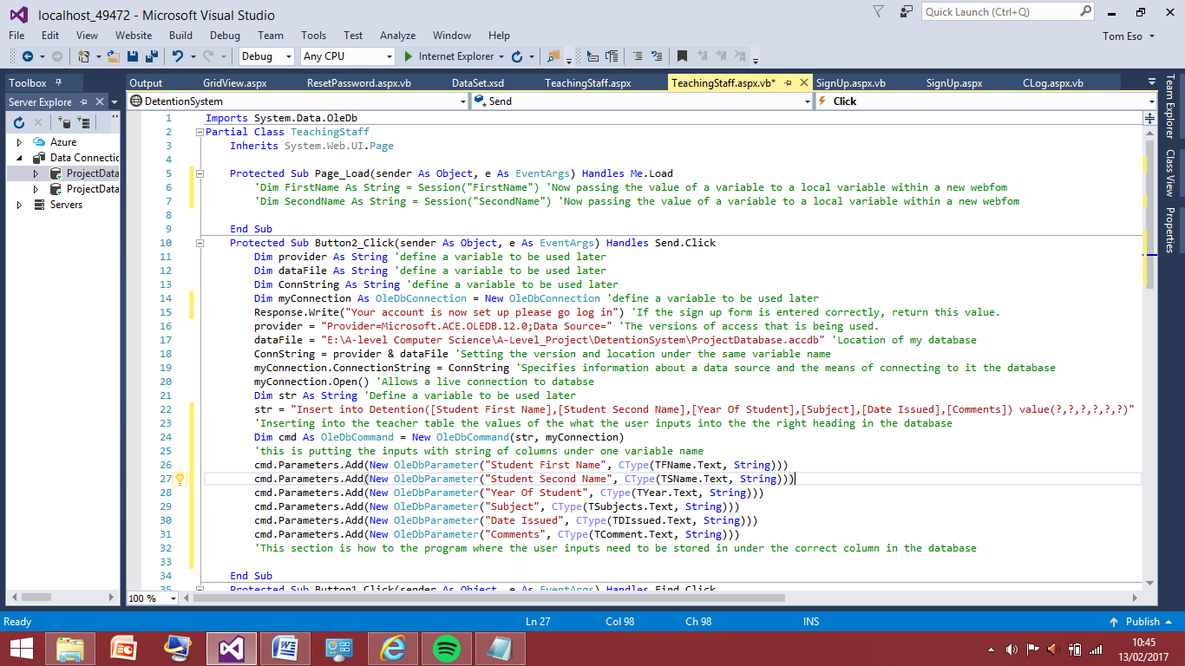The line I have added this because this tells the program what inputs to be expecting and pass them to the right columns in the database. I haven’t added the code for the teacher’s names and second name to be passed as well; I will add this in once I have tested this stage works correctly, as I do not want to do too much at a time because this could end up with more errors that are harder to fix.

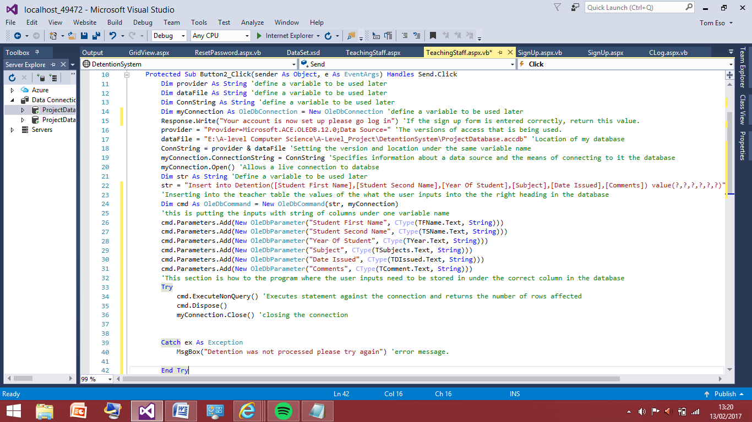I have now added the parameter to which tells the program what textboxes need to put into the right columns. I have named the textboxes ‘T’ then there name the ‘T’ is for teaching staff this code should work as it

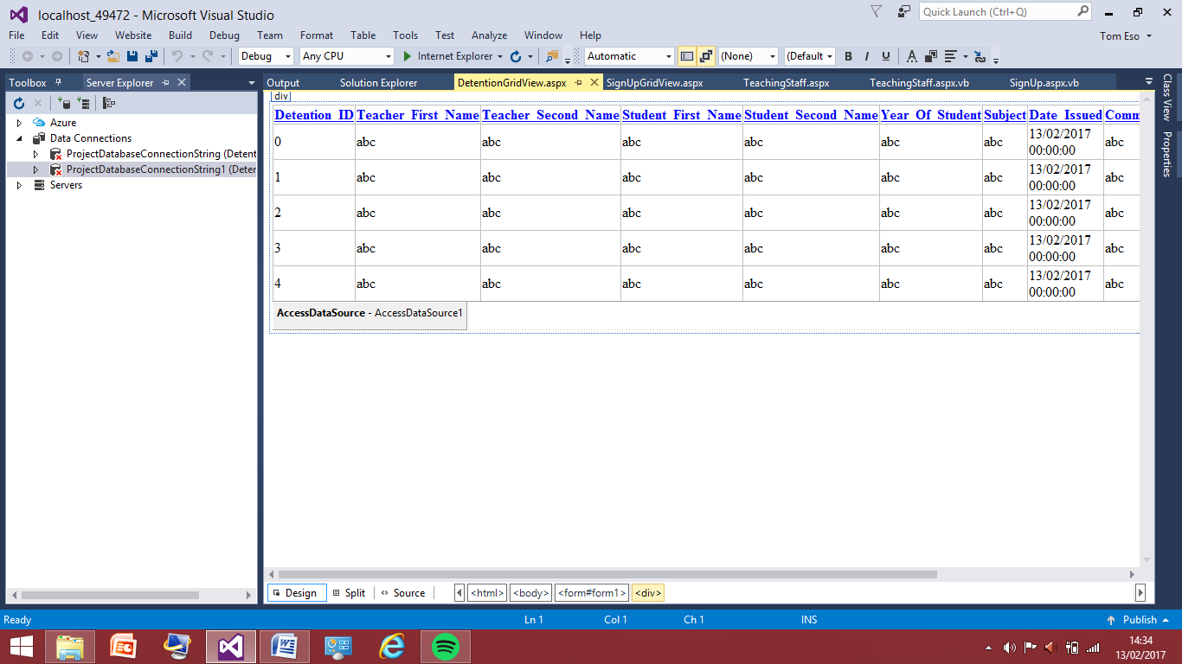I have now added the piece of code that finishes of the statement this was taken from the sign up page and I will now test this for some random students, I’ll now create a grid view for the new table therefore I will be able to view the contents of it without viewing the actual database.

This shows the grid view of the table named detentions in my program which will be used to store the detention. I will now test the insert query which I have taken from the sign up page and modified slightly so it can work for logging the detentions.

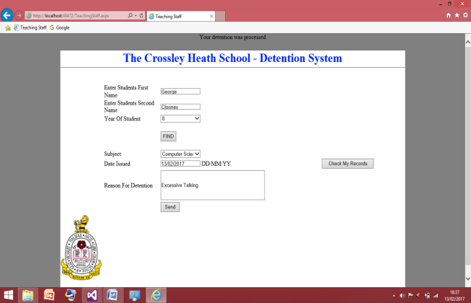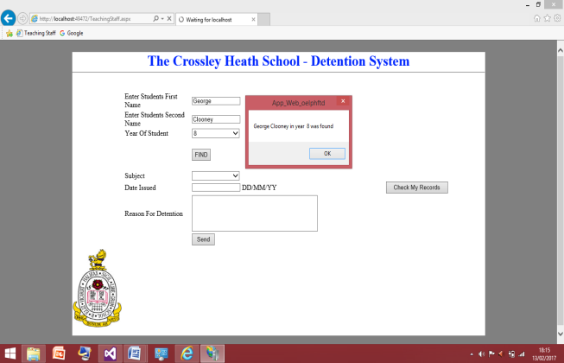

I have entered in these details for the student of ‘George Clooney’ I checked to see if the database would find the user which it did and I have given ‘George Clooney’ a detention for excessive talking I l will now check the grid view in order to ensure the query is working correctly and the fields have been correctly updated. I am expecting teacher first/last name to be left blank and for number of detentions and after school detention to be left blank as I haven’t coded for that to do anything as of 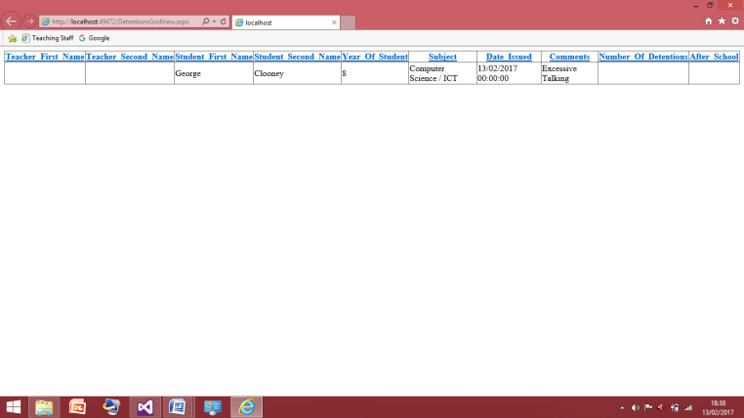yet.

This is a screenshot of the current grid view and this shows the code is now working for the program to take input of the detentions. I will now test this for 3 others to ensure it works correctly before I move on to having the teachers name in the table that gave out the detention because it is on their account.

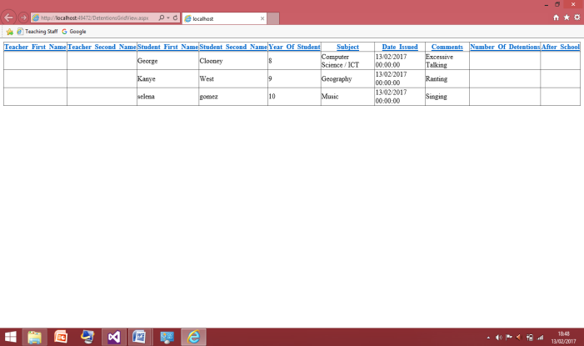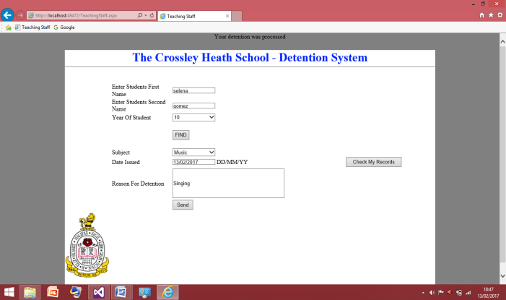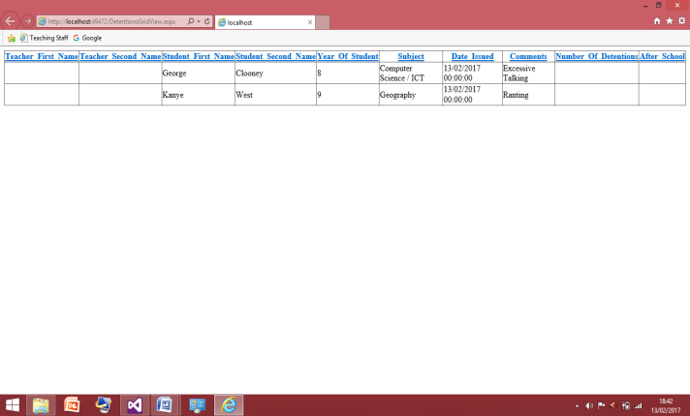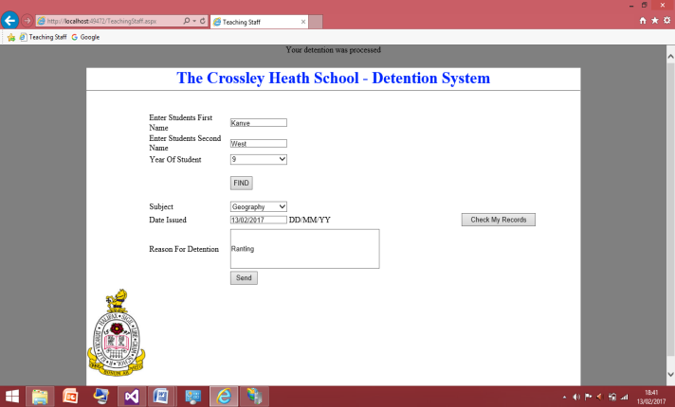These two screenshots show the test was successful again as ‘Kanye West’ was added to the list as expected.

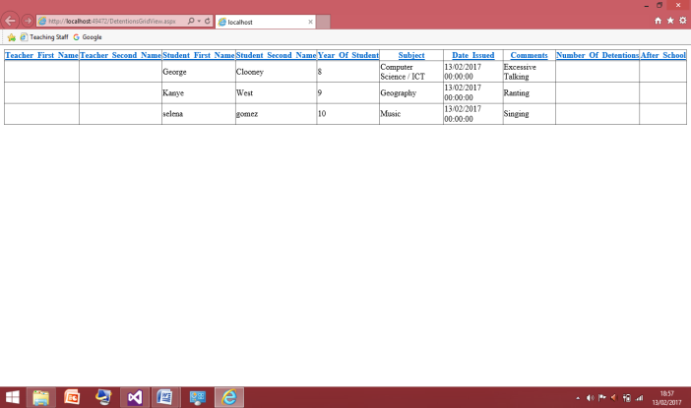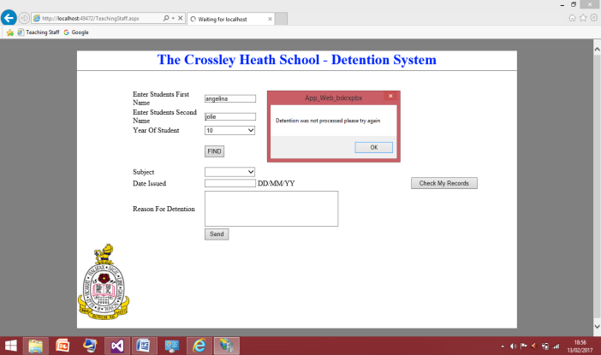These two screenshots show the code now works for adding ‘Selena Gomez’ to the table

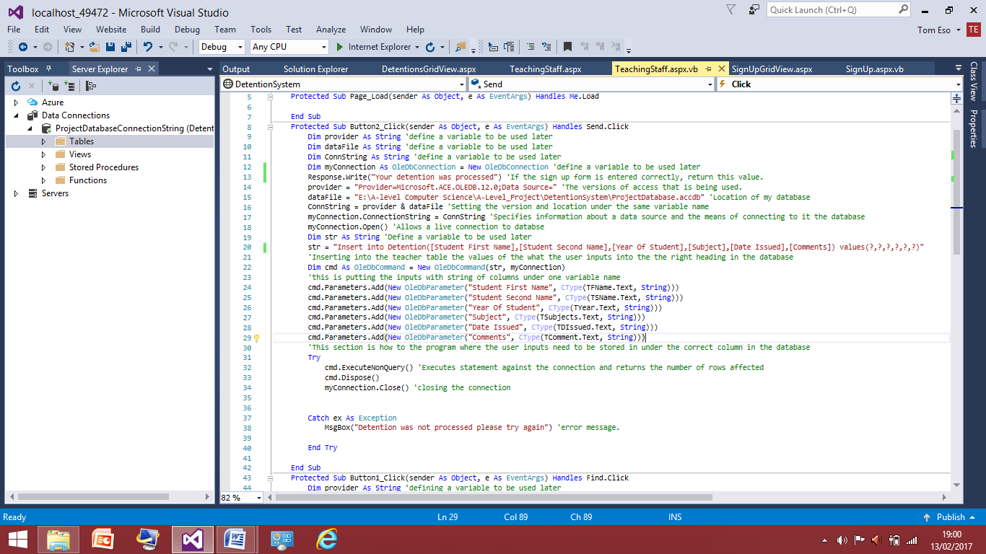The two screenshots above show that the program will not process the detention if not all the fields are filled out I have filled out the first 3 fields correctly but after that I have left the others blank. The error message box appeared successfully and nothing was added to the grid view. Now this is working successfully I will now move on to adding the teacher name to the box so the person who has given out the detention can be seen this will involve passing the sessions from the log in details and putting those detail into the correct columns.

This is the final code for the insert query to get the detentions into the table.

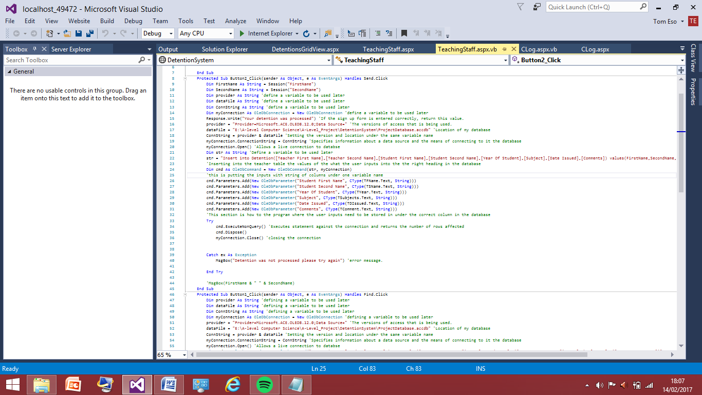Adding the Teachers:

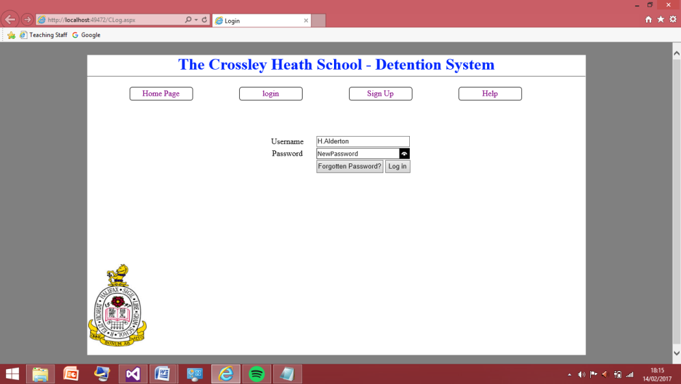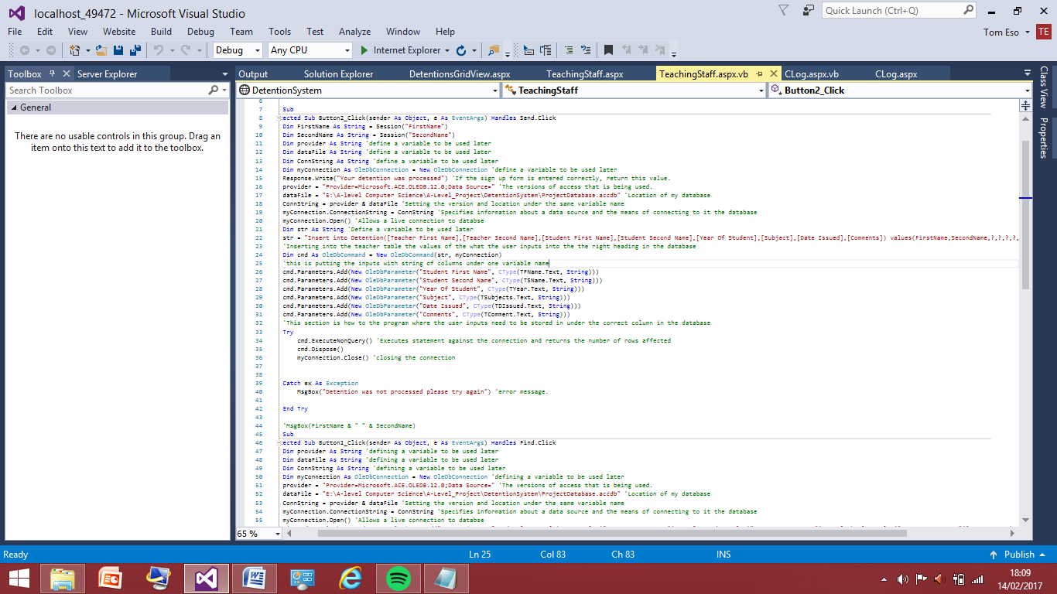I have started by adding the code that allows for first name and last name of the teacher that has logged in to be passed to the teaching form page. By having these variables in the sub function I am then able to manipulate the query in order to allow the program to put these to names in the correct columns.

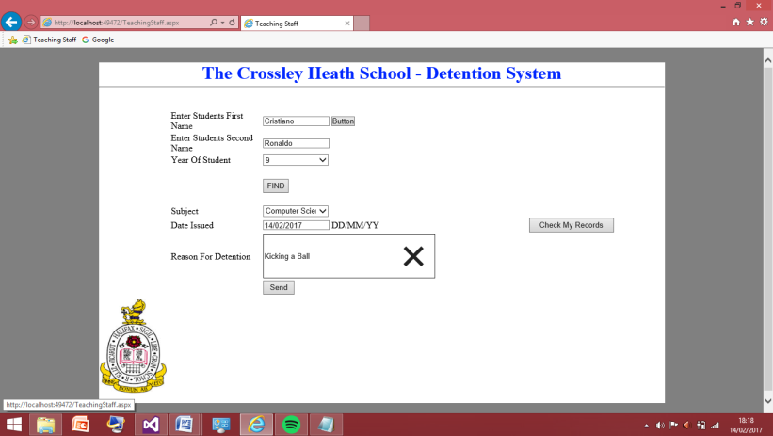I have taken the variable names and added them to the list on values. I am not sure this will work as I have never done anything like this before however I have a few other ideas of where the variable names could go in order to pass them to the table. However now I will test to see if this method works correctly if not I will delete what I have added and try the other method I think may be the alternative.

I logged in on the Harry Alderton account as this is a normal teaching account therefore when I input the detention into the table. Once I load the grid view I should see harry Alderton name and the student they have given a detention too.

This is the information I have typed into the program. Once I press sent the information should be sent the table then I can view this data in the table.

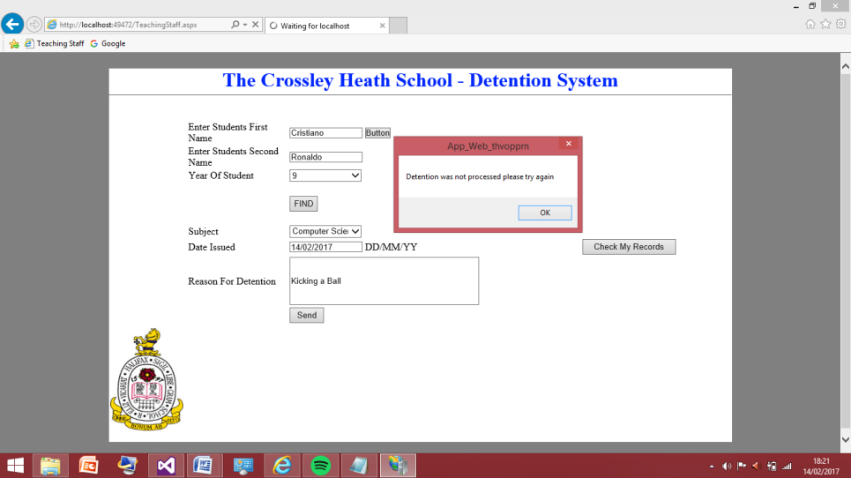When I pressed enter the detention gave this error message where it said the detention was not processed. I am still going to check the grid view but I am not expecting the detention to have been inputted at all.

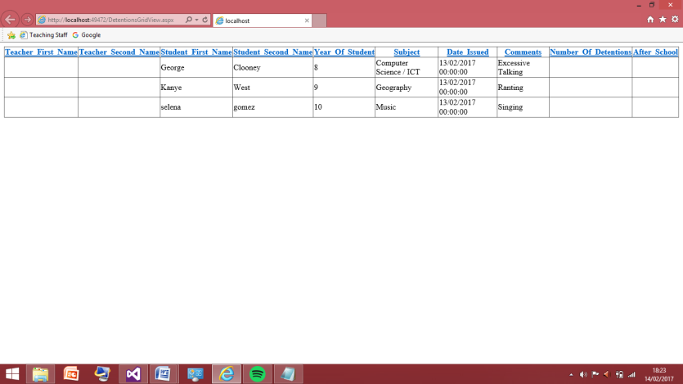

As expected the table is unchanged from before, therefore the code I entered did not work. I will now take this code out and try again with the other method I think may be the better alternative to have the code working.

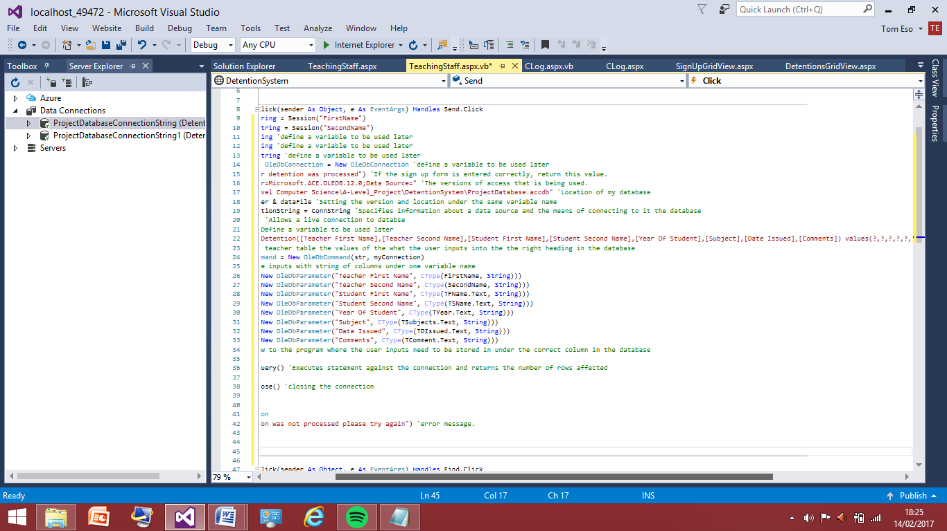

To start with I have taken out the variable that I put in the values bracket as the test shows this was not the right place for these to be.

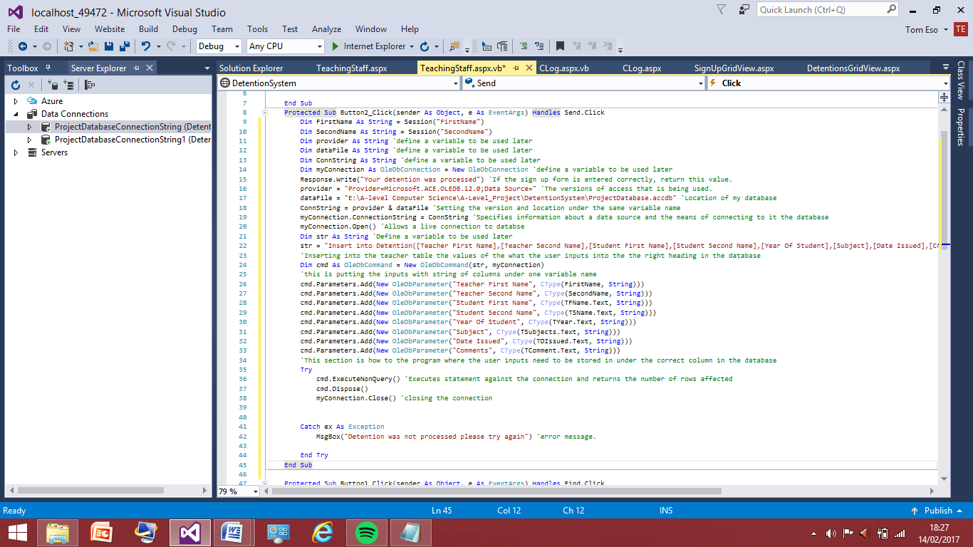

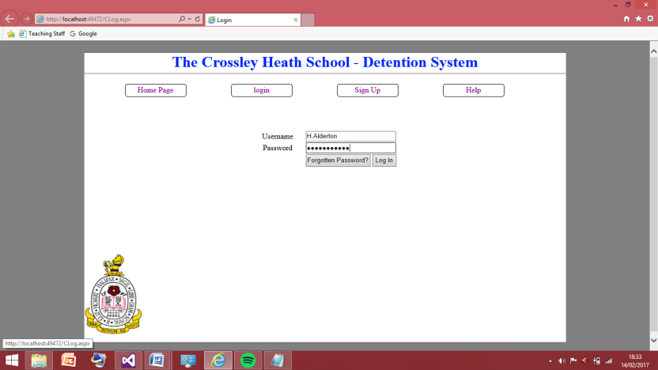From the screenshot above I have now added the place where I think the variables will then be stored into the table. I have taken the format from the lines that allow what is in the textboxes to be put into the right columns. And from that I was able to adapt them into allowing for the variable names just to be passed hence why ‘.text’ is not followed by the variable name it is not a textbox it's just the variable name. I will now test this again for similar inputs and I am now expecting this to work as the logic behind it seems right.

Signing in with the Harry Alderton account again.

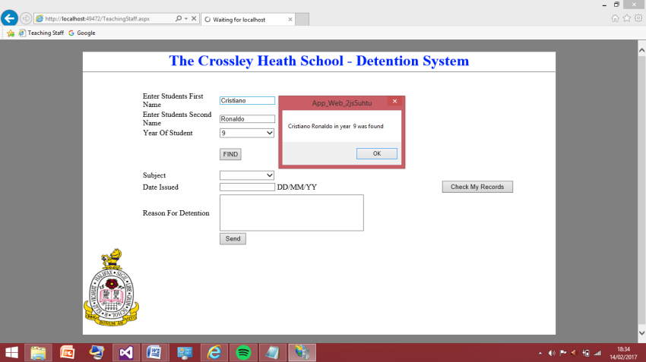

Student was successfully found.

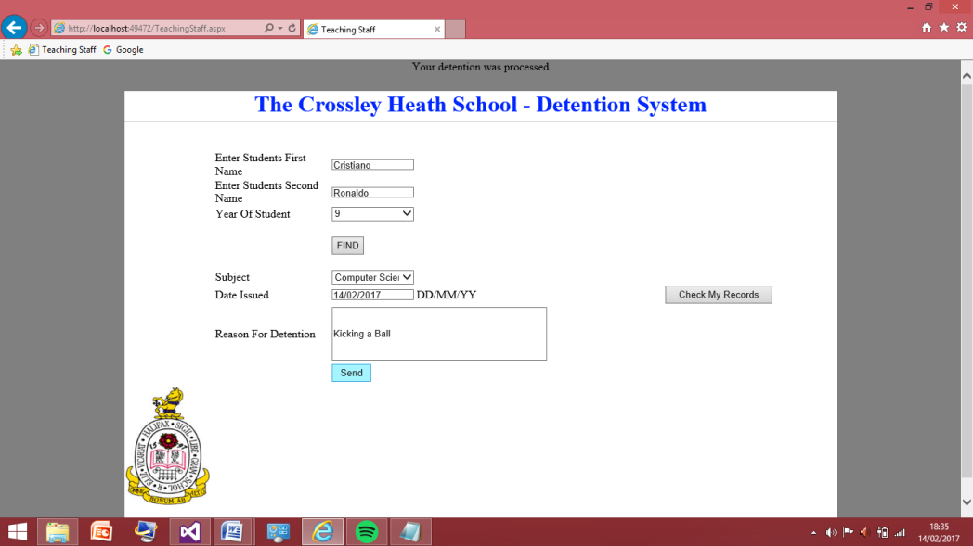

The detention was successfully processed. These shows there were no bugs in the code and that all the inputs should have been inputted into the table properly I will now check the table grid view for the detentions in order to prove this has worked correctly.

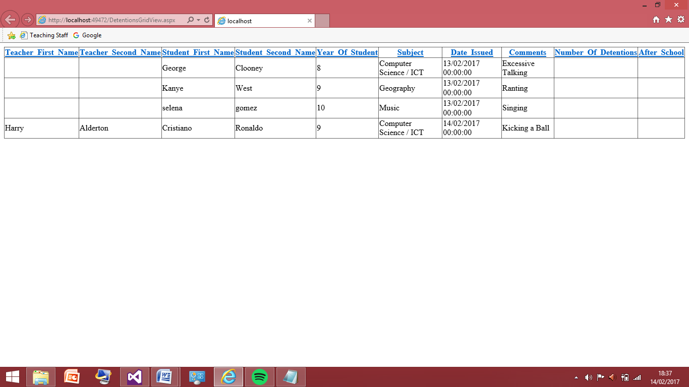

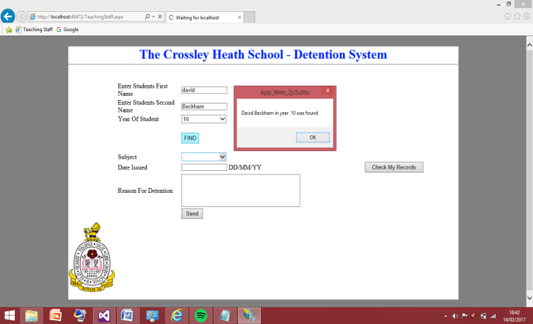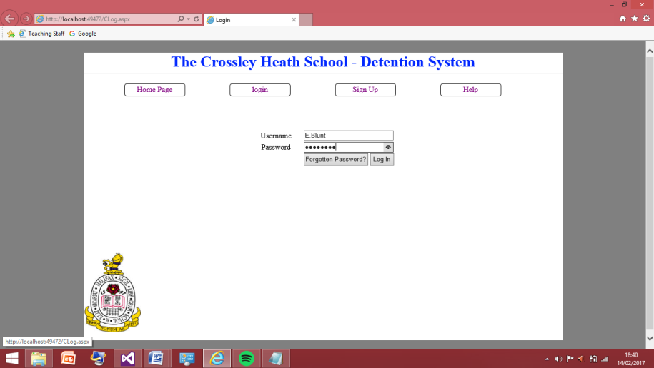This screenshot shows the test was successful in adding the name of user to the table alongside the person they have given the detention to. Having the name is important because when user wants to view their record this table will be queried to allow for the detentions they’re given out only. I will now test this again for the other teaching user and add a couple of detentions under her name and under the Harry Alderton user name.

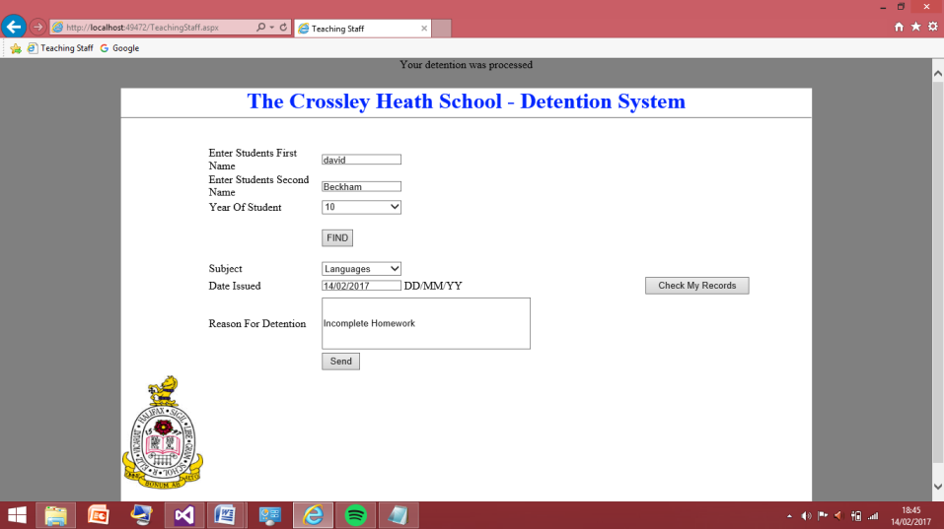Screenshot to the left shows I am signing in with the Emily Blunt account, the screenshot to the right shows the student David Beckham was successfully found in the student table.

This screenshots shows the information was added successfully to the table I will open the grid view in order to ensure of this.

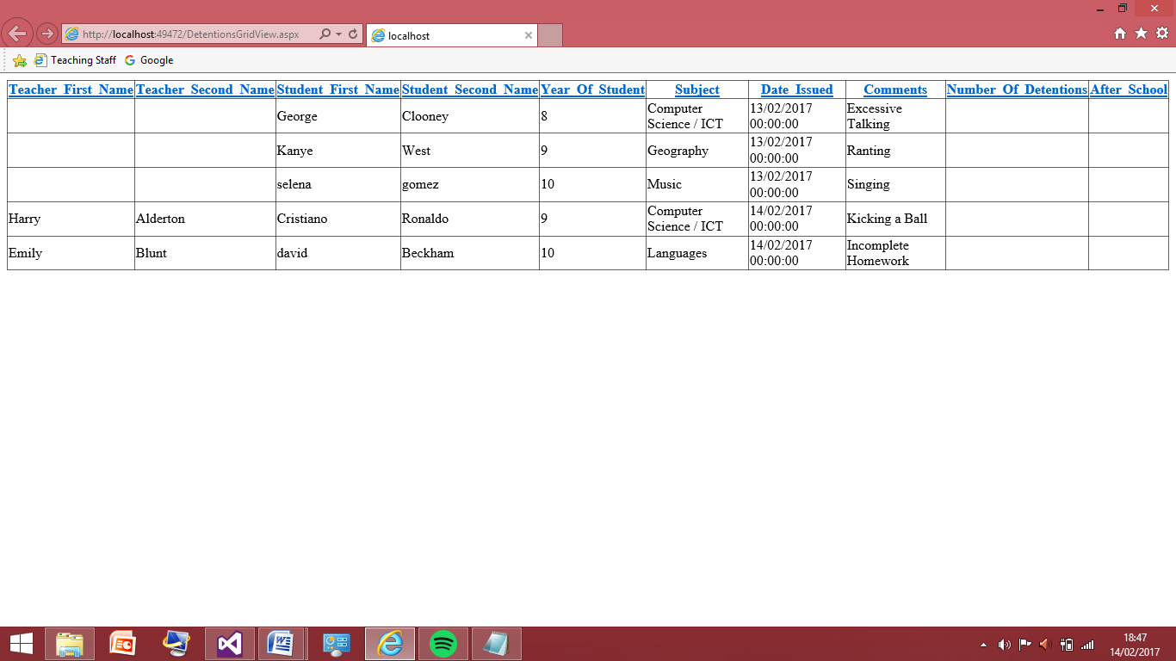

This screenshot shows that the detention was correctly added to the detentions table. I am now confident that this works properly so now I will delete the fields that do not have names assigned to them I will add a new user for normal teaching page just so I can test more names. Then I will add 3 detentions to each user. This is because the next thing I am going to do is have the check my record query working. I need to add more information just so it is obvious it is working for multiple entries 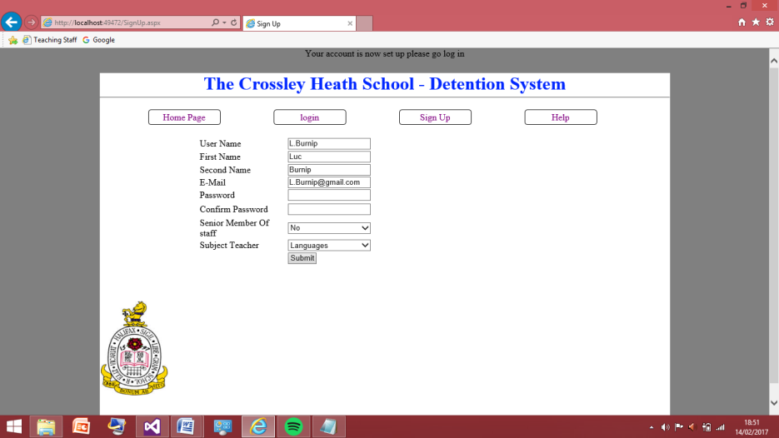there are no false positive tests.

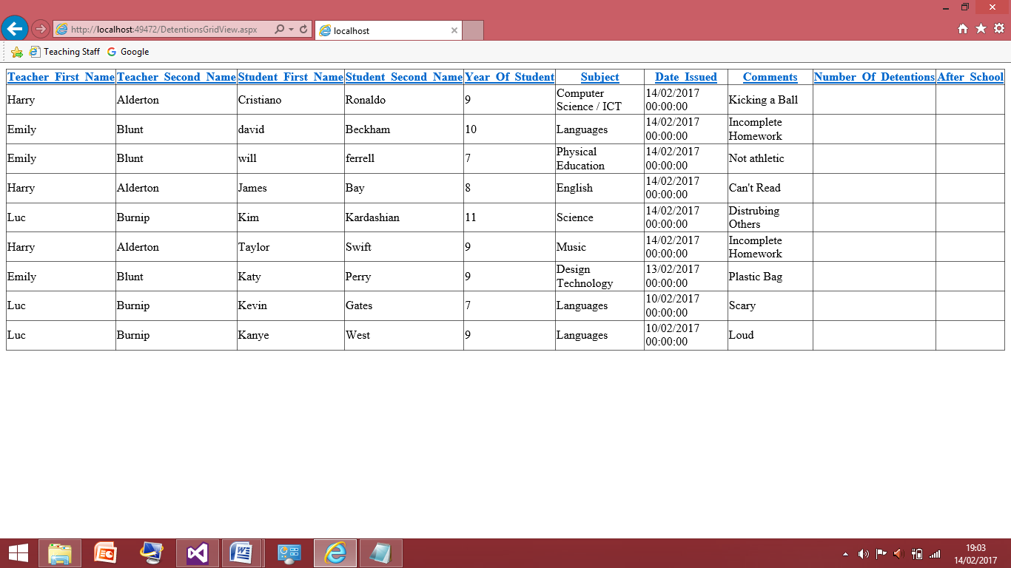The new account I have made is called Luc Burnip now I will add a lot of random detentions to the detentions table I will show the end table in a screenshot before I move onto the query for checking the history.

This now shows I have added loads of random detentions into the table I have given each user 3 detentions assigned to them. I have added some dates that are incorrect as this will be applicable testing last on when the order in which the table is being displayed can be edited. I will now move on to the ‘Check my History’ sub button and what I will now do is depending on the values of variable names the code will get the record relating to those names in the variables.

Check my history – Teaching Staff Page:

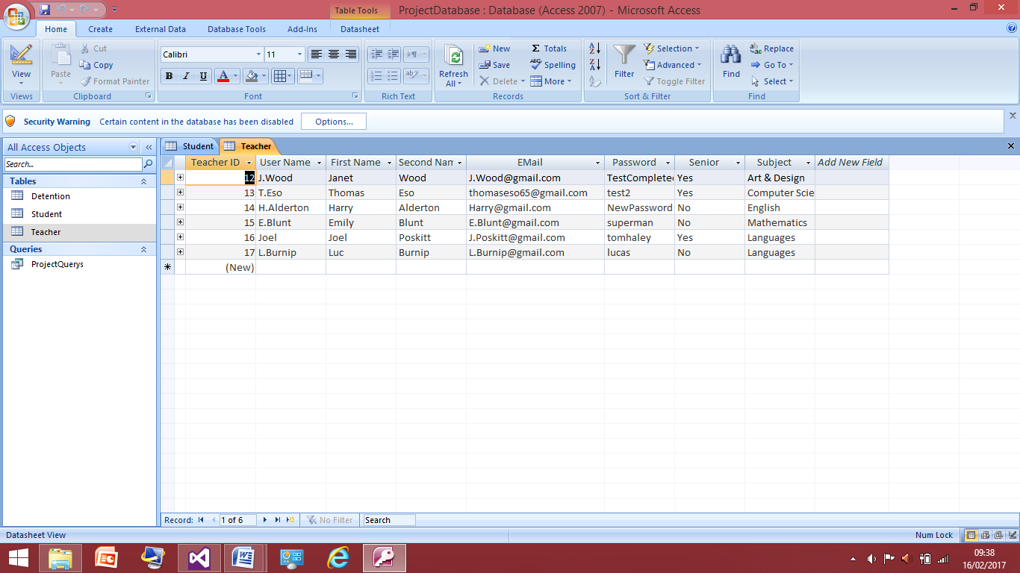During starting to code for the query that will pull all the detentions under a certain student ID I noticed I hadn’t actually set up any relationships between my table that allows them to interact with each other. Therefore quite a lot of changes will have to be made to the tables in order to allow this to happen. Instead of linking the tables through the first and last name would have caused some problems if teachers have the same name, therefore the teachers unique ID would have to be used in this case to provide the linked between databases.

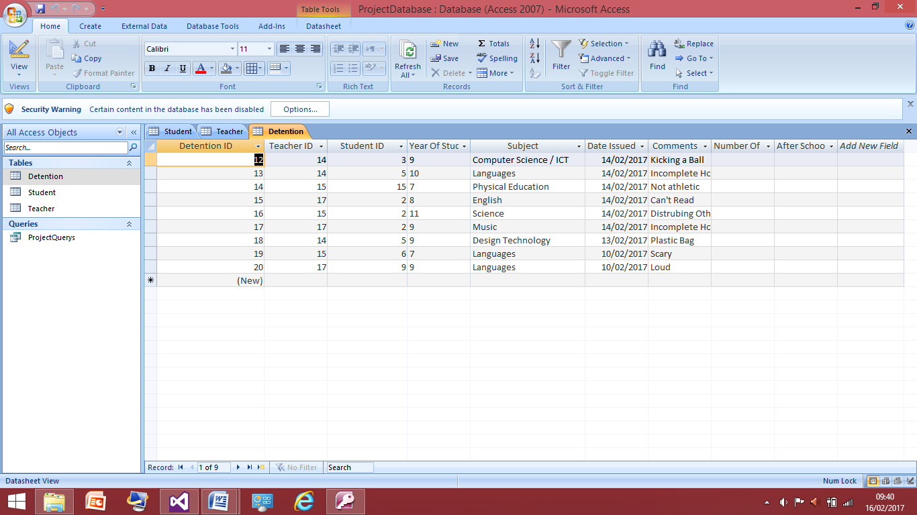This is the teacher table which stores the users no changes have been made to this table but the important thing to notice is that the teacher ID will now replace the teacher first name and last name in the other tables.

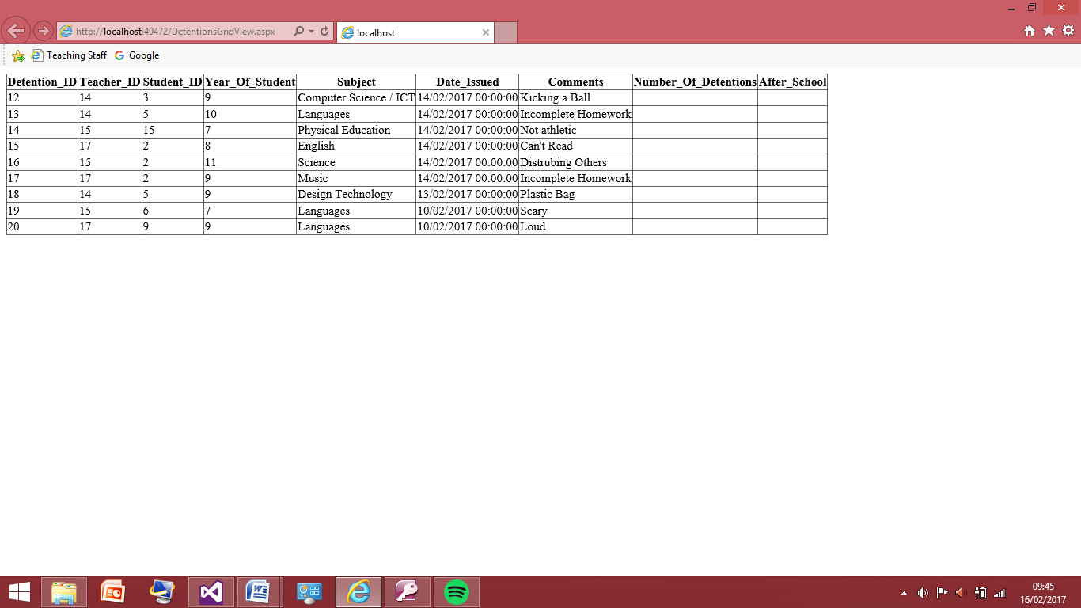This is now the new table for the detention table; I have replaced the teacher first name and last name fields and the student last name and first name with their unique IDs. This will now have changed what is in the grid view as I have entered the ID’s randomly in, but I have ensured the ID is one of a normal teaching staff and the student ID’s are random. I will just load the detention grid view to check what the values in the table now are.

This is now the new look for the grid view of the detentions, as this will be seen by no one it doesn’t matter that the names of students and teachers are not visible and it’s just the ID’s as the information will be dragged from these ID’s later on to product the names of students in the checking of the history. Due to this change in the inputs of the table I will have to go back to the send button and change the query within that to allow the inputs of the teacher now to be adapted to be put into this table.

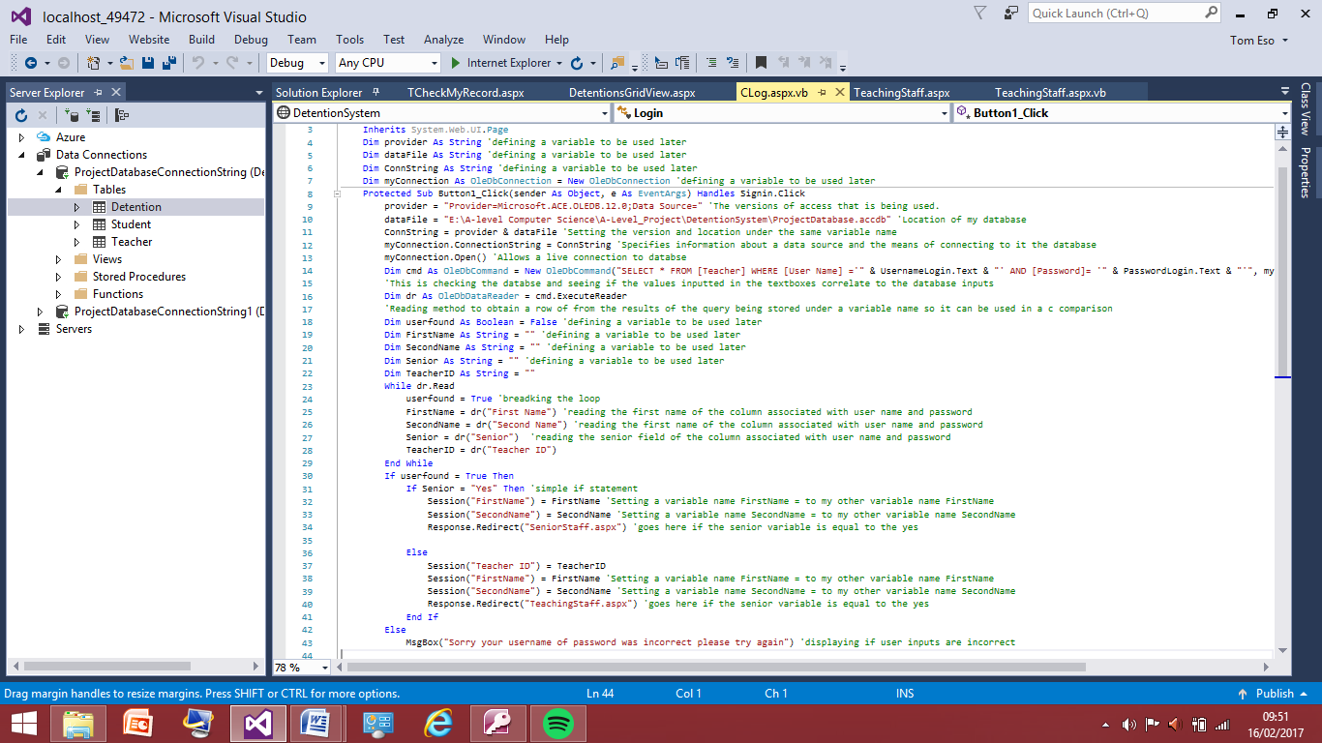Firstly I have started by changing what was passed in the session from being the name of teacher to the teachers ID as this is a new thing that needs to be put into the database not the teacher name. I can even get rid of the session for first name and second name as all that information is accessible from the teacher ID. I have done this in the log in page as this is where the program initially finds out what the teachers ID is through the login process. So I now have the teacher ID that can now be passed into the new detention table and now I need to be able to get the student ID and pass that into to new detention table.

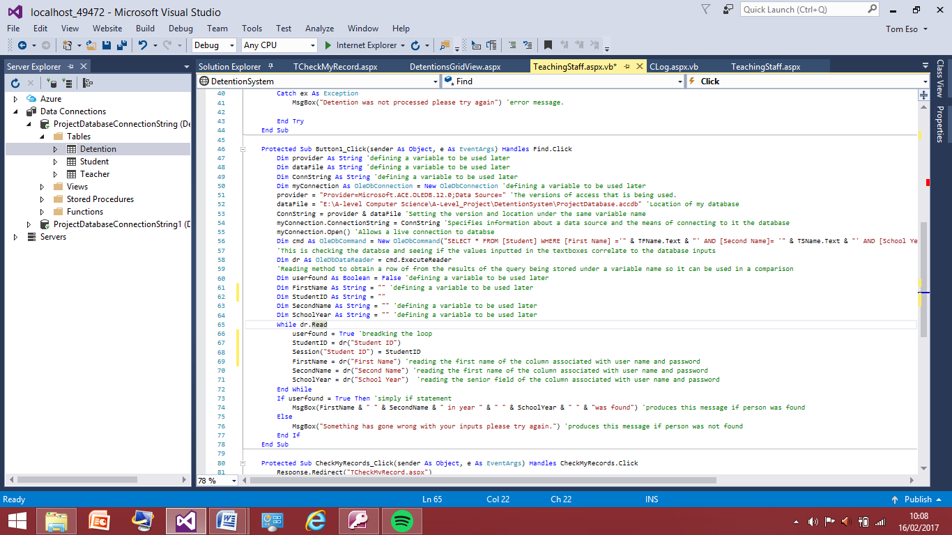I can do this in the ‘find’ button of the web form of where the detention are being processed as I already pull the student name so instead of getting that I will get the student ID this will be a similar change as done here.

I have now added the code that allows the program to pull the information of the student ID alongside the first name and last name. I have not added this to the message box as this isn’t useful to the teacher, as they wouldn’t know the student ID I just need to have it in a session so it can be passed to the table.

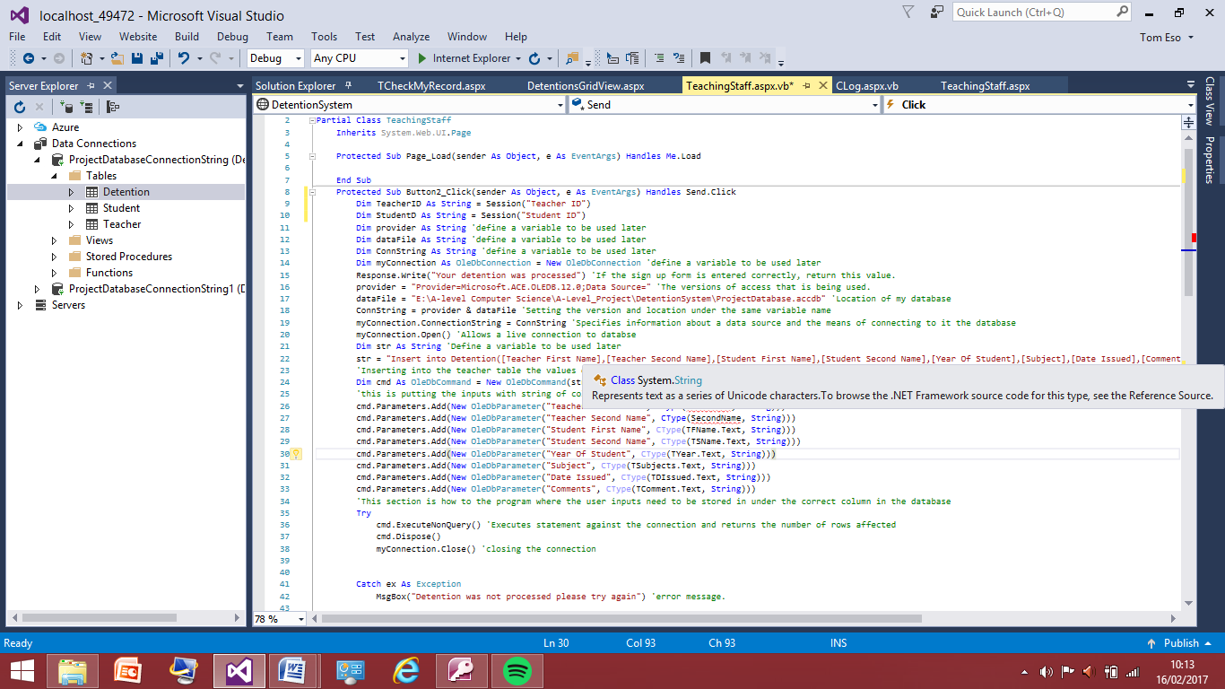Now this is done and I am able to take the Student ID and Teacher ID now I can just change some values in the query that send the information to the table instead of student name it will be changed to student ID and teacher name will be changed to teacher ID within query.

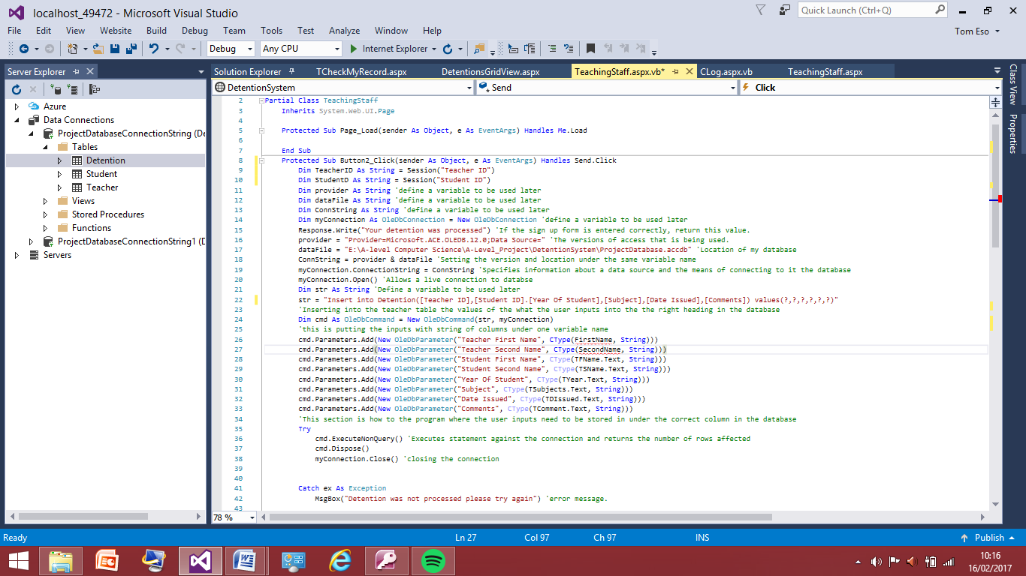I have now used the same code as before that I used to pass the teacher name and last name but instead I have used this to pass the student ID and teacher ID this can now be put into the table just like I did with the teachers name.

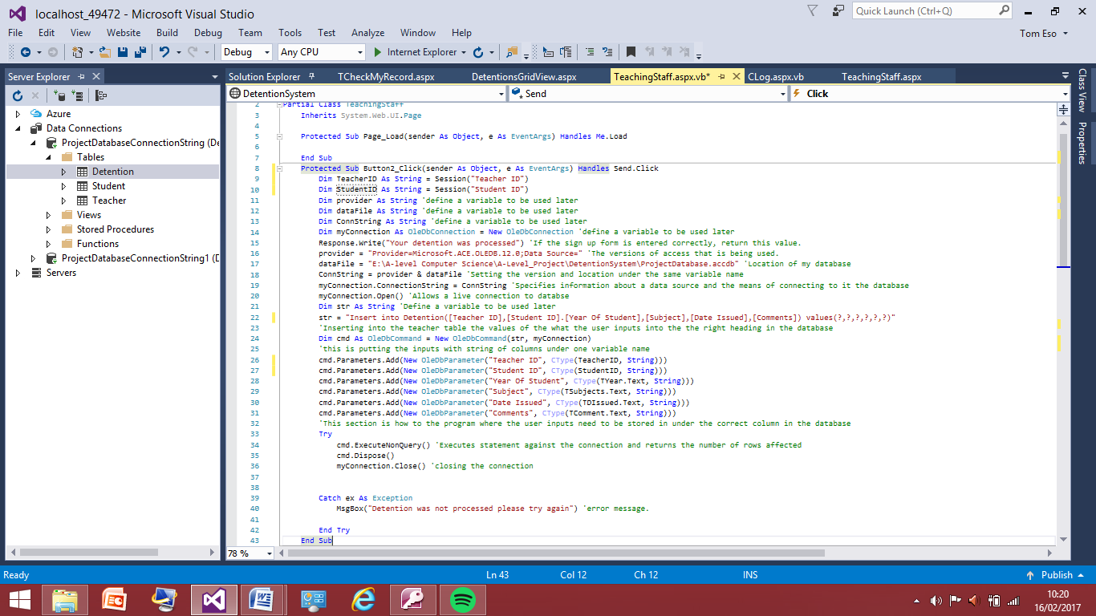I have now changed the line for the insert in to the detention table the new heading within the detention table and reduced the ‘?’ values accordingly.

I have now changed the parameters to the new column titles and the new variable names, I have also got rid of the other two parameters that were not relevant to the table anymore I will now test this again to ensure the updates I have mad are not faulty.

I will use the Harry Alderton user account which has the teacher ID of 14 and I will put a detention in for the student of George Clooney which has the student ID of 5 therefore once I have entered to reasons for the detention and all the other text boxes this detention should be added to the table with 14 in the teacher ID column and 5 in the student ID column

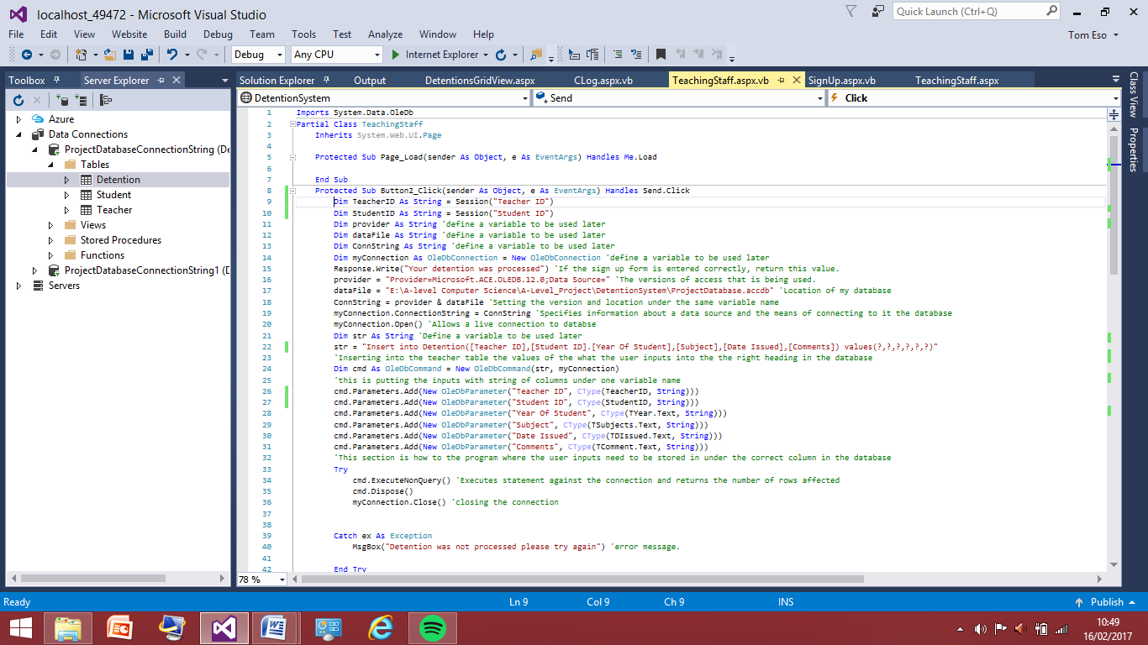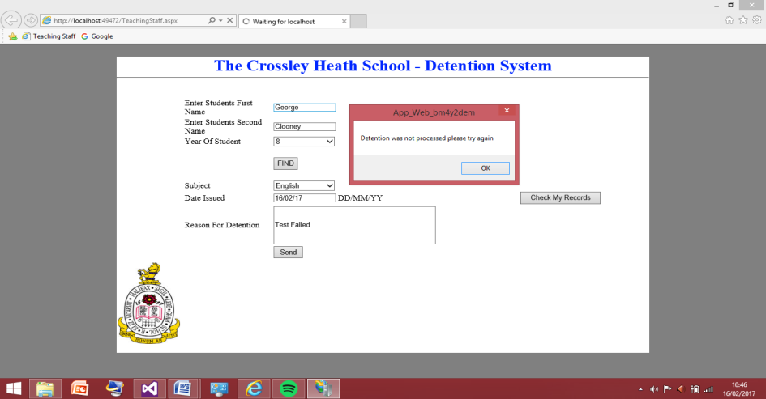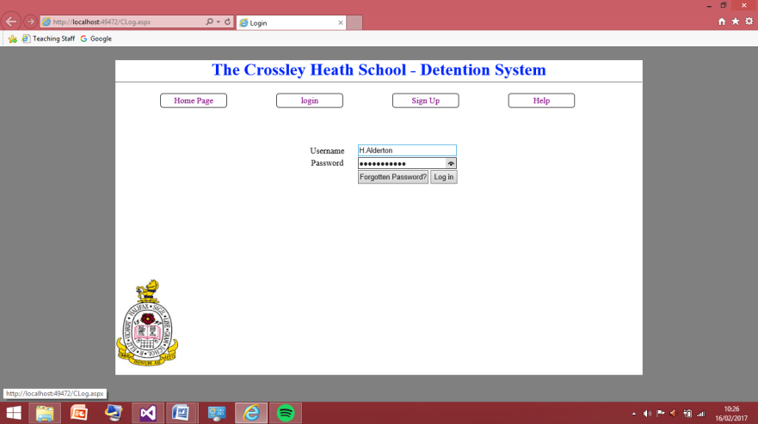The screenshot to the left shows I have signed with the ‘Harry Alderton’ account. However there is a problem with how the query to send the information to the table has been implemented as the screenshot to the right shows that the detention was not processed therefore I will be go back to the send sub of the program and look for errors.

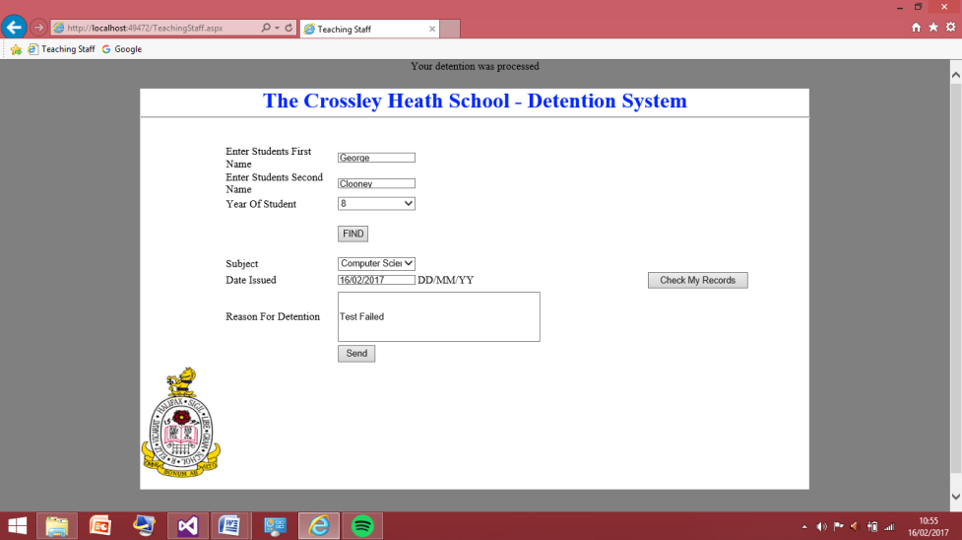After some time of re reading the query over and over I noticed the error was I accidently put a full stop instead of a comma into the program therefore this is the reason behind the problem to not having the detention processed. I have now changed this to a comma and will now test this query again.

This screenshots that I have now corrected the problem as the message at the top was displayed shows that the detention has been processed. I will now go into the detention grid view to ensure the right values have been put in which should be 14 for teacher ID and 5 for student ID

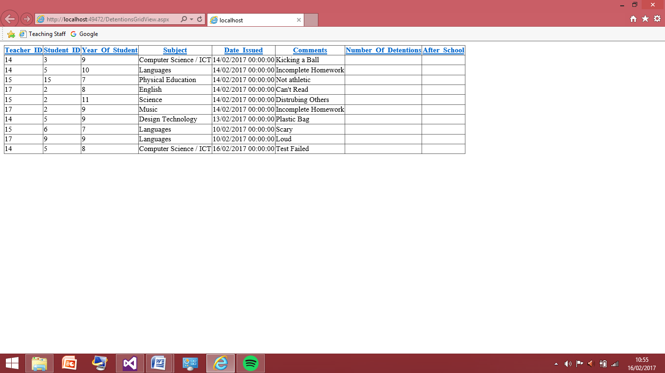This screenshot shows the updated detention view and the right values have now been inputted into the table I will test this for the other 2 user and just add one more detention to each just to prove this wasn’t a fluke or happened by chance and does work for ever user who isn’t a senior member of staff.

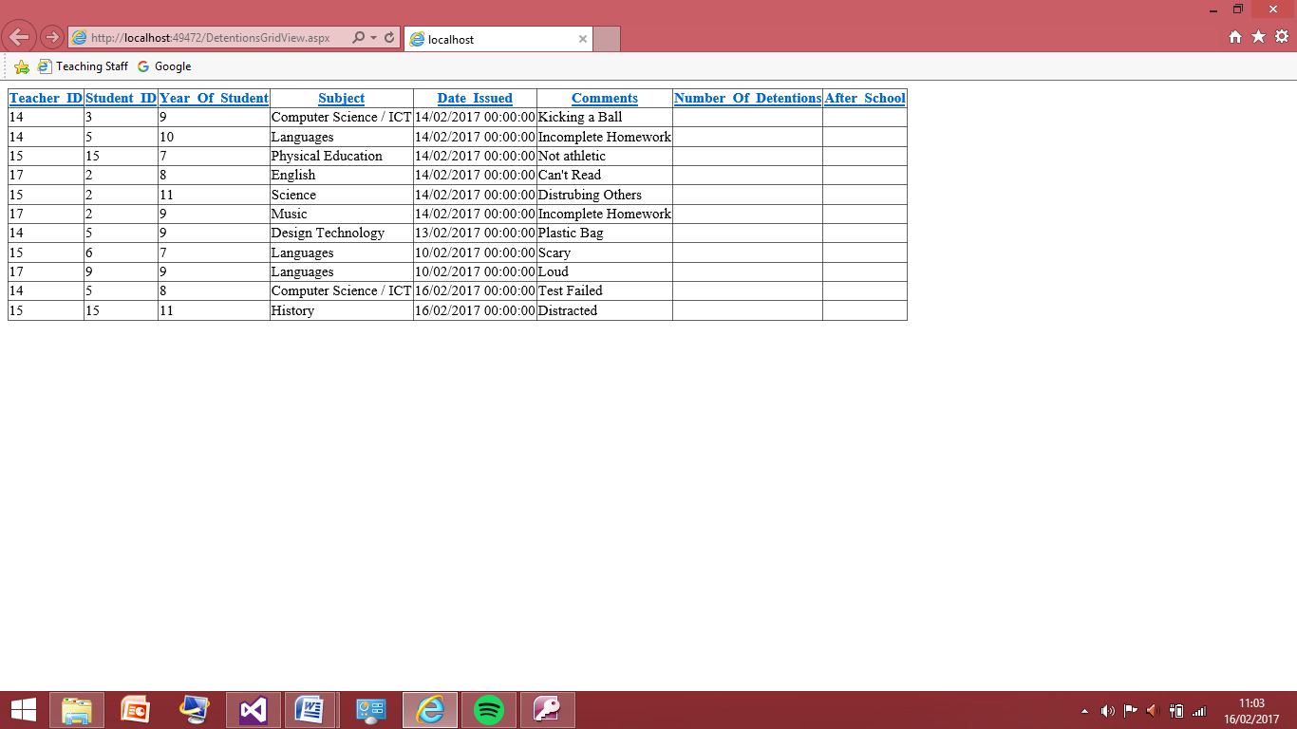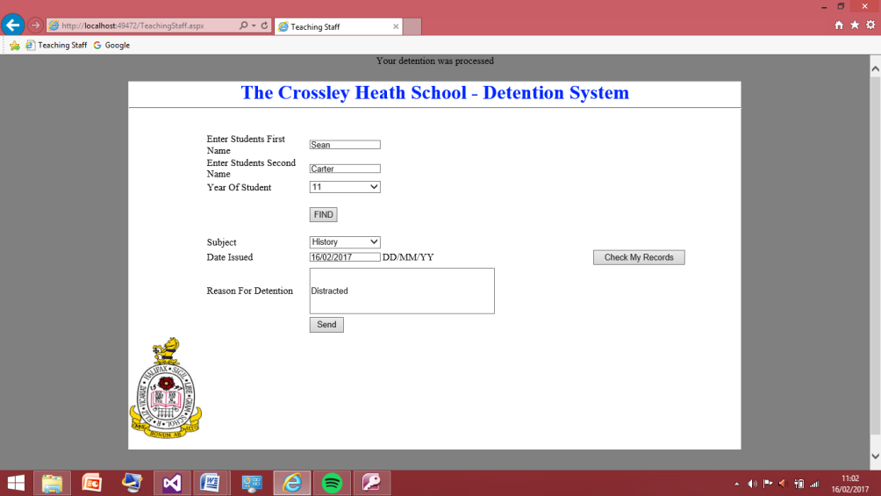I will sign in on ‘Emily Blunt’ user which has the teacher ID of 15 and I will process a detention for ‘Sean Carter’ who is also has the student ID of 15 therefore once I have processed this should be added to the detention table when I load it.

These two screenshots show the test was successful.

I will now sign in on the ‘Luc Burnip’ account which has the teacher ID of 17 and I will put a detention of ‘Taylor Swift’ who has a Student ID of 9.

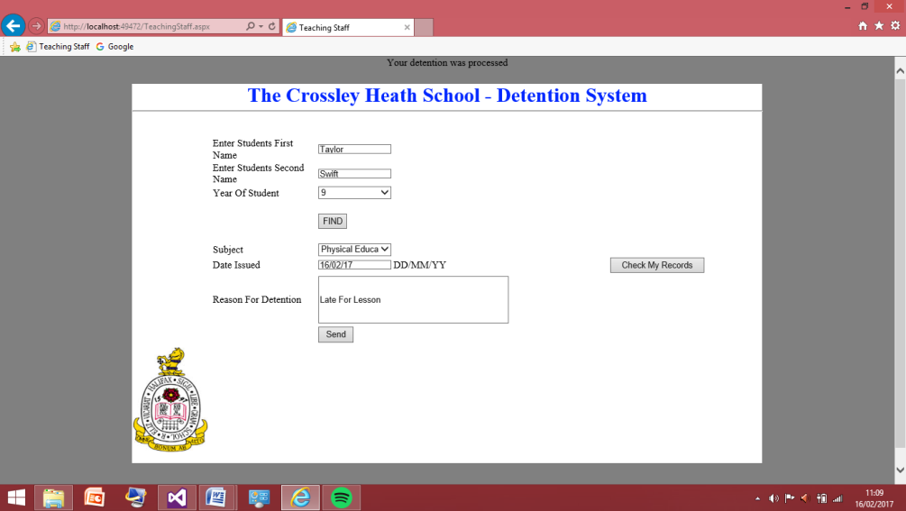

These two screenshots show the test was successful.

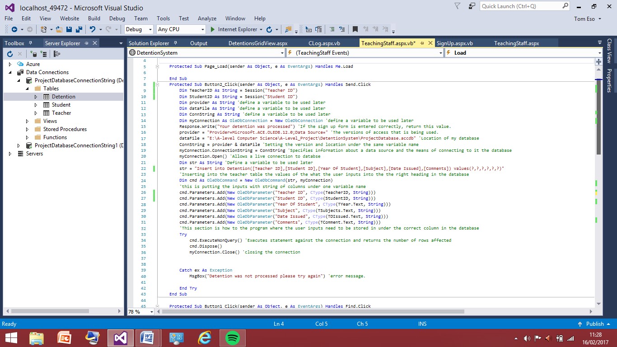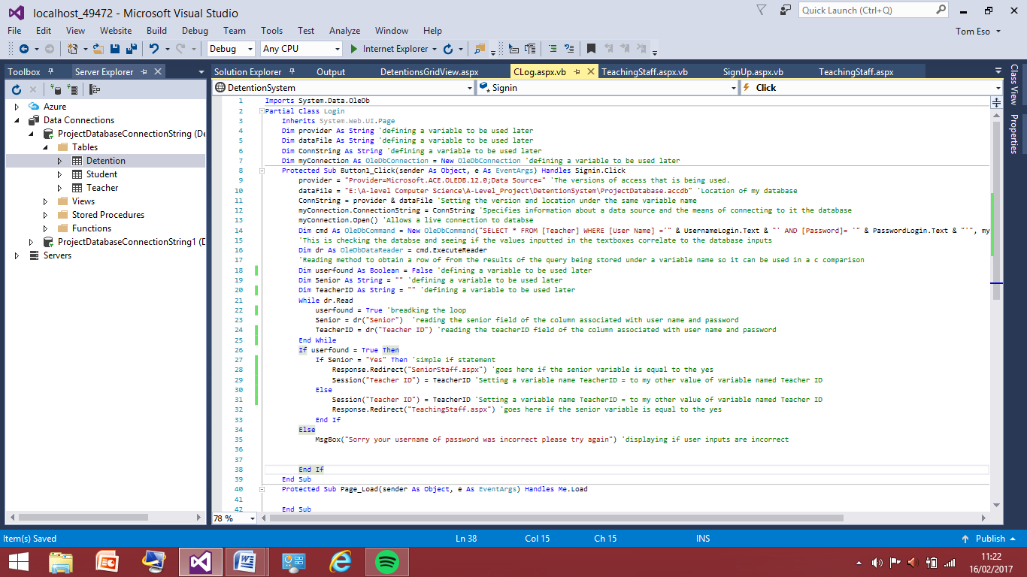This is the new code for logging into to program, the main change I have made is getting rid of collecting the first and last name of the Teacher as the only thing I really need now is the teacher ID.

This is the final code for the insert query for new detention table with teacher id and student id and now the names.

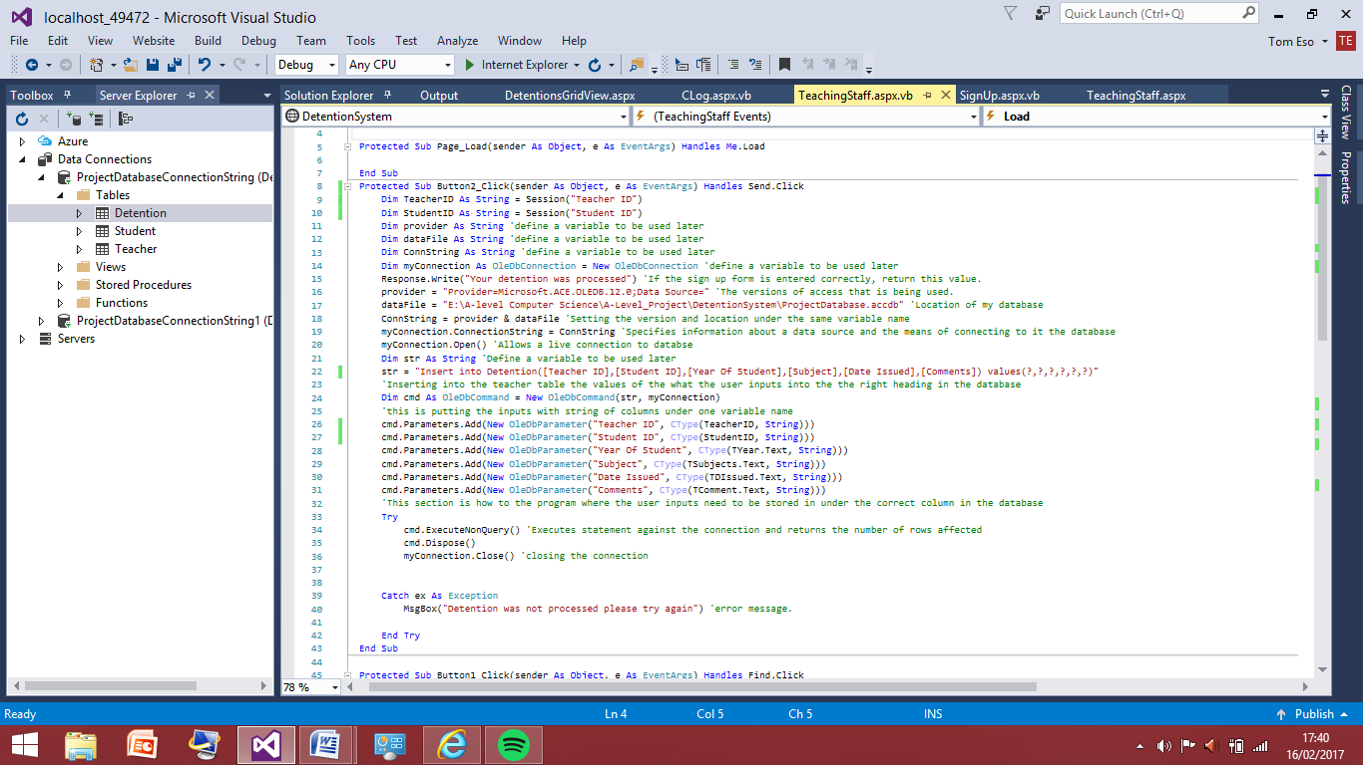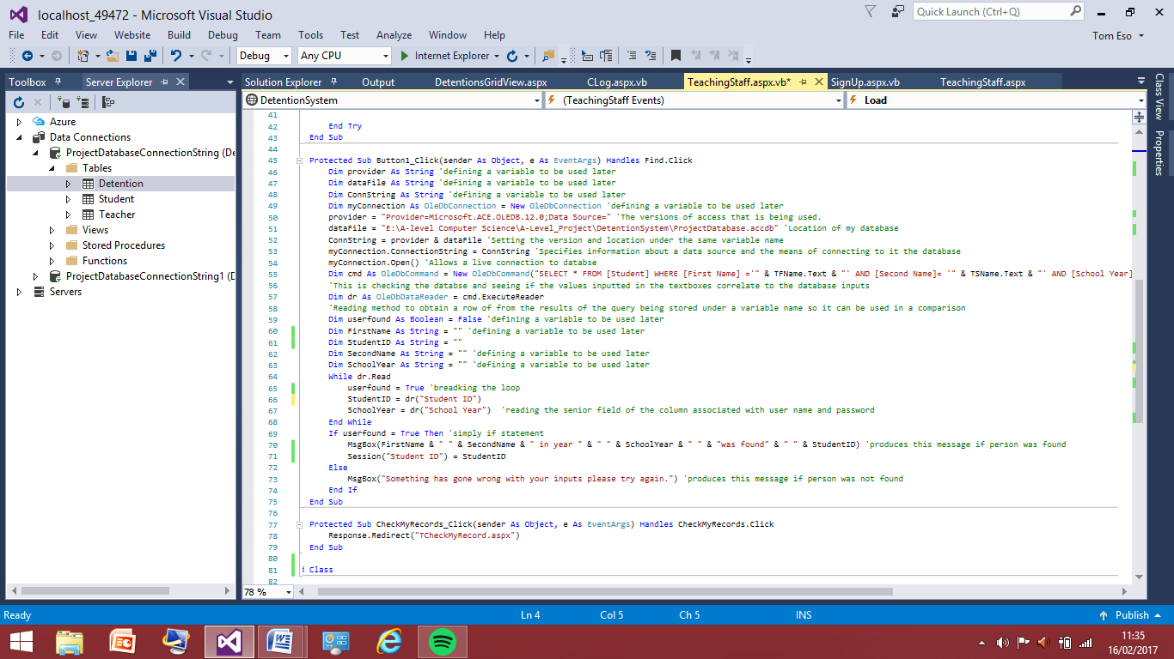This is the code new updated code for finding the student in the table. This now passes the student ID instead of the student name.

This is the final bit of new code that had to be altered this is for query to insert the values in to new detention table that had to be changed.

Now all the code has been updated I need to make the connections between the tables, I’ll do this in the access database. There needs to be a connection between the tables because based on the to check the history the program will take the teacher ID and query that value against every entry in the detention table and produce all the fields that match the one relating to that teacher ID.

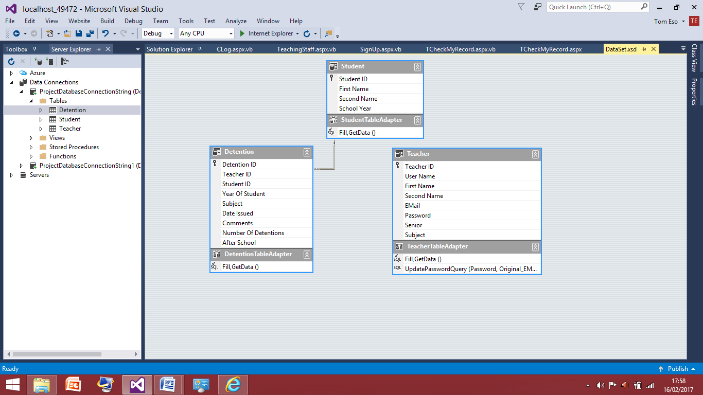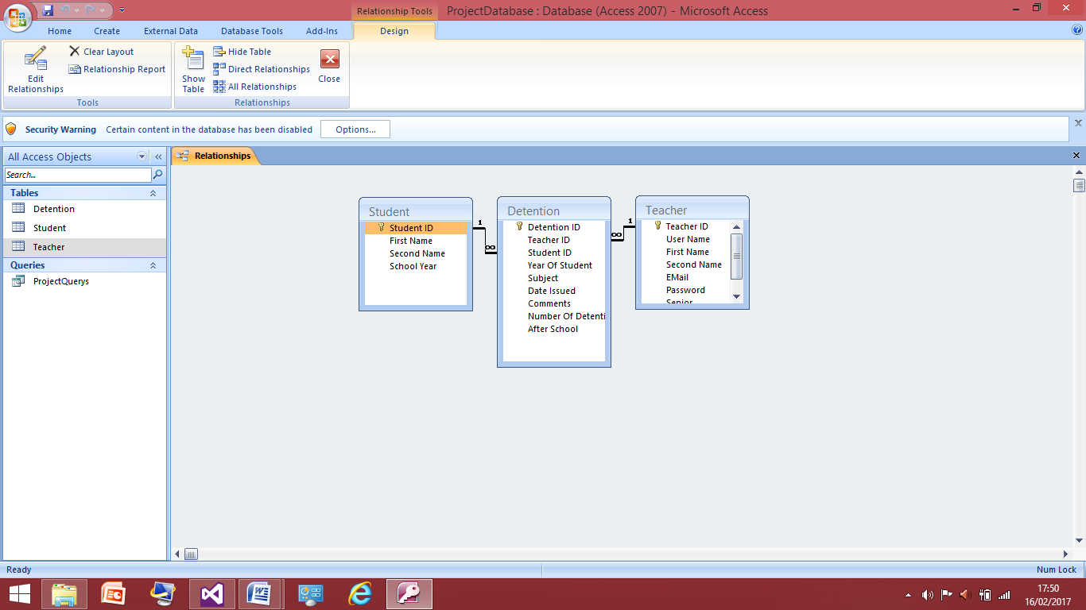This is the screenshot of the relationships between the tables this allows me to pull information from one table to another based on the unique ID of the Teacher ID or Student ID. I have reinforced Referential integrity is a relational database concept, which states that table relationships must always be consistent. So, any foreign key field must agree with the primary key that is referenced by the foreign key. Therefore if a teacher leaves the school and therefore there account needs to be deleted all records relating to this teacher ID will be deleted.

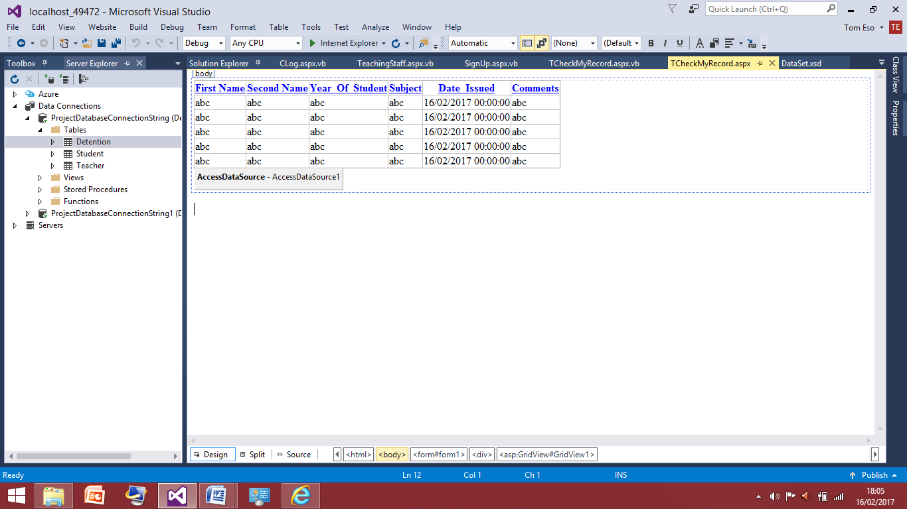 This screenshot shows that I have now also go the connection between the tables into the program, the next this I will need to do is add a grid view to the teaching staff web form then put the query into the view.

This screenshots shows that I have added the detention grid view I have edited the columns to allow for the user to order the column in whatever order they want. I have also edited the table to so it doesn’t display the teacher ID or Student ID as this has 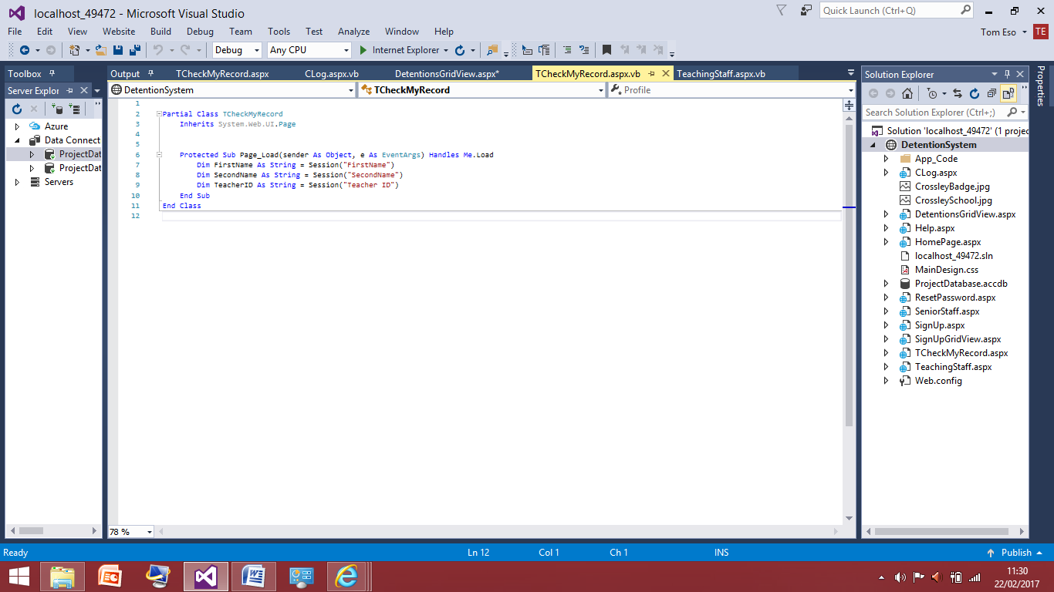no relevance to the teacher, now I will configure the query into the table.

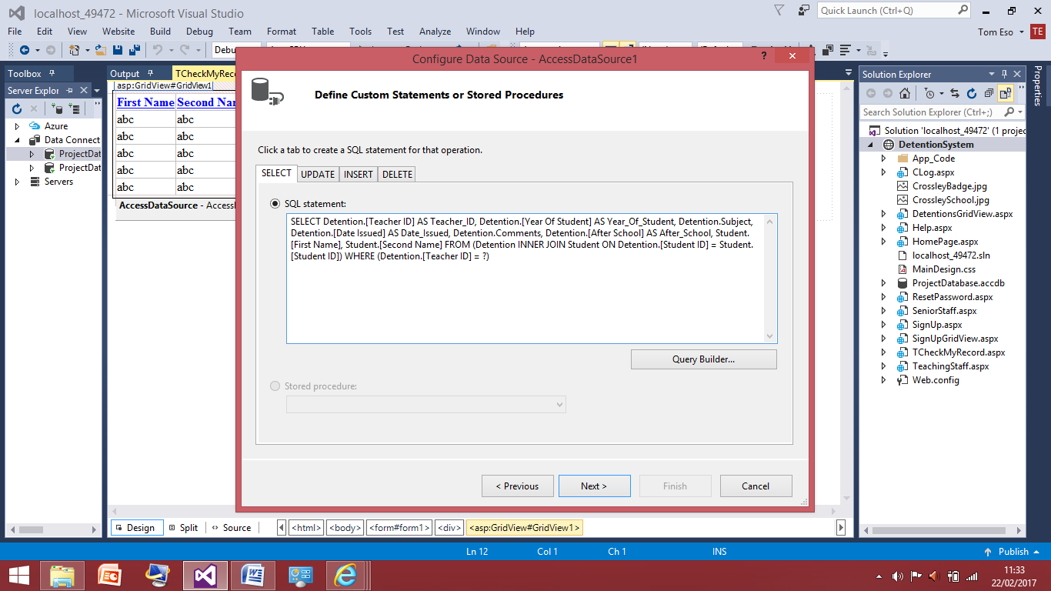In the page load I have passed the teacher ID to the web form of the checking the history page. I have passed this because I am writing a query to where the student’s detentions will be displayed based of the teacher ID therefore the program needs to know what ID it is looking for.

This screenshot shows the sqlz code I have written into the builder here I have written what information should be taken from the detention table and what columns should be outputted as this is a non senior member of staff they do not see if the student now has an after school detention or not.

## This screenshot shows the session variable I passed being used within the query. And I’ve said what parameter source the program is looking for and it’s a session. After this the query was finished therefore I am to now move on to testing to query works.

## 

## These are the detentions currently in the table they are all assigned to the non senior member of staff so firstly I am going to test the teacher ID 14. This teacher is Harry Alderton and one I click the check my records button a page should be produced with just the detentions give on by Teacher ID 14, which should be student ID 3,5,5,5.

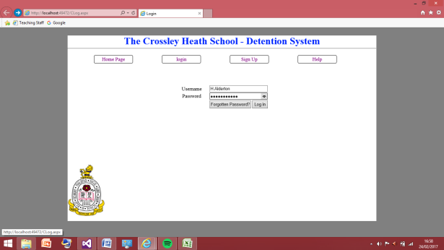

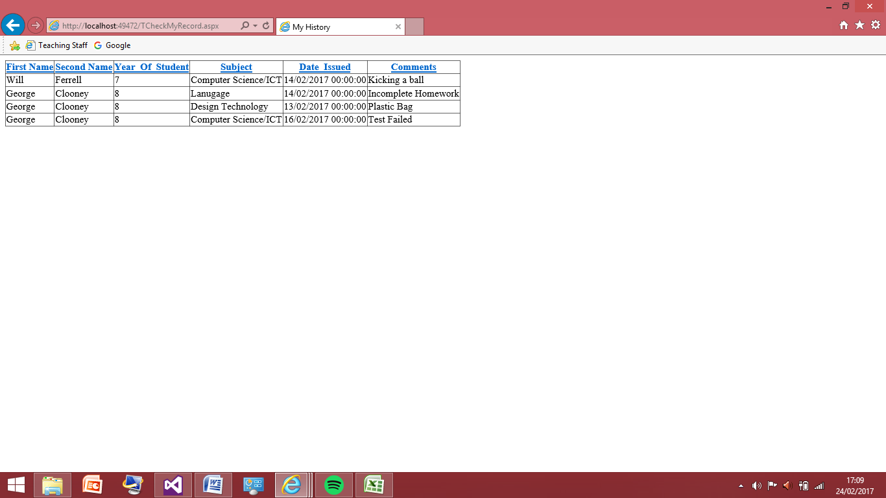This screenshot to the left show me logging in on the Harry Alderton account

## This screenshot shows the test was successful as the right student names were produced from the table and nothing else was shown to the teacher but the ones they have entered in. I will now test this for the other users to ensure that this works as expected.

This screenshot to the left show me logging in on the Emily Blunt account.

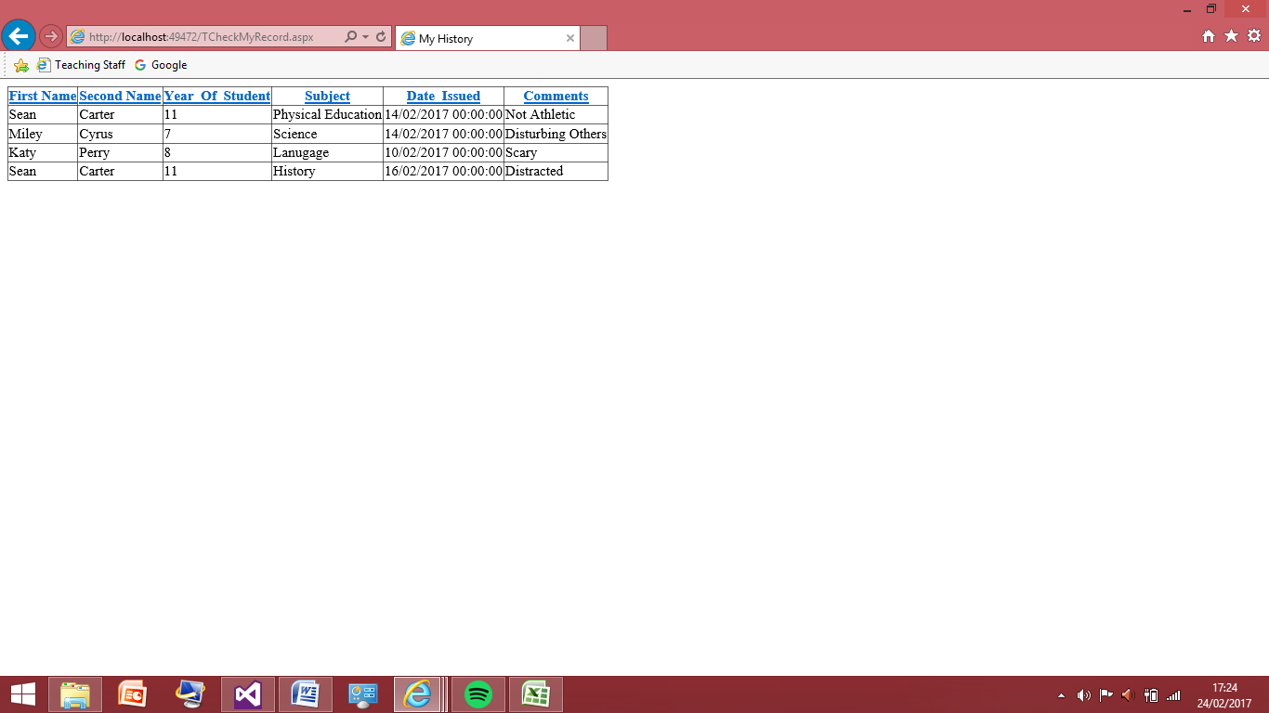

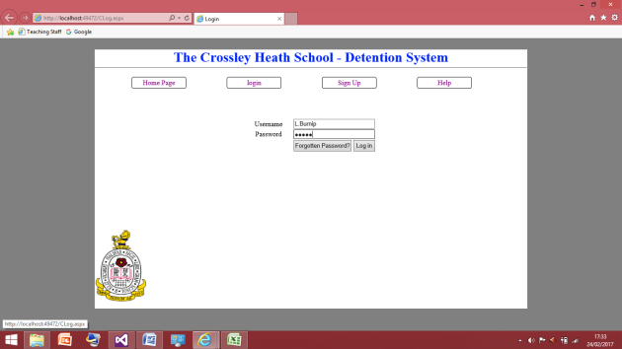This screenshot shows the program works correctly again for this user as the right students were pasted into their history also the teacher can sort the fields into whatever order by clicking the top bar in blue. I will now do the final test for this.

This screenshot to the left show me logging in on the Luc Burnip account

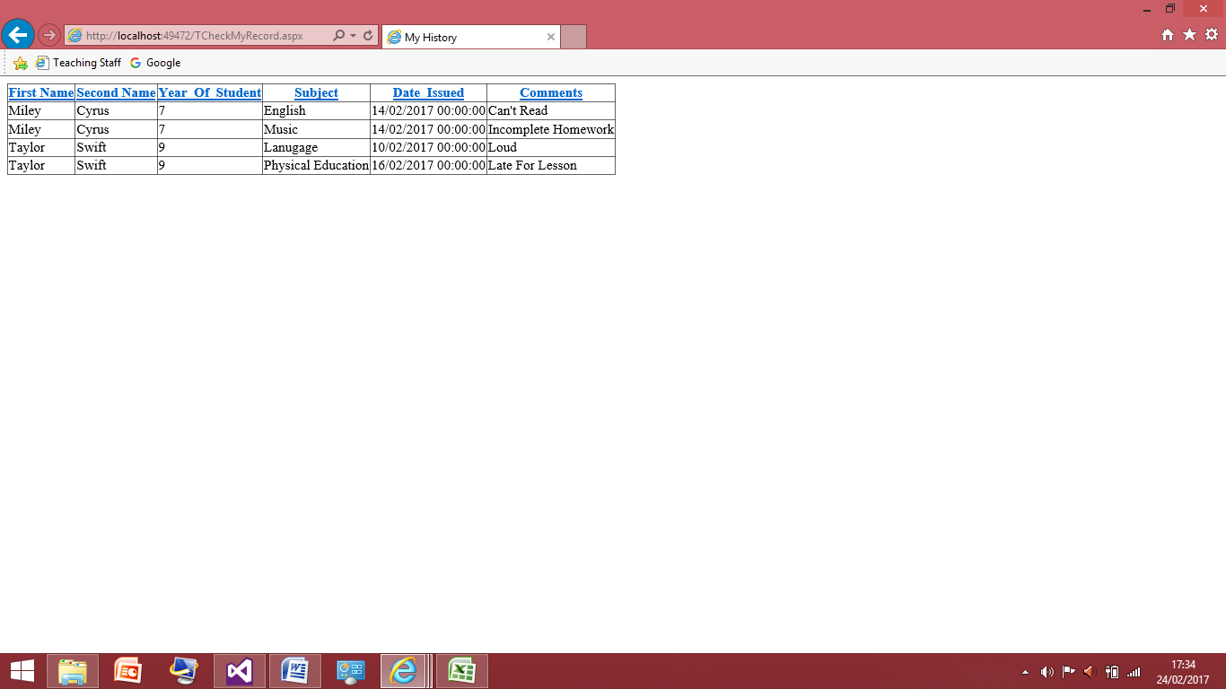

This final screenshot shows the test was successful for Luc Burnip

I have now reached the end of usability of a the normal teaching staff, next I will move onto the senior member of staff who have all these features and more so I will copy this code and attributes over to the senior staff account then add the code needed to add up the detentions to show whether the student has an after school detention or not.

Senior Member of Staff:

I have added 3 detentions to the detention table from the 3 senior members of staff, and have copied all the code from the teaching staff code; therefore I know the code works perfectly alongside the ‘check my history’ button works appropriately as well.

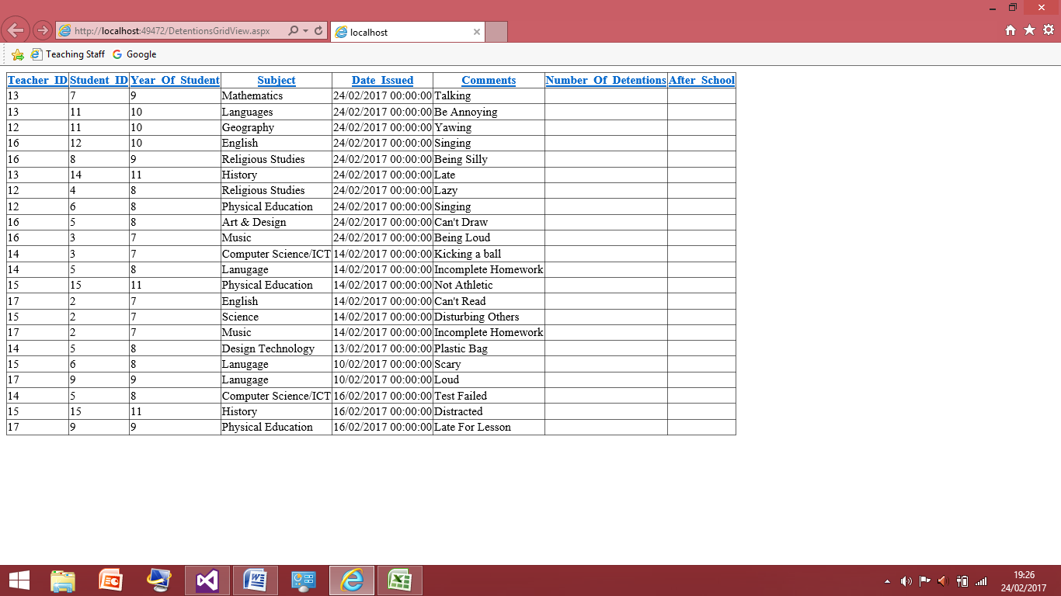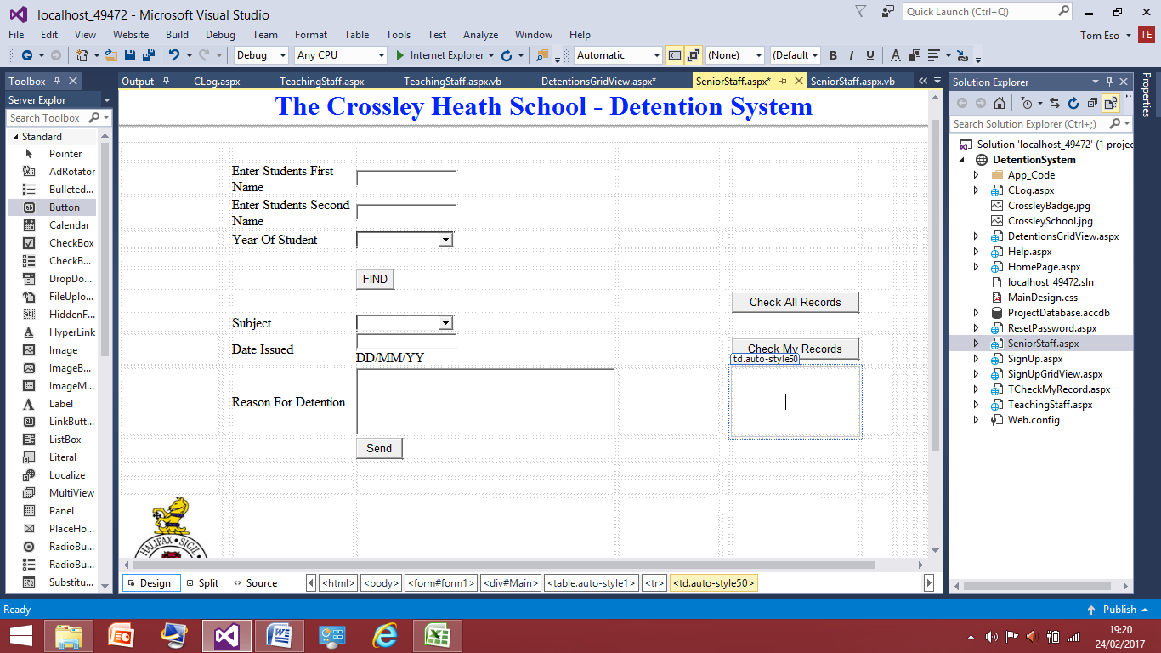This is now the look for the senior stall log in this is very similar to the teaching staff one but they have the option to see all the detentions.

This is the updated version of the detentions I have added 3 each for the 3 senior members of staff they have teacher IDs of 13, 16 and 12.

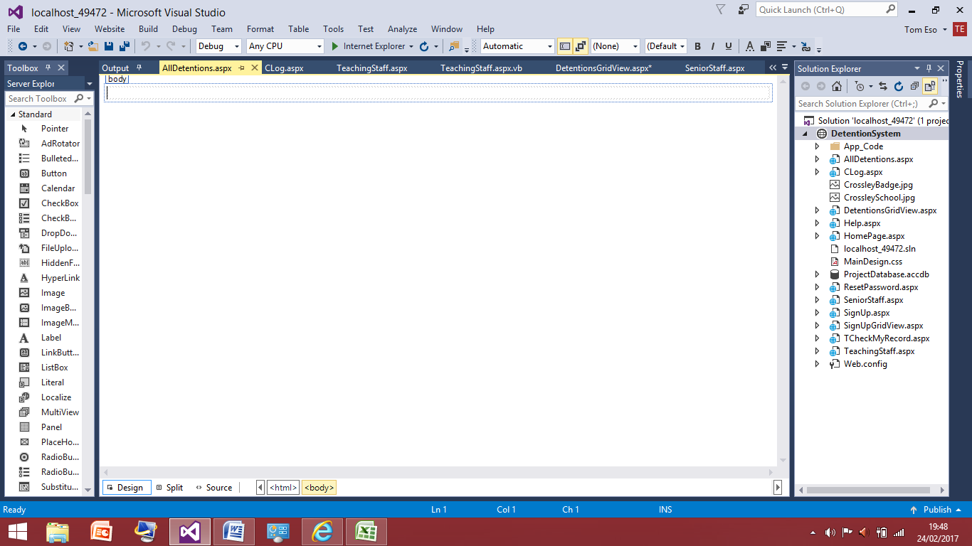After some time of researching and trying to get the detentions to be added up and get told whether the student then has an after school detention or not I found my lack of skills and time didn’t allow me achieve this. Therefore this is something I will have to discuss with my client if they would like to pass the program to someone who can get this done, but instead of allowing the senior teacher to see who has a detention, I have decided the way around this would be to show the senior member of staff the whole of the detentions given out by anyone and allow this for sorting. I have chosen to do this as it’s something I know I can provide for my client and this may benefit the end user as see all the students’ detentions instead of not being able to see it at all.

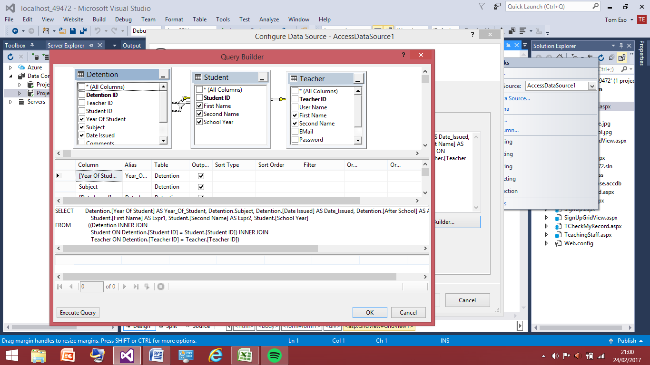Here I have started by adding a new web form called all detentions to the program, as the huge list of detentions will be displayed here in this web form.

This screenshots shows how am using the query builder to control what is outputted to the user here I can see what information I can get from each table. So here through the connections I have made between the tables allows me to get the first and last name of both student and teacher based of the ID. Therefore I have changed to senior member to be allowed to be able to see all detentions even senior one that is there privilege over the normal teaching staff. Now the query is written I will test all the detentions are now displayed to the user by logging in on a senior member of staff account.

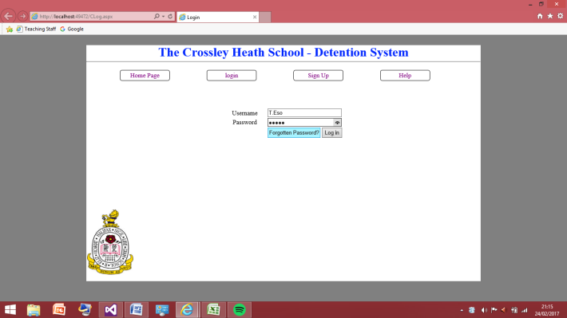This screenshot shows I am logging into the Tom Eso Account which is a senior member.

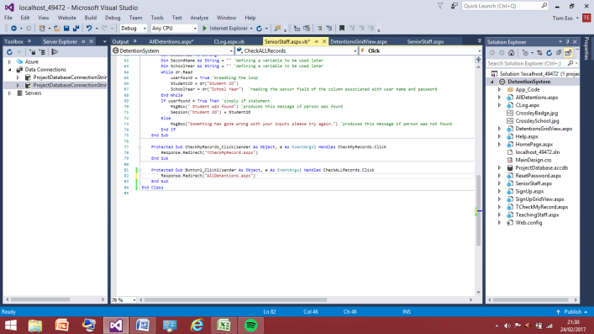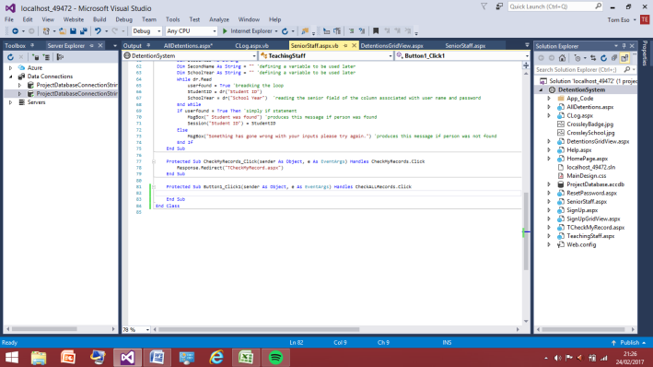During the test there was a problem the ‘Check All Records’ button didn’t do anything, it didn’t take me anywhere this must be because I forgotten to add the redirect or I’ve misspelled the web form it was supposed to take me to.

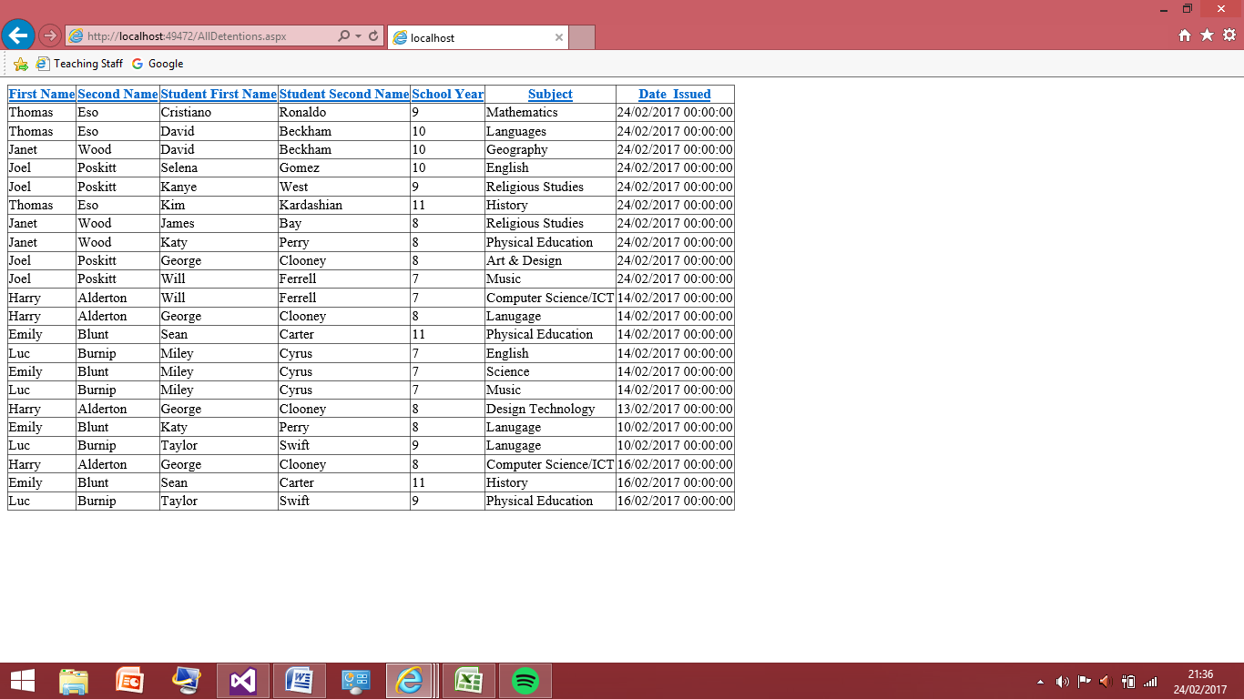The screenshot to the left shows I had forgotten to add the redirect command, the screenshot to the right shows I have now added the redirect therefore this should have corrected the error and it should be working appropriately now.

This screenshot shows the code is now working properly this was an easy fix and the user account can now fully see all detention and what teachers have given them out. I will now check this for the other two users and once that is completed my program is now been completed to the best of my ability and can be given to my client.

## The screenshot to the left shows I am logging in on the other senior member account being Janet Wood and the screenshot to the right shows checking all records are displayed.

## The screenshot to the left shows I am logging in on the other senior member account being Joel Poskitt and the screenshot to the right shows checking all records are displayed.

## Reviews

HomePage:

At the end of designing the home page I showed it to my client as this was going to continuously be the colour scheme for project and continue to form the look on the pages. My client was very happy with the look for home page. He was happy with the size and liked the way the colours came together nicely and was very clear on it indications of where to go such as the font size being big and bold making the usability very easy for the end users. Therefore with an all good review from my client I was clear to move on.

User registration Page:

After I completed to user registration I also had another meet up with my client where we discussed the functionality and usability. He was very impressed with the speed of which I completed this and alongside him using it to check how easy it would be we asked another member of staff to and they both found the program very simple to use so far. They agreed with the validation I had put in process in by restricting what subjects can be put in and the senior/non senior member of staff being a drop down box. My client then asked how come the design here was different to the one I provided in the plans. I explained those were quick mock up and during the execution I had realised the design I now had was better suited to the program.

Login Page:

After the completion of the log in page I was able to show my client that I had completed the success criteria of having the non senior and senior teaching members of staff. When I was able to show this to my client He didn’t have a lot to say but that it was good to have the split between senior and non senior member of staff. Also he was happy the two didn’t have to actually sign up in different places and the program could just use the same places for sign ups.

Forgotten Password:

After this was completed I asked for some feedback from my client on the forgotten password function. He commented on the security of my program as to reset a password the only thing you needed to know was the user name this could leave account vulnerable to being hacked by other people who just know the user name. However we considered because the environment this being used is a work place and the information on the accounts aren’t sensitive information we decided to allow it how it was. Also my client come up with a good idea to relieve me of pressure and this was because I already have a forgotten password button which allows for the passwords to be changed I did not need to have the function that makes the password invalid after 6 weeks because again this may be an unnecessary but good security attribute. Instead of forcing the user to change the password anyone who feels they have had their password for too long can simply press the forgotten password button and change it. I agreed with this as it made sense to have this having both seems unnecessary and could possibly be cause problems for users who find it annoying or stressful to be changing and having to remember their new passwords.

Teaching Staff Page:

After I completely finished this section, so including the design and the functionality, including the reading your own records I was able to have another sit down with my client. Who was immediately impressed by the simplicity and user friendliness which is something he had always stressed from the beginning. He was glad I had the find button in there to distinguish between the years of students who may have the same name. Apart from the positive points he had to make about functionality there were no changes he would make, he was satisfied with the product in its entirety so far.

Senior Member of Staff:

During the execution of this page I was able to have it up to same stage at the teaching staff however I was unable to complete having the after school detentions displayed. So instead I got rid of the column and just decided to have a full set of all the detentions which isn’t available to the normal teaching staff page. After I explained this to my client he wasn’t too disappointed to not have the counter to have the detentions added up as this program can be put into order and counted. He was impressed by the initiative I took by not just leaving both the senior staff and teaching staff the same because this wouldn’t show any priority for the senior staff. Therefore he accepted the end result and was pleased with it. I did offer him to find someone who could get the 5 detention being an after school added to program and he said he would look into that himself once I passed the program over.

Testing to Inform Evaluation:

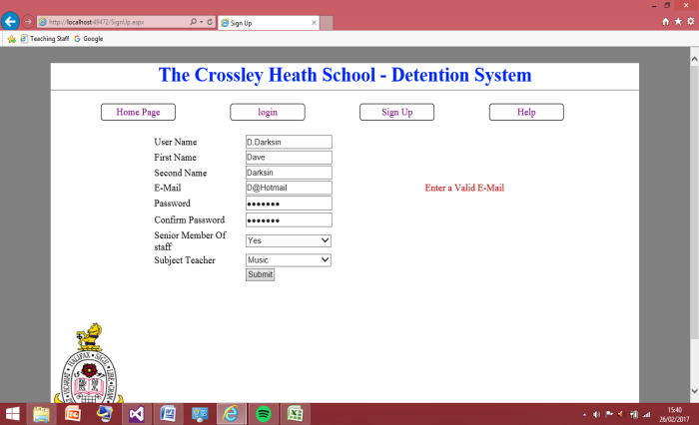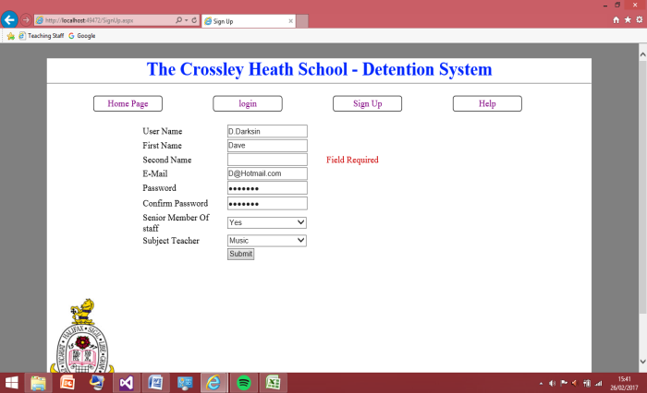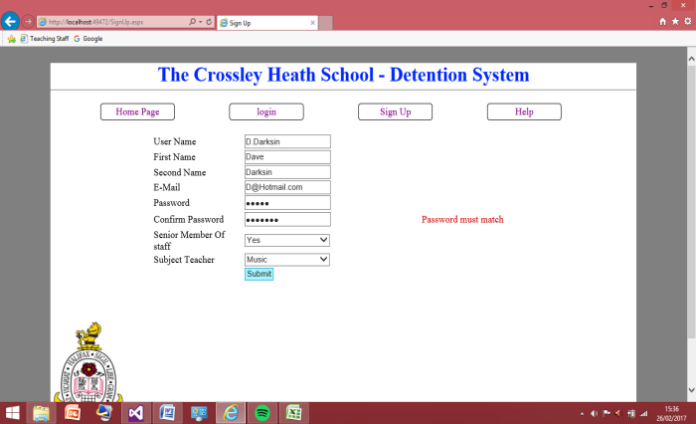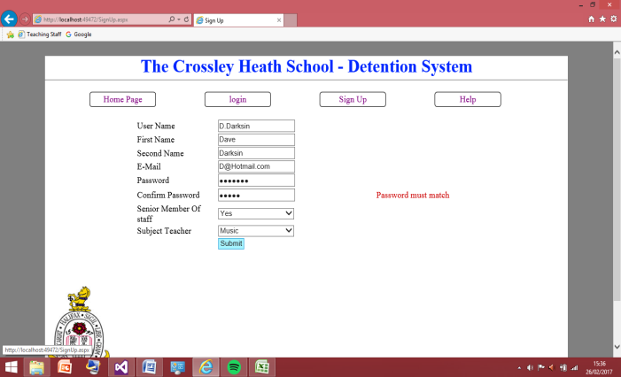For testing the robustness of my program I’ll start with the sign up page and try to break the program, by entering values the program really isn’t expecting to prove the program doesn’t break.

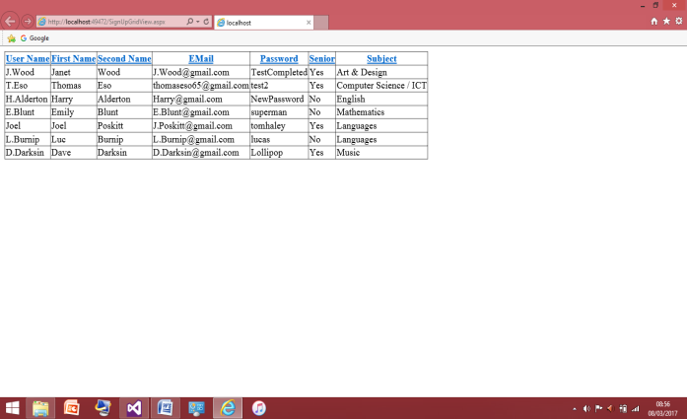These 4 screenshots shows the test I have been applying again to sign up page checking that the field validations work correctly as they all do and the account was set up successfully.

This screenshot is the grid view to show that the user was successfully added to the database with the password of ‘Lollipop’ I will now test the rest password query that will have the password change to ‘Changed’ but I will try a various amount of inputs to insure this works robustly.

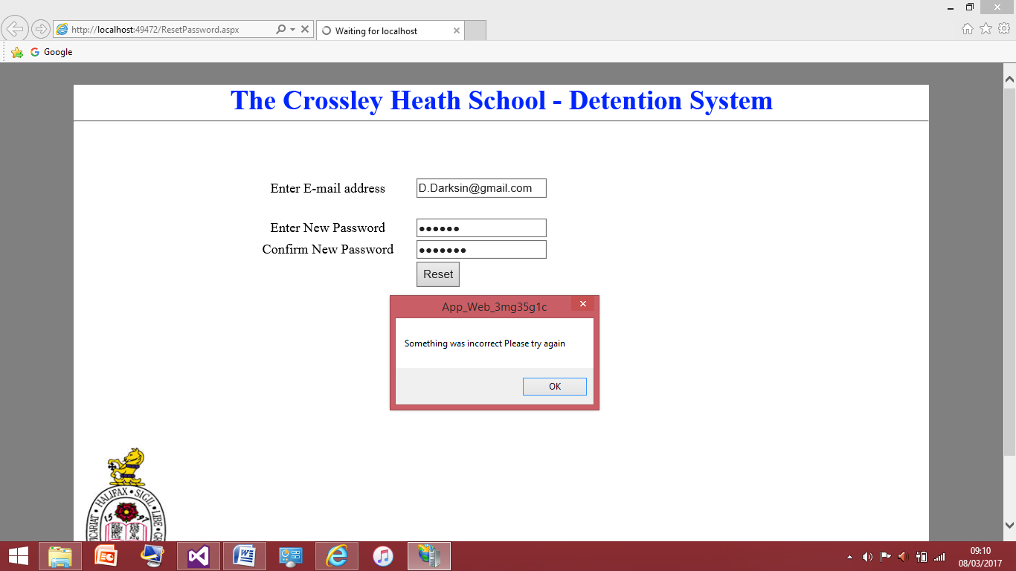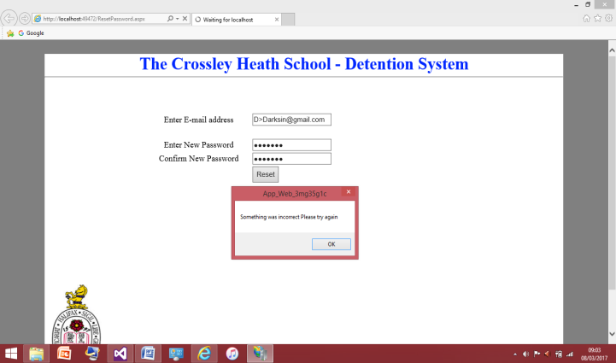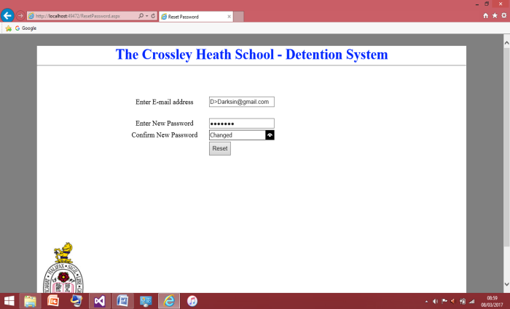The screenshot to the left shows I have entered the email address of the user ‘Dave Darksin’ incorrectly therefore the program was not able to update the field in the table as the email entered does not match any of the inputs in the table therefore the password field couldn’t be updated and the message box displaying error message was produced.

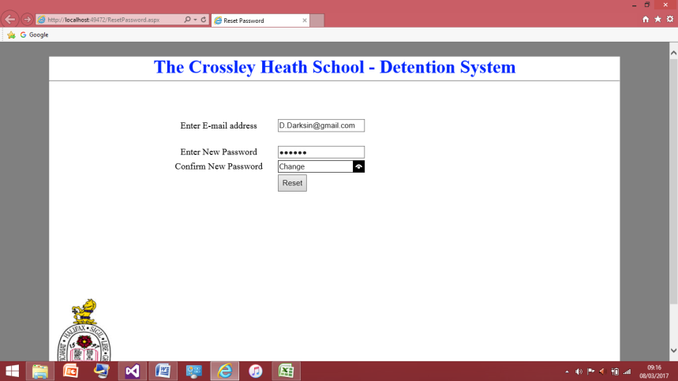This screenshot shows how I have tested the update query differently this time instead of entering the email differently I have entered the password with two different passwords, therefore the passwords don’t match. Henceforth the password field couldn’t be updated and the message box was produced clearly indicating to the user they need to change what they have entered in.

This screenshot is how I have now updated the password field by entering all values correctly I was then redirected to the Log in page where the user can then sign in as usual and have access to all their history as usual.

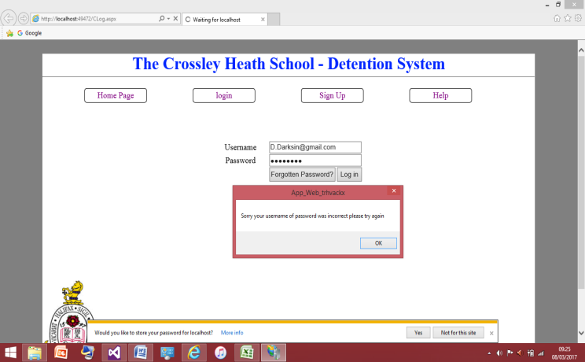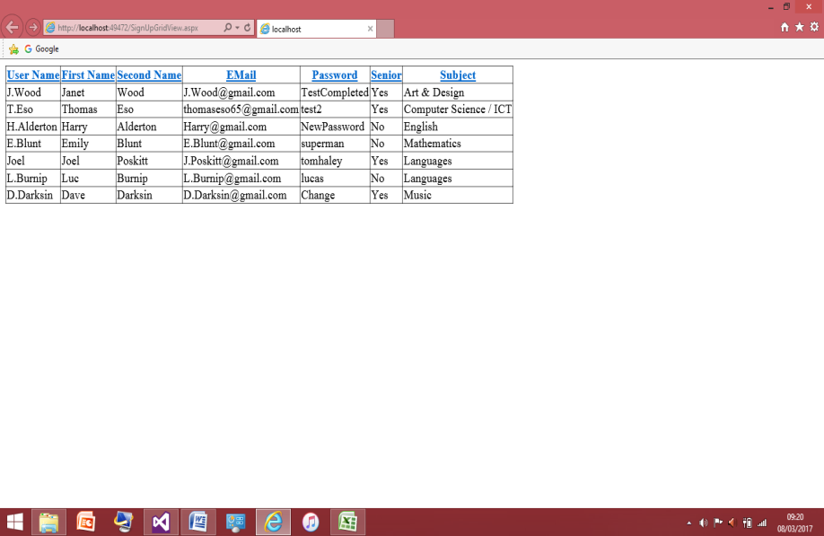This is now the new updated password field, the password for ‘Dave Darksin’ is now ‘Change’ as I expected therefore this works correctly. I will now check this works in the log in and as ‘Dave Darksin’ is a senior member of staff I am expected the features associated with senior members of staff to be put in place in this case is being able to see all the detentions give out.

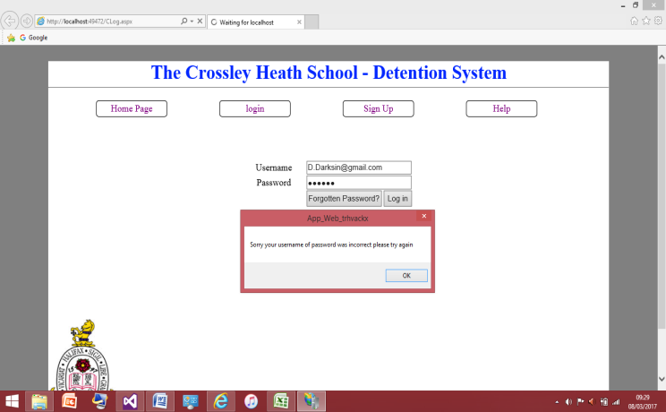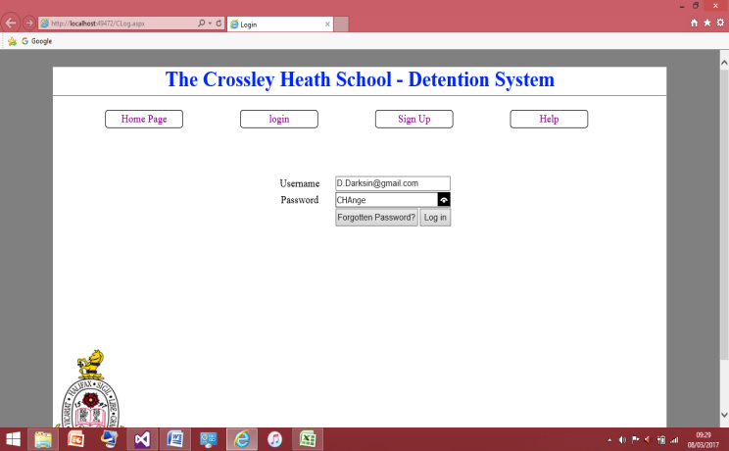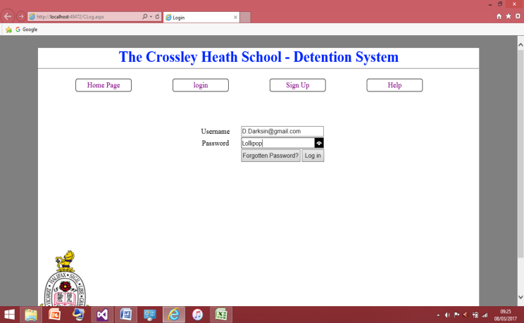Here I have tested to ensure that the old password does not correct so I have entered ‘Dave Darksin’ old password which was ‘lollipop’ which isn’t what it is now, therefore the program saw that the username fields and passwords fields do not match therefore an error message was produced clearly show casing to the user they have entered something in incorrectly for security reasons the program cannot specify whether it is the user name or password.

Here is just another test I have done I have entered the password correctly but in different cases, therefore I was showing the program is case sensitive in how it reads the passwords and the passwords must be entered in the correct case it was entered in during its set up.

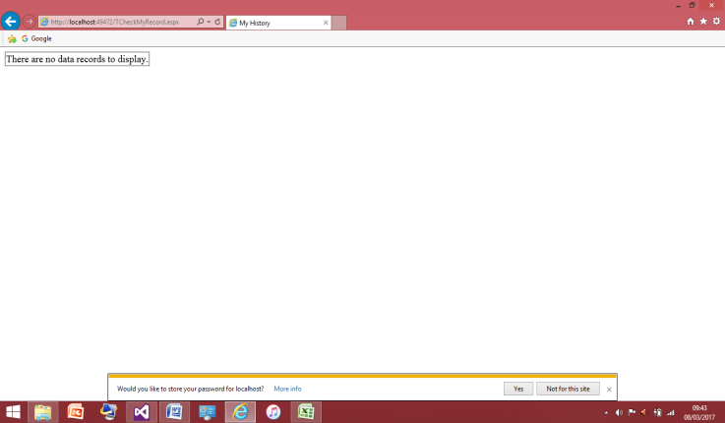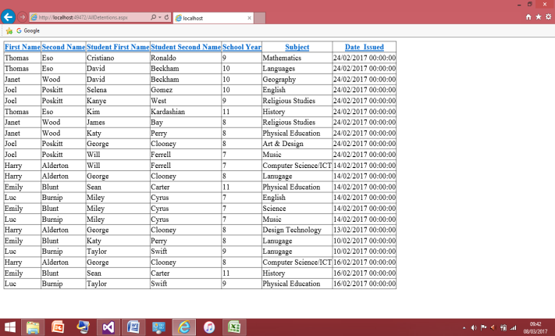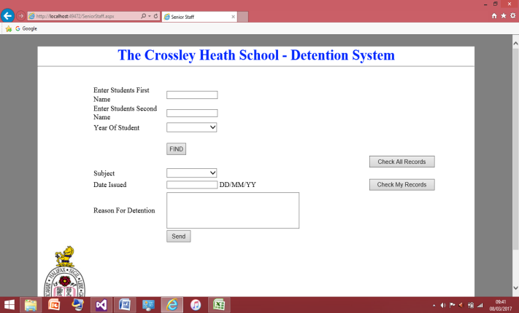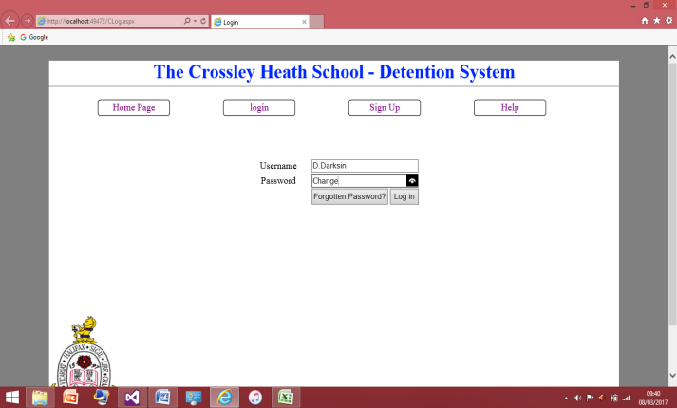Now I have entered all the values correctly and I was successfully logged in as I was taken to senior member of staff page upon pressing log in. This account will not have any detentions linked to it but I will test the ‘check all records button’ works as expected.

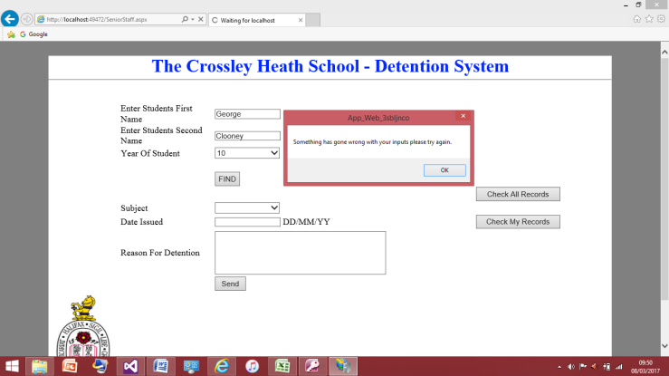The screenshot to the left shows that ‘checking all the records’ button works properly and since and the screenshot to the right shows the ‘check my records’ works correctly so far as this account has no detentions and therefore the box says there is no data to display was displayed as expected, and was clearly visible to the user.

This is the within the ‘Dave Darksin’ account I have started to enter detention for the student that is ‘George Clooney’ but I have purposely entered the values incorrectly and the user was not found. But I shall ignore this and continue to enter a detention for student who doesn’t exist and see what happens.

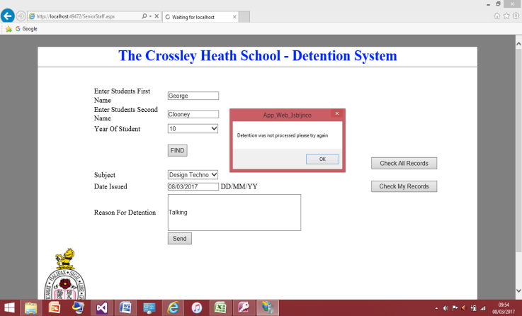

This screenshot shows the detention was not successfully processed as expected as the student cannot be found in the program therefore the detention cannot be issued.

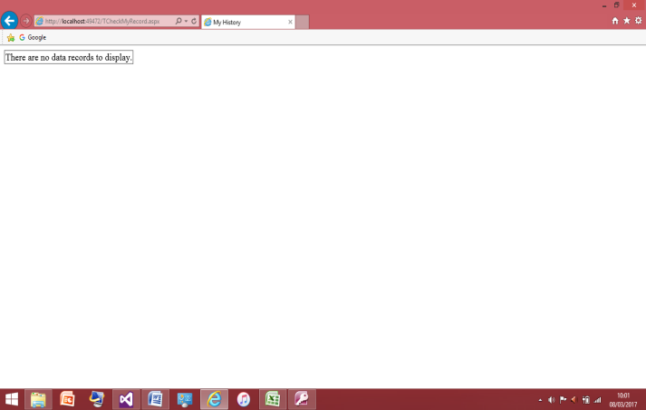To ensure the detention was not process I checked the two places of where the detention could be displayed and that was in ‘Dave Darksin’ personal history and the check all history pages and the detention did not show up in either as expected.

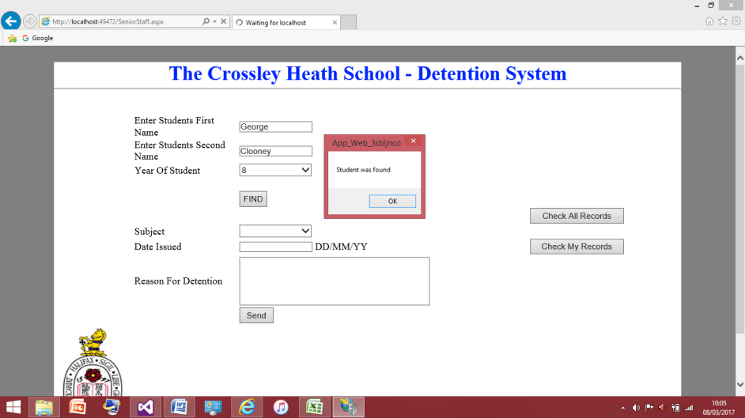

I have now started to enter a new detention for ‘George Clooney’ and have inputted his values correctly as the message box says it has been found.

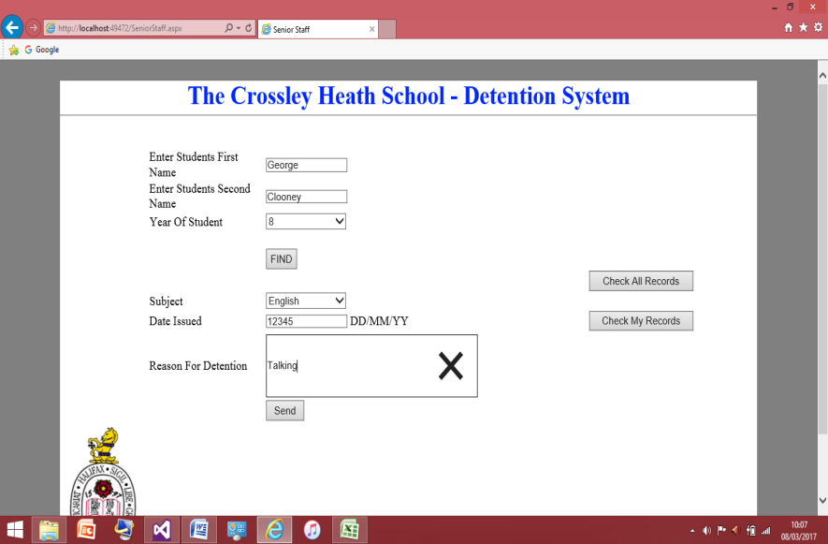

Here I have entered all the values correctly apart from the date which I was unable to have a field validation on it that worked correctly. Therefore I put the format I wanted the user to enter in to the program correctly very clearly beside the textbox. But for this test I have entered in random numbers and I will see what happens when I press send.

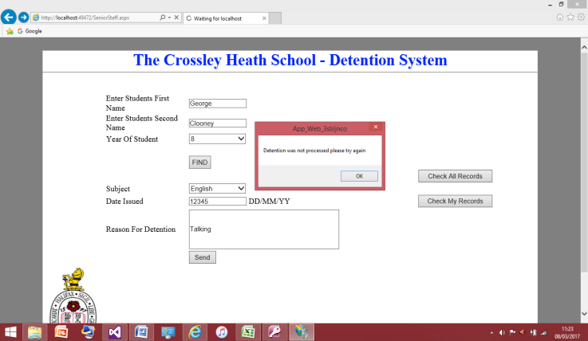

Even though I hadn’t entered in a validation the detention wasn’t processed which confused me to why it wasn’t. It wasn’t until I looked into the database and I noticed I had set the field to be prepared for date/time and since my value of ‘12345’ was not a date format hence the program didn’t enter it into the database.

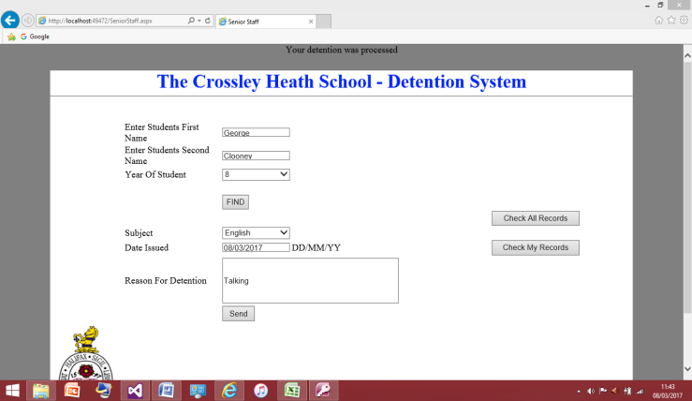

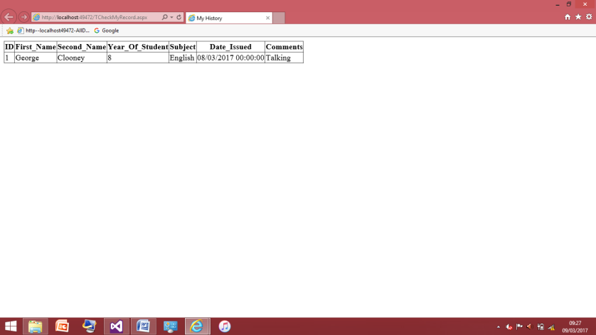This screenshot shows that the detentions are now working as the detention has been processed. Therefore I do have a kind of validation on the ‘Date Issued’ field. Now the detention has been processed the final test I need to do is on checking if the ‘check my records’ button works appropriately. It should only show the one detention I have entered under ‘Dave Darksin’

## This screenshot shows the history that was dragged from the main detention table to display ‘Dave Darksin’. The one detention that was entered under this account was produced correctly with all the right heading names.

This now concludes the end of the post testing of I have tested the sign in, log in process alongside the updating the password field, entering a student detention and checking the history of the user. I tested robustly by entering in values that the program wouldn’t be expecting and I would say the program was good at not breaking. The program was able to display to the user clearly what the problem was and what the user needed to do in order to correct the mistake they have done.

Evaluation of Solution:

## Evaluation

I feel this solution really matches the requirements I and my client set out earlier in the analysis of the program. As I have met 5 out of the 6 success criteria, and have completed them to the fullest of what I expected to. I completed most tasks swiftly as I have had quite a lot of practice from earlier programs and was able to grasp a lot of ideas from there. Also the breakdown of the problem allowed me to tackle it more efficiently because I had a clear plan of the steps needed to tackle each problem. Alongside this a strong point that was made clear to me by my client was the usability as teachers are at different levels of being able to use computers therefore this was important for me to have very easy usability which I think I achieved very well and so does my client as he was very happy with the end result. This was partially why I have made the project very simplistic in its design. Alongside side this program is very easy to follow and all the information needed for the user to navigate through the program with o problems. Through all the testing I have shown that I have been able to separate the senior members of staff from the normal teaching members and even though I was unable to produce the right code to have the detentions added up I gave senior member of staff the ability to see everyone’s detentions so there is a difference between being a senior staff member and a normal teaching staff.

During the development quite a lot of designs were changed, I originally had no home screen and it was just a simple log in and sign up page. But instead when I started actually making the program I thought a homepage would just be a better as I just felt adding a homepage just makes the program look more user friendly and more professional than just getting to sign up or log in page. Alongside this changed the designs on the sign up page as I realised I needed to collect more information on the sign up page that I had currently had, I will have forgotten to think about this in the design because I wasn’t think so far ahead to how the program is going to work and more on how the physical look will be. Also originally I had two places for the senior member of staff to log in and have the teaching members of staff to log in somewhere else, but during my development of the program I realised I was able to have them log in the same place which obviously made it easier for me as this was less designing I had to do. But apart from these nothing else was changed drastically during the development during my program I did my best to stick to what I had previously been shown to my client and any changes were made aware to him to ensure my client was comfortable with it.

Unfortunately I was unable to meet one piece of my success criteria and this was the one I thought would be the most difficult to achieve. This success criteria was having the detentions added together of one student and then have a column in the table with after school detention being yes if the amount of detentions was 5 or above. And this was only supposed to be able to access by the senior member of staff. Due to my lack of skills I realised after some time I was unable to reach this criterion, however in the future with more experience and more research I should be able to achieve this. If my client is comfortable with using the program as it is for the time being and allowing me to have more time then eventually I may be able to get this done. But in the time scale I had I was unable to and my client understands this and wasn’t let down as he knew my original worries about achieving this.

Some further developments that may be able to be added to program could possibly be having this detention program linked to e-mail address. This would be useful as when a student receives an after school detention an e-mail must be sent to the student guardian therefore if the program was able to sent an automated e-mail to the student guardians when the after school detention column says yes this would be a good further development as it improves efficiency. And at the end of every week the worker in the office doesn’t have to worry about sending the e-mails. However this would have to vigorously tested so e-mails are never accidently sent to the student’s parents falsely. Also another improvement could be having the program keep track of who gets frequent detentions and after school detentions and when you click one of these students names it could produce a summary of the average amount of detentions given to this student and based of this the program could offer some action the teacher could make to this student for example putting them of report. This would be an excellent improvement as this really takes the program to next level and would really help the teacher in finding badly behaved students. Another miniature improvement I could make would be to have a strength and weakness analysis on the password given or have some sort of validation that prevents passwords of less than a certain amount of characters to the when the users are setting up the account. Therefore these are the main improvements I think could be made within this program to make it even more useful to the Crossley Heath School.

## Maintenance

When the program is eventually launched there will have to be some changes made to program in order to allow it work in a real world situation. Such as the database, I have made a preliminary student table with the right heading that the school store there students under but the connection will need to be changed in the program. As the connection in the program is connected to my database therefore the school will need to make the new connection to their database and ensure it works properly. Depending on the skills of the maintenance team in the school this could be a problem for them if they do not have experience or are not aware of what to do with the program, however I feel the program is easy to follow therefore I don’t see this being a major issue. Alongside this the student table will need to be updated each year to allow for the new students to be entered into the table and for the student that have left to be deleted from the table. It should be noted that all records regarding students have left should be deleted in order to maintain referential integrity. A problem with the current version is that the program may be slow to become active in the school as I haven’t fully completed the program to all the criteria I and my client discussed however I have produced a detention system that will work effectively. Therefore this can be used in the mean time whilst a developer works on having the code show the after school detention list and then have that implemented into the program. Therefore this could hinder the speed in which the program is being used to its full potential in the school.

I think the program can be modified quite easily and be used in other schools that struggle to keep a record of their detentions. The modification would be the database connected would be one of things that would be needed to be changed. However I have used heading in the tables that correspond to the heading in the Crossley Heath database therefore they do not need change the physical code, which relies on passing the inputs from the textboxes into the corresponding heading in the columns of the table in the database. Therefore if another school would want to use the program they would either have to change all there heading in their databases to match the ones used in my program or go through my program and change all the headings within there, which would be time consuming and possibly break the program in the process of changing the code if they do something wrong.